[MS-VHDX]:
Virtual Hard Disk v2 (VHDX) File Format

Intellectual Property Rights Notice for Open Specifications Documentation
- Technical Documentation. Microsoft publishes Open Specifications documentation (“this documentation”) for protocols, file formats, data portability, computer languages, and standards support. Additionally, overview documents cover inter-protocol relationships and interactions.
- Copyrights. This documentation is covered by Microsoft copyrights. Regardless of any other terms that are contained in the terms of use for the Microsoft website that hosts this documentation, you can make copies of it in order to develop implementations of the technologies that are described in this documentation and can distribute portions of it in your implementations that use these technologies or in your documentation as necessary to properly document the implementation. You can also distribute in your implementation, with or without modification, any schemas, IDLs, or code samples that are included in the documentation. This permission also applies to any documents that are referenced in the Open Specifications documentation.
- No Trade Secrets. Microsoft does not claim any trade secret rights in this documentation.
- Patents. Microsoft has patents that might cover your implementations of the technologies described in the Open Specifications documentation. Neither this notice nor Microsoft's delivery of this documentation grants any licenses under those patents or any other Microsoft patents. However, a given Open Specifications document might be covered by the Microsoft Open Specifications Promise or the Microsoft Community Promise. If you would prefer a written license, or if the technologies described in this documentation are not covered by the Open Specifications Promise or Community Promise, as applicable, patent licenses are available by contacting iplg@microsoft.com.
- License Programs. To see all of the protocols in scope under a specific license program and the associated patents, visit the Patent Map.
- Trademarks. The names of companies and products contained in this documentation might be covered by trademarks or similar intellectual property rights. This notice does not grant any licenses under those rights. For a list of Microsoft trademarks, visit www.microsoft.com/trademarks.
- Fictitious Names. The example companies, organizations, products, domain names, email addresses, logos, people, places, and events that are depicted in this documentation are fictitious. No association with any real company, organization, product, domain name, email address, logo, person, place, or event is intended or should be inferred.
Reservation of Rights. All other rights are reserved, and this notice does not grant any rights other than as specifically described above, whether by implication, estoppel, or otherwise.
Tools. The Open Specifications documentation does not require the use of Microsoft programming tools or programming environments in order for you to develop an implementation. If you have access to Microsoft programming tools and environments, you are free to take advantage of them. Certain Open Specifications documents are intended for use in conjunction with publicly available standards specifications and network programming art and, as such, assume that the reader either is familiar with the aforementioned material or has immediate access to it.
Support. For questions and support, please contact dochelp@microsoft.com.
Revision Summary
Date | Revision History | Revision Class | Comments
7/14/2016 | 1.0 | New | Released new document.
6/1/2017 | 2.0 | Major | Significantly changed the technical content.
9/15/2017 | 3.0 | Major | Significantly changed the technical content.
Table of Contents
1 Introduction 5
1.1 Glossary 5
1.2 References 5
1.2.1 Normative References 5
1.2.2 Informative References 5
1.3 Overview 5
1.4 Relationship to Protocols and Other Structures 7
1.5 Applicability Statement 8
1.6 Versioning and Localization 8
1.7 Vendor-Extensible Fields 8
2 Structures 9
2.1 Layout 9
2.2 Header Section 9
2.2.1 File Type Identifier 10
2.2.2 Headers 10
2.2.2.1 Updating the Headers 12
2.2.3 Region Table 13
2.2.3.1 Region Table Header 13
2.2.3.2 Region Table Entry 13
2.3 Log 14
2.3.1 Log Entry 15
2.3.1.1 Entry Header 16
2.3.1.2 Zero Descriptor 18
2.3.1.3 Data Descriptor 18
2.3.1.4 Data Sector 19
2.3.2 Log Sequence 19
2.3.3 Log Replay 20
2.4 Blocks 21
2.5 BAT 21
2.5.1 BAT Entry 22
2.5.1.1 Payload BAT Entry States 22
2.5.1.2 Sector Bitmap BAT Entry States 25
2.6 Metadata Region 25
2.6.1 Metadata Table 26
2.6.1.1 Metadata Table Header 26
2.6.1.2 Metadata Table Entry 26
2.6.2 Known Metadata Items 27
2.6.2.1 File Parameters 28
2.6.2.2 Virtual Disk Size 28
2.6.2.3 Virtual Disk ID 29
2.6.2.4 Logical Sector Size 29
2.6.2.5 Physical Sector Size 29
2.6.2.6 Parent Locator 30
2.6.2.6.1 Parent Locator Header 30
2.6.2.6.2 Parent Locator Entry 30
2.6.2.6.3 VHDX Parent Locator 31
3 Structure Examples 33
4 Security 34
4.1 Security Considerations for Implementers 34
4.2 Index Of Security Fields 34
5 Appendix A: Product Behavior 35
6 Change Tracking 37
7 Index 38

Introduction
This specification defines the virtual hard disk format that provides a disk-in-a-file abstraction.
Sections 1.7 and 2 of this specification are normative. All other sections and examples in this specification are informative.

Glossary
This document uses the following terms:
block allocation table (BAT): A redirection table that is used in the translation of a virtual hard disk offset to a virtual hard disk file offset.
cyclic redundancy check (CRC): An algorithm used to produce a checksum (a small, fixed number of bits) against a block of data, such as a packet of network traffic or a block of a computer file. The CRC is a broad class of functions used to detect errors after transmission or storage. A CRC is designed to catch random errors, as opposed to intentional errors. If errors might be introduced by a motivated and intelligent adversary, a cryptographic hash function should be used instead.
host disk: The volume or disk on which the virtual hard disk file resides.
MAY, SHOULD, MUST, SHOULD NOT, MUST NOT: These terms (in all caps) are used as defined in [RFC2119]. All statements of optional behavior use either MAY, SHOULD, or SHOULD NOT.

References
Links to a document in the Microsoft Open Specifications library point to the correct section in the most recently published version of the referenced document. However, because individual documents in the library are not updated at the same time, the section numbers in the documents may not match. You can confirm the correct section numbering by checking the Errata.

Normative References
We conduct frequent surveys of the normative references to assure their continued availability. If you have any issue with finding a normative reference, please contact dochelp@microsoft.com. We will assist you in finding the relevant information.
[Castagnoli93] Castagnoli, G., Brauer S., and Herrmann, M., "Optimization of cyclic redundancy-check codes with 24 and 32 parity bits", IEEE Transactions on Communications, Volume 41, Issue 6, June 1993, http://ieeexplore.ieee.org/xpl/articleDetails.jsp?arnumber=231911
Note There is a charge to download the journal.
[RFC2119] Bradner, S., "Key words for use in RFCs to Indicate Requirement Levels", BCP 14, RFC 2119, March 1997, http://www.rfc-editor.org/rfc/rfc2119.txt

Informative References
None.

Overview
The virtual hard disk v2 (VHDX) file format provides features at the virtual hard disk as well as virtual hard disk file layers and is optimized to work well with modern storage hardware configurations and capabilities.
The VHDX format is designed to support three types of virtual hard disks:
- Fixed Virtual Hard Disk: A virtual hard disk file that is allocated to the size of the virtual hard disk and does not change when data is added or removed from the virtual hard disk. For example, for a virtual hard disk that is 1 GB in size, the virtual hard disk file is approximately 1 GB and will not grow or shrink in size as data is added or deleted.
- Dynamic Virtual Hard Disk: A virtual hard disk file that at any given time is as large as the actual data written to it, plus the size of its internal metadata. As more data is written, the file dynamically increases in size by allocating more space. For example, for a 2-GB virtual hard disk, the size of the virtual hard disk file, initially, is around 2 MB. As data is written to this virtual hard disk, the payload size grows in predetermined blocks to a maximum size of 2 GB.
- Differencing Virtual Hard Disk: A virtual hard disk file that represents the current state of the virtual hard disk as a set of modified blocks in comparison to a parent virtual hard disk file.
Any new write to the virtual disk is captured in the latest child virtual hard disk. A read to a virtual disk offset is satisfied by looking for that virtual offset on the latest child virtual hard disk and traversing all the way to the parent if needed.
This mechanism is used to create point-in-time snapshots of disks for backups and other scenarios. The differencing virtual hard disk, in order to be a fully functional file, depends on another virtual hard disk file. The parent hard disk file can be any of the mentioned virtual hard disk types, including another differencing virtual hard disk file.
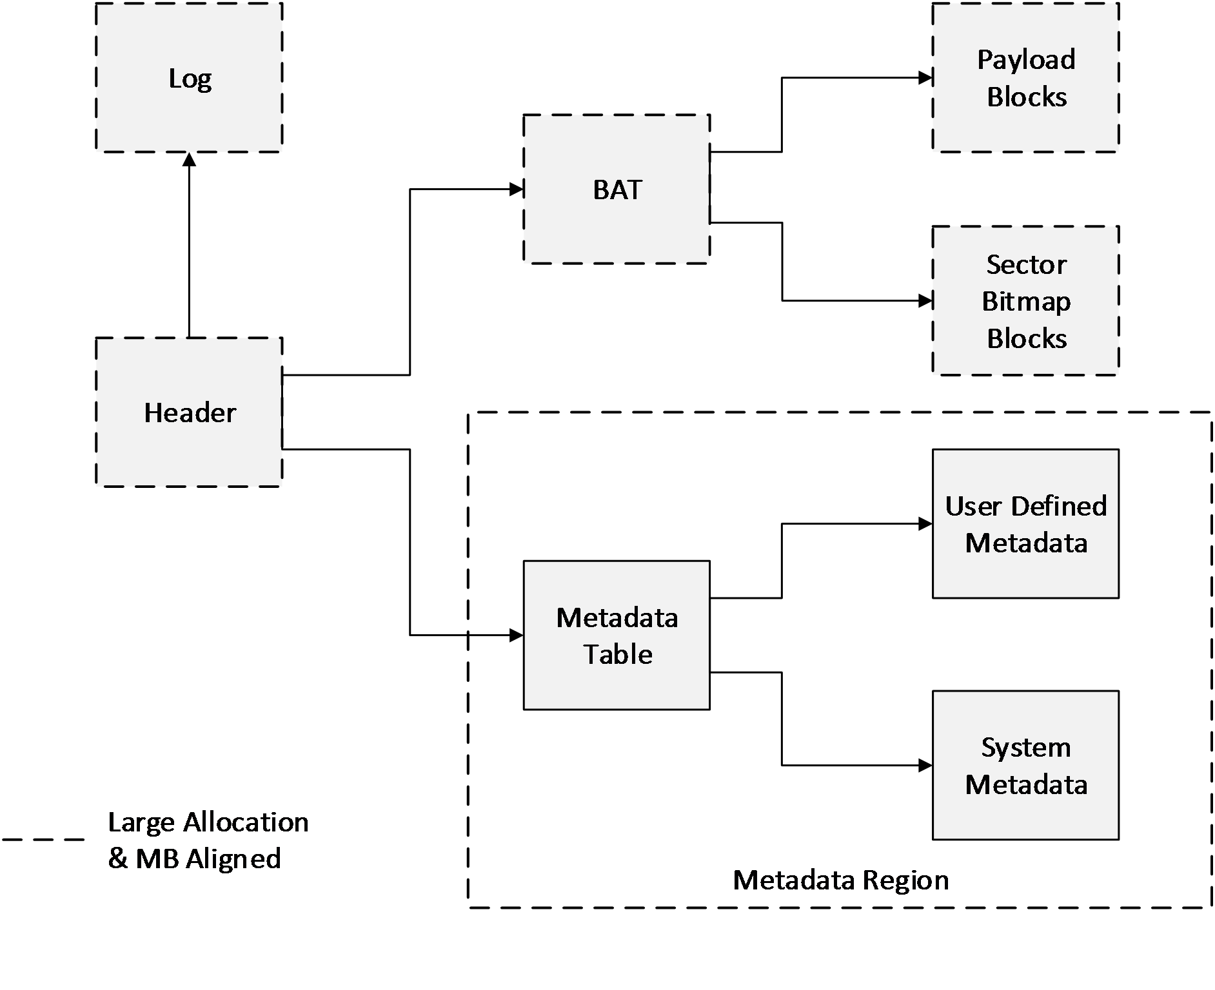
Figure 1: Logical layout
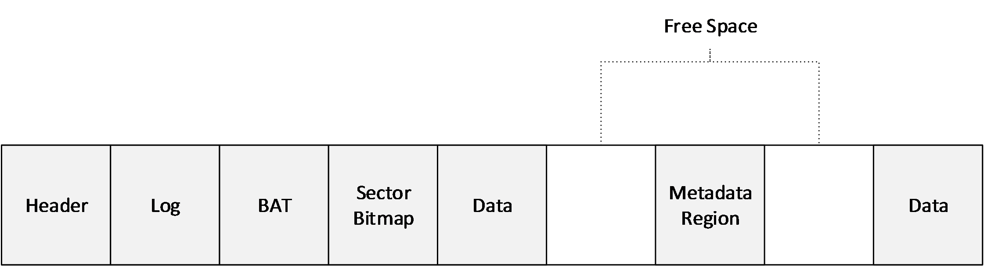
Figure 2: File layout example

Relationship to Protocols and Other Structures
None.

Applicability Statement
The benefits of the structures defined in this document include:
  - The ability to represent a large virtual disk size up to 64 TB.
  - Support for larger logical sector sizes—up to 4 KB—for virtual disks, which facilitates the conversion of 4-KB sector physical disks to virtual disks.
  - Support for large block sizes— up to 256 MB—for virtual disks, which enables fine-tuning block size to match the I/O patterns of the application or system for optimal performance.
  - A log to ensure resiliency of the VHDX file to corruptions from system power-failure events.
  - A mechanism that allows for small pieces of user-generated data to be transported along with the VHDX file.
  - Optimal performance, through improved data alignment, on host disks that have physical sector sizes larger than 512 bytes.
  - Capability to use the information from the UNMAP command, sent by the application or system using the virtual hard disk, to optimize the size of the VHDX file.

Versioning and Localization
The version of the VHDX format is determined by the value of the Version field in the header, as specified in section 2.2.2.

VHDX Version | Value
VHDX Version 2 | 0x00000001

Vendor-Extensible Fields
None.

Structures
All multibyte values MUST be stored in little-endian format with the least significant byte first unless specified otherwise. Bit 0 always means the least significant bit of the least significant byte.
The algorithm used to detect errors after transmission or storage is called a cyclic redundancy check (CRC). Unless specified otherwise, the CRC used to validate data is CRC-32C (see [Castagnoli93]), which uses the Castagnoli polynomial, code 0x11EDC6F41.
The notation Ceil(X) shall mean the minimum integer that is greater than or equal to X.
The notation Fl(X) shall mean the maximum integer that is lesser than or equal to X.
Unless specified otherwise, all fields are unsigned.

Layout
The VHDX file begins with a fixed-sized header section. After this, non-overlapping structures and free space are intermixed freely in no particular order, the only restriction being that all objects have 1-MB alignment within the file.
In addition to the header, the structures currently defined in the VHDX file include the block allocation table (BAT) region (also referred to as BAT), the metadata region, the log, the payload blocks, and the sector bitmap blocks, each of which is specified in the following sections. These structures can be moved around in the file as long as they are non-overlapping and the 1-MB alignment is maintained.
The logical and physical layouts of the structures, illustrated in the figures that follow, are similar for fixed, dynamic, and differencing virtual hard disk types; differences are discussed in the following sections.

Header Section
The header section is the first structure on the disk and is the structure that is examined first when opening a VHDX file. The header section is 1 MB in size and contains five items that are 64 KB in size: the file type identifier, two headers, and two copies of the region table.
The file type identifier contains a short, fixed signature to identify the file as a VHDX file. It is never overwritten. This ensures that even if a failed write corrupts a sector of the file, the file can still be identified as a VHDX file.
Each header acts as a root of the VHDX data structure tree, providing version information, the location and size of the log, and some basic file metadata. Other properties that might be needed to open the file are stored elsewhere in other metadata.
Only one header is active at a time so that the other can be overwritten safely without corrupting the VHDX file. A sequence number and checksum are used to ensure this mechanism is safe.
The region table lists regions, which are virtually contiguous, variable-size, MB-aligned pieces of data within the file. These structure currently include the BAT and the metadata region, but they can be extended by future revisions of the specification without breaking compatibility with different implementations and versions. Implementations MUST maintain structures that they don't support without corrupting them. Implementations MUST fail to open a VHDX file that contains a region that is marked as required but is not understood.
The header section contains five items: the file type identifier, two headers, and two copies of the region table, as shown in the following figure.
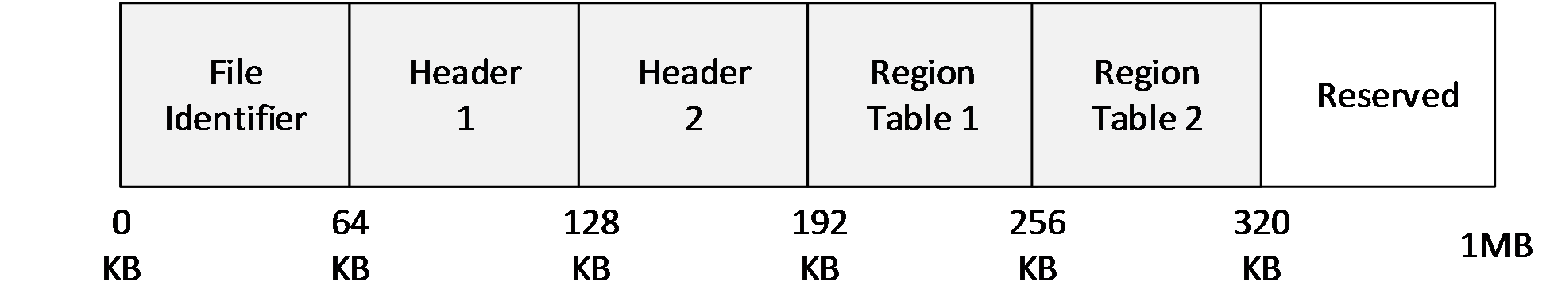
Figure 3: Header section layout

File Type Identifier
The file type identifier is a structure stored at offset zero of the file.
0 | 1 | 2 | 3 | 4 | 5 | 6 | 7 | 8 | 9 | 1  0 | 1 | 2 | 3 | 4 | 5 | 6 | 7 | 8 | 9 | 2  0 | 1 | 2 | 3 | 4 | 5 | 6 | 7 | 8 | 9 | 3  0 | 1
Signature
...
Creator (512 bytes)
...

Signature (8 bytes): MUST be 0x656C696678646876 ("vhdxfile" as UTF8).
Creator (512 bytes): Contains a UTF-16 string that can be null terminated. This field is optional; the implementation fills it in during the creation of the VHDX file to identify, uniquely, the creator of the VHDX file. Implementation MUST NOT use this field as a mechanism to influence implementation behavior; it exists for diagnostic purposes only.
An implementation MUST write the File Type Identifier structure when the file is created and MUST validate the Signature field when loading a VHDX file. The implementation MUST NOT overwrite any data in the first 64 KB of the file after the file has been created.
The space between file identifier data and 64-KB alignment boundary for the file identifier structure is reserved.

Headers
Since the header is used to locate the log, updates to the headers cannot be made through the log. To provide power failure consistency, there are two headers in every VHDX file.
Each of the two headers is a 4-KB structure that is aligned to a 64-KB boundary.<1> One header is stored at offset 64 KB and the other at 128 KB. Only one header is considered current and in use at any point in time.
0 | 1 | 2 | 3 | 4 | 5 | 6 | 7 | 8 | 9 | 1  0 | 1 | 2 | 3 | 4 | 5 | 6 | 7 | 8 | 9 | 2  0 | 1 | 2 | 3 | 4 | 5 | 6 | 7 | 8 | 9 | 3  0 | 1
Signature
Checksum
SequenceNumber
...
FileWriteGuid
...
...
...
DataWriteGuid
...
...
...
LogGuid
...
...
...
LogVersion |  |  |  |  |  |  |  |  |  |  |  |  |  |  |  | Version
LogLength
LogOffset
...
Reserved (4016 bytes)

Signature (4 bytes): MUST be 0x64616568 ("head" as UTF8).
Checksum (4 bytes): A CRC-32C hash over the entire 4-KB structure, with the Checksum field taking the value of zero during the computation of the checksum value.
SequenceNumber (8 bytes): A 64-bit unsigned integer.
A header is valid if the Signature and Checksum fields both validate correctly. A header is current if it is the only valid header or if it is valid and its SequenceNumber field is greater than the other header's SequenceNumber field. The implementation MUST only use data from the current header. If there is no current header, then the VHDX file is corrupt.
FileWriteGuid (16 bytes): Specifies a 128-bit unique identifier that identifies the file's contents. On every open of a VHDX file, an implementation MUST change this GUID to a new and unique identifier before the first modification is made to the file, including system and user metadata as well as log playback. The implementation can skip updating this field if the storage media on which the file is stored is read-only, or if the file is opened in read-only mode.
DataWriteGuid (16 bytes): Specifies a 128-bit unique identifier that identifies the contents of the user visible data. On every open of the VHDX file, an implementation MUST change this field to a new and unique identifier before the first modification is made to user-visible data. If the user of the virtual disk can observe the change through a virtual disk read, then the implementation MUST update this field.<2> This includes changing the system and user metadata, raw block data, or disk size, or any block state transitions that will result in a virtual disk sector read being different from a previous read. This does not include movement of blocks within a file, which changes only the physical layout of the file, not the virtual identity.
LogGuid (16 bytes): Specifies a 128-bit unique identifier used to determine the validity of log entries. If this field is zero, then the log is empty or has no valid entries and MUST not be replayed. Otherwise, only log entries that contain this identifier in their header are valid log entries. Upon open, the implementation MUST update this field to a new nonzero value before overwriting existing space within the log region.
LogVersion (2 bytes): Specifies the version of the log format used within the VHDX file. This field MUST be set to zero. If it is not, the implementation MUST NOT continue to process the file unless the LogGuid field is zero, indicating that there is no log to replay.
Version (2 bytes): Specifies the version of the VHDX format used within the VHDX file. This field MUST be set to 1. If it is not, an implementation MUST NOT attempt to process the file using the details from this format specification.
Reserved (4016 bytes): MUST be set to 0 and ignored.
The LogLength and LogOffset fields specify the byte offset in the file and the length of the log. These values MUST be multiples of 1 MB and LogOffset MUST be at least 1 MB. The log MUST NOT overlap any other structures.
The space between a 4-KB structure containing header data and a 64-KB alignment boundary for the header is reserved.

Updating the Headers
On every open of a VHDX file that allows the VHDX file to be written to, the headers MUST be updated before any other part of the file is modified. While the VHDX file is in use, the headers can also be updated when an operation on the virtual disk or the VHDX file impacts one of the fields contained in the header.
The first time the headers are updated after the open of a VHDX file, the implementation MUST generate a new random value for the FileWriteGuid field. The implementation SHOULD NOT update the DataWriteGuid field until the user has requested an operation that could affect the virtual disk contents or user-visible virtual disk metadata such as the disk size or sector size.
An implementation can follow the following procedure to change the out-of-date header to the current header:
- Identify the current header and noncurrent header.
- Generate a new header in memory. Set the SequenceNumber field to the current header's SequenceNumber field plus one.
- Set the other fields to their current values or updated values. If this is the first header update within the session, use a new value for the FileWriteGuid field.
- Calculate the checksum of the header in memory.
- Overwrite the noncurrent header in the file with the in-memory header. Issue a flush command to ensure that the header update is stable on the host-disk storage media.
After this procedure, the noncurrent header becomes the current header. The implementation SHOULD perform the update procedure a second time so that both the current and noncurrent header contain up-to-date information; this ensures that if one header is corrupted, the file can still be opened.

Region Table
The region table consists of a header followed by a variable number of entries, which specify the identity and location of regions within the file. There are two copies of the region table, stored at file offset 192 KB and file offset 256 KB. Updates to the region table structures must be made through the log.

Region Table Header

0 | 1 | 2 | 3 | 4 | 5 | 6 | 7 | 8 | 9 | 1  0 | 1 | 2 | 3 | 4 | 5 | 6 | 7 | 8 | 9 | 2  0 | 1 | 2 | 3 | 4 | 5 | 6 | 7 | 8 | 9 | 3  0 | 1
Signature
Checksum
EntryCount
Reserved
Signature (4 bytes): MUST be 0x69676572 ("regi" as UTF8).
Checksum (4 bytes): A CRC-32C hash over the entire 64-KB table, with the Checksum field taking the value of zero during the computation of the checksum value.
EntryCount (4 bytes): Specifies the number of valid entries to follow. This MUST be less than or equal to 2,047.
Reserved (4 bytes): MUST be set to 0 and ignored.

Region Table Entry

0 | 1 | 2 | 3 | 4 | 5 | 6 | 7 | 8 | 9 | 1  0 | 1 | 2 | 3 | 4 | 5 | 6 | 7 | 8 | 9 | 2  0 | 1 | 2 | 3 | 4 | 5 | 6 | 7 | 8 | 9 | 3  0 | 1
Guid
...
...
...
FileOffset
...
Length
Required
Guid (16 bytes): Specifies a 128-bit identifier for the object and MUST be unique within the table.
FileOffset (8 bytes): Specifies the 64-bit byte offset of the object within the file. The value MUST be a multiple of 1 MB and MUST be at least 1 MB.
Length (4 bytes): Specifies the 32-bit byte length of the object within the file. The value MUST be a multiple of 1 MB.
Required (4 bytes): Specifies whether this region must be recognized by the implementation in order to load the VHDX file. If this field's value is 1 and the implementation does not recognize this region, the implementation MUST refuse to load the VHDX file.
All objects within the table must be non-overlapping, not only with respect to each other but with respect to the log (defined in the headers) and the payload and sector bitmap blocks (defined in the BAT).
The space between the last region table entry and the 64-KB alignment boundary for the region table is reserved. Implementations MAY set this to zero.
The following table summarizes the properties of the regions defined in this version of the specification.
Known Regions | GUID | IsRequired
BAT | 2DC27766-F623-4200-9D64-115E9BFD4A08 | True
Metadata region | 8B7CA206-4790-4B9A-B8FE-575F050F886E | True

Log
The log is arranged as a variable-sized contiguous ring buffer and is pointed to by the header. Like a region, it is MB-aligned and can reside anywhere after the header section. The log consists of variable-sized log entries that contain data that MUST be rewritten when the file is reopened after an unexpected system failure event. Each log entry has at least a 4-KB alignment, although the alignment can be greater if necessary to ensure writes are isolated on the host-disk storage media.
The log is a single circular buffer stored contiguously at a location that is specified in the VHDX header. It consists of an ordered sequence of variable-sized entries, each of which represents a set of 4-KB sector updates that need to be performed to the VHDX structures.
The log MUST be used to perform updates to all metadata except the header and MUST NOT be used for updates to the payload blocks. Updating a metadata structure through the log involves the following steps:
- Write all metadata updates to the log.
- Flush the updates to the log to ensure that they are stable on the host-disk storage media.
- Apply the metadata updates to their final location in the VHDX file.
- Flush the metadata updates to ensure that they are stable on the host-disk storage media.
Updates that were not written and flushed to their final location on the VHDX file due to a power failure will be detected, validated, and then replayed from the log on a subsequent open of the VHDX file.
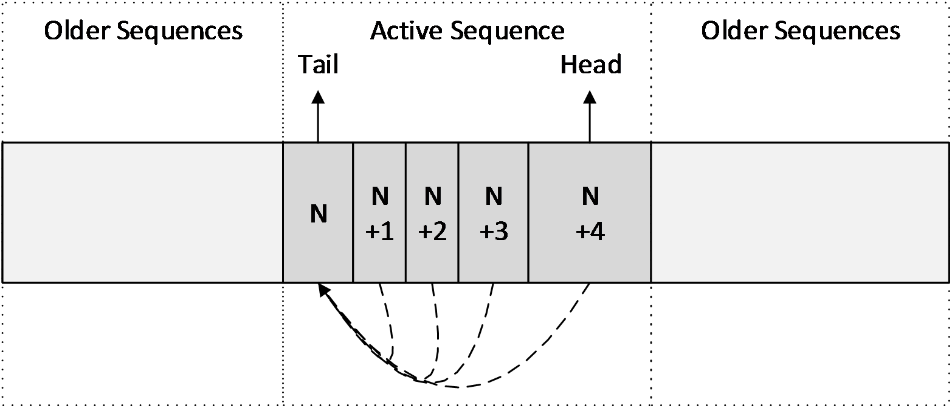
Figure 4: Log layout example

Log Entry
A log entry is a sequence of 4-KB sectors, aligned to a 4-KB sector.<3> This sequence is divided into two parts: a sequence of one or more descriptor sectors, and a sequence of zero or more data sectors.
The descriptor sectors contain header information and describe the writes that are being performed through the log, while the data sectors contain the actual updates. The first descriptor sector contains a 64-byte header and can contain up to 126 32-byte descriptors; any subsequent descriptor sectors that are part of the same log entry do not contain a header and could contain up to 128 32-byte descriptors. The total number of descriptors contained in the log entry is described in the log entry header. Each descriptor could be either a data descriptor or a zero descriptor. Each of the data descriptors describes a 4-KB sector write to perform on the file, and MUST be associated with a data sector that contains the actual 4-KB update to be written. The number of data sectors in the log entry must be equal to the number of data descriptors contained in that log entry. The zero descriptor describes a section of the file to be zero but does not need an associated sector to describe the update, because it is implied to be zero.
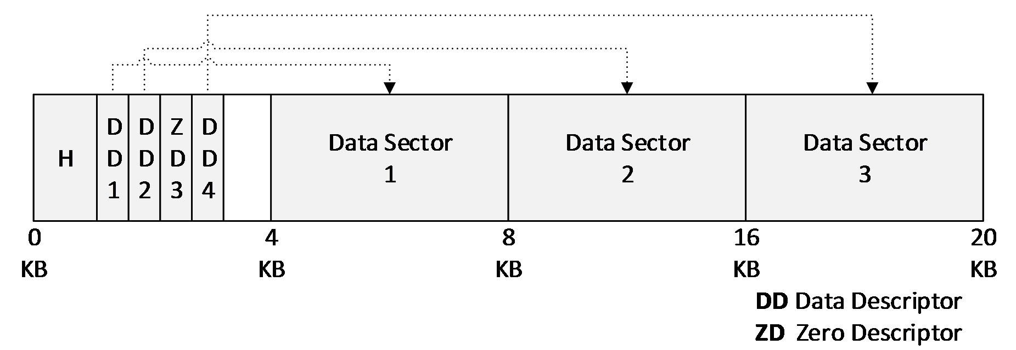
Figure 5: Log Entry Structure Layout Example
The preceding figure shows a log entry that contains four descriptors. The layout contains, in the first 4-KB descriptor sector, a log header with a descriptor count of 4 and associated descriptor sectors, three data descriptors, and one zero descriptor. It is followed by three data sectors, each of length 4 KB.
A variety of techniques is applied to validate the log entry. The entry header sequence number is duplicated in each descriptor and data sector. In the case of a data sector, the sequence number is split between the beginning and end of each data sector. Most cases of torn, missing, or misdirected writes will result in the sequence number validation being incorrect, either between the data descriptor and the associated data sector or between the descriptors and the entry header. Furthermore, a 32-bit CRC is computed over the entire log entry, including the sequence number; this improves the probability that a random entry corruption is detected.
The space for the log entries can be reused for subsequent log writes only when the log entries are not part of the active log sequence (See section 2.3.3).

Entry Header

0 | 1 | 2 | 3 | 4 | 5 | 6 | 7 | 8 | 9 | 1  0 | 1 | 2 | 3 | 4 | 5 | 6 | 7 | 8 | 9 | 2  0 | 1 | 2 | 3 | 4 | 5 | 6 | 7 | 8 | 9 | 3  0 | 1
Signature
Checksum
EntryLength
Tail
SequenceNumber
...
DescriptorCount
Reserved
LogGuid
...
...
...
FlushedFileOffset
...
LastFileOffset
...
Signature (4 bytes): MUST be 0x65676F6C ("loge" as UTF8).
Checksum (4 bytes): A CRC-32C hash computed over the entire entry specified by the EntryLength field, with the Checksum field taking the value of zero during the computation of the checksum value.
EntryLength (4 bytes): Specifies the total length of the entry in bytes. The value MUST be a multiple of 4 KB.
Tail (4 bytes): The offset, in bytes, from the beginning of the log to the beginning log entry of a sequence ending with this entry. The value MUST be a multiple of 4 KB. A tail entry could point to itself, as would be the case when a log is initialized.
SequenceNumber (8 bytes): A 64-bit integer incremented between each log entry. It must be larger than zero.
DescriptorCount (8 bytes): Specifies the number of descriptors that are contained in this log entry. The value can be zero.
Reserved (4 bytes): This field MUST be set to 0.
LogGuid (16 bytes): Contains the LogGuid value in the file header that was present when this log entry was written. When replaying, if this LogGuid does not match the LogGuid field in the file header, this entry MUST NOT be considered valid.
FlushedFileOffset (8 bytes): Stores the VHDX file size in bytes that MUST be at least as large as the size of the VHDX file at the time the log entry was written. The file size specified in the log entry must have been stable on the host disk such that, even in the case of a system power failure, a noncorrupted VHDX file will be at least as large as the size specified by the log entry. Before shrinking a file while the log is in use, an implementation MUST write the target size to a log entry and flush the entry so that the update is stable on the log that is on the host-disk storage media; this will ensure that the VHDX file is not treated as truncated during log replay. An implementation SHOULD write the largest possible value that satisfies these requirements. The value MUST be a multiple of 1 MB.
LastFileOffset (8 bytes): Stores a file size in bytes that all allocated file structures fit into, at the time the log entry was written. An implementation SHOULD write the smallest possible value that satisfies these requirements. The value MUST be a multiple of 1 MB.

Zero Descriptor

0 | 1 | 2 | 3 | 4 | 5 | 6 | 7 | 8 | 9 | 1  0 | 1 | 2 | 3 | 4 | 5 | 6 | 7 | 8 | 9 | 2  0 | 1 | 2 | 3 | 4 | 5 | 6 | 7 | 8 | 9 | 3  0 | 1
ZeroSignature
Reserved
ZeroLength
...
FileOffset
...
SequenceNumber
...
ZeroSignature (4 bytes): MUST be 0x6F72657A ("zero" as ASCII).
Reserved (4 bytes): MUST be 0.
ZeroLength (8 bytes): Specifies the length of the section to zero. The value MUST be a multiple of 4 KB.
FileOffset (8 bytes): Specifies the file offset to which zeros MUST be written. The value MUST be a multiple of 4 KB.
SequenceNumber (8 bytes): MUST match the SequenceNumber field of the log entry's header.

Data Descriptor

0 | 1 | 2 | 3 | 4 | 5 | 6 | 7 | 8 | 9 | 1  0 | 1 | 2 | 3 | 4 | 5 | 6 | 7 | 8 | 9 | 2  0 | 1 | 2 | 3 | 4 | 5 | 6 | 7 | 8 | 9 | 3  0 | 1
DataSignature
TrailingBytes
LeadingBytes
...
FileOffset
...
SequenceNumber
...
DataSignature (4 bytes): MUST be 0x63736564 ("desc" as ASCII).
TrailingBytes (4 bytes): Contains the four trailing bytes that were removed from the update when it was converted to a data sector. These trailing bytes MUST be restored before the data sector is written to its final location on disk.
LeadingBytes (8 bytes): Contains the first eight bytes that were removed from the update when it was converted to a data sector. These leading bytes MUST be restored before the data sector is written to its final location on disk.
FileOffset (8 bytes): Specifies the file offset to which the data described by this descriptor MUST be written. The value MUST be a multiple of 4 KB.
SequenceNumber (8 bytes): MUST match the SequenceNumber field of the entry's header.

Data Sector

0 | 1 | 2 | 3 | 4 | 5 | 6 | 7 | 8 | 9 | 1  0 | 1 | 2 | 3 | 4 | 5 | 6 | 7 | 8 | 9 | 2  0 | 1 | 2 | 3 | 4 | 5 | 6 | 7 | 8 | 9 | 3  0 | 1
DataSignature
SequenceHigh
Data (4084 bytes)
SequenceLow
DataSignature (4 bytes): MUST be 0x61746164 ("data" as ASCII).
SequenceHigh (4 bytes): MUST contain the four most significant bytes of the SequenceNumber field of the associated entry.
Data (4084 bytes): Contains the raw data associated with the update, bytes 8 through 4,091, inclusive. Bytes 0 through 7 and 4,092 through 4,096 are stored in the data descriptor, in the LeadingBytes and TrailingBytes fields, respectively.
SequenceLow (4 bytes): MUST contain the four least significant bytes of the SequenceNumber field of the associated entry.

Log Sequence
At any given moment in the operation of the log, the newest entry in the log (or "head entry") always points to the oldest entry in the log that has the updates yet to be written and flushed to their final location ("tail entry"). Taken as a snapshot in time, this sequence of entries between the tail entry and head entry is called a log sequence. Log sequences are ordered in time by the sequence number of the head entry.
To determine whether a log sequence is both valid and complete, an implementation MUST ensure that each entry within the sequence is valid and that the entries were actually written as a sequence. To check that the entries contained within a sequence were actually written as a sequence, each non-tail entry in a valid sequence MUST have a sequence number one greater than the previous entry, and each entry log guid matches the LogGuid field in the file header.<4>

Log Replay
If the log is non-empty when the VHDX file is opened, the implementation MUST replay the log<5> before performing any I/O to the file other than reading the VHDX header and the log. If an implementation cannot replay the log because it lacks the capability, then it MUST NOT attempt to open the file.
When an implementation needs to perform a log replay, it must find the newest valid and complete log sequence, called the active sequence, and then replay all entries from it and no others.
An implementation can follow the following steps to find the active sequence:
- Set the candidate active sequence to the empty sequence, with a sequence number of zero. Set the current and old tail to zero.
- Set the current sequence to the empty sequence with a head value equal to the current tail, and with a sequence number of zero.
- Evaluate the validity of the log entry starting at the current sequence's head, verifying each field in the header and descriptors, including the checksum. If it is a valid entry, and either the current sequence is empty or the new entry's sequence number is one greater than the current sequence's sequence number, then extend the current sequence to include the log entry and repeat this step.
- If the current sequence's head entry's tail is contained within the current sequence, then the current sequence is valid.
- If the current sequence is valid and has a greater sequence number than the candidate active sequence, then set the candidate active sequence to the current sequence.
- If the current sequence is empty or invalid, increase the current tail by 4 KB, wrapping to zero if equal to the log size. Otherwise, set the current tail to the current sequence's head, wrapping for values greater than or equal to the log size.
- If the current tail is less than the old tail, then the log has been completely scanned. Stop. Otherwise, set the old tail to current tail and go to step 2.
If the candidate active sequence is empty, then there are no valid log sequences, the file is corrupt, and the implementation MUST fail to open it. If the file's size is less than the FlushedFileOffset field of the head entry of the candidate active sequence, then the file has been truncated, and the implementation MUST fail to open it. Otherwise, the active sequence is the candidate active sequence.
Once the active sequence has been found, the implementation MUST replay each descriptor within each entry within the sequence, in order, beginning with the tail entry, by writing the data or zeroing as directed by the descriptors. The file offsets referred to by the descriptors can be larger than the current file offset, in which case the implementation MUST extend the file.
After all the entries have been replayed, the implementation MUST expand the file size to be at least as large as the LastFileOffset field of the head entry of the active sequence. This ensures that, even in the case where a VHDX file expansion operation could not be written and flushed to the host-disk storage media due to a system power failure, all VHDX structures are fully contained within the VHDX file.

Blocks
There are two types of Blocks: payload and sector bitmap. Payload blocks contain virtual disk payload data, while sector bitmap blocks contain parts of the sector bitmap.
Payload blocks are the size of the BlockSize field defined by the File Parameters metadata item (section 2.6.2.1) and can be virtually indexed: payload block 0 contains the first BlockSize bytes of the virtual disk; payload block 1 contains the second BlockSize bytes of the virtual disk; and so on.
Sector bitmap blocks are always 1 MB in size and can be virtually indexed similarly: sector bitmap block 0 contains the first 1 MB of the sector bitmap; sector bitmap block 1 contains the second 1 MB of the sector bitmap; and so on.
Each sector bitmap block contains a bit for each logical sector in the file, representing whether the corresponding virtual disk sector is present in this file. Bit 0 (that is, bit 0 of byte 0) is the entry for the first virtual sector, bit 1 is the entry for the second, and so on. For each bit, a value of 1 indicates that the payload data for the corresponding virtual sector should be retrieved from this file, while a value of zero indicates that the data should be retrieved from the parent VHDX file.
The number of sectors that can be described in each sector bitmap block is 2²³, so the number of bytes described by a single sector bitmap block is 2²³ times the logical sector size (see section 2.6.2.4 for more information on LogicalSectorSize). This value is known as the chunk size. A virtually contiguous, chunk-size aligned and chunk-sized portion of the virtual disk is known as a chunk. The chunk ratio is the number of payload blocks in a chunk, or equivalently, the number of payload blocks per sector bitmap block.

BAT
BAT is a region consisting of a single array of 64-bit values, with an entry for each block that determines the state and file offset of that block. The entries for the payload block and sector bitmap block are interleaved in a way that the sector bitmap block entry associated with a chunk follows the entries for the payload blocks in that chunk. For example, if the chunk ratio is 4, the table's interleaving would look like the following figure.
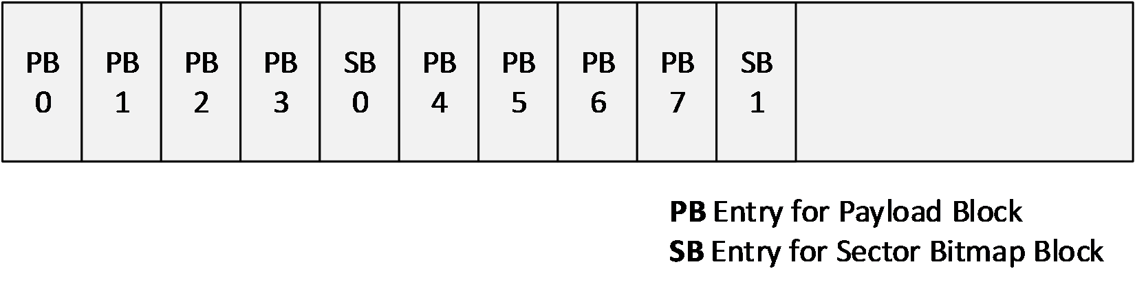
Figure 6: BAT layout example
The BAT for a dynamic VHDX is laid out identically to a differencing VHDX; BAT entries for sector bitmap blocks exist for dynamic VHDX, even though the sector bitmap block will never be allocated in a dynamic VHDX file. The presence of the entries avoids the need to insert or remove the interleaving sector bitmap entries during conversion between dynamic and differencing virtual hard disk types.
The BAT region MUST be at least large enough to contain as many entries as required to describe the possible blocks for a given virtual disk size (see section 2.6.2.2 for more information on VirtualDiskSize).
The number of data blocks can be calculated as
The number of sector bitmap blocks can be calculated as
For a dynamic VHDX, the last BAT entry MUST locate the last payload block of the virtual disk. The total number of BAT entries can be calculated as
For a differencing VHDX, the last BAT entry must be able to locate the last sector bitmap block that contains the last payload sector. The total number of BAT entries can be calculated as

BAT Entry
A BAT entry is 64 bits in length and is divided into bit fields.
0 | 1 | 2 | 3 | 4 | 5 | 6 | 7 | 8 | 9 | 1  0 | 1 | 2 | 3 | 4 | 5 | 6 | 7 | 8 | 9 | 2  0 | 1 | 2 | 3 | 4 | 5 | 6 | 7 | 8 | 9 | 3  0 | 1
A |  |  | Reserved |  |  |  |  |  |  |  |  |  |  |  |  |  |  |  |  | FileOffsetMB
...
A - State (3 bits): Specifies how the associated data block or sector bitmap block is treated. The values are specified in section 2.5.1.1 and section 2.5.1.2.
Reserved (17 bits): This field MUST be set to 0.
FileOffsetMB (44 bits): Specifies the offset within the file in units of 1 MB. The payload or sector bitmap block must reside after the header section and must not overlap any other structure. The FileOffsetMB field value must be unique across all the BAT entries when it is other than zero.

Payload BAT Entry States
The payload BAT entry determines the state of a virtual block and the associated offset in the VHDX file of that block. The following table summarizes the validity of the various states for the three VHDX types.
Payload BAT Entry State | Fixed | Dynamic | Differencing
PAYLOAD_BLOCK_NOT_PRESENT | Valid<6> | Valid | Valid
PAYLOAD_BLOCK_UNDEFINED | Valid<7> | Valid | Valid
PAYLOAD_BLOCK_ZERO | Valid<8> | Valid | Valid
PAYLOAD_BLOCK_UNMAPPED | Valid<9> | Valid | Valid
PAYLOAD_BLOCK_FULLY_PRESENT | Valid | Valid | Valid
PAYLOAD_BLOCK_PARTIALLY_PRESENT | Not Valid | Not Valid | Valid

Values 4 and 5 are reserved.
The behavior for the various block states for fixed VHDX is the same as that of the associated dynamic VHDX block state:
#define PAYLOAD_BLOCK_NOT_PRESENT 0
This is the default state for all new blocks in dynamic and differencing VHDX types.
For fixed or dynamic VHDX files, this block state specifies that the block contents are undefined and can contain arbitrary data.
For reads from blocks in this state, implement one of the following behaviors:
- Return arbitrary data, including data that was previously present elsewhere on the disk.
- Return zero data.
- Return the contents of the block either immediately before it was moved to this state with no modifications or immediately before some parts of it were replaced with zeroes.
For a differencing VHDX file, this block state specifies that the block contents are not present in the file and that the parent virtual disk SHOULD be inspected to determine the associated contents.
The FileOffsetMB field for entries in this state is reserved:
#define PAYLOAD_BLOCK_UNDEFINED 1
For all VHDX file types, this block state indicates that the block contents are not defined in the file and can contain arbitrary data, including data that was previously present elsewhere on the disk.
When a block entry is transitioned to this block state, implement one of the following options for the FileOffsetMB field:
- Leave the field unmodified.
- Set the field to zero value.
- Set the field to a nonzero value that MUST point to a location in the VHDX file that MUST contain the contents of the block immediately before it was moved to this state with no modifications or some parts of it replaced with zeros.
For reads from blocks in this state, implement one of the following behaviors:<10>
- Return arbitrary data, including data that was previously present elsewhere on the disk.
- Return zero data.
- Return the contents of the block immediately before it was moved to this state with no modifications or some parts of it replaced with zeroes:
#define PAYLOAD_BLOCK_ZERO 2
This block state implies that the block contents are defined to be zero.
The FileOffsetMB field for entries in this state is reserved.
For reads from the blocks in this state, implementations MUST return zeros:
#define PAYLOAD_BLOCK_UNMAPPED 3
For all VHDX file types, this block state indicates that all the virtual disk sectors in the payload block were issued an UNMAP command and that the contents of this block are no longer being relied upon by the application or the system using the virtual disk. The block contents are defined to be zero data or the contents of the block immediately before the block was moved to this state with no modifications or with some parts replaced with zeros.
When a block entry is transitioned to this block state, implement one of the following options for the FileOffsetMB field:
- Leave the field unmodified.
- Set the field to zero.
- Set the field to a nonzero value that MUST point to a location in the VHDX file that MUST contain the contents of the block immediately before the block was moved to this state, with no modifications or with some parts of it replaced with zeros.
For reads from blocks in this state, implement one of the following behaviors:<11>
- Return zero data.
- Return the contents of that the block immediately before it was moved to this state with no modifications or with some parts of it replaced with zeros:
#define PAYLOAD_BLOCK_FULLY_PRESENT 6
This is the default state for all blocks in a fixed VHDX type.
For all VHDX file types, the block's contents are defined in the file at the location specified by the FileOffsetMB field.
The FileOffsetMB field can be modified to point to a new nonzero value that contains the contents of that block.
For reads from the blocks in this state, parsers should return the block contents defined in the file at the location specified by the FileOffsetMB field. For differencing VHDX files, the sector bitmap MUST NOT be inspected, because the block is fully present in the VHDX file:
#define PAYLOAD_BLOCK_PARTIALLY_PRESENT 7
This block state MUST NOT be present in a block entry for a fixed or dynamic VHDX file.
For differencing VHDX files, the block's contents are defined in the file at the location specified by the FileOffsetMB field. When the block entry is in this state, the associated sector bitmap block MUST be already allocated and valid.
The FileOffsetMB field can be modified to point to a new nonzero value that contains the contents of that block.
For reads from the blocks in this state, return the block contents defined in the file at the location specified by the FileOffsetMB field, after the associated sector bitmap for that block is inspected, to check if the sector being read is present in the VHDX file. If not, the parent VHDX file needs to be inspected for that sector.

Sector Bitmap BAT Entry States
The sector bitmap BAT entry indicates the presence of sector bitmap blocks for the associated chunk of payload blocks.
The following table summarizes the validity of the various states for the three VHDX types.
Sector Bitmap BAT Entry State | Fixed | Dynamic | Differencing
SB_BLOCK_NOT_PRESENT | Valid | Valid | Valid
SB_BLOCK_ PRESENT | Not Valid | Not Valid | Valid

The various states and values are defined as follows (values 1-5 and 7 are reserved).

#define SB_BLOCK_NOT_PRESENT 0
The SB_BLOCK_NOT_PRESENT state indicates that this sector bitmap block's contents are undefined and that the block is not allocated in the file.
For a fixed or dynamic VHDX file, all sector bitmap block entries MUST be in this state.
For a differencing VHDX file, a sector bitmap block entry MUST NOT be in this state if any of the associated payload block entries are in the PAYLOAD_BLOCK_PARTIALLY_PRESENT state.
The FileOffsetMB field for entries in this state is reserved.

#define SB_BLOCK_PRESENT 6
The SB_BLOCK_PRESENT indicates that the sector bitmap block contents are defined in the file at a location pointed to by the FileOffsetMB field.
For a fixed or dynamic VHDX file, a sector bitmap block entry MUST NOT be in this state.
For differencing VHDX file, a sector bitmap block entry MUST be set to the SB_BLOCK_PRESENT state if any associated payload blocks are the PAYLOAD_BLOCK_ PARTIALLY_PRESENT state. The sector bitmap block contents are defined in the file at the location specified by the FileOffsetMB field.

Metadata Region
The metadata region consists of a fixed-size, 64-KB, unsorted metadata table, followed by unordered, variable-sized, unaligned metadata items and free space, as shown in the following figure. The metadata items represent both user and system metadata, which are distinguished by a bit in the table.
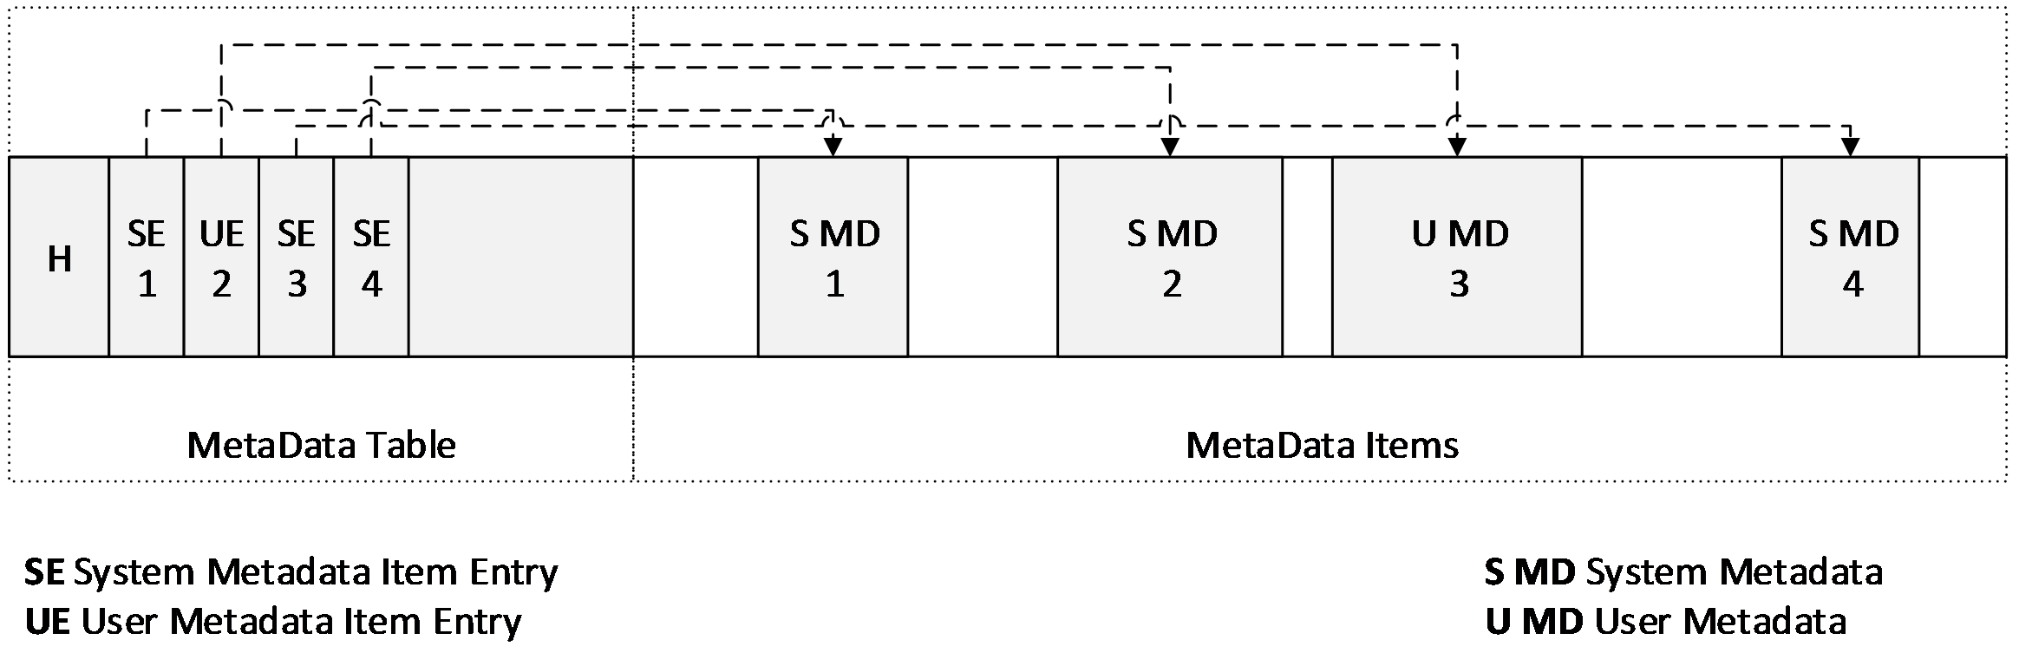
Figure 7: Metadata region layout example

Metadata Table
A metadata table contains a 32-byte header followed immediately by a variable number of valid 32-byte entries.

Metadata Table Header

0 | 1 | 2 | 3 | 4 | 5 | 6 | 7 | 8 | 9 | 1  0 | 1 | 2 | 3 | 4 | 5 | 6 | 7 | 8 | 9 | 2  0 | 1 | 2 | 3 | 4 | 5 | 6 | 7 | 8 | 9 | 3  0 | 1
Signature
Reserved
FileOffsetMB
…
Reserved |  |  |  |  |  |  |  |  |  |  |  |  |  |  |  | EntryCount
Reserved2 (20 bytes)
Signature (8 bytes): MUST be 0x617461646174656D ("metadata" as ASCII).
Reserved (2 bytes): MUST be set to 0.
EntryCount (2 bytes): Specifies the number of entries in the table. This value must be less than or equal to 2,047. The free space in the metadata region may contain data that can be disregarded.
Reserved2 (20 bytes): MUST be set to 0.

Metadata Table Entry

0 | 1 | 2 | 3 | 4 | 5 | 6 | 7 | 8 | 9 | 1  0 | 1 | 2 | 3 | 4 | 5 | 6 | 7 | 8 | 9 | 2  0 | 1 | 2 | 3 | 4 | 5 | 6 | 7 | 8 | 9 | 3  0 | 1
ItemID (16 bytes)
...
...
Offset
Length
A | B | C | Reserved
D
ItemID (16 bytes): Specifies a 128-bit identifier for the metadata item. The ItemId and IsUser value pair for an entry MUST be unique within the table.
Offset (4 bytes): Specifies the byte offset of the metadata item in bytes. The Offset field MUST be at least 64 KB and is relative to the beginning of the metadata region.
The item specified by the Offset and Length pair MUST fall entirely within the metadata region without overlapping any other item.
Length (4 bytes): Specifies the length of the metadata item in bytes. Length MUST be less than or equal to 1 MB. If Length is zero, then Offset MUST also be zero, in which case the metadata item SHOULD be considered present but empty.
A - IsUser (1 bit): Specifies whether this metadata item is considered system or user metadata. No more than 1,024 entries can have this bit set; otherwise, the metadata table is invalid. An implementation SHOULD NOT allow users to query metadata items that have this bit set to False.
B - IsVirtualDisk (1 bit): Specifies whether the metadata is file metadata or virtual disk metadata. This determines the behavior when forking a new differencing VHDX file from an existing VHDX file, or when merging a differencing VHDX file into its parent. When forking, an implementation MUST copy all metadata items with this field set in the existing VHDX file to the new file, while leaving items with this field clear. When merging, an implementation MUST destroy any metadata with this field set in the parent, and copy all metadata with this field set in the child to the parent.
C - IsRequired (1 bit): Specifies whether the implementation MUST understand this metadata item to be able load the file. If this field is set to True and the implementation does not recognize this metadata item, the implementation MUST fail to load the file.
Reserved (29 bits): MUST be set to 0.
D - Reserved2 (2 bits): MUST be set to 0.

Known Metadata Items
There are certain metadata items that are defined in this specification, some of which are optional and some of which are required. The following table summarizes the known metadata items and their optional or required state.
Known Items | GUID | IsUser | IsVirtualDisk | IsRequired
File Parameters | CAA16737-FA36-4D43-B3B6-33F0AA44E76B | False | False | True
Virtual Disk Size | 2FA54224-CD1B-4876-B211-5DBED83BF4B8 | False | True | True
Virtual Disk ID | BECA12AB-B2E6-4523-93EF-C309E000C746 | False | True | True
Logical Sector Size | 8141BF1D-A96F-4709-BA47-F233A8FAAB5F | False | True | True
Physical Sector Size | CDA348C7-445D-4471-9CC9-E9885251C556 | False | True | True
Parent Locator | A8D35F2D-B30B-454D-ABF7-D3D84834AB0C | False | False | True

File Parameters

0 | 1 | 2 | 3 | 4 | 5 | 6 | 7 | 8 | 9 | 1  0 | 1 | 2 | 3 | 4 | 5 | 6 | 7 | 8 | 9 | 2  0 | 1 | 2 | 3 | 4 | 5 | 6 | 7 | 8 | 9 | 3  0 | 1
BlockSize
A | B | Reserved
BlockSize (4 bytes): Specifies the size of each payload block in bytes. The value MUST be at least 1 MB and not greater than 256 MB, and MUST be a power of 2.
A - LeaveBlockAllocated (1 bit): Specifies whether blocks can be unallocated from the file. If this field is set to 1, the implementation SHOULD NOT change the state of any blocks to a BLOCK_NOT_PRESENT state, and the implementation MUST NOT reduce the size of the file to a value lower than would be required to allocate every block. This field is intended to be used to create a fixed VHDX file that is fully provisioned.
B - HasParent (1 bit): Specifies whether this file has a parent VHDX file. If set, the file is a differencing file, and one or more parent locators specify the location and identity of the parent.
Reserved (30 bits): MUST be 0.

Virtual Disk Size

0 | 1 | 2 | 3 | 4 | 5 | 6 | 7 | 8 | 9 | 1  0 | 1 | 2 | 3 | 4 | 5 | 6 | 7 | 8 | 9 | 2  0 | 1 | 2 | 3 | 4 | 5 | 6 | 7 | 8 | 9 | 3  0 | 1
VirtualDiskSize
...
B
VirtualDiskSize (8 bytes): Specifies the virtual disk size, in bytes. This field MUST be a multiple of the LogicalSectorSize (see section 2.6.2.4) metadata item and MUST be at most 64 TB.

Virtual Disk ID

0 | 1 | 2 | 3 | 4 | 5 | 6 | 7 | 8 | 9 | 1  0 | 1 | 2 | 3 | 4 | 5 | 6 | 7 | 8 | 9 | 2  0 | 1 | 2 | 3 | 4 | 5 | 6 | 7 | 8 | 9 | 3  0 | 1
VirtualDiskId
...
B
...

...

VirtualDiskId (16 bytes): A GUID that specifies the identification of the disk.

Logical Sector Size

0 | 1 | 2 | 3 | 4 | 5 | 6 | 7 | 8 | 9 | 1  0 | 1 | 2 | 3 | 4 | 5 | 6 | 7 | 8 | 9 | 2  0 | 1 | 2 | 3 | 4 | 5 | 6 | 7 | 8 | 9 | 3  0 | 1
LogicalSectorSize
LogicalSectorSize (4 bytes): Specifies the virtual disk's sector size, in bytes. This value MUST be set to 512 or 4,096. An implementation MUST expose the virtual disk as having the specified sector size, but it can fail to load files with sector sizes that it does not support. If the file has a parent, the logical sector size for the parent and child MUST be the same. Note that the LogicalSectorSize value also determines the chunk size.

Physical Sector Size

0 | 1 | 2 | 3 | 4 | 5 | 6 | 7 | 8 | 9 | 1  0 | 1 | 2 | 3 | 4 | 5 | 6 | 7 | 8 | 9 | 2  0 | 1 | 2 | 3 | 4 | 5 | 6 | 7 | 8 | 9 | 3  0 | 1
PhysicalSectorSize
PhysicalSectorSize (4 bytes): Specifies the virtual disk's physical sector size, in bytes. This value MUST be set to 512 or 4,096. An implementation MUST expose the virtual disk as having the specified physical sector size, but it can fail to load files with sector sizes that it does not support.

Parent Locator
The parent locator specifies the type of the parent virtual block device as a GUID and a set of key-value pairs specifying anything necessary to locate and connect to the parent block device.
When the HasParent field of the file-parameters metadata item is set, there MUST be a parent locator. This metadata item specifies the identity and location of a parent virtual block device, whether this device is another VHDX file, a different type of virtual disk file, a logical unit in a SAN, or otherwise.
This specification describes only one such parent locator type (see section 2.6.2.6.3), but other implementations can extend this as required.
The parent locator item is made up of a 20-byte header immediately followed by a table of 12-byte entries specifying the offset and length of each key and value.

Parent Locator Header

0 | 1 | 2 | 3 | 4 | 5 | 6 | 7 | 8 | 9 | 1  0 | 1 | 2 | 3 | 4 | 5 | 6 | 7 | 8 | 9 | 2  0 | 1 | 2 | 3 | 4 | 5 | 6 | 7 | 8 | 9 | 3  0 | 1
LocatorType
...
...
...
Reserved |  |  |  |  |  |  |  |  |  |  |  |  |  |  |  | KeyValueCount
LocatorType (16 bytes): Specifies the type of the parent virtual disk. This value will be different for each type (for example, VHDX, VHD or iSCSI). An implementation MUST validate that it understands that type.
Reserved (2 bytes): MUST be set to 0.
KeyValueCount (2 bytes): Specifies the number of key-value pairs defined for this parent locator.

Parent Locator Entry

0 | 1 | 2 | 3 | 4 | 5 | 6 | 7 | 8 | 9 | 1  0 | 1 | 2 | 3 | 4 | 5 | 6 | 7 | 8 | 9 | 2  0 | 1 | 2 | 3 | 4 | 5 | 6 | 7 | 8 | 9 | 3  0 | 1
KeyOffset
ValueOffset
KeyLength |  |  |  |  |  |  |  |  |  |  |  |  |  |  |  | ValueLength
KeyOffset (4 bytes): Specifies the offset within the metadata item. This field MUST be must be greater than zero.
ValueOffset (4 bytes): Specifies the offset within the metadata item. This field MUST be greater than zero.
KeyLength (4 bytes): Specifies the length in bytes of the entry's key. This field MUST be greater than zero.
ValueLength (4 bytes): Specifies the length in bytes of an entry's value. This field MUST be greater than zero.
The key and value strings are to be UNICODE strings with UTF-16 little-endian encoding. There must be no internal NUL characters, and the Length field must not include a trailing NUL character. The key string is case sensitive, and lowercase keys are recommended. All keys must be unique, and there is no ordering to the entries.

VHDX Parent Locator
The only parent-locator type defined by this specification is the VHDX locator type with a GUID value of "B04AEFB7-D19E-4A81-B789-25B8E9445913".
The VHDX parent locator has several possible key-value pair entries, some of which are required, as shown in the following table. The entries are UTF-16 encoded, with no escape characters.
Entry | Type | Example
parent_linkage | GUID | {83ed0ec3-24c8-49a6-a959-5e4bf1288bfb}
parent_linkage2 | GUID | {83ed0ec3-24c8-49a6-a959-5e4bf1288bfb}
relative_path | Path | ..\..\path2\sub3\parent.vhdx
volume_path | Path | \\?\Volume{26A21BDA-A627-11D7-9931-806E6F6E6963}\path2\sub3\parent.vhdx
absolute_win32_path | Path | \\?\d:\path2\sub3\parent.vhdx

The two entries with key values of parent_linkage and parent_linkage2 specify possible values of the parent's identity. The parent_linkage entry MUST be present, and parent_linkage2 can't be present. The value field is encoded as a lowercase string with enclosing braces; for example: {83ED0EC3-24C8-49A6-A959-5E4BF1288BFB}. When a differencing VHDX file is created, the implementation MUST populate the parent's DataWriteGuid field in this field. When opening the parent VHDX file of a differencing VHDX, the implementation MUST verify that the DataWriteGuid field of the parent's header matches one of these two fields.<12>
At least one entry with key value of relative_path, volume_path, or absolute_win32_path MUST be present to locate the parent VHDX file. An implementation has to evaluate the paths in a specific order to locate the parent: relative_path, volume_path and then absolute_path. Upon successful open of a chain, an implementation has to update any existing stale path entries to point to its current parent file.
The entry with key value of relative_path specifies the path of the parent VHDX file relative to the path of the current VHDX file, using "\" as the path separator and ".." to mean parent directory. For example, if the VHDX file is in "d:\path1\sub2\file.vhdx" and the parent file is in "d:\path2\sub3\parent.vhdx", the value field for this entry could contain "..\..\path2\sub3\parent.vhdx".
The entry with key value of volume_path specifies the path of the parent VHDX using an absolute Win32 path containing the volume GUID of the volume on which the parent resides (for example, "\\?\Volume{26A21BDA-A627-11D7-9931-806E6F6E6963}\path2\sub3\parent.vhdx"). This helps locate the parent when drive letters are not available or stable. It MUST NOT contain other forms of Win32 paths.
The entry with key value of absolute_win32_path specifies the path of the parent VHDX using an absolute extended-length Win32 path on a local drive. This path MUST begin with "\\?\" and can be followed by a drive letter (for example, "d:") or a UNC share (for example,"\\ServerName\ShareName"), then the path to the file on that drive using "\" as the path separator (for example, "\path2\sub3\parent.vhdx"). The value field for this entry could contain "\\?\d:\path1\sub2\file.vhdx" or "\\?\MyServer\MyShare\ path3\sub4\file.vhdx".

Structure Examples
None.

Security

Security Considerations for Implementers
None.

Index Of Security Fields
None.

Appendix A: Product Behavior
The information in this specification is applicable to the following Microsoft products or supplemental software. References to product versions include updates to those products.
- Windows 8 operating system
- Windows Server 2012 operating system
- Windows 8.1 operating system
- Windows Server 2012 R2 operating system
- Windows 10 operating system
- Windows Server 2016 operating system
- Windows Server operating system
Exceptions, if any, are noted in this section. If an update version, service pack or Knowledge Base (KB) number appears with a product name, the behavior changed in that update. The new behavior also applies to subsequent updates unless otherwise specified. If a product edition appears with the product version, behavior is different in that product edition.
Unless otherwise specified, any statement of optional behavior in this specification that is prescribed using the terms "SHOULD" or "SHOULD NOT" implies product behavior in accordance with the SHOULD or SHOULD NOT prescription. Unless otherwise specified, the term "MAY" implies that the product does not follow the prescription.
<1> Section 2.2.2: This ensures that isolated updates to the headers can be performed on storage systems with up to a 64-KB sector size. The resiliency breaks down if the hosting volume's physical sector size is greater than 64 KB.
<2> Section 2.2.2: The DataWriteGuid field is used in the integrity validation of a differential VHDX chain. Implementations have to ensure that they are updated as specified.
<3> Section 2.3.1: Each log entry has at least a 4-KB alignment, but it can be greater, if necessary, to ensure that writes are isolated on the host-disk storage disk. All implementations have to be prepared to replay from a log that has 4-KB alignment or smaller, and no implementation is obligated to maintain an alignment greater than 4 KB. An implementation running on a large-sector-size disk might need to make a copy of the log, expanding the writes to the larger sector size, before replaying.
<4> Section 2.3.2: Having a matching LogGuid in the log entry is necessary to ensure that a non-current but fully written entry is not incorrectly used in log replay, which would be possible with the sequence number check alone.
<5> Section 2.3.3: If the storage media on which the file is stored is read-only or the file is opened in read-only mode, the implementation cannot allow reads from the virtual disk without replaying the log in memory.
<6> Section 2.5.1.1: Implementations can accept the VHDX files with these block states, but an implementation cannot transition blocks to these states in fixed VHDX files.
<7> Section 2.5.1.1: If an implementation chooses to preserve sector stability, it has to continue to return the same data on subsequent block reads while the block remains in this state. To preserve sector stability across different implementations, it is recommended to transition the block to a state that has a tightly defined read behavior.
<8> Section 2.5.1.1: If an implementation chooses to preserve sector stability, it has to continue to return the same data on subsequent block reads while the block remains in this state. To preserve sector stability across different implementations, the recommendation is to transition the block to a state that has a tightly defined read behavior.
<9> Section 2.5.1.1: If an implementation chooses to preserve sector stability, it has to continue to return the same data on subsequent block reads while the block remains in this state. To preserve sector stability across different implementations, the recommendation is to transition the block to a state that has a tightly defined read behavior.
<10> Section 2.5.1.1: If an implementation chooses to preserve sector stability guarantees, it has to continue to return the same data on subsequent block reads while the block remains in this state. To preserve sector stability across different implementations, it has to transition the block to a state that has a tightly defined read behavior.
<11> Section 2.5.1.1: If the implementation chooses to return data that was previously present elsewhere on the disk, it could result in private data being leaked.
<12> Section 2.6.2.6.3: There are two fields so that parent-child links can be safely maintained while merging child data into the parent. In that case, the parent's write GUID has to be changed. When this occurs, the implementation has to first store the new GUID in the parent identifier, and then update the parent's write GUID.

Change Tracking
This section identifies changes that were made to this document since the last release. Changes are classified as Major, Minor, or None.
The revision class Major means that the technical content in the document was significantly revised. Major changes affect protocol interoperability or implementation. Examples of major changes are:
- A document revision that incorporates changes to interoperability requirements.
- A document revision that captures changes to protocol functionality.
The revision class Minor means that the meaning of the technical content was clarified. Minor changes do not affect protocol interoperability or implementation. Examples of minor changes are updates to clarify ambiguity at the sentence, paragraph, or table level.
The revision class None means that no new technical changes were introduced. Minor editorial and formatting changes may have been made, but the relevant technical content is identical to the last released version.
The changes made to this document are listed in the following table. For more information, please contact dochelp@microsoft.com.
Section | Description | Revision class
5 Appendix A: Product Behavior | Added Windows Server to the list of applicable products. | Major

Index
A

Applicability 8

C

Change tracking 37
Common data types and fields 9

D

Data types and fields - common 9
Details
common data types and fields 9

E

Examples 33

F

Fields - vendor-extensible 8

G

Glossary 5

I

Implementer - security considerations 34
Informative references 5
Introduction 5

L

Localization 8

N

Normative references 5

O

Overview (synopsis) 5

P

Product behavior 35

R

References 5
informative 5
normative 5
Relationship to protocols and other structures 7

S

Security
implementer considerations 34
Structures
overview 9

T

Tracking changes 37

V

Vendor-extensible fields 8
Versioning 8

