[MS-TSWP]:
Terminal Services Workspace Provisioning Protocol

Intellectual Property Rights Notice for Open Specifications Documentation
- Technical Documentation. Microsoft publishes Open Specifications documentation for protocols, file formats, languages, standards as well as overviews of the interaction among each of these technologies.
- Copyrights. This documentation is covered by Microsoft copyrights. Regardless of any other terms that are contained in the terms of use for the Microsoft website that hosts this documentation, you may make copies of it in order to develop implementations of the technologies described in the Open Specifications and may distribute portions of it in your implementations using these technologies or your documentation as necessary to properly document the implementation. You may also distribute in your implementation, with or without modification, any schema, IDL's, or code samples that are included in the documentation. This permission also applies to any documents that are referenced in the Open Specifications.
- No Trade Secrets. Microsoft does not claim any trade secret rights in this documentation.
- Patents. Microsoft has patents that may cover your implementations of the technologies described in the Open Specifications. Neither this notice nor Microsoft's delivery of the documentation grants any licenses under those or any other Microsoft patents. However, a given Open Specification may be covered by Microsoft Open Specification Promise or the Community Promise. If you would prefer a written license, or if the technologies described in the Open Specifications are not covered by the Open Specifications Promise or Community Promise, as applicable, patent licenses are available by contacting iplg@microsoft.com.
- Trademarks. The names of companies and products contained in this documentation may be covered by trademarks or similar intellectual property rights. This notice does not grant any licenses under those rights. For a list of Microsoft trademarks, visit www.microsoft.com/trademarks.
- Fictitious Names. The example companies, organizations, products, domain names, e-mail addresses, logos, people, places, and events depicted in this documentation are fictitious. No association with any real company, organization, product, domain name, email address, logo, person, place, or event is intended or should be inferred.
Reservation of Rights. All other rights are reserved, and this notice does not grant any rights other than specifically described above, whether by implication, estoppel, or otherwise.
Tools. The Open Specifications do not require the use of Microsoft programming tools or programming environments in order for you to develop an implementation. If you have access to Microsoft programming tools and environments you are free to take advantage of them. Certain Open Specifications are intended for use in conjunction with publicly available standard specifications and network programming art, and assumes that the reader either is familiar with the aforementioned material or has immediate access to it.
Revision Summary
Date | Revision History | Revision Class | Comments
12/5/2008 | 0.1 | Major | Initial Availability
1/16/2009 | 0.2 | Minor | Clarified the meaning of the technical content.
2/27/2009 | 0.2.1 | Editorial | Changed language and formatting in the technical content.
4/10/2009 | 1.0 | Major | Updated and revised the technical content.
5/22/2009 | 1.0.1 | Editorial | Changed language and formatting in the technical content.
7/2/2009 | 2.0 | Major | Updated and revised the technical content.
8/14/2009 | 2.0.1 | Editorial | Changed language and formatting in the technical content.
9/25/2009 | 2.1 | Minor | Clarified the meaning of the technical content.
11/6/2009 | 2.2 | Minor | Clarified the meaning of the technical content.
12/18/2009 | 3.0 | Major | Updated and revised the technical content.
1/29/2010 | 3.1 | Minor | Clarified the meaning of the technical content.
3/12/2010 | 4.0 | Major | Updated and revised the technical content.
4/23/2010 | 5.0 | Major | Updated and revised the technical content.
6/4/2010 | 6.0 | Major | Updated and revised the technical content.
7/16/2010 | 6.0 | None | No changes to the meaning, language, or formatting of the technical content.
8/27/2010 | 6.0 | None | No changes to the meaning, language, or formatting of the technical content.
10/8/2010 | 6.0 | None | No changes to the meaning, language, or formatting of the technical content.
11/19/2010 | 7.0 | Major | Updated and revised the technical content.
1/7/2011 | 7.0 | None | No changes to the meaning, language, or formatting of the technical content.
2/11/2011 | 7.0 | None | No changes to the meaning, language, or formatting of the technical content.
3/25/2011 | 8.0 | Major | Updated and revised the technical content.
5/6/2011 | 8.0 | None | No changes to the meaning, language, or formatting of the technical content.
6/17/2011 | 8.1 | Minor | Clarified the meaning of the technical content.
9/23/2011 | 8.1 | None | No changes to the meaning, language, or formatting of the technical content.
12/16/2011 | 9.0 | Major | Updated and revised the technical content.
3/30/2012 | 9.0 | None | No changes to the meaning, language, or formatting of the technical content.
7/12/2012 | 9.0 | None | No changes to the meaning, language, or formatting of the technical content.
10/25/2012 | 9.1 | Minor | Clarified the meaning of the technical content.
1/31/2013 | 9.1 | None | No changes to the meaning, language, or formatting of the technical content.
8/8/2013 | 10.0 | Major | Updated and revised the technical content.
11/14/2013 | 11.0 | Major | Updated and revised the technical content.
2/13/2014 | 11.0 | None | No changes to the meaning, language, or formatting of the technical content.
5/15/2014 | 11.0 | None | No changes to the meaning, language, or formatting of the technical content.
6/30/2015 | 11.0 | No Change | No changes to the meaning, language, or formatting of the technical content.
Table of Contents
1 Introduction 6
1.1 Glossary 6
1.2 References 8
1.2.1 Normative References 8
1.2.2 Informative References 8
1.3 Overview 9
1.3.1 General Message Flow 9
1.4 Relationship to Other Protocols 10
1.5 Prerequisites/Preconditions 10
1.6 Applicability Statement 10
1.7 Versioning and Capability Negotiation 10
1.8 Vendor-Extensible Fields 10
1.9 Standards Assignments 11
2 Messages 12
2.1 Transport 12
2.2 Message Syntax 12
2.2.1 Resource List Syntax 12
2.2.1.1 Schema Version 1.1 12
2.2.1.2 Schema Version 2.0 14
2.2.1.3 Schema Version 2.1 17
2.2.1.4 Resource List Content-Type 20
2.2.2 Schema Element Definitions 21
2.2.2.1 Schema Version 1.1 Element Definitions 21
2.2.2.1.1 ResourceCollection Element 21
2.2.2.1.2 Publisher Element 21
2.2.2.1.3 Resources Element 21
2.2.2.1.4 Resource Element 21
2.2.2.1.5 Icons Element 22
2.2.2.1.6 Icon Elements 22
2.2.2.1.7 HostingTerminalServers Element 22
2.2.2.1.8 HostingTerminalServer Element 23
2.2.2.1.9 ResourceFile Element 23
2.2.2.1.10 TerminalServerRef Element 23
2.2.2.1.11 TerminalServers Element 23
2.2.2.1.12 TerminalServer Element 23
2.2.2.1.13 FileExtensions Element 23
2.2.2.1.14 FileExtension Element 23
2.2.2.2 Schema Version 2.0 Element Definitions 24
2.2.2.2.1 ResourceCollection Element 24
2.2.2.2.2 FileExtensions Element 24
2.2.2.2.3 FileExtension Element 24
2.2.2.2.4 FileAssociationIcons Element 24
2.2.2.2.5 SubFolders Element 25
2.2.2.2.6 Folders Element 25
2.2.2.2.7 Folder Element 25
2.2.2.3 Schema Version 2.1 Element Definitions 25
2.2.2.3.1 Resource Element 25
2.2.3 .ASPXAUTH Cookie 26
2.2.4 Resources 26
2.2.5 Content Negotiation 27
2.2.6 Folders 27
3 Protocol Details 28
3.1 Common Details 28
3.1.1 Abstract Data Model 28
3.1.1.1 Authentication Cookie 28
3.1.1.2 XML Files 28
3.1.1.3 Icon Files 28
3.1.1.4 Resource Files 28
3.1.1.5 Resources 28
3.1.2 Timers 28
3.1.3 Initialization 29
3.1.4 Higher-Layer Triggered Events 29
3.1.5 Message Processing Events and Sequencing Rules 29
3.1.5.1 Message Flow for First Request 29
3.1.5.1.1 Without Content Negotiation 29
3.1.5.1.2 With Content Negotiation 30
3.1.5.2 Message Flow for Subsequent Requests 31
3.1.5.2.1 Without Content Negotiation 31
3.1.5.2.2 With Content Negotiation 32
3.1.5.3 Message Flow for Icon and Resource File Requests 33
3.1.6 Timer Events 33
3.1.7 Other Local Events 34
3.2 Client Details 34
3.2.1 Abstract Data Model 34
3.2.2 Timers 34
3.2.3 Initialization 34
3.2.4 Higher-Layer Triggered Events 34
3.2.5 Message Processing Events and Sequencing Rules 34
3.2.6 Timer Events 34
3.2.7 Other Local Events 34
3.3 Server Details 34
3.3.1 Abstract Data Model 34
3.3.1.1 Authentication Cookie 35
3.3.2 Timers 35
3.3.3 Initialization 35
3.3.4 Higher-Layer Triggered Events 35
3.3.5 Message Processing Events and Sequencing Rules 35
3.3.6 Timer Events 35
3.3.7 Other Local Events 35
4 Protocol Examples 36
4.1 Schema Version 1.1 Examples 36
4.1.1 Message with One Hosting Terminal Server 36
4.1.2 Message with Multiple Terminal Servers 37
4.2 Schema Version 2.0 Examples 40
4.2.1 Message with One Hosting Terminal Server 40
4.2.2 Message with Subfolders and Display Folder 42
4.2.3 Message with Multiple Folders and No Display Folder 43
4.3 .ASPXAUTH Cookie Message Returned from the Server 46
5 Security 47
5.1 Security Considerations for Implementers 47
5.2 Index of Security Parameters 47
6 Appendix A: Product Behavior 48
7 Change Tracking 49
8 Index 50

Introduction
This is a specification of the Terminal Services Workspace Provisioning Protocol.
The Terminal Services Workspace Provisioning Protocol is used to discover and provision workspaces by transferring remote resource information from a server to a client. The client can use this resource information to launch resources such as remote applications on a remote server.
Sections 1.8, 2, and 3 of this specification are normative and can contain the terms MAY, SHOULD, MUST, MUST NOT, and SHOULD NOT as defined in [RFC2119]. Sections 1.5 and 1.9 are also normative but do not contain those terms. All other sections and examples in this specification are informative.

Glossary
The following terms are specific to this document:
authentication: The act of proving an identity to a server while providing key material that binds the identity to subsequent communications.
binary large object (BLOB): A discrete packet of data that is stored in a database and is treated as a sequence of uninterpreted bytes.
client: The entity that initiates the HTTP connection.
Content-Type: A property of an HTTP message, specified in the message header, which defines the type of data in the message payload. The Content Type header is defined in [RFC7231] section 3.1.1.5.
domain name: A name with a structure indicated by dots.
globally unique identifier (GUID): A term used interchangeably with universally unique identifier (UUID) in Microsoft protocol technical documents (TDs). Interchanging the usage of these terms does not imply or require a specific algorithm or mechanism to generate the value. Specifically, the use of this term does not imply or require that the algorithms described in [RFC4122] or [C706] must be used for generating the GUID. See also universally unique identifier (UUID).
HTTPS proxy: An intermediary program that acts as both a server and a client for the purpose of making requests on behalf of other clients, tunneled using Secure Sockets Layer (SSL) or Transport Layer Security (TLS) for providing secure, encrypted communication.
Hypertext Transfer Protocol (HTTP): An application-level protocol for distributed, collaborative, hypermedia information systems (text, graphic images, sound, video, and other multimedia files) on the World Wide Web.
Hypertext Transfer Protocol over Secure Sockets Layer (HTTPS): An extension of HTTP that securely encrypts and decrypts webpage requests.
Kerberos: An authentication system that enables two parties to exchange private information across an otherwise open network by assigning a unique key (called a ticket) to each user that logs on to the network and then embedding these tickets into messages sent by the users. For more information, see [MS-KILE].
NT LAN Manager (NTLM) Authentication Protocol: A protocol using a challenge-response mechanism for authentication in which clients are able to verify their identities without sending a password to the server. It consists of three messages, commonly referred to as Type 1 (negotiation), Type 2 (challenge) and Type 3 (authentication). For more information, see [MS-NLMP].
publisher: A set of resources that are contained in the same workspace.
remote application: An application running on a remote server.
Remote Desktop Protocol (RDP): A multi-channel protocol that allows a user to connect to a computer running Microsoft Terminal Services (TS). RDP enables the exchange of client and server settings and also enables negotiation of common settings to use for the duration of the connection, so that input, graphics, and other data can be exchanged and processed between client and server.
schema: The set of attributes and object classes that govern the creation and update of objects.
server: The entity that responds to the HTTP connection. See [MS-TSWP].
Simple and Protected GSS-API Negotiation Mechanism (SPNEGO): An authentication mechanism that allows Generic Security Services (GSS) peers to determine whether their credentials support a common set of GSS-API security mechanisms, to negotiate different options within a given security mechanism or different options from several security mechanisms, to select a service, and to establish a security context among themselves using that service. SPNEGO is specified in [RFC4178].
terminal server: A computer on which terminal services is running.
terminal services (TS): A service on a server computer that allows delivery of applications, or the desktop itself, to various computing devices. When a user runs an application on a terminal server, the application execution takes place on the server computer and only keyboard, mouse, and display information is transmitted over the network. Each user sees only his or her individual session, which is managed transparently by the server operating system and is independent of any other client session.
Transmission Control Protocol (TCP): A protocol used with the Internet Protocol (IP) to send data in the form of message units between computers over the Internet. TCP handles keeping track of the individual units of data (called packets) that a message is divided into for efficient routing through the Internet.
TSWPP: The Terminal Services Workspace Provisioning Protocol.
Uniform Resource Locator (URL): A string of characters in a standardized format that identifies a document or resource on the World Wide Web. The format is as specified in [RFC1738].
workspace: A set of remote resources, such as remote applications and desktops, which are published to end users.
XML: The Extensible Markup Language, as described in [XML1.0].
XML namespace: A collection of names that is used to identify elements, types, and attributes in XML documents identified in a URI reference [RFC3986]. A combination of XML namespace and local name allows XML documents to use elements, types, and attributes that have the same names but come from different sources. For more information, see [XMLNS-2ED].
XML resource list: An XML file that is sent from a TSWPP server to a TSWPP client. This file, which conforms to the XML schema (XSD) in section 2.2.1, describes a set of remote resources.
XML schema: A description of a type of XML document that is typically expressed in terms of constraints on the structure and content of documents of that type, in addition to the basic syntax constraints that are imposed by XML itself. An XML schema provides a view of a document type at a relatively high level of abstraction.
XML Schema (XSD): A language that defines the elements, attributes, namespaces, and data types for XML documents as defined by [XMLSCHEMA1/2] and [W3C-XSD] standards. An XML schema uses XML syntax for its language.
MAY, SHOULD, MUST, SHOULD NOT, MUST NOT: These terms (in all caps) are used as defined in [RFC2119]. All statements of optional behavior use either MAY, SHOULD, or SHOULD NOT.

References
Links to a document in the Microsoft Open Specifications library point to the correct section in the most recently published version of the referenced document. However, because individual documents in the library are not updated at the same time, the section numbers in the documents may not match. You can confirm the correct section numbering by checking the Errata.

Normative References
We conduct frequent surveys of the normative references to assure their continued availability. If you have any issue with finding a normative reference, please contact dochelp@microsoft.com. We will assist you in finding the relevant information.
[MS-DTYP] Microsoft Corporation, "Windows Data Types".
[RFC2109] Kristol, D., and Montulli, L., "HTTP State Management Mechanism", RFC 2109, February 1997, http://www.rfc-editor.org/rfc/rfc2109.txt
[RFC2119] Bradner, S., "Key words for use in RFCs to Indicate Requirement Levels", BCP 14, RFC 2119, March 1997, http://www.rfc-editor.org/rfc/rfc2119.txt
[RFC2818] Rescorla, E., "HTTP Over TLS", RFC 2818, May 2000, http://www.rfc-editor.org/rfc/rfc2818.txt
[RFC4559] Jaganathan, K., Zhu, L., and Brezak, J., "SPNEGO-based Kerberos and NTLM HTTP Authentication in Microsoft Windows", RFC 4559, June 2006, http://www.rfc-editor.org/rfc/rfc4559.txt
[RFC7230] Fielding, R., and Reschke, J., Eds., "Hypertext Transfer Protocol -- HTTP/1.1: Message Syntax and Routing", RFC 7230, June 2014, http://www.rfc-editor.org/rfc/rfc7230.txt
[RFC7231] Fielding, R., and Reschke, J., Eds., "Hypertext Transfer Protocol -- HTTP/1.1: Semantics and Content", RFC7231, June 2014, http://www.rfc-editor.org/rfc/rfc7231.txt

Informative References
[MS-RDPBCGR] Microsoft Corporation, "Remote Desktop Protocol: Basic Connectivity and Graphics Remoting".
[MS-RDWR] Microsoft Corporation, "Remote Desktop Workspace Runtime Protocol".
[MSDN-TSCCRDP] Microsoft Corporation, "Terminal Services Client Configuration through the .rdp File", http://msdn.microsoft.com/en-us/library/aa915001.aspx
[NTLM] Microsoft Corporation, "Microsoft NTLM", http://msdn.microsoft.com/en-us/library/aa378749.aspx
[XML10/4] W3C Recommendation, "Extensible Markup Language (XML) 1.0 (Fourth Edition)", August 16, 2006, http://www.w3.org/TR/2006/REC-xml-20060816
[XMLSCHEMA1.1/1] Thompson, H.S., Sperberg-McQueen, C.M., Mendelsohn, N., et al., Eds., "XML Schema 1.1 Part 1: Structures", W3C Working Draft, March 2006, http://www.w3.org/TR/2006/WD-xmlschema11-1-20060330/
[XMLSCHEMA1.1/2:2008] Peterson, D., Biron, P.V., Malhotra, A., et al., Eds., "W3C XML Schema Definition Language (XSD) 1.1 Part 2: Datatypes", W3C Working Draft, June 2008, http://www.w3.org/TR/2008/WD-xmlschema11-2-20080620/

Overview
The Terminal Services Workspace Provisioning Protocol (TSWPP) was created to provide users with a unified view of the resources that have been made available to them by an administrator. This protocol obtains information that a client machine can use to launch a remote application that runs on a server or a virtual machine (VM). The client can arrange the remote resources so that a user can use a pointing device to launch the application.
TSWPP specifies an HTTP–based interface [RFC7230] that uses XML messages to describe the remote resources that are available. In this specification, the entity that initiates the HTTP connection is referred to as the client, and the entity that responds to the HTTP connection is referred to as the server.

General Message Flow
The general communication pattern between a TSWPP client and TSWPP server is shown in the following figure.
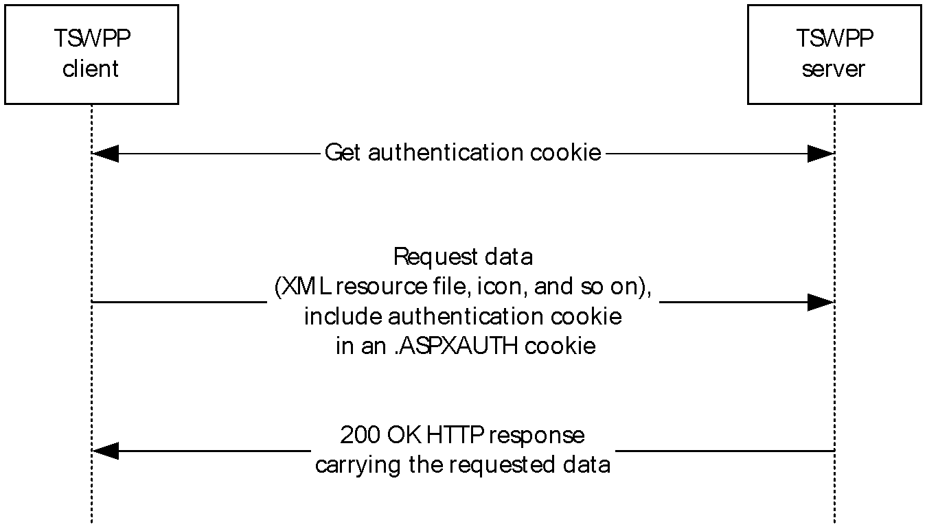
Figure 1: Basic message flow between a TSWPP client and TSWPP server
Communication between a TSWPP client and a TSWPP server is always initiated by the client. During the first request from the client to the server, the client obtains an authentication cookie from the server as specified in section 3.1.5.1. On subsequent requests, the previously obtained authentication cookie is simply passed to the server as specified in section 3.1.5.2. The TSWPP client can request various forms of data from the TSWPP server, such as an XML file describing the resources that are available, and icon and resource files for the available resources. Information about the available forms of data is specified in section 3.1.1, details about the message flow for downloading the XML file are specified in sections 3.1.5.1 and 3.1.5.2, and details for downloading resource files and icon files are specified in section 3.1.5.3.

Relationship to Other Protocols
TSWPP depends on HTTP (as defined in [RFC7230] and [RFC2109]) and HTTPS ([RFC2818]) to transfer all protocol messages, including resource information. Any version of HTTP can be used with TSWPP.
For initial authentication, TSWPP depends on the authentication scheme defined in [RFC4559].

Prerequisites/Preconditions
The following are prerequisites for using TSWPP:
- TSWPP does not provide a mechanism for a client to discover the Uniform Resource Locator (URL) to the server; thus, the client is required to have a valid URL to the server. This URL provides a path either to the XML resource list or to the entry point that the server uses to generate the XML resource list for the client.
- Both client and server implementations of TSWPP are present and running.
- The client machine has the necessary applications to launch any of the resource files contained in the XML resource file. For example, if one of the resource files in the XML resource file is a Remote Desktop Protocol (RDP) configuration file [MSDN-TSCCRDP], then the Terminal Services client is required to be present in order to launch the application, and that client will use the RDP protocol [MS-RDPBCGR] to connect.

Applicability Statement
TSWPP is applicable when a client requires the constituent elements of an application that is located on a remote server in order to execute that application remotely on the server machine. These elements can include, but are not limited to, icons, remote files, and information describing the remotely-executing resource or application.

Versioning and Capability Negotiation
This document covers versioning issues in the following areas:
- Supported Transports: TSWPP is implemented on HTTP (section 2.1).
- Protocol Versions: Servers specify the protocol version by using the SchemaVersion attribute in the XML file. Clients support the version specified by the server because TSWPP does not support protocol negotiation. For more information, see section 2.2.5.<1><2>
- Security and Authentication Methods: TSWPP supports HTTP access authentication, as specified in [RFC4559].
- Localization: This specification does not define any locale-specific protocol behavior.
- Capability Negotiation: Communication of the XML feed is performed using the highest schema version recognized by both the HTTP/1.1 client and the HTTP server, as defined in section 2.2.5.<3><4>

Vendor-Extensible Fields
None.

Standards Assignments
Parameter | Value | Reference
TCP port | 443 | [RFC2818]
XML namespace | "http://schemas.microsoft.com/ts/2007/05/tswf" | [XML10/4]

Messages

Transport
TSWPP uses HTTP protocol messages that are carried in the HTTP message headers and message body, as specified in [RFC7230] and [RFC2109]. TSWPP uses HTTPS to transport these messages, as specified in [RFC2818].
A TCP port has not been reserved for TSWPP. Administrators often use TCP port 443 when setting up their web servers, because many HTTPS proxy servers forward only HTTPS traffic that uses port 443. TSWPP can use any port as defined in [RFC2818] section 2.3 "Port Number".
TSWPP uses the access authentication functionality of the HTTP layer. The supported HTTP access authentication schemes are implementation-specific, as specified in [RFC4559].

Message Syntax

Resource List Syntax
This section specifies the complete XML schema, the set of attributes and object classes that govern the creation and update of objects, (see [XMLSCHEMA1.1/1] and [XMLSCHEMA1.1/2:2008] for details on XML schemas) for messages that are sent from the TSWPP server to the TSWPP client, which defines the syntax for XML resource lists.
The targetNamespace listed here (http://schemas.microsoft.com/ts/2007/05/tswf) is a URI (see http://www.w3.org/tr/REC-xml-names/ and http://www.ietf.org/rfc/rfc3986.txt for details on XML namespace URIs), and is just meant to be used as a string identifier for the TSWPP namespace.

Schema Version 1.1
The schema version for this XML schema is 1.1 and is listed in the version attribute of the <xs:schema> element example that follows.
<?xml version="1.0" encoding="utf-8"?>
<xs:schema targetNamespace="http://schemas.microsoft.com/ts/2007/05/tswf" elementFormDefault="qualified" xmlns="http://schemas.microsoft.com/ts/2007/05/tswf" xmlns:mstns="http://schemas.microsoft.com/ts/2007/05/tswf" xmlns:xs="http://www.w3.org/2001/XMLSchema" version="1.1">
<xs:element name="ResourceCollection" type="ResourceCollectionType" />
<xs:complexType name="ResourceCollectionType">
<xs:sequence>
<xs:element name="Publisher" type="PublisherType" minOccurs="1" maxOccurs="unbounded">
<xs:key name="ResourceIDKey">
<xs:selector xpath="mstns:Resources/mstns:Resource" />
<xs:field xpath="@ID" />
</xs:key>
<xs:key name="TerminalServerIDKey">
<xs:selector xpath="mstns:TerminalServers/mstns:TerminalServer" />
<xs:field xpath="@ID" />
</xs:key>
<xs:keyref name="ResourceToTerminalServerRef" refer="TerminalServerIDKey">
<xs:selector xpath="mstns:Resources/mstns:Resource/mstns:HostingTerminalServers/mstns:HostingTerminalServer/mstns:TerminalServerRef" />
<xs:field xpath="@Ref" />
</xs:keyref>
</xs:element>
</xs:sequence>
<xs:attribute name="SchemaVersion" type="xs:string" use="required" />
<xs:attribute name="PubDate" type="xs:dateTime" />
<xs:anyAttribute />
</xs:complexType>
<xs:complexType name="PublisherType">
<xs:sequence>
<xs:element name="Resources">
<xs:complexType>
<xs:sequence>
<xs:element name="Resource" type="ResourceType" minOccurs="0" maxOccurs="unbounded" />
</xs:sequence>
</xs:complexType>
</xs:element>
<xs:element name="TerminalServers">
<xs:complexType>
<xs:sequence>
<xs:element name="TerminalServer" type="TerminalServerType" minOccurs="0" maxOccurs="unbounded" />
</xs:sequence>
</xs:complexType>
</xs:element>
<xs:any minOccurs="0" maxOccurs="unbounded" />
</xs:sequence>
<xs:attribute name="LastUpdated" type="xs:dateTime" />
<xs:attribute name="Name" type="xs:string" />
<xs:attribute name="ID" type="xs:string" />
<xs:attribute name="Description" type="xs:string" />
<xs:anyAttribute />
</xs:complexType>
<!-- Resource and related Types -->
<xs:complexType name="ResourceType">
<xs:sequence>
<xs:element name="Icons" minOccurs="0" maxOccurs="1">
<xs:complexType>
<xs:all>
<xs:element name="Icon16" type="IconType" minOccurs="0" maxOccurs="1" />
<xs:element name="Icon32" type="IconType" minOccurs="0" maxOccurs="1" />
<xs:element name="Icon48" type="IconType" minOccurs="0" maxOccurs="1" />
<xs:element name="Icon64" type="IconType" minOccurs="0" maxOccurs="1" />
<xs:element name="Icon100" type="IconType" minOccurs="0" maxOccurs="1" />
<xs:element name="Icon256" type="IconType" minOccurs="0" maxOccurs="1" />
<xs:element name="IconRaw" type="IconType">
</xs:element>
</xs:all>
</xs:complexType>
</xs:element>
<xs:element name="FileExtensions" minOccurs="0" maxOccurs="1">
<xs:complexType>
<xs:sequence>
<xs:element name="FileExtension" type="FileExtensionType" minOccurs="0" maxOccurs="unbounded" />
</xs:sequence>
</xs:complexType>
</xs:element>
<xs:element name="HostingTerminalServers">
<xs:complexType>
<xs:sequence>
<xs:element name="HostingTerminalServer" type="HostingTerminalServerType" minOccurs="0" maxOccurs="unbounded" />
</xs:sequence>
<xs:anyAttribute />
</xs:complexType>
</xs:element>
<xs:any minOccurs="0" maxOccurs="unbounded" />
</xs:sequence>
<xs:attribute name="ID" type="xs:string" use="required" />
<xs:attribute name="Alias" type="xs:string" />
<xs:attribute name="Title" type="xs:string" />
<xs:attribute name="LastUpdated" type="xs:dateTime" />
<xs:attribute name="Type">
<xs:simpleType>
<xs:restriction base="xs:string">
<xs:enumeration value="Desktop" />
<xs:enumeration value="RemoteApp" />
</xs:restriction>
</xs:simpleType>
</xs:attribute>
<xs:attribute name="RequiredCommandLine" type="xs:string" />
<xs:attribute name="ExecutableName" type="xs:string" />
<xs:anyAttribute />
</xs:complexType>
<xs:complexType name="IconType">
<xs:sequence>
<xs:element name="FileContent" type="xs:string" minOccurs="0" maxOccurs="1" />
</xs:sequence>
<xs:attribute name="Dimensions" type="xs:string" />
<xs:attribute name="FileType" type="xs:string" />
<xs:attribute name="FileURL" type="xs:string" />
<xs:attribute name="Index" type="xs:integer" />
<xs:anyAttribute />
</xs:complexType>
<xs:complexType name="FileExtensionType">
<xs:sequence>
<xs:any minOccurs="0" maxOccurs="unbounded" />
</xs:sequence>
<xs:attribute name="Name" type="xs:string" />
<xs:anyAttribute />
</xs:complexType>
<xs:complexType name="TerminalServerRefType">
<xs:attribute name="Ref" type="xs:string" use="required" />
</xs:complexType>
<xs:complexType name="ResourceFileType">
<xs:sequence>
<xs:element name="Content" type="xs:string" minOccurs="0" maxOccurs="1" />
</xs:sequence>
<xs:attribute name="URL" type="xs:string" />
<xs:attribute name="FileExtension" type="xs:string" default=".rdp" />
<xs:anyAttribute />
</xs:complexType>
<xs:complexType name="HostingTerminalServerType">
<xs:sequence>
<xs:element name="ResourceFile" type="ResourceFileType" minOccurs="0" maxOccurs="1" />
<xs:element name="TerminalServerRef" type="TerminalServerRefType" />
<xs:any minOccurs="0" maxOccurs="unbounded" />
</xs:sequence>
<xs:anyAttribute />
</xs:complexType>
<!-- TerminalServer and related Types -->
<xs:complexType name="TerminalServerType">
<xs:attribute name="ID" type="xs:string" use="required" />
<xs:attribute name="Name" type="xs:string" />
<xs:attribute name="LastUpdated" type="xs:dateTime" />
<xs:anyAttribute />
</xs:complexType>
</xs:schema>

Schema Version 2.0
The schema version for this XML schema is 2.0 and is listed in the version attribute of the <xs:schema> element example below.
Due to the way the schema is written, documents that adhere to schema version 1.1 will also validate against schema version 2.0. Documents that adhere to schema version 2.0 will not necessarily validate against schema version 1.1.
<?xml version="1.0" encoding="utf-8"?>
<xs:schema targetNamespace="http://schemas.microsoft.com/ts/2007/05/tswf"
elementFormDefault="qualified" xmlns="http://schemas.microsoft.com/ts/2007/05/tswf" xmlns:mstns="http://schemas.microsoft.com/ts/2007/05/tswf" xmlns:xs="http://www.w3.org/2001/XMLSchema" version="2.0">
<xs:element name="ResourceCollection" type="ResourceCollectionType" />
<xs:complexType name="ResourceCollectionType">
<xs:sequence>
<xs:element name="Publisher" type="PublisherType"
minOccurs="1" maxOccurs="unbounded">
<xs:key name="ResourceIDKey">
<xs:selector xpath="mstns:Resources/mstns:Resource" />
<xs:field xpath="@ID" />
</xs:key>
<xs:key name="TerminalServerIDKey">
<xs:selector xpath="mstns:TerminalServers/mstns:TerminalServer" />
<xs:field xpath="@ID" />
</xs:key>
<xs:keyref name="ResourceToTerminalServerRef" refer="TerminalServerIDKey">
<xs:selector xpath="mstns:Resources/mstns:Resource/
mstns:HostingTerminalServers/mstns:HostingTerminalServer/
mstns:TerminalServerRef" />
<xs:field xpath="@Ref" />
</xs:keyref>
</xs:element>
</xs:sequence>
<xs:attribute name="SchemaVersion" type="xs:string" use="required" />
<xs:attribute name="PubDate" type="xs:dateTime" />
<xs:anyAttribute processContents="lax" />
</xs:complexType>
<xs:complexType name="PublisherType">
<xs:sequence>
<xs:element name="SubFolders" minOccurs="0" maxOccurs="unbounded">
<xs:complexType>
<xs:sequence>
<xs:element name="Folder" type="FolderType"
minOccurs="0" maxOccurs="unbounded" />
</xs:sequence>
<xs:anyAttribute processContents="lax" />
</xs:complexType>
</xs:element>
<xs:element name="Resources">
<xs:complexType>
<xs:sequence>
<xs:element name="Resource" type="ResourceType"
minOccurs="0" maxOccurs="unbounded" />
</xs:sequence>
</xs:complexType>
</xs:element>
<xs:element name="TerminalServers">
<xs:complexType>
<xs:sequence>
<xs:element name="TerminalServer" type="TerminalServerType"
minOccurs="0" maxOccurs="unbounded" />
</xs:sequence>
</xs:complexType>
</xs:element>
<xs:any minOccurs="0" maxOccurs="unbounded" processContents="lax" />
</xs:sequence>
<xs:attribute name="LastUpdated" type="xs:dateTime" />
<xs:attribute name="Name" type="xs:string" />
<xs:attribute name="ID" type="xs:string" />
<xs:attribute name="Description" type="xs:string" />
<xs:attribute name="SupportsReconnect" type="xs:boolean" />
<xs:attribute name="DisplayFolder" type="xs:string"/>
<xs:anyAttribute processContents="lax" />
</xs:complexType>
<!-- Resource and related Types -->
<xs:complexType name="ResourceType">
<xs:sequence>
<xs:element name="Icons" minOccurs="0" maxOccurs="1">
<xs:complexType>
<xs:sequence>
<xs:element name="IconRaw" type="IconType" />
<xs:element name="Icon16" type="IconType" minOccurs="0" maxOccurs="1" />
<xs:element name="Icon32" type="IconType" minOccurs="0" maxOccurs="1" />
<xs:element name="Icon48" type="IconType" minOccurs="0" maxOccurs="1" />
<xs:element name="Icon64" type="IconType" minOccurs="0" maxOccurs="1" />
<xs:element name="Icon100" type="IconType" minOccurs="0" maxOccurs="1" />
<xs:element name="Icon256" type="IconType" minOccurs="0" maxOccurs="1" />
<xs:element name="Icon" type="IconType" minOccurs="0" maxOccurs="unbounded" />
</xs:sequence>
</xs:complexType>
</xs:element>
<xs:element name="FileExtensions" minOccurs="0" maxOccurs="1">
<xs:complexType>
<xs:sequence>
<xs:element name="FileExtension" type="FileExtensionType"
minOccurs="0" maxOccurs="unbounded" />
</xs:sequence>
<xs:anyAttribute processContents="lax" />
</xs:complexType>
</xs:element>
<xs:element name="Folders" minOccurs="0" maxOccurs="1">
<xs:complexType>
<xs:sequence>
<xs:element name="Folder" type="FolderType"
minOccurs="0" maxOccurs="unbounded" />
</xs:sequence>
<xs:anyAttribute processContents="lax" />
</xs:complexType>
</xs:element>
<xs:element name="HostingTerminalServers">
<xs:complexType>
<xs:sequence>
<xs:element name="HostingTerminalServer" type="HostingTerminalServerType"
minOccurs="0" maxOccurs="unbounded" />
</xs:sequence>
<xs:anyAttribute processContents="lax" />
</xs:complexType>
</xs:element>
<xs:any minOccurs="0" maxOccurs="unbounded" processContents="lax" />
</xs:sequence>
<xs:attribute name="ID" type="xs:string" use="required" />
<xs:attribute name="Alias" type="xs:string" />
<xs:attribute name="Title" type="xs:string" />
<xs:attribute name="LastUpdated" type="xs:dateTime" />
<xs:attribute name="Type">
<xs:simpleType>
<xs:restriction base="xs:string">
<xs:enumeration value="Desktop" />
<xs:enumeration value="RemoteApp" />
</xs:restriction>
</xs:simpleType>
</xs:attribute>
<xs:attribute name="RequiredCommandLine" type="xs:string" />
<xs:attribute name="ExecutableName" type="xs:string" />
<xs:anyAttribute processContents="lax" />
</xs:complexType>
<xs:complexType name="IconType">
<xs:sequence>
<xs:element name="FileContent" type="xs:string" minOccurs="0" maxOccurs="1" />
</xs:sequence>
<xs:attribute name="Dimensions" type="xs:string" />
<xs:attribute name="FileType" type="xs:string" />
<xs:attribute name="FileURL" type="xs:string" />
<xs:attribute name="Index" type="xs:integer" />
<xs:anyAttribute processContents="lax" />
</xs:complexType>
<xs:complexType name="FileExtensionType">
<xs:sequence>
<xs:any minOccurs="0" maxOccurs="unbounded" processContents="lax" />
</xs:sequence>
<xs:attribute name="Name" type="xs:string" />
<xs:attribute name="PrimaryHandler" type="xs:string" />
<xs:anyAttribute processContents="lax" />
</xs:complexType>
<xs:element name="FileAssociationIcons">
<xs:complexType>
<xs:sequence>
<xs:element name="IconRaw" type="IconType" />
<xs:element name="Icon16" type="IconType" minOccurs="0" maxOccurs="1" />
<xs:element name="Icon32" type="IconType" minOccurs="0" maxOccurs="1" />
<xs:element name="Icon48" type="IconType" minOccurs="0" maxOccurs="1" />
<xs:element name="Icon64" type="IconType" minOccurs="0" maxOccurs="1" />
<xs:element name="Icon100" type="IconType" minOccurs="0" maxOccurs="1" />
<xs:element name="Icon256" type="IconType" minOccurs="0" maxOccurs="1" />
<xs:element name="Icon" type="IconType" minOccurs="0" maxOccurs="unbounded" />
</xs:sequence>
</xs:complexType>
</xs:element>
<xs:complexType name="TerminalServerRefType">
<xs:attribute name="Ref" type="xs:string" use="required" />
</xs:complexType>
<xs:complexType name="FolderType">
<xs:attribute name="Name" type="xs:string" use="required" />
<xs:anyAttribute processContents="lax" />
</xs:complexType>
<xs:complexType name="ResourceFileType">
<xs:sequence>
<xs:element name="Content" type="xs:string" minOccurs="0" maxOccurs="1" />
</xs:sequence>
<xs:attribute name="URL" type="xs:string" />
<xs:attribute name="FileExtension" type="xs:string" default=".rdp" />
<xs:anyAttribute processContents="lax" />
</xs:complexType>
<xs:complexType name="HostingTerminalServerType">
<xs:sequence>
<xs:element name="ResourceFile" type="ResourceFileType"
minOccurs="0" maxOccurs="1" />
<xs:element name="TerminalServerRef" type="TerminalServerRefType" />
<xs:any minOccurs="0" maxOccurs="unbounded" processContents="lax" />
</xs:sequence>
<xs:anyAttribute processContents="lax" />
</xs:complexType>
<!-- TerminalServer and related Types -->
<xs:complexType name="TerminalServerType">
<xs:attribute name="ID" type="xs:string" use="required" />
<xs:attribute name="Name" type="xs:string" />
<xs:attribute name="LastUpdated" type="xs:dateTime" />
<xs:anyAttribute processContents="lax" />
</xs:complexType>
</xs:schema>

Schema Version 2.1
The schema version for this XML schema is 2.1 and is listed in the version attribute of the <xs:schema> element example later in this section.
Due to the way the schema is written, documents that adhere to schema version 2.1 will also validate against schema version 2.0. Similarly, documents that adhere to schema version 2.0 will also validate against the schema version 2.1. Documents that adhere to schema version 1.1 will validate against schema version 2.1, but documents that adhere to schema version 2.1 will not necessarily validate against schema version 1.1.

<?xml version="1.0" encoding="utf-8"?>
<xs:schema targetNamespace="http://schemas.microsoft.com/ts/2007/05/tswf" elementFormDefault="qualified" xmlns="http://schemas.microsoft.com/ts/2007/05/tswf" xmlns:mstns="http://schemas.microsoft.com/ts/2007/05/tswf" xmlns:xs="http://www.w3.org/2001/XMLSchema" version="2.1">
<xs:element name="ResourceCollection" type="ResourceCollectionType" />
<xs:complexType name="ResourceCollectionType">
<xs:sequence>
<xs:element name="Publisher" type="PublisherType" minOccurs="1" maxOccurs="unbounded">
<xs:key name="ResourceIDKey">
<xs:selector xpath="mstns:Resources/mstns:Resource" />
<xs:field xpath="@ID" />
</xs:key>
<xs:key name="TerminalServerIDKey">
<xs:selector xpath="mstns:TerminalServers/mstns:TerminalServer" />
<xs:field xpath="@ID" />
</xs:key>
<xs:keyref name="ResourceToTerminalServerRef" refer="TerminalServerIDKey">
<xs:selector xpath="mstns:Resources/mstns:Resource/mstns:HostingTerminalServers/mstns:HostingTerminalServer/mstns:TerminalServerRef" />
<xs:field xpath="@Ref" />
</xs:keyref>
</xs:element>
</xs:sequence>
<xs:attribute name="SchemaVersion" type="xs:string" use="required" />
<xs:attribute name="PubDate" type="xs:dateTime" />
<xs:anyAttribute processContents="lax" />
</xs:complexType>
<xs:complexType name="PublisherType">
<xs:sequence>
<xs:element name="SubFolders" minOccurs="0" maxOccurs="unbounded">
<xs:complexType>
<xs:sequence>
<xs:element name="Folder" type="FolderType" minOccurs="0" maxOccurs="unbounded" />
</xs:sequence>
<xs:anyAttribute processContents="lax" />
</xs:complexType>
</xs:element>
<xs:element name="Resources">
<xs:complexType>
<xs:sequence>
<xs:element name="Resource" type="ResourceType" minOccurs="0" maxOccurs="unbounded" />
</xs:sequence>
</xs:complexType>
</xs:element>
<xs:element name="TerminalServers">
<xs:complexType>
<xs:sequence>
<xs:element name="TerminalServer" type="TerminalServerType" minOccurs="0" maxOccurs="unbounded" />
</xs:sequence>
</xs:complexType>
</xs:element>
<xs:any minOccurs="0" maxOccurs="unbounded" processContents="lax" />
</xs:sequence>
<xs:attribute name="LastUpdated" type="xs:dateTime" />
<xs:attribute name="Name" type="xs:string" />
<xs:attribute name="ID" type="xs:string" />
<xs:attribute name="Description" type="xs:string" />
<xs:attribute name="SupportsReconnect" type="xs:boolean" />
<xs:attribute name="DisplayFolder" type="xs:string"/>
<xs:anyAttribute processContents="lax" />
</xs:complexType>
<!-- Resource and related Types -->
<xs:complexType name="ResourceType">
<xs:sequence>
<xs:element name="Icons" minOccurs="0" maxOccurs="1">
<xs:complexType>
<xs:sequence>
<xs:element name="IconRaw" type="IconType" />
<xs:element name="Icon16" type="IconType" minOccurs="0" maxOccurs="1" />
<xs:element name="Icon32" type="IconType" minOccurs="0" maxOccurs="1" />
<xs:element name="Icon48" type="IconType" minOccurs="0" maxOccurs="1" />
<xs:element name="Icon64" type="IconType" minOccurs="0" maxOccurs="1" />
<xs:element name="Icon100" type="IconType" minOccurs="0" maxOccurs="1" />
<xs:element name="Icon256" type="IconType" minOccurs="0" maxOccurs="1" />
<xs:element name="Icon" type="IconType" minOccurs="0" maxOccurs="unbounded" />
</xs:sequence>
</xs:complexType>
</xs:element>
<xs:element name="FileExtensions" minOccurs="0" maxOccurs="1">
<xs:complexType>
<xs:sequence>
<xs:element name="FileExtension" type="FileExtensionType" minOccurs="0" maxOccurs="unbounded" />
</xs:sequence>
<xs:anyAttribute processContents="lax" />
</xs:complexType>
</xs:element>
<xs:element name="Folders" minOccurs="0" maxOccurs="1">
<xs:complexType>
<xs:sequence>
<xs:element name="Folder" type="FolderType" minOccurs="0" maxOccurs="unbounded" />
</xs:sequence>
<xs:anyAttribute processContents="lax" />
</xs:complexType>
</xs:element>
<xs:element name="HostingTerminalServers">
<xs:complexType>
<xs:sequence>
<xs:element name="HostingTerminalServer" type="HostingTerminalServerType" minOccurs="0" maxOccurs="unbounded" />
</xs:sequence>
<xs:anyAttribute processContents="lax" />
</xs:complexType>
</xs:element>
<xs:any minOccurs="0" maxOccurs="unbounded" processContents="lax" />
</xs:sequence>
<xs:attribute name="ID" type="xs:string" use="required" />
<xs:attribute name="Alias" type="xs:string" />
<xs:attribute name="Title" type="xs:string" />
<xs:attribute name="LastUpdated" type="xs:dateTime" />
<xs:attribute name="Type">
<xs:simpleType>
<xs:restriction base="xs:string">
<xs:enumeration value="Desktop" />
<xs:enumeration value="RemoteApp" />
</xs:restriction>
</xs:simpleType>
</xs:attribute>
<xs:attribute name="RequiredCommandLine" type="xs:string" />
<xs:attribute name="ExecutableName" type="xs:string" />
<xs:attribute name="ShowByDefault" type="xs:boolean" />
<xs:anyAttribute processContents="lax" />
</xs:complexType>
<xs:complexType name="IconType">
<xs:sequence>
<xs:element name="FileContent" type="xs:string" minOccurs="0" maxOccurs="1" />
</xs:sequence>
<xs:attribute name="Dimensions" type="xs:string" />
<xs:attribute name="FileType" type="xs:string" />
<xs:attribute name="FileURL" type="xs:string" />
<xs:attribute name="Index" type="xs:integer" />
<xs:anyAttribute processContents="lax" />
</xs:complexType>
<xs:complexType name="FileExtensionType">
<xs:sequence>
<xs:any minOccurs="0" maxOccurs="unbounded" processContents="lax" />
</xs:sequence>
<xs:attribute name="Name" type="xs:string" />
<xs:attribute name="PrimaryHandler" type="xs:string" />
<xs:anyAttribute processContents="lax" />
</xs:complexType>
<xs:element name="FileAssociationIcons">
<xs:complexType>
<xs:sequence>
<xs:element name="IconRaw" type="IconType" />
<xs:element name="Icon16" type="IconType" minOccurs="0" maxOccurs="1" />
<xs:element name="Icon32" type="IconType" minOccurs="0" maxOccurs="1" />
<xs:element name="Icon48" type="IconType" minOccurs="0" maxOccurs="1" />
<xs:element name="Icon64" type="IconType" minOccurs="0" maxOccurs="1" />
<xs:element name="Icon100" type="IconType" minOccurs="0" maxOccurs="1" />
<xs:element name="Icon256" type="IconType" minOccurs="0" maxOccurs="1" />
<xs:element name="Icon" type="IconType" minOccurs="0" maxOccurs="unbounded" />
</xs:sequence>
</xs:complexType>
</xs:element>
<xs:complexType name="TerminalServerRefType">
<xs:attribute name="Ref" type="xs:string" use="required" />
</xs:complexType>
<xs:complexType name="FolderType">
<xs:attribute name="Name" type="xs:string" use="required" />
<xs:anyAttribute processContents="lax" />
</xs:complexType>
<xs:complexType name="ResourceFileType">
<xs:sequence>
<xs:element name="Content" type="xs:string" minOccurs="0" maxOccurs="1" />
</xs:sequence>
<xs:attribute name="URL" type="xs:string" />
<xs:attribute name="FileExtension" type="xs:string" default=".rdp" />
<xs:anyAttribute processContents="lax" />
</xs:complexType>
<xs:complexType name="HostingTerminalServerType">
<xs:sequence>
<xs:element name="ResourceFile" type="ResourceFileType" minOccurs="0" maxOccurs="1" />
<xs:element name="TerminalServerRef" type="TerminalServerRefType" />
<xs:any minOccurs="0" maxOccurs="unbounded" processContents="lax" />
</xs:sequence>
<xs:anyAttribute processContents="lax" />
</xs:complexType>
<!-- TerminalServer and related Types -->
<xs:complexType name="TerminalServerType">
<xs:attribute name="ID" type="xs:string" use="required" />
<xs:attribute name="Name" type="xs:string" />
<xs:attribute name="LastUpdated" type="xs:dateTime" />
<xs:anyAttribute processContents="lax" />
</xs:complexType>
</xs:schema>

Resource List Content-Type
If the client sends an HTTP Accept header ([RFC7231] section 5.3.2) requesting the "application/x-msts-radc+xml" and content compatible with schema version 2.0 (see section 2.2.5), the server SHOULD set the Content-Type of the response resource list as "application\x-msts-radc+xml". Otherwise, the server MUST set the Content-Type of the response resource list as "text/xml".<5>

Schema Element Definitions

Schema Version 1.1 Element Definitions
This section specifies the elements in the XML schema (XSD) that are defined in section 2.2.1.1. The values of all attributes MUST be xs:string, unless specified otherwise.

ResourceCollection Element
The <ResourceCollection> element contains all the other elements defined in section 2.2.2.1. The server MUST only put one <Publisher> element as defined in section 2.2.2.1.2. The <ResourceCollection> element defines the following attributes:
- PubDate: The publication date. This date SHOULD be included in the <ResourceCollection> element and MUST be in the form xs:dateTime.
- SchemaVersion: The version number of the XML schema. This attribute MUST be included in the <ResourceCollection> element and SHOULD be based on the version of the schema described in section 2.2.1.1 of this document. The schema version for the XML schema listed in section 2.2.1.1 of this document is schema version 1.1. The schema version number can be found in the version attribute of the <xs:schema> element in the XML schema (section 2.2.1).

Publisher Element
The <Publisher> element contains all the attributes for one publisher. It defines the following attributes:
- LastUpdated: A timestamp that indicates the date and time of any changes made by any entries under the <Publisher> element. This timestamp MUST be in xs:dateTime format.
- Name: The name of the publisher of the resources.
- ID: A GUID, as defined in [MS-DTYP] sections 2.3.4, 2.3.4.2, and 2.3.4.3, or the fully qualified domain name, a name with a structure indicated by dots, of the server that provides the XML file. The value of this attribute MUST be globally unique.
- Description: An optional description of the publisher.
The <Publisher> element contains the following keys in the schema that MUST be unique in a <Publisher> element.
- TerminalServerIDKey: This declares that the ID attribute of the <TerminalServer> element (section 2.2.2.1.12) MUST be unique among the <TerminalServer> elements contained in the <TerminalServer> element (section 2.2.2.1.11). The ID attribute is defined in section 2.2.2.1.12.
- ResourceToTerminalServerRef: This declares that references to a <TerminalServer> element by ID SHOULD be contained in <TerminalServerRef> elements. The link to the <TerminalServer> ID is in the Ref attribute as defined in section 2.2.2.1.10.

Resources Element
The <Resources>element contains all of the resources that have been published by a publisher as specified in section 2.2.2.1.2.

Resource Element
The <Resource> element describes one resource such as an application that can be launched remotely. It contains all information that a client requires to display and launch the application. This element defines the following attributes:
- ID: A unique identifier for the resource. This identifier MUST be unique among all other resource identifiers within the containing <Resources> element (section 2.2.2.1.3). The unique identifier SHOULD be generated in such a manner that the identifier remains the same on each request for the XML file.
- Alias: An identifier that the server uses to look up the requested resource. This identifier MUST be unique among all other resource identifiers within the containing <Resources> element (section 2.2.2.1.3). The unique identifier SHOULD be generated in such a manner that the identifier remains the same on each request for the XML file.
- Title: The name of the resource. The client SHOULD use the value of this attribute to display the resource name to the user.
- LastUpdated: An optional timestamp, which specifies the last time that anything changed in this resource. The timestamp MUST be in xs:dateTime format.
- Type: The type of resource that this <Resource> element specifies. This type MUST be either "Desktop" or "RemoteApp". If the resource will start a complete desktop on a remote computer, use the "Desktop" type; otherwise, use the "RemoteApp" type.
- ExecutableName: This attribute specifies the executable that runs on the server if this resource is launched.
- RequiredCommandLine: This attribute is ignored by the client and MUST NOT be used by the server.

Icons Element
The <Icons> element contains all icons associated with one resource.

Icon Elements
The Icon elements specify icons for a resource or application. Icon elements include <Icon16>, <Icon32>, <Icon48>, <Icon64>, <Icon100>, <Icon256>, and <IconRaw>. The numeric part of the name specifies that the image used for the icon MUST be square, with height and width equal to that number. For example, an icon with the name Icon256 must have a height and width of 256 pixels. The <IconRaw> element can contain multiple icons with different sizes.
Icon elements define the following attributes:
- Dimensions: An attribute that specifies the height and width of the icon with an "x" separating the two entries, such as "32x32". This attribute SHOULD appear only when the icon name is a value that contains a specific size such as Icon16 and SHOULD NOT appear when the icon name is IconRaw.
- FileType: The file extension for the file type of the image. For example, if the image file on the server is named Paint.ico, then the FileType attribute would be "Ico".
- FileURL: An optional URL that specifies the location of the image file. This attribute MUST be present if the icon is available from a web server.
- FileContent: This element is ignored by the client and MUST NOT be used by the server.
- Index: This attribute is ignored by the client and MUST NOT be used by the server.

HostingTerminalServers Element
The <HostingTerminalServers> element contains elements for all the terminal servers, computers on which Terminal Services is running, that are hosting a resource. This element MUST contain at least one HostingTerminalServer element, as defined in section 2.2.2.1.8.

HostingTerminalServer Element
The <HostingTerminalServer> element contains the name of the file required to launch a remote resource as defined in section 2.2.2.1.9 and an element that links to the terminal server reference, as defined in section 2.2.2.1.10.

ResourceFile Element
The <ResourceFile> element contains the name of the file that is required in order to launch a remote resource on a server. This element defines the following attributes:
- FileExtension: The file extension of the resource file that is defined in this resource. This file extension is what the client SHOULD use to determine how to launch the resource file. For example, if the file is for the terminal server client, then this file extension MUST be ".rdp".
- URL: The URL to the location of this resource file. This attribute MUST be present if the resource file is available from a web server.
- Content: This element is ignored by the client and MUST NOT be used by the server.

TerminalServerRef Element
The <TerminalServerRef> element is a link element that contains one attribute: Ref. This attribute is the unique identifier for the terminal server as defined in section 2.2.2.1.12.

TerminalServers Element
The <TerminalServers> element contains <TerminalServer> elements (section 2.2.2.1.12) for all terminal servers that host the remote resources defined in section 2.2.2.1.3.

TerminalServer Element
The <TerminalServer> element contains the definition for one hosting terminal server. It defines the following attributes:
- ID: A reference as defined in section 2.2.2.1.10. This attribute value MUST be unique among all terminal server elements contained in the <TerminalServers> element (section 2.2.2.1.11).
- Name: The name of the terminal server, which SHOULD be the fully qualified domain name of that server.
- LastUpdated: The timestamp, which specifies the last time anything changed in this <TerminalServer> element. This entry MUST be in xs:dateTime format.

FileExtensions Element
The <FileExtensions> element SHOULD contain <FileExtension> elements (section 2.2.2.1.14) for all the file types that can be opened by the remote resource defined in section 2.2.2.1.4.<6>
The <FileExtensions> element MUST be set as empty by the server if the remote resource does not handle any file types.

FileExtension Element
The <FileExtension> element MUST contain the definition of one file type that the remote resource is capable of opening.
- Name: The name of the file type, which MUST be preceded by a dot (for example, ".txt"). This attribute value SHOULD be unique among all <FileExtension> elements contained in the <Resources> element (see section 2.2.2.1.3).

Schema Version 2.0 Element Definitions
This section specifies the elements in the XML schema (XSD) that are defined in section 2.2.1.2. It does this by listing the changes from schema version 1.1, the element definitions for which can be found in section 2.2.2.1. Unless specified otherwise in this section, the definition of an element in schema version 2.0 is the same as its definition in schema version 1.1.

ResourceCollection Element
The <ResourceCollection> element contains all of the other elements defined in sections 2.2.2.1 and 2.2.2.2. The server MUST only put one <Publisher> element as defined in section 2.2.2.1.2. The <ResourceCollection> element defines the following attributes:
- PubDate: The publication date. This date SHOULD be included in the <ResourceCollection> element and MUST be in the form xs:dateTime.
- SchemaVersion: The version number of the XML schema. This attribute MUST be included in the <ResourceCollection> element and SHOULD be based on the version of the schema described in section 2.2.1.2 of this document. The schema version for the XML schema listed in section 2.2.1.2 of this document is schema version 2.0. The schema version number can be found in the version attribute of the <xs:schema> element in the XML schema (see section 2.2.1).
- DisplayFolder: When present, this attribute indicates that the <ResourceCollection> element contains a subset of the available resources. The subset consists of the resources that exist in the folder name specified in this attribute. If this attribute is not present, the <ResourceCollection> element contains resources from all folders. Folders are described in section 2.2.6.
- SupportsReconnect: Indicates whether the server supports the Remote Desktop Workspace Runtime Protocol [MS-RDWR]. This attribute SHOULD be included in the <ResourceCollection> element and MUST be in the form xs:boolean.

FileExtensions Element
The <FileExtensions> element SHOULD contain <FileExtension> elements (section 2.2.2.2.3) for all the file types that can be opened by the remote resource defined in section 2.2.2.1.4.
The <FileExtensions> element MUST be set as empty by the server if the remote resource cannot handle any file types.

FileExtension Element
The <FileExtension> element contains the definition of one file type such that the remote resource is capable of opening documents of that type.
- Name: The name of the file type, which MUST be preceded by a dot (for example, ".txt"). This attribute value SHOULD be unique among all <FileExtension> elements contained in the <Resources> element (section 2.2.2.1.3).
- PrimaryHandler: This attribute is reserved for future use and MUST be set by the server to the xs:boolean value of True.

FileAssociationIcons Element
The <FileAssociationIcons> element contains all icons associated with one file type. The icon element is defined in section 2.2.2.1.6.

SubFolders Element
The <SubFolders> element SHOULD contain <Folder> elements (section 2.2.2.2.7) for all folders contained in the current display folder as defined by the DisplayFolder attribute of the <ResourceCollection> element (section 2.2.2.2.1). If no display folder is defined, the <SubFolders> element MUST NOT be included. The <Folder> elements included in the <SubFolders> element describe any folders that are contained in the current display folder.

Folders Element
The <Folders> element SHOULD contain <Folder> elements (section 2.2.2.2.7) for all folders within which the remote resource exists. Folders are described in section 2.2.6.

Folder Element
The <Folder> element describes a folder (see section 2.2.6) and defines the following attribute:
- Name: The name of the folder as specified in section 2.2.6. This attribute MUST be included in the <Folder> element.

Schema Version 2.1 Element Definitions
This section specifies the elements in the XML schema (XSD) that are defined in section 2.2.1.3. It does this by listing the changes from schema version 2.0, the element definitions for which can be found in section 2.2.2.2. Unless specified otherwise in this section, the definition of an element in schema version 2.1 is the same as its definition in schema version 2.0 (which may in turn be the same as its definition in schema version 1.1).

Resource Element
The <Resource> element describes one resource, such as an application that can be launched remotely. It contains all information that a client requires to display and launch the application. This element defines the following attributes:
- ID: A unique identifier for the resource. This identifier MUST be unique among all other resource identifiers within the containing <Resource> element (section 2.2.2.1.3). The unique identifier SHOULD be generated in such a manner that the identifier remains the same on each request for the XML file.
- Alias: An identifier that the server uses to look up the requested resource. This identifier MUST be unique among all other resource identifiers within the containing <Resources> element (section 2.2.2.1.3). The unique identifier SHOULD be generated in such a manner that the identifier remains the same on each request for the XML file.
- Title: The name of the resource. The client SHOULD use the value of this attribute to display the resource name to the user.
- LastUpdated: An optional time stamp, which specifies the last time that anything changed in this resource. The time stamp MUST be in xs:dateTime format.
- Type: The type of resource that this <Resource> element specifies. This type MUST be either "Desktop" or "RemoteApp". If the resource will start a complete desktop on a remote computer, use the "Desktop" type; otherwise, use the "RemoteApp" type.
- ExecutableName: This attribute specifies the executable that runs on the server if this resource is launched.
- RequiredCommandLine: This attribute is ignored by the client and MUST NOT be used by the server.
- ShowByDefault: Clients MAY take advantage of this attribute to run in two different modes: "install" mode, and "catalog" mode.
Clients running in "install" mode SHOULD ignore all resources with a ShowByDefault value of "false" and make all resources with a ShowByDefault value of "true" available to be launched by the user.
Clients running in "catalog" mode SHOULD provide a list of all resources to the user and let the user choose which ones to make available to be launched.
This attribute SHOULD be included in the <Resource> element and MUST be in the form xs:boolean. If this attribute is not present in the <Resource> element, clients MUST act as if it were present with a value of "true".

.ASPXAUTH Cookie
If a user's interactions with the HTML login URL have allowed the TSWPP server to establish the user’s identity, the remote server SHOULD generate a cookie that identifies the user and allows authentication to the server. The contents of the cookie SHOULD be signed and encrypted. The specific implementation of this cookie including the signing and encryption algorithms is dependent on the implementation of the TSWPP server, because only the server is required to parse the contents of the cookie. If the server implements the cookie, then the cookie MUST be returned in an HTTP payload with a Content-Type of "application/x-msts-webfeed-login".

Resources
Resources are stored on the TSWPP server in memory and comprise the list of resources that are used to generate the XML files (section 3.1.1.2) that are sent to the TSWPP client. The data stored for a resource includes the following:
- The resource file (section 3.1.1.4)
- A friendly display name for the resource
- A unique identifier for the resource
- Any icon files (section 3.1.1.3) associated with the resource
- A list of folder paths that specifies the folders where the resource exists (see section 2.2.6)
A client MUST be able to authenticate to the TSWPP server before the client can retrieve the XML file (section 3.1.1.2) containing the list of resources. A client MUST request the XML file from the TSWPP server, and the server MUST respond to requests from a client for the XML file containing the list of resources, as specified in section 2. The mechanism by which the XML file (section 3.1.1.2) contents are assembled is server implementation-specific. The server SHOULD receive a user identity as shown in the figures in section 3.1.5, and it SHOULD use that identity to create a customized XML resource list for that user. How the XML resource list is customized or if is customized at all is up to the server implementation. This is done by including only <ResourceFile> elements that the user can access.
If the server is configured to customize the XML resource list for each user, each user can have a different XML resource list returned from a TSWPP server. The server SHOULD cache the information used to generate the XML file (section 3.1.1.2), so that the server can quickly respond to requests for the list of resources.
If the XML resource list that the client requests from the server is not available, the server MUST return an HTTP "404 Not Found" error code [RFC7230].
The client implementation can run in two modes: "install" mode and "catalog" mode. The client implementation makes some of the resources described in the XML resource list available to the user by installing them in a manner that allows easy user access to the resources. The client implementation SHOULD use the ShowByDefault attribute to determine which resources should be installed (section 2.2.2.3.1). In addition, the client implementation stores the XML resource list locally and updates it at least every 24 hours through new TSWPP transactions.
The client SHOULD make efforts to keep the locally stored XML resource list up-to-date. The client SHOULD accomplish this by periodically retrieving a new copy of the resource list from the server. The method of triggering this periodic retrieval of the XML resource list is specific to the client implementation. The client MAY trigger retrieval of the XML resource list by using a periodic task scheduler provided by the client operating system.
The client SHOULD prevent resource files with unsafe file extensions from being downloaded. This SHOULD be done before downloading by checking the FileExtension attribute of the <ResourceFile> element section 2.2.2.1.9 and determining whether the file extension listed in that attribute is registered as being safe. Which file extensions are considered safe and the manner in which they are registered as safe for download with the client is a detail of the client implementation. The server has no concept of safe or unsafe file extensions.
If the server returns an HTTP "404 Not Found" error code [RFC7230] when the client is connecting on the initial attempt to set up a workspace, the client SHOULD NOT set up a workspace and SHOULD warn the user that the connection could not be made. If the server returns an HTTP "404 Not Found" error when the client is connecting in order to update workspace resources that were previously downloaded, the client SHOULD log a warning but leave the existing resources untouched.

Content Negotiation
The client SHOULD request that the server provide a copy of the XML feed that will validate against the highest schema version that the client is able to process.<7> The client MUST do this by requesting a specific schema version in an HTTP Accept header ([RFC7231] section 5.3.2). The header MUST specify a media-range of "application\x-msts-radc+xml" and MUST specify an accept-extension parameter named "radc_schema_version" with a value of either "1.1" or "2.0". For example: "radc_schema_version=2.0" requests schema versions 2.0 and 2.1.
The server SHOULD support content negotiation.<8> If the server does not support content negotiation, or if the client does not request a specific schema version, the server MUST provide a copy of the XML feed adhering to schema version 1.1. If the server supports content negotiation but does not recognize the requested schema version, it SHOULD provide a copy of the XML feed adhering to schema version 1.1.

Folders
Resources in the XML file can be organized in a hierarchical tree of folders consisting of a root folder that contains zero or more subfolders, and where only the root folder can contain subfolders.
Each subfolder in the hierarchy contains one or more remote resources and each resource can exist in one or more subfolders. When no subfolders are specified for a resource, the resource exists only in the root folder.
The name of the root folder is "/". The name of each subfolder is a descriptive string with the root folder name prepended to it, as in "/subfolder_name".

Protocol Details

Common Details

Abstract Data Model
This section describes a conceptual model of possible data organization that an implementation maintains to participate in this protocol. The described organization is provided to facilitate the explanation of how the protocol behaves. This document does not mandate that implementations adhere to this model as long as their external behavior is consistent with that described in this document.

Authentication Cookie
When a TSWPP client first connects to the TSWPP server, an authentication cookie is transmitted to the client, as specified in section 3.1. This opaque server generated cookie contains information to authenticate a user to the server as well as the security identifier (SID), as defined in [MS-DTYP] section 2.4.2, for the user that originally authenticated to the server.

XML Files
XML files contain resource lists, as specified in Resource List Syntax (section 2.2.1). The TSWPP server generates these XML files and passes them back to the TSWPP client when the client requests them, so that each user can get a unique XML file. The files that are referenced by the XML file are stored on the server so that the client can download them on subsequent connections without the additional overhead of retrieving the resources.

Icon Files
Icon files represent icons and are stored on the TSWPP server file system. An XML resource list references icon files so that a TSWPP client can download and store them on the client machine for use in the presentation of the operating system user interface.<9>

Resource Files
Resource files represent the resources that are stored on the TSWPP server file system. An XML resource list references resource files so that a TSWPP client can download and store them on the client machine for use in launching remote applications from the operating system user interface.<10>

Resources
Resources are stored on the TSWPP server in memory and comprise the list of resources that are used to generate the XML files (section 3.1.1.2) that are sent to the TSWPP client. The data stored for a resource includes any icon files (section 3.1.1.3) associated with that resource as well as the resource file (section 3.1.1.4) itself. This data includes a friendly display name for the resource as well as a unique identifier. In addition, if the server implementation makes XML files unique for each user, then the information to determine whether a user is authorized to see a particular resource is also stored.

Timers
None.

Initialization
None.

Higher-Layer Triggered Events
None.

Message Processing Events and Sequencing Rules

Message Flow for First Request

Without Content Negotiation
The message flow between a TSWPP client and TSWPP server on the first connection without content negotiation is shown in the following figure.
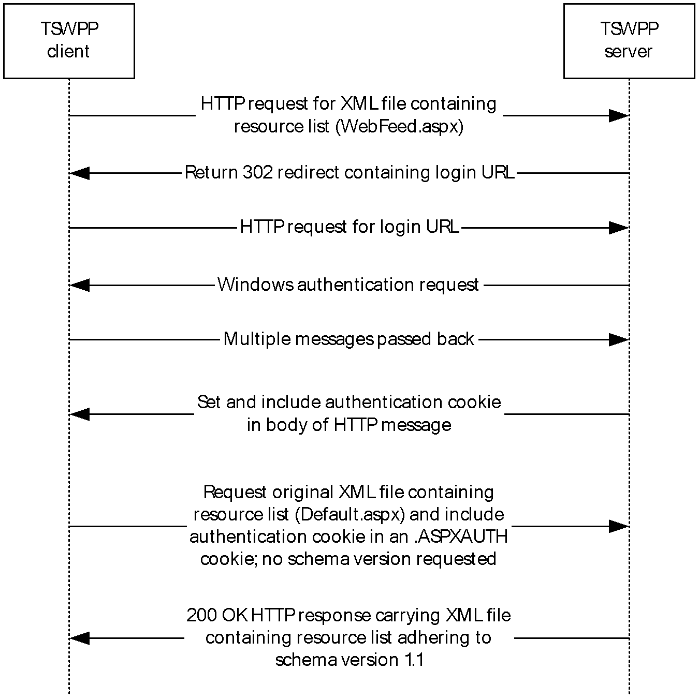
Figure 2: Message flow between TSWPP client and TSWPP server on first connection without content negotiation
In the above figure, the TSWPP client MUST send an HTTP request for the XML file containing the resource list. The XML resource list MUST conform to the XML schema (XSD) for messages that are sent from a TSWPP server to a TSWPP client as specified in section 2.2.1.
Because the TSWPP client did not include the .ASPXAUTH cookie in its request, the client is not authenticated and the server SHOULD send a 302 redirect code with the login URL for the client to authenticate. If the client receives the 302 packet from the server, the client MUST send an HTTP request to the login URL provided by the server.
The server SHOULD then redirect the client to the login URL. This login URL SHOULD initiate the authentication process, and this process SHOULD be achieved using the Simple and Protected GSS-API Negotiation Mechanism (SPNEGO)-based Kerberos and the NT LAN Manager (NTLM) Authentication Protocol over HTTP, as specified in [RFC4559]. For more information about the authentication process, see [NTLM].
The specific authentication mechanism is negotiated between the server and the client, and therefore results in multiple messages being passed between the client and server to complete authentication as defined in [RFC4559].
The authentication cookie SHOULD be obtained in the initial request to the server and MUST be carried in the HTTP message body, as specified in [RFC7230] and [RFC2109]. If the server provides an authentication cookie in the previous step, the authentication cookie is treated as an opaque binary large object (BLOB) and MUST be sent by the client to the server in all subsequent requests and MUST be carried in the HTTP message headers, as specified in [RFC7230] and [RFC2109].
If the client does not request that the resource list adhere to a specific version of the XML schema, the server SHOULD return a version of the resource list adhering to schema version 1.1.

With Content Negotiation
The message flow between a TSWPP client and TSWPP server on the first connection with content negotiation is shown in the following figure.
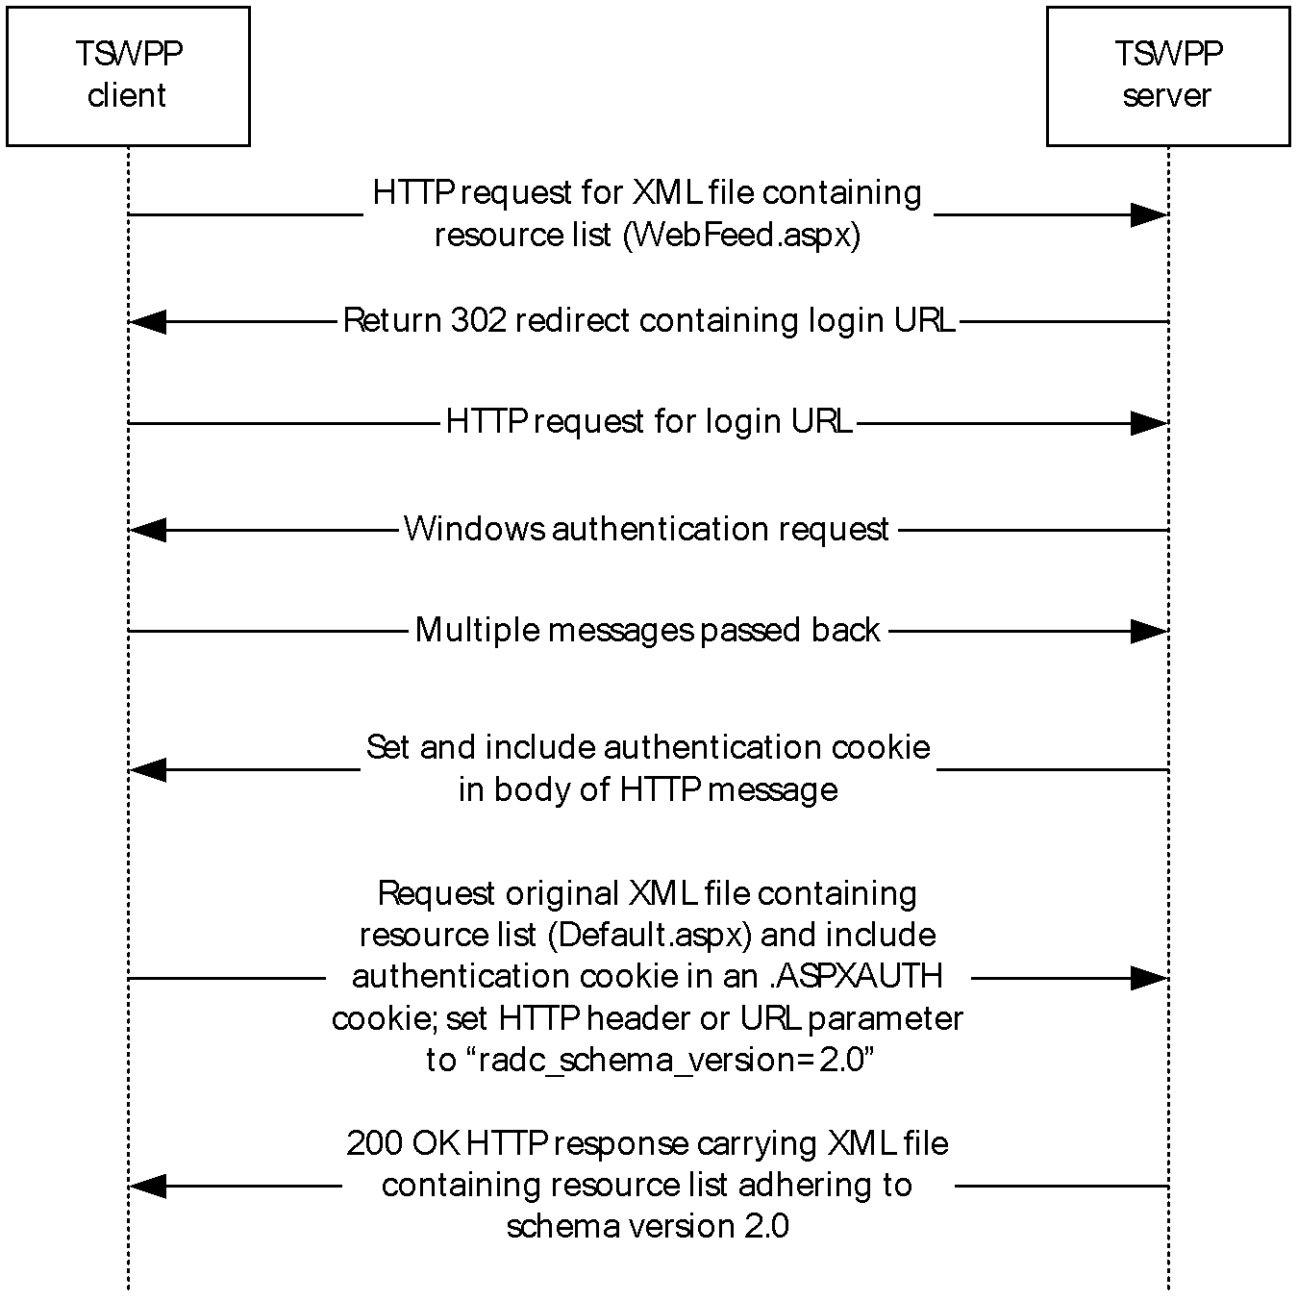
Figure 3: Message flow between TSWPP client and TSWPP server on first connection with content negotiation
The message flow proceeds as in section 3.1.5.1 until the final round of communication between the client and the server in the figure.
If the client requests that the server return a copy of the resource list adhering to schema version 2.0, as defined in section 2.2.5, and if the server is capable of returning a copy of the resource list adhering to schema version 2.0, the server SHOULD return a resource list that adheres to that schema version. Otherwise, the server MUST return a copy of the resource list adhering to schema version 1.1.

Message Flow for Subsequent Requests

Without Content Negotiation
The message flow between a client and server on subsequent requests for the XML file containing the resource list, without content negotiation, is shown in the following figure.
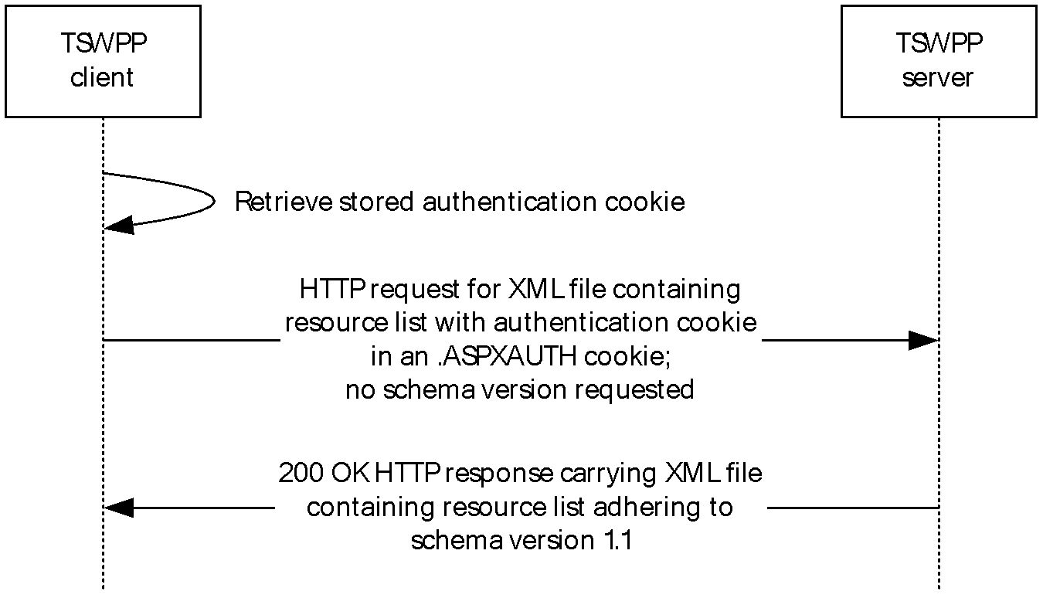
Figure 4: Message flow between TSWPP client and TSWPP server on subsequent requests without content negotiation
In the preceding figure, the TSWPP client has already obtained the .ASPXAUTH cookie shown in section 3.1.5.1.1. This cookie is set in the HTTP request header (section 2.2.3) and the XML file containing the resource list is requested. No schema version is requested by the client.
When no schema version is requested, the XML resource list SHOULD conform to the XML schema (XSD) version 1.1 for messages that are sent from a TSWPP server to a TSWPP client as specified in section 2.2.1.1.
If the server provides a cookie authentication mechanism, the server SHOULD authenticate the user's access by using the .ASPXAUTH cookie (section 3.3.1.1) and MUST return the XML file to the client.

With Content Negotiation
The message flow between a client and a server on subsequent requests for the XML file containing the resource list, with content negotiation, is shown in the following figure.
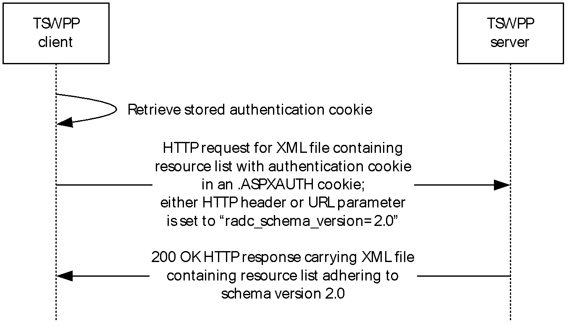
Figure 5: Message flow between TSWPP client and TSWPP server on subsequent requests with content negotiation
In the preceding figure, the TSWPP client has already obtained the .ASPXAUTH cookie as shown in section 3.1.5.2.1. This cookie is set in the HTTP request header (section 2.2.3) and the XML file containing the resource list is requested.
The client requests that the server generate a resource list adhering to the XML schema version 2.0 by specifying the parameter "radc_schema_version=2.0" as either an HTTP Header or as an URL parameter (section 2.2.5).
When the client requests that the resource list adhere to a schema version, the server SHOULD return an XML resource list conforming to XML schema (XSD) version 2.0 as specified in section 2.2.1.
If the server provides a cookie authentication mechanism, the server SHOULD authenticate the user's access by using the .ASPXAUTH cookie (section 3.3.1.1) and MUST return the XML file to the client.

Message Flow for Icon and Resource File Requests
The message flow between a client and a server for requests for icon and resource file URLs that were specified in the XML file containing the resource list is shown in the following diagram. Icon and resource file URLs are specified in the XML schema definitions for <Icon> elements (section 2.2.2.1.6) and the <ResourceFile> element (section 2.2.2.1.9).
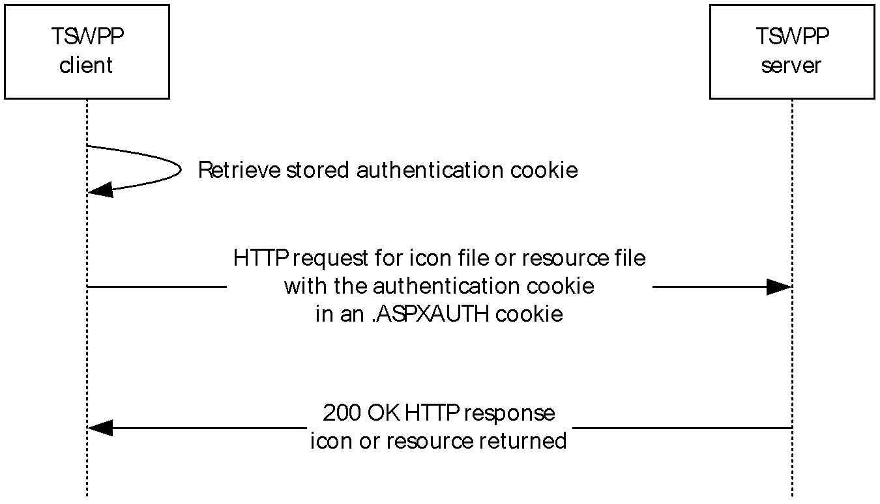
Figure 6: Message flow between TSWPP client and TSWPP server on requests for icon and resource file URLs
In the preceding figure, the XML file containing the list of resources has already been downloaded. The client is downloading the resource files and icon files that are defined in the XML file.
If the server provided an authentication cookie, the client MUST set the .ASPXAUTH cookie and the client MUST request the resource and icon files by using the resources that were returned in the XML file.
If the requested resource or icon does not exist, the server MUST return an HTTP "404 Not Found" error code [RFC7230].

Timer Events
None.

Other Local Events
None.

Client Details

Abstract Data Model
This section describes a conceptual model of possible data organization that an implementation maintains to participate in this protocol. The described organization is provided to facilitate the explanation of how the protocol behaves. This document does not mandate that implementations adhere to this model as long as their external behavior is consistent with that described in this document.

Timers
None.

Initialization
None.

Higher-Layer Triggered Events
None.

Message Processing Events and Sequencing Rules
The only sequence rule is that the client initiates a request for an XML file (section 3.1.1.2).
The client can request the resources that are described in the XML file in separate HTTP requests (section 2.1), and the order of those requests is not significant.

Timer Events
None.

Other Local Events
None.

Server Details

Abstract Data Model
This section describes a conceptual model of possible data organization that an implementation maintains to participate in this protocol. The described organization is provided to facilitate the explanation of how the protocol behaves. This document does not mandate that implementations adhere to this model as long as their external behavior is consistent with that described in this document.

Authentication Cookie
When a TSWPP client first connects to the TSWPP server, an authentication cookie is transmitted to the client, as specified in section 3.1. This cookie contains information to authenticate a user to the server, as well as the security identifier (SID), as defined in [MS-DTYP] section 2.4.2, for the user that originally authenticated to the server.

Timers
None.

Initialization
None.

Higher-Layer Triggered Events
The TSWPP server SHOULD be implemented so that changing a resource triggers the update of an XML resource list that contains that resource. How this event is triggered is implementation-specific, and it depends on how the server obtains data about resources that are being included in XML resource lists.

Message Processing Events and Sequencing Rules
When a client makes a request for an XML file, the server returns the XML file containing the resources. The set of resource elements contained in the XML file (section 3.1.1.2) are determined entirely by the identity of the user making the request. If the server is unable to provide the requested file to the client, the server returns an HTTP "404 Not Found" error code [RFC7230].

Timer Events
None.

Other Local Events
None.

Protocol Examples

Schema Version 1.1 Examples

Message with One Hosting Terminal Server
The following is an example of a message adhering to schema version 1.1 that specifies only one <HostingTerminalServer> element.
<?xml version="1.0" encoding="utf-8"?>
<ResourceCollection PubDate="2010-09-02T22:22:25.295284Z" SchemaVersion="1.1" xmlns="http://schemas.microsoft.com/ts/2007/05/tswf">
<Publisher LastUpdated="2010-09-02T22:22:25.295284Z" Name="Remote Desktop Services Default Connection" ID="examplehost.exampledomain" Description="">
<Resources>
<Resource ID="daecc587f26279f5626ba992a9c5842b04f3c1ac" Alias="calc-TestAppCollection-CmsRdsh" Title="Calculator" LastUpdated="2010-09-02T22:22:25.2796622Z" Type="RemoteApp">
<Icons>
<IconRaw FileType="Ico" FileURL="/RDWeb/Pages/rdp/calc-TestAppCollection-CmsRdsh.ico" />
<Icon32 Dimensions="32x32" FileType="Png" FileURL="/RDWeb/Pages/rdp/calc-TestAppCollection-CmsRdsh_32x32.png" />
</Icons>
<FileExtensions />
<HostingTerminalServers>
<HostingTerminalServer>
<ResourceFile FileExtension=".rdp" URL="/RDWeb/Pages/rdp/examplehost-calc-TestAppCollection-CmsRdsh.rdp" />
<TerminalServerRef Ref="examplehost" />
</HostingTerminalServer>
</HostingTerminalServers>
</Resource>
<Resource ID="48765b62a141dda2f1f4ae3465d3fa7fc5528c1b" Alias="mspaint-TestAppCollection-CmsRdsh" Title="Paint" LastUpdated="2010-09-02T22:22:25.295284Z" Type="RemoteApp">
<Icons>
<IconRaw FileType="Ico" FileURL="/RDWeb/Pages/rdp/mspaint-TestAppCollection-CmsRdsh.ico" />
<Icon32 Dimensions="32x32" FileType="Png" FileURL="/RDWeb/Pages/rdp/mspaint-TestAppCollection-CmsRdsh_32x32.png" />
</Icons>
<FileExtensions>
<FileExtension Name=".bmp" />
<FileExtension Name=".dib" />
<FileExtension Name=".emf" />
<FileExtension Name=".rle" />
<FileExtension Name=".wmf" />
</FileExtensions>
<HostingTerminalServers>
<HostingTerminalServer>
<ResourceFile FileExtension=".rdp" URL="/RDWeb/Pages/rdp/examplehost-mspaint-TestAppCollection-CmsRdsh.rdp" />
<TerminalServerRef Ref="examplehost" />
</HostingTerminalServer>
</HostingTerminalServers>
</Resource>
<Resource ID="9358b60fd0d1d2f6d170bca9af66efc29e2c3092" Alias="wordpad-TestAppCollection-CmsRdsh" Title="WordPad" LastUpdated="2010-09-02T22:22:25.295284Z" Type="RemoteApp">
<Icons>
<IconRaw FileType="Ico" FileURL="/RDWeb/Pages/rdp/wordpad-TestAppCollection-CmsRdsh.ico" />
<Icon32 Dimensions="32x32" FileType="Png" FileURL="/RDWeb/Pages/rdp/wordpad-TestAppCollection-CmsRdsh_32x32.png" />
</Icons>
<FileExtensions>
<FileExtension Name=".docx" />
<FileExtension Name=".odt" />
<FileExtension Name=".rtf" />
</FileExtensions>
<HostingTerminalServers>
<HostingTerminalServer>
<ResourceFile FileExtension=".rdp" URL="/RDWeb/Pages/rdp/examplehost-wordpad-TestAppCollection-CmsRdsh.rdp" />
<TerminalServerRef Ref="examplehost" />
</HostingTerminalServer>
</HostingTerminalServers>
</Resource>
<Resource ID="be8f309b7755f3b495f98a7075e4e7cd8bb82c3f" Alias="TSRemoteDesktop-TestDesktopCollection-CmsRdsh" Title="Remote Desktop" LastUpdated="2010-09-02T22:22:25.295284Z" Type="Desktop">
<Icons>
<IconRaw FileType="Ico" FileURL="/RDWeb/Pages/rdp/mstsc256.ico" />
<Icon32 Dimensions="32x32" FileType="Png" FileURL="/RDWeb/Pages/rdp/mstsc256_32x32.png" />
</Icons>
<FileExtensions />
<HostingTerminalServers>
<HostingTerminalServer>
<ResourceFile FileExtension=".rdp" URL="/RDWeb/Pages/rdp/examplehost-TSRemoteDesktop-TestDesktopCollection-CmsRdsh.rdp" />
<TerminalServerRef Ref="examplehost" />
</HostingTerminalServer>
</HostingTerminalServers>
</Resource>
</Resources>
<TerminalServers>
<TerminalServer ID="examplehost" Name="examplehost" LastUpdated="2010-09-02T22:22:25.295284Z" />
</TerminalServers>
</Publisher>
</ResourceCollection>

Message with Multiple Terminal Servers
The following is an example of a message adhering to schema version 1.1 that specifies multiple <HostingTerminalServer> elements.
<?xml version="1.0" encoding="utf-8" ?>
<ResourceCollection PubDate="2008-08-09T21:04:44.4216774Z"
SchemaVersion="1.0" xmlns="http://schemas.microsoft.com/ts/2007/05/tswf">
<Publisher LastUpdated="2008-08-09T21:04:30.0467694Z" Name="TSWF Default
Publisher" ID="C5DBDC2D-AED2-3871-5216-B4B26E523DAC" Description="A test
publisher">
<Resources>
<Resource ID="6e4514834a0969aaa34b36149a6e5db453a4347e"
Alias="wmplayer-examplehost2-VmFarm" Title="Windows Media Player"
LastUpdated="2008-08-09T21:04:29.9842698Z" Type="RemoteApp">
<Icons>
<IconRaw FileType="Ico" FileURL="/TS/images/wmplayer-examplehost2-
VmFarm032x32.ico" />
<Icon32 Dimensions="32x32" FileType="Png" FileURL="/TS/images/wmplayer-
examplehost2-VmFarm032x32.png" />
</Icons>
<FileExtensions />
<HostingTerminalServers>
<HostingTerminalServer>
<ResourceFile FileExtension=".rdp" URL="/TS/images/EXAMPLEHOST2-wmplayer-
kl-testbed4-VmFarm.rdp" />
<TerminalServerRef Ref=" EXAMPLEHOST2" />
</HostingTerminalServer>
</HostingTerminalServers>
</Resource>
<Resource ID="95c33f5c2e9042e18e046c7fae8248fa91a8c399" Alias="dfrgui-examplehost2-VmFarm" Title="Disk Defragmenter" LastUpdated="2008-08-
09T21:04:29.9842698Z" Type="RemoteApp">
<Icons>
<IconRaw FileType="Ico" FileURL="/TS/images/dfrgui-kl-testbed4-
VmFarm032x32.ico" />
<Icon32 Dimensions="32x32" FileType="Png" FileURL="/TS/images/dfrgui-examplehost2-VmFarm032x32.png" />
</Icons>
<FileExtensions />
<HostingTerminalServers>
<HostingTerminalServer>
<ResourceFile FileExtension=".rdp" URL="/TS/images/EXAMPLEHOST2-dfrgui-
examplehost2-VmFarm.rdp" />
<TerminalServerRef Ref="EXAMPLEHOST2" />
</HostingTerminalServer>
</HostingTerminalServers>
</Resource>
<Resource ID="e7692debcdcabebfa3acfe0de2c84cfa05e5b18e" Alias="cleanmgr-examplehost2-VmFarm" Title="Disk Cleanup" LastUpdated="2008-08-
09T21:04:29.9998947Z" Type="RemoteApp">
<Icons>
<IconRaw FileType="Ico" FileURL="/TS/images/cleanmgr-examplehost2-
VmFarm032x32.ico" />
<Icon32 Dimensions="32x32" FileType="Png" FileURL="/TS/images/cleanmgr-
examplehost2-VmFarm032x32.png" />
</Icons>
<FileExtensions />
<HostingTerminalServers>
<HostingTerminalServer>
<ResourceFile FileExtension=".rdp" URL="/TS/images/EXAMPLEHOST2-cleanmgr-
examplehost2-VmFarm.rdp" />
<TerminalServerRef Ref="EXAMPLEHOST2" />
</HostingTerminalServer>
</HostingTerminalServers>
</Resource>
<Resource ID="aa8cfd93a7028f13b1c6e0579923f824ea9f0cbf"
Alias="TSRemoteDesktop-localhost-VmFarm" Title="Remote Desktop"
LastUpdated="2008-08-09T21:04:30.0155196Z" Type="RemoteApp">
<Icons>
<IconRaw FileType="Ico" FileURL="/TS/images/TSRemoteDesktop-localhost-
VmFarm32x32.ico" />
<Icon32 Dimensions="32x32" FileType="Png"
FileURL="/TS/images/mstsc25632x32.png" />
</Icons>
<FileExtensions />
<HostingTerminalServers>
<HostingTerminalServer>
<ResourceFile FileExtension=".rdp" URL="/TS/images/EXAMPLEHOST1-
TSRemoteDesktop-localhost-VmFarm.rdp" />
<TerminalServerRef Ref="EXAMPLEHOST1" />
</HostingTerminalServer>
</HostingTerminalServers>
</Resource>
<Resource ID="ed04af6be1cc8fe836bbb136dbe61f07162551e9" Alias="wordpad-
localhost-VmFarm" Title="WordPad" LastUpdated="2008-08-
09T21:04:30.0155196Z" Type="RemoteApp">
<Icons>
<IconRaw FileType="Ico" FileURL="/TS/images/wordpad-localhost-
VmFarm032x32.ico" />
<Icon32 Dimensions="32x32" FileType="Png" FileURL="/TS/images/wordpad-
localhost-VmFarm032x32.png" />
</Icons>
<FileExtensions />
<HostingTerminalServers>
<HostingTerminalServer>
<ResourceFile FileExtension=".rdp" URL="/TS/images/EXAMPLEHOST1-wordpad-
localhost-VmFarm.rdp" />
<TerminalServerRef Ref="EXAMPLEHOST1" />
</HostingTerminalServer>
</HostingTerminalServers>
</Resource>
<Resource ID="5c97c0e4e29031e123965236f9d0385f863faa9a" Alias="mspaint
(1)-localhost-VmFarm" Title="Paint" LastUpdated="2008-08-
09T21:04:30.0311445Z" Type="RemoteApp">
<Icons>
<IconRaw FileType="Ico" FileURL="/TS/images/mspaint__1_-localhost-
VmFarm032x32.ico" />
<Icon32 Dimensions="32x32" FileType="Png"
FileURL="/TS/images/mspaint__1_-localhost-VmFarm032x32.png" />
</Icons>
<FileExtensions />
<HostingTerminalServers>
<HostingTerminalServer>
<ResourceFile FileExtension=".rdp" URL="/TS/images/EXAMPLEHOST1-
mspaint_(1_-localhost-VmFarm.rdp" />
<TerminalServerRef Ref="EXAMPLEHOST1" />
</HostingTerminalServer>
</HostingTerminalServers>
</Resource>
<Resource ID="34cf1eb036041f5e31c20cb569e9125b8fdc4edb"
Alias="CompMgmtLauncher-localhost-VmFarm" Title="Server Manager"
LastUpdated="2008-08-09T21:04:30.0467694Z" Type="RemoteApp">
<Icons>
<IconRaw FileType="Ico" FileURL="/TS/images/CompMgmtLauncher-localhost-
VmFarm032x32.ico" />
<Icon32 Dimensions="32x32" FileType="Png"
FileURL="/TS/images/CompMgmtLauncher-localhost-VmFarm032x32.png" />
</Icons>
<FileExtensions />
<HostingTerminalServers>
<HostingTerminalServer>
<ResourceFile FileExtension=".rdp" URL="/TS/images/EXAMPLEHOST1-
CompMgmtLauncher-localhost-VmFarm.rdp" />
<TerminalServerRef Ref="EXAMPLEHOST1" />
</HostingTerminalServer>
</HostingTerminalServers>
</Resource>
<Resource ID="35a43a391cb9654cfd2c5b6d732fd054667e2fc6" Alias="calc-
localhost-VmFarm" Title="Calculator" LastUpdated="2008-08-
09T21:04:30.0467694Z" Type="RemoteApp">
<Icons>
<IconRaw FileType="Ico" FileURL="/TS/images/calc-localhost-
VmFarm032x32.ico" />
<Icon32 Dimensions="32x32" FileType="Png" FileURL="/TS/images/calc-
localhost-VmFarm032x32.png" />
</Icons>
<FileExtensions />
<HostingTerminalServers>
<HostingTerminalServer>
<ResourceFile FileExtension=".rdp" URL="/TS/images/EXAMPLEHOST1-calc-
localhost-VmFarm.rdp" />
<TerminalServerRef Ref="EXAMPLEHOST1" />
</HostingTerminalServer>
</HostingTerminalServers>
</Resource>
</Resources>
<TerminalServers>
<TerminalServer ID="EXAMPLEHOST1" Name="EXAMPLEHOST1.exampledomain" LastUpdated="2008-08-
09T21:04:30.0467694Z">
</TerminalServer>
<TerminalServer ID="EXAMPLEHOST1" Name="EXAMPLEHOST2.exampledomain" LastUpdated="2008-08-
09T21:04:30.0467694Z">
</TerminalServer>
</TerminalServers>
</Publisher>
</ResourceCollection>

Schema Version 2.0 Examples

Message with One Hosting Terminal Server
The following is an example of a message adhering to schema version 2.0 that specifies only one <HostingTerminalServer> element.
<?xml version="1.0" encoding="utf-8"?>
<ResourceCollection PubDate="2010-09-02T22:49:50.4818001Z" SchemaVersion="2.0" xmlns="http://schemas.microsoft.com/ts/2007/05/tswf">
<Publisher LastUpdated="2010-09-02T22:22:25.295284Z" Name="Remote Desktop Services Default Connection" ID="examplehost.exampledomain" Description="" SupportsReconnect="true">
<Resources>
<Resource ID="daecc587f26279f5626ba992a9c5842b04f3c1ac" Alias="calc-TestAppCollection-CmsRdsh" Title="Calculator" LastUpdated="2010-09-02T22:22:25.2796622Z" Type="RemoteApp">
<Icons>
<IconRaw FileType="Ico" FileURL="/RDWeb/Pages/rdp/calc-TestAppCollection-CmsRdsh.ico" />
<Icon32 Dimensions="32x32" FileType="Png" FileURL="/RDWeb/Pages/rdp/calc-TestAppCollection-CmsRdsh_32x32.png" />
</Icons>
<FileExtensions />
<Folders>
<Folder Name="Utility" />
</Folders>
<HostingTerminalServers>
<HostingTerminalServer>
<ResourceFile FileExtension=".rdp" URL="/RDWeb/Pages/rdp/examplehost-calc-TestAppCollection-CmsRdsh.rdp" />
<TerminalServerRef Ref="examplehost" />
</HostingTerminalServer>
</HostingTerminalServers>
</Resource>
<Resource ID="48765b62a141dda2f1f4ae3465d3fa7fc5528c1b" Alias="mspaint-TestAppCollection-CmsRdsh" Title="Paint" LastUpdated="2010-09-02T22:22:25.295284Z" Type="RemoteApp">
<Icons>
<IconRaw FileType="Ico" FileURL="/RDWeb/Pages/rdp/mspaint-TestAppCollection-CmsRdsh.ico" />
<Icon32 Dimensions="32x32" FileType="Png" FileURL="/RDWeb/Pages/rdp/mspaint-TestAppCollection-CmsRdsh_32x32.png" />
</Icons>
<FileExtensions>
<FileExtension Name=".bmp" PrimaryHandler="True">
<FileAssociationIcons>
<IconRaw FileType="Ico" FileURL="/RDWeb/Pages/rdp/fileassoc/.bmp/mspaint-TestAppCollection-CmsRdsh.ico" />
</FileAssociationIcons>
</FileExtension>
<FileExtension Name=".dib" PrimaryHandler="True">
<FileAssociationIcons>
<IconRaw FileType="Ico" FileURL="/RDWeb/Pages/rdp/fileassoc/.dib/mspaint-TestAppCollection-CmsRdsh.ico" />
</FileAssociationIcons>
</FileExtension>
<FileExtension Name=".emf" PrimaryHandler="True">
<FileAssociationIcons>
<IconRaw FileType="Ico" FileURL="/RDWeb/Pages/rdp/fileassoc/.emf/mspaint-TestAppCollection-CmsRdsh.ico" />
</FileAssociationIcons>
</FileExtension>
<FileExtension Name=".rle" PrimaryHandler="True">
<FileAssociationIcons>
<IconRaw FileType="Ico" FileURL="/RDWeb/Pages/rdp/fileassoc/.rle/mspaint-TestAppCollection-CmsRdsh.ico" />
</FileAssociationIcons>
</FileExtension>
<FileExtension Name=".wmf" PrimaryHandler="True">
<FileAssociationIcons>
<IconRaw FileType="Ico" FileURL="/RDWeb/Pages/rdp/fileassoc/.wmf/mspaint-TestAppCollection-CmsRdsh.ico" />
</FileAssociationIcons>
</FileExtension>
</FileExtensions>
<HostingTerminalServers>
<HostingTerminalServer>
<ResourceFile FileExtension=".rdp" URL="/RDWeb/Pages/rdp/examplehost-mspaint-TestAppCollection-CmsRdsh.rdp" />
<TerminalServerRef Ref="examplehost" />
</HostingTerminalServer>
</HostingTerminalServers>
</Resource>
<Resource ID="9358b60fd0d1d2f6d170bca9af66efc29e2c3092" Alias="wordpad-TestAppCollection-CmsRdsh" Title="WordPad" LastUpdated="2010-09-02T22:22:25.295284Z" Type="RemoteApp">
<Icons>
<IconRaw FileType="Ico" FileURL="/RDWeb/Pages/rdp/wordpad-TestAppCollection-CmsRdsh.ico" />
<Icon32 Dimensions="32x32" FileType="Png" FileURL="/RDWeb/Pages/rdp/wordpad-TestAppCollection-CmsRdsh_32x32.png" />
</Icons>
<FileExtensions>
<FileExtension Name=".docx" PrimaryHandler="True">
<FileAssociationIcons>
<IconRaw FileType="Ico" FileURL="/RDWeb/Pages/rdp/fileassoc/.docx/wordpad-TestAppCollection-CmsRdsh.ico" />
</FileAssociationIcons>
</FileExtension>
<FileExtension Name=".odt" PrimaryHandler="True">
<FileAssociationIcons>
<IconRaw FileType="Ico" FileURL="/RDWeb/Pages/rdp/fileassoc/.odt/wordpad-TestAppCollection-CmsRdsh.ico" />
</FileAssociationIcons>
</FileExtension>
<FileExtension Name=".rtf" PrimaryHandler="True">
<FileAssociationIcons>
<IconRaw FileType="Ico" FileURL="/RDWeb/Pages/rdp/fileassoc/.rtf/wordpad-TestAppCollection-CmsRdsh.ico" />
</FileAssociationIcons>
</FileExtension>
</FileExtensions>
<HostingTerminalServers>
<HostingTerminalServer>
<ResourceFile FileExtension=".rdp" URL="/RDWeb/Pages/rdp/examplehost-wordpad-TestAppCollection-CmsRdsh.rdp" />
<TerminalServerRef Ref="examplehost" />
</HostingTerminalServer>
</HostingTerminalServers>
</Resource>
<Resource ID="be8f309b7755f3b495f98a7075e4e7cd8bb82c3f" Alias="TSRemoteDesktop-TestDesktopCollection-CmsRdsh" Title="Remote Desktop" LastUpdated="2010-09-02T22:22:25.295284Z" Type="Desktop">
<Icons>
<IconRaw FileType="Ico" FileURL="/RDWeb/Pages/rdp/mstsc256.ico" />
<Icon32 Dimensions="32x32" FileType="Png" FileURL="/RDWeb/Pages/rdp/mstsc256_32x32.png" />
</Icons>
<FileExtensions />
<HostingTerminalServers>
<HostingTerminalServer>
<ResourceFile FileExtension=".rdp" URL="/RDWeb/Pages/rdp/examplehost-TSRemoteDesktop-TestDesktopCollection-CmsRdsh.rdp" />
<TerminalServerRef Ref="examplehost" />
</HostingTerminalServer>
</HostingTerminalServers>
</Resource>
</Resources>
<TerminalServers>
<TerminalServer ID="examplehost" Name="examplehost.exampledomain" LastUpdated="2010-09-02T22:22:25.295284Z" />
</TerminalServers>
</Publisher>
</ResourceCollection>

Message with Subfolders and Display Folder
The following is an example of a message adhering to schema version 2.0 that specifies a DisplayFolder attribute and a <SubFolders> element.
<?xml version="1.0" encoding="utf-8"?>
<ResourceCollection
PubDate="2011-06-17T19:04:10.5016737Z"
SchemaVersion="2.0" xmlns="http://schemas.microsoft.com/ts/2007/05/tswf">
<Publisher
LastUpdated="2011-06-17T19:03:31.5149404Z"
Name="Example Connection"
ID="examplehost.exampledomain"
Description=""
SupportsReconnect="true"
DisplayFolder="/">
<SubFolders>
<Folder
Name="/Utility" />
<Folder
Name="/System tools" />
</SubFolders>
<Resources>
<Resource
ID="e13cf7ba28237d579452c939bf0ce33157b2effb"
Alias="wordpad-Remote-CmsRdsh"
Title="WordPad"
LastUpdated="2011-06-17T19:03:31.5149404Z"
Type="RemoteApp">
<Icons>
<IconRaw
FileType="Ico"
FileURL="/RDWeb/Pages/rdp/wordpad-Remote-CmsRdsh.ico" />
<Icon32
Dimensions="32x32"
FileType="Png"
FileURL="/RDWeb/Pages/rdp/wordpad-Remote-CmsRdsh_32x32.png" />
</Icons>
<FileExtensions />
<Folders>
<Folder
Name="/" />
</Folders>
<HostingTerminalServers>
<HostingTerminalServer>
<ResourceFile
FileExtension=".rdp"
URL="/RDWeb/Pages/rdp/examplehost.exampledomain-wordpad-Remote-CmsRdsh.rdp" />
<TerminalServerRef
Ref="examplehost.exampledomain" />
</HostingTerminalServer>
</HostingTerminalServers>
</Resource>
</Resources>
<TerminalServers>
<TerminalServer
ID="examplehost.exampledomain"
Name="examplehost.exampledomain"
LastUpdated="2011-06-17T19:03:31.5149404Z" />
</TerminalServers>
</Publisher>
</ResourceCollection>

Message with Multiple Folders and No Display Folder
The following is an example of a message adhering to schema version 2.0 that does not specify a DisplayFolder attribute, but does have multiple folders containing resources and some resources that are contained in multiple folders.
<?xml version="1.0" encoding="utf-8"?>
<ResourceCollection
PubDate="2011-06-17T20:10:46.6550408Z"
SchemaVersion="2.0" xmlns="http://schemas.microsoft.com/ts/2007/05/tswf">
<Publisher
LastUpdated="2011-06-17T20:10:13.17941Z"
Name="Example Connection"
ID="examplehost.exampledomain"
Description=""
SupportsReconnect="true">
<Resources>
<Resource
ID="3572b2f082b9081a91c406b8c74f3559eebe2613"
Alias="calc-Remote-CmsRdsh"
Title="Calculator"
LastUpdated="2011-06-17T20:10:13.1744096Z"
Type="RemoteApp">
<Icons>
<IconRaw
FileType="Ico"
FileURL="/RDWeb/Pages/rdp/calc-Remote-CmsRdsh.ico" />
<Icon32
Dimensions="32x32"
FileType="Png"
FileURL="/RDWeb/Pages/rdp/calc-Remote-CmsRdsh_32x32.png" />
</Icons>
<FileExtensions />
<Folders>
<Folder
Name="/Utility" />
</Folders>
<HostingTerminalServers>
<HostingTerminalServer>
<ResourceFile
FileExtension=".rdp"
URL="/RDWeb/Pages/rdp/examplehost.exampledomain-calc-Remote-CmsRdsh.rdp" />
<TerminalServerRef
Ref="examplehost.exampledomain" />
</HostingTerminalServer>
</HostingTerminalServers>
</Resource>
<Resource
ID="294ec54b83ccc5a80343f600c37aa5765a8deaf2"
Alias="mspaint-Remote-CmsRdsh"
Title="Paint"
LastUpdated="2011-06-17T20:10:13.1764105Z"
Type="RemoteApp">
<Icons>
<IconRaw
FileType="Ico"
FileURL="/RDWeb/Pages/rdp/mspaint-Remote-CmsRdsh.ico" />
<Icon32
Dimensions="32x32"
FileType="Png"
FileURL="/RDWeb/Pages/rdp/mspaint-Remote-CmsRdsh_32x32.png" />
</Icons>
<FileExtensions />
<Folders>
<Folder
Name="/Utility" />
</Folders>
<HostingTerminalServers>
<HostingTerminalServer>
<ResourceFile
FileExtension=".rdp"
URL="/RDWeb/Pages/rdp/examplehost.exampledomain-mspaint-Remote-CmsRdsh.rdp" />
<TerminalServerRef
Ref="examplehost.exampledomain" />
</HostingTerminalServer>
</HostingTerminalServers>
</Resource>
<Resource
ID="0776bf31f519bd7f3456f9ff631d2c6709484aed"
Alias="msconfig-Remote-CmsRdsh"
Title="System Configuration"
LastUpdated="2011-06-17T20:10:13.1754104Z"
Type="RemoteApp">
<Icons>
<IconRaw
FileType="Ico"
FileURL="/RDWeb/Pages/rdp/msconfig-Remote-CmsRdsh.ico" />
<Icon32
Dimensions="32x32"
FileType="Png"
FileURL="/RDWeb/Pages/rdp/msconfig-Remote-CmsRdsh_32x32.png" />
</Icons>
<FileExtensions />
<Folders>
<Folder
Name="/System tools" />
</Folders>
<HostingTerminalServers>
<HostingTerminalServer>
<ResourceFile
FileExtension=".rdp"
URL="/RDWeb/Pages/rdp/examplehost.exampledomain-msconfig-Remote-CmsRdsh.rdp" />
<TerminalServerRef
Ref="examplehost.exampledomain" />
</HostingTerminalServer>
</HostingTerminalServers>
</Resource>
<Resource
ID="bbad20436e5237b6e2789b1eee200518920c06d5"
Alias="powershell-Remote-CmsRdsh"
Title="Windows PowerShell"
LastUpdated="2011-06-17T20:10:13.1774102Z"
Type="RemoteApp">
<Icons>
<IconRaw
FileType="Ico"
FileURL="/RDWeb/Pages/rdp/powershell-Remote-CmsRdsh.ico" />
<Icon32
Dimensions="32x32"
FileType="Png"
FileURL="/RDWeb/Pages/rdp/powershell-Remote-CmsRdsh_32x32.png" />
</Icons>
<FileExtensions />
<Folders>
<Folder
Name="/" />
<Folder
Name="/System tools" />
<Folder
Name="/Utility" />
</Folders>
<HostingTerminalServers>
<HostingTerminalServer>
<ResourceFile
FileExtension=".rdp"
URL="/RDWeb/Pages/rdp/examplehost.exampledomain-powershell-Remote-CmsRdsh.rdp" />
<TerminalServerRef
Ref="examplehost.exampledomain" />
</HostingTerminalServer>
</HostingTerminalServers>
</Resource>
<Resource
ID="e13cf7ba28237d579452c939bf0ce33157b2effb"
Alias="wordpad-Remote-CmsRdsh"
Title="WordPad"
LastUpdated="2011-06-17T20:10:13.1784095Z"
Type="RemoteApp">
<Icons>
<IconRaw
FileType="Ico"
FileURL="/RDWeb/Pages/rdp/wordpad-Remote-CmsRdsh.ico" />
<Icon32
Dimensions="32x32"
FileType="Png"
FileURL="/RDWeb/Pages/rdp/wordpad-Remote-CmsRdsh_32x32.png" />
</Icons>
<FileExtensions />
<Folders>
<Folder
Name="/" />
</Folders>
<HostingTerminalServers>
<HostingTerminalServer>
<ResourceFile
FileExtension=".rdp"
URL="/RDWeb/Pages/rdp/examplehost.exampledomain-wordpad-Remote-CmsRdsh.rdp" />
<TerminalServerRef
Ref="examplehost.exampledomain" />
</HostingTerminalServer>
</HostingTerminalServers>
</Resource>
<Resource
ID="d6cf42c8757f9cecac42f4bce3ff2cef5a6d6188"
Alias="Remote-Remote-CmsRdsh"
Title="Remote"
LastUpdated="2011-06-17T20:10:13.17941Z"
Type="Desktop">
<Icons>
<IconRaw
FileType="Ico"
FileURL="/RDWeb/Pages/rdp/mstsc256.ico" />
<Icon32
Dimensions="32x32"
FileType="Png"
FileURL="/RDWeb/Pages/rdp/mstsc256_32x32.png" />
</Icons>
<FileExtensions />
<HostingTerminalServers>
<HostingTerminalServer>
<ResourceFile
FileExtension=".rdp"
URL="/RDWeb/Pages/rdp/examplehost.exampledomain-Remote-Remote-CmsRdsh.rdp" />
<TerminalServerRef
Ref="examplehost.exampledomain" />
</HostingTerminalServer>
</HostingTerminalServers>
</Resource>
</Resources>
<TerminalServers>
<TerminalServer
ID="examplehost.exampledomain"
Name="examplehost.exampledomain"
LastUpdated="2011-06-17T20:10:13.17941Z" />
</TerminalServers>
</Publisher>
</ResourceCollection>

.ASPXAUTH Cookie Message Returned from the Server
The following is an example of the .ASPXAUTH cookie that is returned from the server after the server has authorized the user for access. The contents of the cookie are then set as a cookie, in the client's responses, with the name of .ASPXAUTH.
HTTP/1.1 200 OK
Cache-Control: private
Content-Type: application/x-msts-webfeed-login; charset=utf-8
Server: Microsoft-IIS/7.5
X-AspNet-Version: 2.0.50727
Persistent-Auth: true
X-Powered-By: ASP.NET
Date: Thu, 11 Mar 2010 00:51:13 GMT
Content-Length: 384

Note The contents of a server-generated cookie are as defined in section 2.2.3

Security

Security Considerations for Implementers
None.

Index of Security Parameters
None.

Appendix A: Product Behavior
The information in this specification is applicable to the following Microsoft products or supplemental software. References to product versions include released service packs.
- Windows 7 operating system
- Windows 8 operating system
- Windows Server 2008 R2 operating system
- Windows Server 2012 operating system
- Windows Server 2012 R2 operating system
- Windows Server 2016 Technical Preview operating system
Exceptions, if any, are noted below. If a service pack or Quick Fix Engineering (QFE) number appears with the product version, behavior changed in that service pack or QFE. The new behavior also applies to subsequent service packs of the product unless otherwise specified. If a product edition appears with the product version, behavior is different in that product edition.
Unless otherwise specified, any statement of optional behavior in this specification that is prescribed using the terms SHOULD or SHOULD NOT implies product behavior in accordance with the SHOULD or SHOULD NOT prescription. Unless otherwise specified, the term MAY implies that the product does not follow the prescription.
<1> Section 1.7: The Windows 7 TSWPP client implementation never requests a specific version of the XML feed from the server.
<2> Section 1.7: The Windows Server 2008 R2 operating system TSWPP server implementation never honors client requests for a specific schema version and always returns an XML feed adhering to schema version 1.1.
<3> Section 1.7: The Windows 7 TSWPP client implementation never requests a specific version of the XML feed from the server.
<4> Section 1.7: The Windows Server 2008 R2 TSWPP server implementation never honors client requests for a specific schema version and always returns an XML feed adhering to schema version 1.1.
<5> Section 2.2.1.4: The Windows Server 2008 R2 TSWPP server implementation always uses the "text/xml" Content-Type.
<6> Section 2.2.2.1.13: The Windows Server 2008 R2 implementation always leaves the <FileExtensions> element empty.
<7> Section 2.2.5: The Windows 7 TSWPP client implementation never requests a specific version of the XML feed from the server.
<8> Section 2.2.5: The Windows Server 2008 R2 TSWPP server implementation never honors client requests for a specific schema version and always returns an XML feed adhering to schema version 1.1.
<9> Section 3.1.1.3: Windows client implementations use the information in icon files in the presentation of the Windows Start menu.
<10> Section 3.1.1.4: The Windows client implementations use the information in resource files in launching remote applications from the Windows Start menu.

Change Tracking
No table of changes is available. The document is either new or has had no changes since its last release.

Index
.

.ASPXAUTH
cookie 26
cookie message returned from server example 46
.aspxauth cookie message returned from the server example 46

A

Abstract data model
client 34
authentication cookie 28
icon files 28
overview (section 3.1.1 28, section 3.2.1 34)
resource files 28
resources 28
XML files 28
server 34
authentication cookie (section 3.1.1.1 28, section 3.3.1.1 35)
icon files 28
overview (section 3.1.1 28, section 3.3.1 34)
resource files 28
resources 28
XML files 28
Applicability 10
ASPXAUTH
cookie 26
cookie message returned from server example 46

C

Capability negotiation 10
Change tracking 49
Client
abstract data model 34
authentication cookie 28
icon files 28
overview (section 3.1.1 28, section 3.2.1 34)
resource files 28
resources 28
XML files 28
higher-layer triggered events 34
initialization 34
local events 34
message flow
for first request
with content negotiation 30
without content negotiation 29
for icon and resource file requests 33
for subsequent requests
with content negotiation 32
without content negotiation 31
message processing 34
overview 28
sequencing rules 34
timer events 34
timers 34
Content negotiation 27
Content-Type - resource list message syntax 20

D

Data model - abstract
client 34
authentication cookie 28
icon files 28
overview (section 3.1.1 28, section 3.2.1 34)
resource files 28
resources 28
XML files 28
server 34
authentication cookie (section 3.1.1.1 28, section 3.3.1.1 35)
icon files 28
overview (section 3.1.1 28, section 3.3.1 34)
resource files 28
resources 28
XML files 28

E

Element definitions
schema version 1.1 21
schema version 2.0 24
Events
local - client 34
local - server 35
timer - client 34
timer - server 35
Examples
.ASPXAUTH cookie message returned from server 46
.aspxauth cookie message returned from the server 46
messages
with multiple terminal servers 37
with one hosting terminal server
schema version 1.1 36
schema version 2.0 40

F

Fields - vendor-extensible 10

G

Glossary 6

H

Higher-layer triggered events
client 34
server 35

I

Implementer - security considerations 47
Index of security parameters 47
Informative references 8
Initialization
client 34
server 35
Introduction 6

L

Local events
client 34
server 35

M

Message processing
client 34
server 35
Messages
.ASPXAUTH cookie 26
content negotiation 27
element definitions
schema version 1.1 21
schema version 2.0 24
flow
for first request
with content negotiation 30
without content negotiation 29
for icon and resource requests 33
for subsequent requests
with content negotiation 32
without content negotiation 31
multiple terminal servers example 37
one hosting terminal server example
schema version 1.1 36
schema version 2.0 40
resource list syntax
Content-Type 20
overview 12
schema version 1.1 12
schema version 2.0 14
resources 26
transport 12

N

Normative references 8

O

Overview (synopsis) 9

P

Parameters - security index 47
Preconditions 10
Prerequisites 10
Product behavior 48

R

References 8
informative 8
normative 8
Relationship to other protocols 10
Resource list syntax
Content-Type 20
overview 12
schema version 1.1 12
schema version 2.0 14

S

Schema version 1.1
element definitions 21
examples - messages
with multiple terminal servers 37
with one hosting terminal server 36
resource list syntax 12
Schema version 2.0
element definitions 24
example - message with one hosting terminal server 40
resource list syntax 14
Security
implementer considerations 47
parameter index 47
Sequencing rules
client 34
server 35
Server
abstract data model 34
authentication cookie (section 3.1.1.1 28, section 3.3.1.1 35)
icon files 28
overview (section 3.1.1 28, section 3.3.1 34)
resource files 28
resources 28
XML files 28
higher-layer triggered events 35
initialization 35
local events 35
message flow
for first request
with content negotiation 30
without content negotiation 29
for icon and resource file requests 33
for subsequent requests
with content negotiation 32
without content negotiation 31
message processing 35
overview 28
sequencing rules 35
timer events 35
timers 35
Standards assignments 11

T

Timer events
client 34
server 35
Timers
client 34
server 35
Tracking changes 49
Transport 12
Triggered events
client 34
server 35

V

Vendor-extensible fields 10
Versioning 10

