[MS-SSEAN]:
Simple Mail Transfer Protocol (SMTP) AUTH Extension for SPNEGO

Intellectual Property Rights Notice for Open Specifications Documentation
- Technical Documentation. Microsoft publishes Open Specifications documentation (“this documentation”) for protocols, file formats, data portability, computer languages, and standards support. Additionally, overview documents cover inter-protocol relationships and interactions.
- Copyrights. This documentation is covered by Microsoft copyrights. Regardless of any other terms that are contained in the terms of use for the Microsoft website that hosts this documentation, you can make copies of it in order to develop implementations of the technologies that are described in this documentation and can distribute portions of it in your implementations that use these technologies or in your documentation as necessary to properly document the implementation. You can also distribute in your implementation, with or without modification, any schemas, IDLs, or code samples that are included in the documentation. This permission also applies to any documents that are referenced in the Open Specifications documentation.
- No Trade Secrets. Microsoft does not claim any trade secret rights in this documentation.
- Patents. Microsoft has patents that might cover your implementations of the technologies described in the Open Specifications documentation. Neither this notice nor Microsoft's delivery of this documentation grants any licenses under those patents or any other Microsoft patents. However, a given Open Specifications document might be covered by the Microsoft Open Specifications Promise or the Microsoft Community Promise. If you would prefer a written license, or if the technologies described in this documentation are not covered by the Open Specifications Promise or Community Promise, as applicable, patent licenses are available by contacting iplg@microsoft.com.
- License Programs. To see all of the protocols in scope under a specific license program and the associated patents, visit the Patent Map.
- Trademarks. The names of companies and products contained in this documentation might be covered by trademarks or similar intellectual property rights. This notice does not grant any licenses under those rights. For a list of Microsoft trademarks, visit www.microsoft.com/trademarks.
- Fictitious Names. The example companies, organizations, products, domain names, email addresses, logos, people, places, and events that are depicted in this documentation are fictitious. No association with any real company, organization, product, domain name, email address, logo, person, place, or event is intended or should be inferred.
Reservation of Rights. All other rights are reserved, and this notice does not grant any rights other than as specifically described above, whether by implication, estoppel, or otherwise.
Tools. The Open Specifications documentation does not require the use of Microsoft programming tools or programming environments in order for you to develop an implementation. If you have access to Microsoft programming tools and environments, you are free to take advantage of them. Certain Open Specifications documents are intended for use in conjunction with publicly available standards specifications and network programming art and, as such, assume that the reader either is familiar with the aforementioned material or has immediate access to it.
Support. For questions and support, please contact dochelp@microsoft.com.
Revision Summary
Date | Revision History | Revision Class | Comments
10/25/2012 | 1.0 | New | Release new document.
1/31/2013 | 1.0 | None | No changes to the meaning, language, or formatting of the technical content.
8/8/2013 | 2.0 | Major | Significantly changed the technical content.
11/14/2013 | 2.0 | None | No changes to the meaning, language, or formatting of the technical content.
2/13/2014 | 2.0 | None | No changes to the meaning, language, or formatting of the technical content.
5/15/2014 | 2.0 | None | No changes to the meaning, language, or formatting of the technical content.
6/30/2015 | 2.0 | None | No changes to the meaning, language, or formatting of the technical content.
10/16/2015 | 2.0 | None | No changes to the meaning, language, or formatting of the technical content.
7/14/2016 | 2.0 | None | No changes to the meaning, language, or formatting of the technical content.
6/1/2017 | 3.0 | Major | Significantly changed the technical content.
9/15/2017 | 4.0 | Major | Significantly changed the technical content.
9/12/2018 | 5.0 | Major | Significantly changed the technical content.
Table of Contents
1 Introduction 4
1.1 Glossary 4
1.2 References 4
1.2.1 Normative References 4
1.2.2 Informative References 5
1.3 Overview 5
1.4 Relationship to Other Protocols 6
1.5 Prerequisites/Preconditions 7
1.6 Applicability Statement 7
1.7 Versioning and Capability Negotiation 7
1.8 Vendor-Extensible Fields 7
1.9 Standards Assignments 7
2 Messages 8
2.1 Transport 8
2.2 Message Syntax 8
2.2.1 SASL Mechanism Name 8
3 Protocol Details 9
3.1 Client Details 9
3.1.1 Abstract Data Model 9
3.1.2 Timers 9
3.1.3 Initialization 9
3.1.4 Higher-Layer Triggered Events 9
3.1.5 Message Processing Events and Sequencing Rules 9
3.1.5.1 Initiating the "GSSAPI" Mechanism 9
3.1.6 Timer Events 9
3.1.7 Other Local Events 9
3.2 Server Details 10
3.2.1 Abstract Data Model 10
3.2.2 Timers 10
3.2.3 Initialization 10
3.2.4 Higher-Layer Triggered Events 10
3.2.5 Message Processing Events and Sequencing Rules 10
3.2.5.1 Receiving an AUTH GSSAPI Command 10
3.2.6 Timer Events 10
3.2.7 Other Local Events 10
4 Protocol Examples 11
4.1 Server Successfully Authenticating Client 11
5 Security 13
5.1 Security Considerations for Implementers 13
5.2 Index of Security Parameters 13
6 Appendix A: Product Behavior 14
7 Change Tracking 16
8 Index 17

Introduction
The Simple Mail Transfer Protocol (SMTP) AUTH Extension for SPNEGO enables SMTP clients and servers to negotiate a mutually supported authentication mechanism by using the Simple and Protected GSS-API Negotiation Mechanism (SPNEGO).
Sections 1.5, 1.8, 1.9, 2, and 3 of this specification are normative. All other sections and examples in this specification are informative.

Glossary
This document uses the following terms:
base64 encoding: A binary-to-text encoding scheme whereby an arbitrary sequence of bytes is converted to a sequence of printable ASCII characters, as described in [RFC4648].
Kerberos: An authentication system that enables two parties to exchange private information across an otherwise open network by assigning a unique key (called a ticket) to each user that logs on to the network and then embedding these tickets into messages sent by the users. For more information, see [MS-KILE].
NT LAN Manager (NTLM) Authentication Protocol: A protocol using a challenge-response mechanism for authentication in which clients are able to verify their identities without sending a password to the server. It consists of three messages, commonly referred to as Type 1 (negotiation), Type 2 (challenge) and Type 3 (authentication). For more information, see [MS-NLMP].
SASL: The Simple Authentication and Security Layer, as described in [RFC2222]. This is an authentication mechanism used by the Lightweight Directory Access Protocol (LDAP).
Simple and Protected GSS-API Negotiation Mechanism (SPNEGO): An authentication mechanism that allows Generic Security Services (GSS) peers to determine whether their credentials support a common set of GSS-API security mechanisms, to negotiate different options within a given security mechanism or different options from several security mechanisms, to select a service, and to establish a security context among themselves using that service. SPNEGO is specified in [RFC4178].
Simple Mail Transfer Protocol (SMTP): A member of the TCP/IP suite of protocols that is used to transport Internet messages, as described in [RFC5321].
MAY, SHOULD, MUST, SHOULD NOT, MUST NOT: These terms (in all caps) are used as defined in [RFC2119]. All statements of optional behavior use either MAY, SHOULD, or SHOULD NOT.

References
Links to a document in the Microsoft Open Specifications library point to the correct section in the most recently published version of the referenced document. However, because individual documents in the library are not updated at the same time, the section numbers in the documents may not match. You can confirm the correct section numbering by checking the Errata.

Normative References
We conduct frequent surveys of the normative references to assure their continued availability. If you have any issue with finding a normative reference, please contact dochelp@microsoft.com. We will assist you in finding the relevant information.
[MS-SPNG] Microsoft Corporation, "Simple and Protected GSS-API Negotiation Mechanism (SPNEGO) Extension".
[RFC2119] Bradner, S., "Key words for use in RFCs to Indicate Requirement Levels", BCP 14, RFC 2119, March 1997, http://www.rfc-editor.org/rfc/rfc2119.txt
[RFC2222] Myers, J., "Simple Authentication and Security Layer (SASL)", RFC 2222, October 1997, http://www.ietf.org/rfc/rfc2222.txt
[RFC2554] Myers, J., "SMTP Service Extension for Authentication", RFC 2554, March, 1999, http://www.rfc-editor.org/rfc/rfc2554.txt
[RFC4752] Melnikov, A., Ed., "The Kerberos V5 ("GSSAPI") Simple Authentication and Security Layer (SASL) Mechanism", RFC 4752, November 2006, http://www.rfc-editor.org/rfc/rfc4752.txt

Informative References
[IANA-SASL] IANA, "Simple Authentication and Security Layer (SASL) Mechanisms", December 2006, http://www.iana.org/assignments/sasl-mechanisms
[MS-NLMP] Microsoft Corporation, "NT LAN Manager (NTLM) Authentication Protocol".
[RFC2743] Linn, J., "Generic Security Service Application Program Interface Version 2, Update 1", RFC 2743, January 2000, http://www.rfc-editor.org/rfc/rfc2743.txt
[RFC4121] Zhu, L., Jaganathan, K., and Hartman, S., "The Kerberos Version 5 Generic Security Service Application Program Interface (GSS-API) Mechanism: Version 2", RFC 4121, July 2005, http://www.ietf.org/rfc/rfc4121.txt
[RFC4178] Zhu, L., Leach, P., Jaganathan, K., and Ingersoll, W., "The Simple and Protected Generic Security Service Application Program Interface (GSS-API) Negotiation Mechanism", RFC 4178, October 2005, https://www.rfc-editor.org/rfc/rfc4178.txt
[RFC5321] Klensin, J., "Simple Mail Transfer Protocol", RFC 5321, October 2008, http://rfc-editor.org/rfc/rfc5321.txt

Overview
The Simple Mail Transfer Protocol (SMTP) [RFC5321] is commonly used to transfer email between computers, and securing such transfers requires authentication. The ability for a client and server to negotiate authentication mechanisms for SMTP is specified in [RFC2554], which allows the use of any mechanism that is defined as a Simple Authentication and Security Layer (SASL) mechanism [RFC2222]. A server advertises a list of supported SASL mechanism names, from which the client selects one.
Separately, the Generic Security Services API (GSS-API) [RFC2743] defines a set of abstract functions that allow security mechanisms to be defined in a way that can be used by any protocol that is defined to use GSS-API. Examples of GSS-API security mechanisms include Kerberos [RFC4121] and the NT LAN Manager (NTLM) Authentication Protocol [MS-NLMP].
SMTP requires authentication mechanisms to be defined as SASL mechanisms rather than GSS-API mechanisms. In an attempt to support the use of GSS-API mechanisms by protocols that are defined to use SASL mechanisms, [RFC2222] section 7.2 specified how to map all GSS-API mechanisms to SASL mechanisms. However, it specified a single SASL mechanism name ("GSSAPI") to be used for all GSS-API mechanisms, which made it impossible to determine which GSS-API mechanism to use when the "GSSAPI" SASL mechanism name is negotiated. As a result, protocols such as SMTP that negotiate SASL mechanism names were unable to agree on which GSS-API mechanism was referred to by "GSSAPI". [RFC2222] is rendered obsolete by [RFC4752], which specifies "GSSAPI" as specifically referring to Kerberos.
The Simple and Protected Generic Security Service Application Program Interface (GSS-API) Negotiation Mechanism (SPNEGO) [RFC4178] is defined for use by protocols that use GSS-API to negotiate security mechanisms. This allows such protocols to negotiate the use of GSS-API mechanisms such as Kerberos and NTLM. It does so by exposing itself as a single GSS-API mechanism that performs the negotiation and is layered atop other GSS-API mechanisms. It does not, however, define any SASL mechanism name for use by protocols defined to use SASL mechanisms rather than GSS-API mechanisms.
Using the SMTP AUTH Extension for SPNEGO, SMTP clients and servers map the SASL mechanism name "GSSAPI" to the SPNEGO Extension GSS-API mechanism specified in [MS-SPNG], rather than to Kerberos. The SMTP AUTH Extension for SPNEGO conforms to the problematic [RFC2222] section 7.2, but it resolves the issue of the ambiguous SASL mechanism name "GSSAPI" differently from the later [RFC4752].
In summary, the SMTP client and server use the SMTP AUTH Extension for SPNEGO to negotiate the use of the SPNEGO Extension by using the "GSSAPI" SASL mechanism name and then use SPNEGO to further negotiate a specific GSS-API mechanism underneath, which does not need to have its own SASL mechanism name.

Relationship to Other Protocols
This extension uses the SPNEGO Extension specified in [MS-SPNG], which differs slightly from SPNEGO [RFC4178]. The following diagram illustrates the relationships between its related protocols and mechanisms.
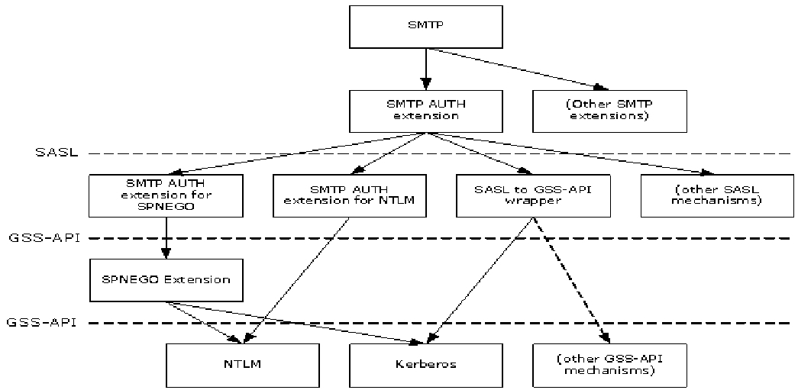
Figure 1: Relationship to other protocols
The SMTP AUTH Extension specified in [RFC2554] is defined to use SASL mechanisms. The SMTP AUTH Extension for SPNEGO is one SASL mechanism. The SASL to GSS-API wrapper defined in [RFC2222] section 7.2 is another SASL mechanism; however, it does not define a SASL mechanism name for any particular GSS-API mechanism (thus the diagram contains a dotted line from "SASL to GSS-API wrapper" to "(other GSS-API mechanisms)". To use a particular GSS-API mechanism in SMTP requires that the mechanism have a SASL mechanism name defined for it. [RFC4752] specifies the SASL to GSS-API wrapper over Kerberos. The SMTP AUTH Extension for NTLM specified in [MS-SMTP] is another SASL mechanism.
The SPNEGO Extension specified in [MS-SPNG] is both a GSS-API mechanism (as used in this document) as well as a protocol that uses other GSS-API mechanisms, including NTLM and Kerberos.
Since both the SMTP AUTH Extension for SPNEGO and the SASL to GSS-API wrapper over Kerberos defined in [RFC4752] use the same SASL mechanism name, they cannot be used in the same environment. However, the SASL mechanism name for the SMTP AUTH Extension for NTLM, as well as other SASL mechanisms, are different and therefore can be used in the same environment.

Prerequisites/Preconditions
The SMTP AUTH Extension for SPNEGO is only invoked after an SMTP client with this extension has initiated an SMTP connection and is using the SMTP AUTH Extension [RFC2554].
It is assumed that the client knows that the server supports the SMTP AUTH Extension for SPNEGO (as opposed to the SASL to GSS-API wrapper specified in [RFC4752]) before the client determines to use this extension.

Applicability Statement
The SMTP AUTH Extension for SPNEGO is used when implementing an SMTP client and SMTP server that negotiate a mutually supported authentication mechanism using SPNEGO.
Since this extension and the SASL to GSS-API wrapper defined in [RFC4752] use the same SASL mechanism name, this extension is not applicable to clients in environments with servers that implement the Kerberos V5 ("GSSAPI") SASL Mechanism specified in [RFC4752]. A client in such an environment will use the SPNEGO Extension specified in [MS-SPNG] when the server advertises "GSSAPI", and authentication will fail.
However, the SMTP AUTH Extension for SPNEGO can be used by servers that support Kerberos with clients that use either this extension or the Kerberos V5 ("GSSAPI") SASL Mechanism. When the server advertises "GSSAPI", the former will use the SPNEGO Extension and the latter will use Kerberos directly, and both can succeed.

Versioning and Capability Negotiation
The SMTP AUTH Extension for SPNEGO introduces no new versioning mechanisms.
Negotiation of SMTP options is specified in [RFC5321] sections 2.2 and 3.2. Negotiation of authentication mechanisms using SASL mechanism names is specified by [RFC2554]. Negotiation of GSS-API mechanisms is specified by [MS-SPNG].

Vendor-Extensible Fields
None.

Standards Assignments
This extension reuses the following assignment.
Parameter | Value | Reference
SASL mechanism name | GSSAPI | [IANA-SASL]
This use is consistent with the problematic specification in [RFC2222] section 7.2.

Messages

Transport
The SMTP AUTH Extension for SPNEGO does not establish transport connections. Instead, its messages are encapsulated in SMTP AUTH commands and responses as specified in [RFC2554].

Message Syntax
[RFC2554] section 4 specifies messages that are usable by any SASL mechanism that defines a mechanism name, an optional initial response to be encoded by using base64, and a reply also to be encoded by using base64.
[RFC2222] section 7.2 specifies the mapping of the initial response and the reply to specific GSS-API functions. In the SMTP AUTH Extension for SPNEGO, the GSS-API calls are directed to the SPNEGO Extension, so the calls use the syntax specified in [MS-SPNG].

SASL Mechanism Name
The SASL mechanism name is defined as "GSSAPI".

Protocol Details

Client Details

Abstract Data Model
This section describes a conceptual model of possible data organization that an implementation maintains to participate in this protocol. The described organization is provided to facilitate the explanation of how the protocol behaves. This document does not mandate that implementations adhere to this model as long as their external behavior is consistent with that described in this document.
This extension specifies no additional state beyond what is already required by [RFC2554] and [MS-SPNG]. The abstract state specified by [RFC2554] and used by this protocol is as follows.
For each SMTP connection:
Authentication Mechanism: The choice of authentication mechanism being used on that connection.

Timers
None.

Initialization
None.

Higher-Layer Triggered Events
None.

Message Processing Events and Sequencing Rules

Initiating the "GSSAPI" Mechanism
When the SMTP AUTH Extension [RFC2554] determines to use the "GSSAPI" SASL mechanism, the client MUST then associate the SPNEGO Extension [MS-SPNG] GSS-API mechanism with the connection. The way the client determines which of the SASL mechanisms to use is implementation-specific, but the client SHOULD use the SPNEGO Extension only if "GSSAPI" is returned in the list of SASL mechanisms in the EHLO exchange specified in [RFC2554] and SHOULD prefer the SPNEGO Extension over any other such SASL mechanisms supported.
As a result of the client associating the SPNEGO Extension with the connection, the rest of the exchange will proceed as specified in [RFC2554] for AUTH command processing, in [RFC2222] for mapping the SASL mechanism to specific GSS-API function calls, and in [MS-SPNG] for the behavior of those GSS-API function calls.

Timer Events
None.

Other Local Events
None.

Server Details

Abstract Data Model
This section describes a conceptual model of possible data organization that an implementation maintains to participate in this protocol. The described organization is provided to facilitate the explanation of how the protocol behaves. This document does not mandate that implementations adhere to this model as long as their external behavior is consistent with that described in this document.
This extension specifies no additional state beyond what is already required by [RFC2554] and [MS-SPNG]. The abstract state specified by [RFC2554] and used by this protocol is as follows.
List of SASL Mechanisms: The list of SASL mechanism names to be returned in an EHLO response.
For each SMTP connection:
Authentication Mechanism: The choice of authentication mechanism being used on that connection.

Timers
None.

Initialization
When the server is initialized, it MUST place "GSSAPI" in its List of SASL Mechanisms abstract data model element.

Higher-Layer Triggered Events
None.

Message Processing Events and Sequencing Rules

Receiving an AUTH GSSAPI Command
When the server receives an AUTH GSSAPI command from a client over a given SMTP connection, the server MUST set that connection's Authentication Mechanism to the SPNEGO Extension [MS-SPNG] and thus route all subsequent GSS-API function calls for that connection to the SPNEGO Extension.

Timer Events
None.

Other Local Events
None.

Protocol Examples

Server Successfully Authenticating Client
In this example a server successfully authenticates a client by using the SMTP AUTH Extension for SPNEGO. The following sequence diagram shows the flow of command requests and responses in a successful authentication negotiation.
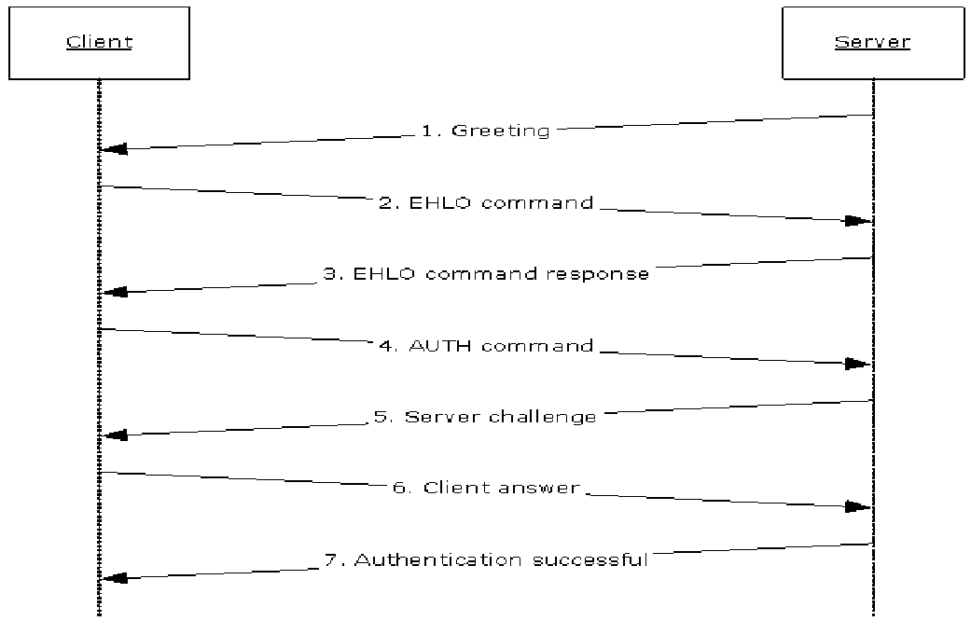
Figure 2: Server successfully authenticates client
- When the client connects to the SMTP port on the server, the server responds with a greeting.
220 server.contoso.com Authenticated Receive Connector
- The client sends an EHLO command as described in [RFC5321].
EHLO client.contoso.com
- The server sends a response that includes an AUTH keyword containing a list of SASL mechanism names that it supports, including "GSSAPI".
250-server-contoso.com Hello [203.0.113.1]
250-AUTH GSSAPI NTLM
250 OK
- The client examines the SASL mechanism names after the AUTH keyword and selects one that it supports. In this example, the client selects "GSSAPI" and begins to use the SPNEGO Extension. The SMTP AUTH Extension for SPNEGO then uses GSS-API to ask the SPNEGO Extension for an initial response. As specified in [MS-SPNG], this is a NegTokenInit message that contains the client's list of requested GSS-API mechanisms, which the SMTP AUTH Extension specified in [RFC2554] then base64-encodes.
AUTH GSSAPI <base64-encoded NegTokenInit>
- The server determines that the client is requesting "GSSAPI" and begins to use the SPNEGO Extension. The SMTP AUTH Extension for SPNEGO then base64-decodes the initial response and uses GSS-API to supply the NegTokenInit message and to request a reply from the SPNEGO Extension. As specified in [MS-SPNG], this will be a NegTokenResp message, which in this example includes a server challenge for the selected GSS-API mechanism. The SMTP AUTH Extension base64-encodes the message and returns it in a 334 reply.
334 <base64-encoded NegTokenResp>
- The client base64-decodes the reply and passes the result to the SPNEGO Extension. Depending on the GSS-API mechanism used by the SPNEGO Extension, there might or might not be another response to send to the server. In this example, the SPNEGO Extension returns another response to send, which the SMTP AUTH Extension again base64-encodes.
<base64-encoded client answer>
- The server base64-decodes the response and passes the result to the SPNEGO Extension. Depending on the GSS-API mechanism used by the SPNEGO Extension, there might or might not be another challenge reply to send to the client. In this example, the SPNEGO Extension determines that the authentication succeeded, so the SMTP AUTH Extension reports success back to the client.
235 2.7.0 Authentication successful

Security

Security Considerations for Implementers
As with all other SMTP authentication mechanisms, the security considerations described in [RFC2554] section 9 and [RFC2222] section 9 apply. Since this extension uses the SPNEGO Extension, the security considerations described in [MS-SPNG] section 5.1 also apply.

Index of Security Parameters
None.

Appendix A: Product Behavior
The information in this specification is applicable to the following Microsoft products or supplemental software. References to product versions include updates to those products.
- Microsoft .NET Framework 2.0
- Microsoft .NET Framework 3.5
- Microsoft .NET Framework 4.0
- Microsoft .NET Framework 4.5
- Microsoft .NET Framework 4.6
- Microsoft .NET Framework 4.7
- Microsoft Exchange Server 2003
- Microsoft Exchange Server 2007
- Microsoft Exchange Server 2010
- Microsoft Exchange Server 2013
- Microsoft Exchange Server 2016
- Microsoft Exchange Server 2019
- Microsoft Office Outlook 2003
- Microsoft Office Outlook 2007
- Microsoft Outlook 2010
- Microsoft Outlook 2013
- Microsoft Outlook 2016
- Windows 2000 Professional operating system
- Windows 2000 Server operating system
- Windows XP operating system
- Windows Server 2003 operating system
- Windows Vista operating system
- Windows Server 2008 operating system
- Windows 7 operating system
- Windows Server 2008 R2 operating system
- Windows 8 operating system
- Windows Server 2012 operating system
- Windows 8.1 operating system
- Windows Server 2012 R2 operating system
- Windows 10 operating system
- Windows Server 2016 operating system
- Windows Server operating system
- Windows Server 2019 operating system
Exceptions, if any, are noted in this section. If an update version, service pack or Knowledge Base (KB) number appears with a product name, the behavior changed in that update. The new behavior also applies to subsequent updates unless otherwise specified. If a product edition appears with the product version, behavior is different in that product edition.
Unless otherwise specified, any statement of optional behavior in this specification that is prescribed using the terms "SHOULD" or "SHOULD NOT" implies product behavior in accordance with the SHOULD or SHOULD NOT prescription. Unless otherwise specified, the term "MAY" implies that the product does not follow the prescription.

Change Tracking
This section identifies changes that were made to this document since the last release. Changes are classified as Major, Minor, or None.
The revision class Major means that the technical content in the document was significantly revised. Major changes affect protocol interoperability or implementation. Examples of major changes are:
- A document revision that incorporates changes to interoperability requirements.
- A document revision that captures changes to protocol functionality.
The revision class Minor means that the meaning of the technical content was clarified. Minor changes do not affect protocol interoperability or implementation. Examples of minor changes are updates to clarify ambiguity at the sentence, paragraph, or table level.
The revision class None means that no new technical changes were introduced. Minor editorial and formatting changes may have been made, but the relevant technical content is identical to the last released version.
The changes made to this document are listed in the following table. For more information, please contact dochelp@microsoft.com.
Section | Description | Revision class
6 Appendix A: Product Behavior | Added Windows Server 2019 and Exchange Server 2019 to the list of applicable products. | Major

Index
A

Abstract data model
client 9
server 10
Applicability 7

C

Capability negotiation 7
Change tracking 16
Client
abstract data model 9
higher-layer triggered events 9
initialization 9
other local events 9
timer events 9
timers 9

D

Data model - abstract
client 9
server 10

E

Examples
server successfully authenticating client 11

F

Fields - vendor-extensible 7

G

Glossary 4

H

Higher-layer triggered events
client 9
server 10

I

Implementer - security considerations 13
Index of security parameters 13
Informative references 5
Initialization
client 9
server 10
Introduction 4

M

Message syntax 8
Messages
SASL Mechanism Name 8
SASL Mechanism Name message 8
syntax 8
transport 8

N

Normative references 4

O

Other local events
client 9
server 10
Overview (synopsis) 5

P

Parameters - security index 13
Preconditions 7
Prerequisites 7
Product behavior 14

R

References 4
informative 5
normative 4
Relationship to other protocols 6

S

SASL Mechanism Name message 8
Security
implementer considerations 13
parameter index 13
Server
abstract data model 10
higher-layer triggered events 10
initialization 10
other local events 10
timer events 10
timers 10
Server successfully authenticating client example 11
Standards assignments 7

T

Timer events
client 9
server 10
Timers
client 9
server 10
Tracking changes 16
Transport 8
Triggered events - higher-layer
client 9
server 10

V

Vendor-extensible fields 7
Versioning 7

