[MS-SFU]:
Kerberos Protocol Extensions: Service for User and Constrained Delegation Protocol

Intellectual Property Rights Notice for Open Specifications Documentation
- Technical Documentation. Microsoft publishes Open Specifications documentation (“this documentation”) for protocols, file formats, data portability, computer languages, and standards support. Additionally, overview documents cover inter-protocol relationships and interactions.
- Copyrights. This documentation is covered by Microsoft copyrights. Regardless of any other terms that are contained in the terms of use for the Microsoft website that hosts this documentation, you can make copies of it in order to develop implementations of the technologies that are described in this documentation and can distribute portions of it in your implementations that use these technologies or in your documentation as necessary to properly document the implementation. You can also distribute in your implementation, with or without modification, any schemas, IDLs, or code samples that are included in the documentation. This permission also applies to any documents that are referenced in the Open Specifications documentation.
- No Trade Secrets. Microsoft does not claim any trade secret rights in this documentation.
- Patents. Microsoft has patents that might cover your implementations of the technologies described in the Open Specifications documentation. Neither this notice nor Microsoft's delivery of this documentation grants any licenses under those patents or any other Microsoft patents. However, a given Open Specifications document might be covered by the Microsoft Open Specifications Promise or the Microsoft Community Promise. If you would prefer a written license, or if the technologies described in this documentation are not covered by the Open Specifications Promise or Community Promise, as applicable, patent licenses are available by contacting iplg@microsoft.com.
- License Programs. To see all of the protocols in scope under a specific license program and the associated patents, visit the Patent Map.
- Trademarks. The names of companies and products contained in this documentation might be covered by trademarks or similar intellectual property rights. This notice does not grant any licenses under those rights. For a list of Microsoft trademarks, visit www.microsoft.com/trademarks.
- Fictitious Names. The example companies, organizations, products, domain names, email addresses, logos, people, places, and events that are depicted in this documentation are fictitious. No association with any real company, organization, product, domain name, email address, logo, person, place, or event is intended or should be inferred.
Reservation of Rights. All other rights are reserved, and this notice does not grant any rights other than as specifically described above, whether by implication, estoppel, or otherwise.
Tools. The Open Specifications documentation does not require the use of Microsoft programming tools or programming environments in order for you to develop an implementation. If you have access to Microsoft programming tools and environments, you are free to take advantage of them. Certain Open Specifications documents are intended for use in conjunction with publicly available standards specifications and network programming art and, as such, assume that the reader either is familiar with the aforementioned material or has immediate access to it.
Support. For questions and support, please contact dochelp@microsoft.com.
Revision Summary
Date | Revision History | Revision Class | Comments
3/2/2007 | 1.0 | New | Version 1.0 release
4/3/2007 | 1.1 | Minor | Version 1.1 release
5/11/2007 | 1.2 | Minor | Version 1.2 release
6/1/2007 | 1.2.1 | Editorial | Changed language and formatting in the technical content.
7/3/2007 | 1.2.2 | Editorial | Changed language and formatting in the technical content.
8/10/2007 | 1.2.3 | Editorial | Changed language and formatting in the technical content.
9/28/2007 | 1.2.4 | Editorial | Changed language and formatting in the technical content.
10/23/2007 | 2.0 | Major | Converted document to unified format.
1/25/2008 | 2.1 | Minor | Clarified the meaning of the technical content.
3/14/2008 | 2.1.1 | Editorial | Changed language and formatting in the technical content.
6/20/2008 | 2.2 | Minor | Clarified the meaning of the technical content.
7/25/2008 | 2.2.1 | Editorial | Changed language and formatting in the technical content.
8/29/2008 | 2.2.2 | Editorial | Changed language and formatting in the technical content.
10/24/2008 | 2.2.3 | Editorial | Changed language and formatting in the technical content.
12/5/2008 | 2.3 | Minor | Clarified the meaning of the technical content.
1/16/2009 | 2.4 | Minor | Clarified the meaning of the technical content.
2/27/2009 | 2.5 | Minor | Clarified the meaning of the technical content.
4/10/2009 | 2.5.1 | Editorial | Changed language and formatting in the technical content.
5/22/2009 | 2.5.2 | Editorial | Changed language and formatting in the technical content.
7/2/2009 | 3.0 | Major | Updated and revised the technical content.
8/14/2009 | 3.0.1 | Editorial | Changed language and formatting in the technical content.
9/25/2009 | 3.1 | Minor | Clarified the meaning of the technical content.
11/6/2009 | 4.0 | Major | Updated and revised the technical content.
12/18/2009 | 5.0 | Major | Updated and revised the technical content.
1/29/2010 | 5.1 | Minor | Clarified the meaning of the technical content.
3/12/2010 | 5.1.1 | Editorial | Changed language and formatting in the technical content.
4/23/2010 | 6.0 | Major | Updated and revised the technical content.
6/4/2010 | 6.1 | Minor | Clarified the meaning of the technical content.
7/16/2010 | 6.2 | Minor | Clarified the meaning of the technical content.
8/27/2010 | 6.2 | None | No changes to the meaning, language, or formatting of the technical content.
10/8/2010 | 6.3 | Minor | Clarified the meaning of the technical content.
11/19/2010 | 6.3 | None | No changes to the meaning, language, or formatting of the technical content.
1/7/2011 | 6.4 | Minor | Clarified the meaning of the technical content.
2/11/2011 | 7.0 | Major | Updated and revised the technical content.
3/25/2011 | 7.0 | None | No changes to the meaning, language, or formatting of the technical content.
5/6/2011 | 7.1 | Minor | Clarified the meaning of the technical content.
6/17/2011 | 8.0 | Major | Updated and revised the technical content.
9/23/2011 | 8.0 | None | No changes to the meaning, language, or formatting of the technical content.
12/16/2011 | 9.0 | Major | Updated and revised the technical content.
3/30/2012 | 10.0 | Major | Updated and revised the technical content.
7/12/2012 | 11.0 | Major | Updated and revised the technical content.
10/25/2012 | 12.0 | Major | Updated and revised the technical content.
1/31/2013 | 13.0 | Major | Updated and revised the technical content.
8/8/2013 | 14.0 | Major | Updated and revised the technical content.
11/14/2013 | 14.0 | None | No changes to the meaning, language, or formatting of the technical content.
2/13/2014 | 14.0 | None | No changes to the meaning, language, or formatting of the technical content.
5/15/2014 | 14.0 | None | No changes to the meaning, language, or formatting of the technical content.
6/30/2015 | 15.0 | Major | Significantly changed the technical content.
10/16/2015 | 15.0 | None | No changes to the meaning, language, or formatting of the technical content.
7/14/2016 | 15.0 | None | No changes to the meaning, language, or formatting of the technical content.
6/1/2017 | 15.0 | None | No changes to the meaning, language, or formatting of the technical content.
9/15/2017 | 16.0 | Major | Significantly changed the technical content.
9/12/2018 | 17.0 | Major | Significantly changed the technical content.
Table of Contents
1 Introduction 6
1.1 Glossary 6
1.2 References 8
1.2.1 Normative References 8
1.2.2 Informative References 9
1.3 Overview 9
1.3.1 S4U2self 9
1.3.2 S4U2proxy 10
1.3.3 Protocol Overview 10
1.4 Relationship to Other Protocols 13
1.5 Prerequisites/Preconditions 14
1.6 Applicability Statement 14
1.7 Versioning and Capability Negotiation 14
1.8 Vendor-Extensible Fields 14
1.9 Standards Assignments 14
2 Messages 15
2.1 Transport 15
2.2 Message Syntax 15
2.2.1 PA-FOR-USER 15
2.2.2 PA_S4U_X509_USER 16
2.2.3 CNAME-IN-ADDL-TKT 17
2.2.4 S4U_DELEGATION_INFO 17
2.2.5 PA-PAC-OPTIONS 18
3 Protocol Details 19
3.1 Service Details 19
3.1.1 Abstract Data Model 19
3.1.2 Timers 19
3.1.3 Initialization 19
3.1.4 Higher-Layer Triggered Events 19
3.1.4.1 S4U2self Triggered Events 19
3.1.4.2 S4U2proxy Triggered Events 19
3.1.5 Message Processing Events and Sequencing Rules 20
3.1.5.1 Service for User to Self 20
3.1.5.1.1 Service Sends S4U2self KRB_TGS_REQ 20
3.1.5.1.1.1 Using the User's Realm and User Name to Identify the User 20
3.1.5.1.1.2 Using the User's Certificate to Identify the User 21
3.1.5.1.2 Service Receives S4U2self KRB_TGS_REP 21
3.1.5.2 Service for User to Proxy 21
3.1.5.2.1 Sends S4U2proxy KRB_TGS_REQ 21
3.1.5.2.2 Receives Referral 22
3.1.5.2.3 Receives KRB-ERR-BADOPTION 22
3.1.5.2.4 Receives S4U2proxy KRB_TGS_REP 22
3.1.6 Timer Events 23
3.1.7 Other Local Events 23
3.2 KDC Details 23
3.2.1 Abstract Data Model 23
3.2.2 Timers 23
3.2.3 Initialization 23
3.2.4 Higher-Layer Triggered Events 24
3.2.5 Message Processing Events and Sequencing Rules 24
3.2.5.1 KDC Receives S4U2self KRB_TGS_REQ 24
3.2.5.1.1 KDC Replies with Referral TGT 24
3.2.5.1.2 KDC Replies with Service Ticket 24
3.2.5.2 KDC Receives S4U2proxy KRB_TGS_REQ 25
3.2.5.2.1 KDC Confirms Delegation is Allowed 25
3.2.5.2.1.1 Using ServicesAllowedToReceiveForwardedTicketsFrom 25
3.2.5.2.1.2 Using ServicesAllowedToSendForwardedTicketsTo 26
3.2.5.2.2 KDC Replies with Service Ticket 26
3.2.6 Timer Events 26
3.2.7 Other Local Events 26
4 Protocol Examples 27
4.1 S4U2self Single Realm Example 27
4.2 S4U2self Multiple Realm Example 27
4.3 S4U2proxy Example 29
5 Security 30
5.1 Security Considerations for Implementers 30
5.2 Index of Security Parameters 30
6 Appendix A: Product Behavior 31
7 Change Tracking 35
8 Index 36

Introduction
The Kerberos Network Authentication Service (V5) Service for User (S4U) Extension provides two extensions to the Kerberos Protocol. Collectively, these two extensions enable an application service to obtain a Kerberos service ticket on behalf of a user. The resulting service ticket can be used for:
- The requesting service's own information.
- Access control local to the service's machine, impersonating the user.
- Requests to some other service, impersonating the user.
There are two different Service for User (S4U) extensions. The first is the Service for User to Self (S4U2self) extension, which allows a service to obtain a Kerberos service ticket to itself on behalf of a user. This enables the service to obtain the user's authorization data that is then used in authorization decisions in the local service.
The second S4U extension is the Service for User to Proxy (S4U2proxy) extension. This Kerberos extension enables a service to obtain a service ticket on behalf of the user to a second, back end service. This allows back-end services to use Kerberos user credentials as if the user had obtained the service ticket and sent it to the back end service directly. Local policy at the ticket-granting service (TGS) can be used to limit the scope of the S4U2proxy extension.
Sections 1.5, 1.8, 1.9, 2, and 3 of this specification are normative. All other sections and examples in this specification are informative.

Glossary
This document uses the following terms:
Active Directory: The Windows implementation of a general-purpose directory service, which uses LDAP as its primary access protocol. Active Directory stores information about a variety of objects in the network such as user accounts, computer accounts, groups, and all related credential information used by Kerberos [MS-KILE]. Active Directory is either deployed as Active Directory Domain Services (AD DS) or Active Directory Lightweight Directory Services (AD LDS), which are both described in [MS-ADOD]: Active Directory Protocols Overview.
Authentication Protocol (AP) exchange: The Kerberos subprotocol called the "authentication protocol", sometimes referred to as the "Client/Server Authentication Exchange", in which the client presents a service ticket and an authenticator to a service to establish an authenticated communication session with the service (see [RFC4120] section 3.2).
Authentication Service (AS) exchange: The Kerberos subprotocol in which the Authentication Service (AS) component of the key distribution center (KDC) accepts an initial logon or authentication request from a client and provides the client with a ticket-granting ticket (TGT) and necessary cryptographic keys to make use of the ticket. This is specified in [RFC4120] section 3.1. The AS exchange is always initiated by the client, usually in response to the initial logon of a principal such as a user.
authorization: The secure computation of roles and accesses granted to an identity.
authorization data: An extensible field within a Kerberos ticket, used to pass authorization data about the principal on whose behalf the ticket was issued to the application service.
constrained delegation: A Windows feature used in conjunction with S4U2proxy. This feature limits the proxy services for which the application service is allowed to get tickets on behalf of a user.
domain: A set of users and computers sharing a common namespace and management infrastructure. At least one computer member of the set must act as a domain controller (DC) and host a member list that identifies all members of the domain, as well as optionally hosting the Active Directory service. The domain controller provides authentication of members, creating a unit of trust for its members. Each domain has an identifier that is shared among its members. For more information, see [MS-AUTHSOD] section 1.1.1.5 and [MS-ADTS].
domain controller (DC): The service, running on a server, that implements Active Directory, or the server hosting this service. The service hosts the data store for objects and interoperates with other DCs to ensure that a local change to an object replicates correctly across all DCs. When Active Directory is operating as Active Directory Domain Services (AD DS), the DC contains full NC replicas of the configuration naming context (config NC), schema naming context (schema NC), and one of the domain NCs in its forest. If the AD DS DC is a global catalog server (GC server), it contains partial NC replicas of the remaining domain NCs in its forest. For more information, see [MS-AUTHSOD] section 1.1.1.5.2 and [MS-ADTS]. When Active Directory is operating as Active Directory Lightweight Directory Services (AD LDS), several AD LDS DCs can run on one server. When Active Directory is operating as AD DS, only one AD DS DC can run on one server. However, several AD LDS DCs can coexist with one AD DS DC on one server. The AD LDS DC contains full NC replicas of the config NC and the schema NC in its forest. The domain controller is the server side of Authentication Protocol Domain Support [MS-APDS].
forwardable: A flag, as specified in [RFC4120] section 2.6, used in an S4U2self KRB_TGS_REQ message to request that the resulting service ticket be marked as forwardable, allowing it to be used in a subsequent S4U2proxy KRB_TGS_REQ message.
Kerberos principal: A unique individual account known to the Key Distribution Center (KDC). Often a user, but it can be a service offering a resource on the network.
key: In cryptography, a generic term used to refer to cryptographic data that is used to initialize a cryptographic algorithm. Keys are also sometimes referred to as keying material.
Key Distribution Center (KDC): The Kerberos service that implements the authentication and ticket granting services specified in the Kerberos protocol. The service runs on computers selected by the administrator of the realm or domain; it is not present on every machine on the network. It must have access to an account database for the realm that it serves. KDCs are integrated into the domain controller role. It is a network service that supplies tickets to clients for use in authenticating to services.
pre-authentication: In Kerberos, a state in which a key distribution center (KDC) demands that the requestor in the Authentication Service (AS) exchange demonstrate knowledge of the key associated with the account. If the requestor cannot demonstrate this knowledge, the KDC will not issue a ticket-granting ticket (TGT) ([RFC4120] sections 5.2.7 and 7.5.2).
principal: An authenticated entity that initiates a message or channel in a distributed system.
privilege attribute certificate (PAC): A Microsoft-specific authorization data present in the authorization data field of a ticket. The PAC contains several logical components, including group membership data for authorization, alternate credentials for non-Kerberos authentication protocols, and policy control information for supporting interactive logon.
realm: A collection of key distribution centers (KDCs) with a common set of principals, as described in [RFC4120] section 1.2.
security principal name (SPN): The name that identifies a security principal (for example, machinename$@domainname for a machine joined to a domain or username@domainname for a user). Domainname is resolved using the Domain Name System (DNS).
service: A process or agent that is available on the network, offering resources or services for clients. Examples of services include file servers, web servers, and so on.
Service for User (S4U): Extensions to the Kerberos protocol that allow a service to obtain a Kerberos service ticket for a user that has not authenticated to the Key Distribution Center (KDC). S4U includes S4U2proxy and S4U2self.
Service for User to Proxy (S4U2proxy): An extension that allows a service to obtain a service ticket on behalf of a user to a different service.
Service for User to Self (S4U2self): An extension that allows a service to obtain a Kerberos service ticket to itself. The service ticket contains the user's groups and can therefore be used in authorization decisions.
service ticket: A ticket for any service other than the ticket-granting service (TGS). A service ticket serves only to classify a ticket as not a ticket-granting ticket (TGT) or cross-realm TGT, as specified in [RFC4120].
session key: A relatively short-lived symmetric key (a cryptographic key negotiated by the client and the server based on a shared secret). A session key's lifespan is bounded by the session to which it is associated. A session key has to be strong enough to withstand cryptanalysis for the lifespan of the session.
ticket: A record generated by the key distribution center (KDC) that helps a client authenticate to a service. It contains the client's identity, a unique cryptographic key for use with this ticket (the session key), a time stamp, and other information, all sealed using the service's secret key. It only serves to authenticate a client when presented along with a valid authenticator.
ticket-granting service (TGS): A service that issues tickets for admission to other services in its own domain or for admission to the ticket-granting service in another domain.
ticket-granting service (TGS) exchange: The Kerberos subprotocol in which the key distribution center (KDC) distributes a session key and a ticket for the service requested by the client, as specified in [RFC4120] section 3.3. This exchange is initiated when the client sends the KDC a KRB_TGS_REQ message.
ticket-granting ticket (TGT): A special type of ticket that can be used to obtain other tickets. The TGT is obtained after the initial authentication in the Authentication Service (AS) exchange; thereafter, users do not need to present their credentials, but can use the TGT to obtain subsequent tickets.
MAY, SHOULD, MUST, SHOULD NOT, MUST NOT: These terms (in all caps) are used as defined in [RFC2119]. All statements of optional behavior use either MAY, SHOULD, or SHOULD NOT.

References
Links to a document in the Microsoft Open Specifications library point to the correct section in the most recently published version of the referenced document. However, because individual documents in the library are not updated at the same time, the section numbers in the documents may not match. You can confirm the correct section numbering by checking the Errata.

Normative References
We conduct frequent surveys of the normative references to assure their continued availability. If you have any issue with finding a normative reference, please contact dochelp@microsoft.com. We will assist you in finding the relevant information.
[MS-ADA2] Microsoft Corporation, "Active Directory Schema Attributes M".
[MS-ADTS] Microsoft Corporation, "Active Directory Technical Specification".
[MS-DTYP] Microsoft Corporation, "Windows Data Types".
[MS-KILE] Microsoft Corporation, "Kerberos Protocol Extensions".
[MS-PAC] Microsoft Corporation, "Privilege Attribute Certificate Data Structure".
[Referrals] Raeburn, K., Zhu, L., and Jaganathan, K., "Generating KDC Referrals to Locate Kerberos Realms", February 2008, http://tools.ietf.org/html/draft-ietf-krb-wg-kerberos-referrals-10
[RFC1964] Linn, J., "The Kerberos Version 5 GSS-API Mechanism", RFC 1964, June 1996, http://www.rfc-editor.org/rfc/rfc1964.txt
[RFC2119] Bradner, S., "Key words for use in RFCs to Indicate Requirement Levels", BCP 14, RFC 2119, March 1997, http://www.rfc-editor.org/rfc/rfc2119.txt
[RFC3280] Housley, R., Polk, W., Ford, W., and Solo, D., "Internet X.509 Public Key Infrastructure Certificate and Certificate Revocation List (CRL) Profile", RFC 3280, April 2002, http://www.ietf.org/rfc/rfc3280.txt
[RFC3961] Raeburn, K., "Encryption and Checksum Specifications for Kerberos 5", RFC 3961, February 2005, http://www.ietf.org/rfc/rfc3961.txt
[RFC4120] Neuman, C., Yu, T., Hartman, S., and Raeburn, K., "The Kerberos Network Authentication Service (V5)", RFC 4120, July 2005, https://www.rfc-editor.org/rfc/rfc4120.txt
[RFC4121] Zhu, L., Jaganathan, K., and Hartman, S., "The Kerberos Version 5 Generic Security Service Application Program Interface (GSS-API) Mechanism: Version 2", RFC 4121, July 2005, http://www.ietf.org/rfc/rfc4121.txt
[RFC4757] Jaganathan, K., Zhu, L., and Brezak, J., "The RC4-HMAC Kerberos Encryption Types Used by Microsoft Windows", RFC 4757, December 2006, http://www.ietf.org/rfc/rfc4757.txt
[RFC822] Crocker, D.H., "Standard for ARPA Internet Text Messages", STD 11, RFC 822, August 1982, http://www.ietf.org/rfc/rfc0822.txt

Informative References
None.

Overview
This protocol extends Kerberos by specifying Service for User (S4U) extensions in relation to [RFC4120] and [Referrals].
S4U supports two subprotocols: Service for User to Self (S4U2self) and Service for User to Proxy (S4U2proxy). Both of these extensions allow a service to request a ticket from the Key Distribution Center (KDC) on behalf of a user. A ticket can be retrieved by the service to itself by using S4U2self or to another service via S4U2proxy. The client name, realm, and authorization data in the service ticket that uses these extensions are of the user, not of the service making the S4U request. This is in contrast to the Kerberos Protocol specified in [RFC4120] where any service tickets requested by a service will have the client name, realm, and authorization data of that requesting service.

S4U2self
The S4U2self extension allows a service to obtain a service ticket to itself on behalf of a user. The user is identified to the KDC using the user's name and realm. Alternatively, the user might be identified based on the user's certificate. The Kerberos ticket-granting service (TGS) exchange request and response messages, KRB_TGS_REQ and KRB_TGS_REP, are used along with one of two new data structures. The new PA-FOR-USER data structure is used when the user is identified to the KDC by the user name and realm name. The other structure, PA-S4U-X509-USER, is used when the user certificate is presented to the KDC to obtain the authorization information. By obtaining a service ticket to itself on behalf of the user, the service receives the user's authorization data in the ticket.

S4U2proxy
The Service for User to Proxy (S4U2proxy) extension provides a service that obtains a service ticket to another service on behalf of a user. This feature is known as constrained delegation. The Kerberos ticket-granting service (TGS) exchange request and response messages, KRB_TGS_REQ and KRB_TGS_REP, are used along with the new CNAME-IN-ADDL-TKT and S4U_DELEGATION_INFO data structures. The second service is typically a proxy performing some work on behalf of the first service, and the proxy is doing that work under the authorization context of the user.
The S4U2proxy extension requires that the service ticket to the first service has the forwardable flag set (see Service 1 in the figure specifying Kerberos delegation with forwarded TGT, section 1.3.3). This ticket can be obtained through an S4U2self protocol exchange.
This feature differs from the Kerberos forwarded-TGT delegation mechanism and the proxy-service-ticket delegation mechanism ([RFC4120] section 2.5) in the following ways:
- The service does not require the user to forward either the user's ticket-granting ticket (TGT) or the proxy ticket and the associated session key.
- The user does not need to authenticate through Kerberos (the S4U2self extension can be used instead, but this is not a requirement). In other words, the user does not need to have a TGT or a proxy service ticket.
- Local policy can be used to limit the services that can be delegated. This is contradictory to the forwarding-TGT delegation mechanism, as specified in [RFC4120] section 2.6, where a service can delegate to any other service. This is similar to the proxy ticket delegation, as specified in [RFC4120] section 2.5, except the client is not involved in making the delegation decision.
- The client has no control over whether a service can delegate on behalf of the user. The client does not request delegation nor does it pass a forwardable TGT to the service. The client cannot detect that delegation will be, or has been, performed. If local policy allows the service to perform S4U2proxy delegation, this delegation is performed solely at the discretion of the service.
When using the S4U2proxy delegation and forwarded-TGT delegation mechanisms, the delegation is invoked when the server impersonates the client and performs operations on a remote server (such as ldap_bind() or RPC_bind()). The Kerberos Security Support Provider (SSP) will first detect whether the forwarded-TGT delegation mechanism is available (by checking whether there is a forwarded TGT in the local ticket cache); if no forwarded TGT is available, the Kerberos SSP will then try to perform the S4U2proxy delegation.

Protocol Overview
The following figure shows the message sequence for Kerberos delegation with a forwarded ticket-granting ticket (TGT). This is background information designed to show the workings of Kerberos delegation, as specified in [RFC4120] section 2.8. This mechanism is then compared to the Service for User (S4U) extensions.
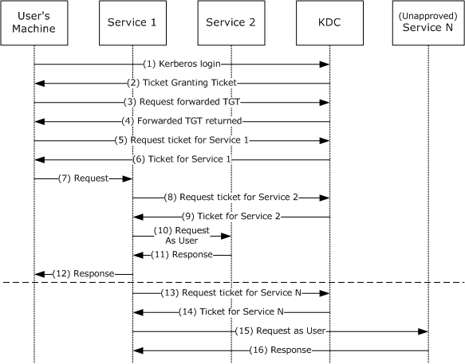
Figure 1: Kerberos Delegation with Forwarded TGT
The preceding figure depicts the following protocol steps:
- The user authenticates to the Key Distribution Center (KDC) by sending a KRB_AS_REQ message, the request message in an Authentication Service (AS) exchange, and requests a forwardable TGT.
- The KDC returns a forwardable TGT in the KRB_AS_REP message, the response message in an Authentication Service (AS) exchange.
- The user requests a forwarded TGT based on the forwardable TGT from step 2. This is done by the KRB_TGS_REQ message.
- The KDC returns a forwarded TGT for the user in the KRB_TGS_REP message.
- The user makes a request for a service ticket to Service 1 using the TGT returned in step 2. This is done by the KRB_TGS_REQ message.
- The ticket-granting service (TGS) returns the service ticket in a KRB_TGS_REP.
- The user makes a request to Service 1 by sending a KRB_AP_REQ message, presenting the service ticket, the forwarded TGT, and the session key for the forwarded TGT.
Note: The KRB_AP_REQ message is the request message in the Authentication Protocol (AP) exchange.
- To fulfill the user's request, Service 1 needs Service 2 to perform some action on behalf of the user. Service 1 uses the forwarded TGT of the user and sends that in a KRB_TGS_REQ to the KDC, asking for a ticket for Service 2 in the name of the user.
- The KDC returns a ticket for Service 2 to Service 1 in a KRB_TGS_REP message, along with a session key that Service 1 can use. The ticket identifies the client as the user, not as Service 1.
- Service 1 makes a request to Service 2 by a KRB_AP_REQ, acting as the user.
- Service 2 responds.
- With that response, Service 1 can now respond to the user's request in step 7.
- The TGT forwarding delegation mechanism as described here does not constrain Service 1's use of the forwarded TGT. Service 1 can ask the KDC for a ticket for any other service in the name of the user.
- The KDC will return the requested ticket.
- Service 1 can then continue to impersonate the user with Service N. This can pose a risk if, for example, Service 1 is compromised. Service 1 can continue to masquerade as a legitimate user to other services.
- Service N will respond to Service 1 as if it was the user's process.
The Server-for-User-to-Self (S4U2self) extension is intended to be used when the user authenticates to the service in some way other than by using Kerberos. For example, a user could authenticate to a web server by some means private to the web server. The web server could then use S4U2self to get a ticket, with authorization data, just as if the user had used Kerberos originally. This simplifies the server's authorization decision by making all decision paths behave as though Kerberos was used. S4U2self primarily uses the KDC to get information about the user for the caller's own benefit. The Service for User to Proxy (S4U2proxy) extension allows the caller to contact some other service, acting on behalf of the user. The detailed overview is given in the following figure.
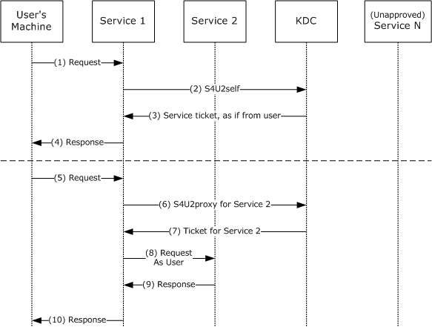
Figure 2: S4U2self and S4U2proxy
S4U2self is described in the top half of the preceding figure. Using this extension, the service receives a service ticket to the service itself (a ticket that cannot be used elsewhere).
The preceding figure depicts the following protocol steps:
- The user's machine makes a request to Service 1. The user is authenticated, but Service 1 does not have the user's authorization data. Typically this is due to the authentication being performed by some means other than Kerberos.
- Service 1, which has already authenticated with the KDC and has obtained its TGT, asks for a service ticket to itself on behalf of the named user by the S4U2self extension. The user is identified by the user name and the user's realm name in the S4U2self data (as specified in section 2.2.1). Alternatively, if Service 1 is in possession of the user's certificate, it can use the certificate to identify the user to the KDC using the PA-S4U-X509-USER structure.
- The KDC returns a service ticket addressed to Service 1 as if it had been requested from the user with the user's own TGT. The service ticket might contain the authorization data of the user.
- Service 1 can use the authorization data from the service ticket to fulfill the user's request. The service then responds to the user.
Although S4U2self provides information about the user to Service 1, this extension does not allow Service 1 to make requests of other services on the user's behalf. That is the role of S4U2proxy. S4U2proxy is described in the bottom half of the preceding figure.
- The user's machine makes a request to Service 1. Service 1 needs to access resources on Service 2 as the user. However, Service 1 does not have a forwarded TGT from the user to perform delegation by a forwarded TGT, as described in the figure specifying Kerberos delegation with forwarded TGT. Two preconditions apply to this step. First, Service 1 has already authenticated with the KDC and has a valid TGT. Second, Service 1 has a forwardable service ticket from the user to Service 1. This forwardable service ticket might have been obtained by a KRB_AP_REQ message, as specified in [RFC4120] section 3.2 or by an S4U2self request.
- Service 1 requests a service ticket to Service 2 on behalf of the named user. The user is identified by the client name and the client realm in the service ticket for Service 1. The authorization data in the ticket to be returned is also copied from the service ticket.<1>
- If a privilege attribute certificate (PAC) is in the request, the KDC validates the PAC by checking the signature data of the PAC structure, as specified in [MS-PAC] section 2.8. If the PAC is valid, or not present, the KDC returns a service ticket for Service 2, but the client identity stored in the cname and crealm fields of the service ticket are that of the user, not Service 1.
- Service 1 uses the service ticket to make a request to Service 2. Service 2 treats this request as coming from the user and assumes that the user was authenticated by the KDC.
- Service 2 responds to the request.
- Service 1 responds to the user's request of message 5.

Relationship to Other Protocols
The S4U extensions are based on the Kerberos Protocol, as specified in [RFC4120]. [RFC4120] also details the dependence on lower-layer protocols such as TCP and UDP. Applications using other protocols can use S4U to create a common authorization path within the application.
The S4U2self extension can be used to obtain a privilege attribute certificate (PAC), as specified in [MS-PAC], to determine the authorization capabilities of the user. In addition, the PAC is used in the S4U2proxy extension to validate that S4U2proxy service tickets have not been misused.
The referral mechanism, as specified in [Referrals], is used in the S4U2self protocol extension if the user's realm is different from that of the service trying to obtain an S4U2self service ticket.
Microsoft Kerberos Protocol Extensions, as specified in [MS-KILE], includes extensions that provide platform-specific data to support the encoding of authorization data ([MS-PAC], section 2) in the authorization data field ([RFC4120], sections 5.2.6 and 5.2.7) of the ticket.

Prerequisites/Preconditions
All Key Distribution Centers (KDCs) and Kerberos servers that send or receive the Service for User (S4U) extensions in the KRB_TGS_REQ and KRB_TGS_REP messages have to recognize the protocol extensions. Services can detect whether the KDC supports these extensions by checking the client name of the returned ticket. KDCs that do not understand these extensions will return the client name as the service that is making the request. KDCs that understand these extensions either return an error or return a service ticket that contains the client name as the user, not the service that is making the request.<2>
To support the lookup of users based on a supplied certificate, an accounts database is available to the KDC that supports looking up user accounts using one or more fields present in the certificate.

Applicability Statement
The Service for User to Proxy (S4U2proxy) extension supports delegation that is transparent to the client. Activities are performed under the user's identity in one or more services. Local policy can be used to limit this functionality and control which services can use this feature.

Versioning and Capability Negotiation
There is no version information in the Service for User (S4U) extensions. A service that uses these extensions will send the new options or data structures in the KRB_TGS_REQ and KRB_TGS_REP messages. Detecting whether a given Key Distribution Center (KDC) can support the extensions is specified in section 1.5.

Vendor-Extensible Fields
None.

Standards Assignments
None.

Messages

Transport
For details on the Kerberos Protocol as well as dependencies on lower-level protocols, see [RFC4120], section 7.2.

Message Syntax
The Service for User (S4U) extensions<3> use new structures conforming to the extensibility mechanisms provided in the Kerberos RFC, as specified in [RFC4120] section 1.5, and new values for options already specified by Kerberos in [RFC4120] section 1.1. The following sections describe these new structures and values.

PA-FOR-USER
In a KRB_TGS_REQ and KRB_TGS_REP subprotocol message sequence, as specified in [RFC4120] section 3.3, a Kerberos principal uses its ticket-granting ticket (TGT) to request a service ticket to a service. The TGS uses the requesting principal's identity from the TGT passed in the KRB_TGS_REQ message to create the service ticket.
In the S4U2self TGS exchange subprotocol extension, a service requests a service ticket to itself on behalf of a user. The user is identified to the KDC by the user's name and realm. Alternatively, the user might be identified using the user's certificate. The service uses its own TGT and adds a new type of padata. The padata type is specified in [RFC4120] section 5.2.7.
If the user, on whose behalf the service requests the service ticket, is identified using the user name and user realm, then the padata type PA-FOR-USER (ID 129) is used. This padata type contains a unique identifier that indicates the user's identity. This unique identifier consists of the user name and user realm.
The PA-FOR-USER padata value is protected with the help of a keyed checksum, as defined below.
The following code defines the ASN.1 structure of the PA-FOR-USER padata type.
padata-type ::= PA-FOR-USER
-- value 129
padata-value ::= EncryptedData
-- PA-FOR-USER-ENC

PA-FOR-USER-ENC ::= SEQUENCE {
userName[0] PrincipalName,
userRealm[1] Realm,
cksum[2] Checksum,
auth-package[3] KerberosString
}
userName: The PrincipalName type discussed in detail in [RFC4120] section 5.2.2. It consists of a name type and name string. The default value for name type is NT_UNKNOWN as specified in [RFC4120] section 6.2. The name string is a sequence of strings encoded as KerberosString, as specified in [RFC4120] section 5.2.1, that (together with the userRealm) represents a user principal.
userRealm: A KerberosString that represents the realm in which the user account is located. This value is not case-sensitive.
cksum: A checksum of userName, userRealm, and auth-package. This is calculated using the KERB_CHECKSUM_HMAC_MD5 function ([RFC4757]). The value of the userName.name-type is first encoded as a 4-byte integer in little endian byte order, then these 4 bytes are concatenated with all string values in the sequence of strings contained in the userName.name-string field, then the string value of the userRealm field, and then the string value of auth-package field, in that order, to form a byte array which can be called S4UByteArray. Note that, in the computation of S4UByteArray, the null terminator is not included when concatenating the strings. Finally cksum is computed by calling the KERB_CHECKSUM_HMAC_MD5 hash with the following three parameters: the session key of the TGT of the service performing the S4U2self request, the message type value of 17, and the byte array S4UByteArray.
Note The term "message type" is used here as in [RFC4757]. This usage corresponds to the term, "Key Usage Number" used in [RFC4120].
auth-package: A string name of the authentication mechanism used to authenticate the user. This MUST be set to the string, "Kerberos". This value is not case-sensitive.

PA_S4U_X509_USER
If the service possesses the user certificate, it can obtain a service ticket to itself on that user's behalf using the S4U2self TGS exchange subprotocol extension, with a new padata type PA-S4U-X509-USER (ID 130).<4> This padata type contains a unique identifier that indicates the user's identity. This unique identifier consists of the user's certificate and, optionally, the user's name and realm.
The following code defines the structure of the PA-S4U-X509-USER padata type.
Message Type padata-type Contents of padata-value

AS-REQ 130 X509 certificate encoded per
[RFC3280].

TGS-REQ/TGS-REP 130 PA-S4U-X509-USER ASN.1 structure

The corresponding data contains the DER encoded PA-S4U-X509-USER structure.
PA-S4U-X509-USER::= SEQUENCE {
user-id[0] S4UUserID,
checksum[1] Checksum
}

S4UUserID ::= SEQUENCE {
nonce [0] UInt32, -- the nonce in KDC-REQ-BODY
cname [1] PrincipalName OPTIONAL,
-- Certificate mapping hints
crealm [2] Realm,
subject-certificate [3] OCTET STRING OPTIONAL,
options [4] BIT STRING OPTIONAL,
...
}

user-id: Contains the user identifiers. This can be either the user name and realm or the user's certificate.
checksum: This is the Kerberos checksum (as defined in [RFC3961]) computed over the DER encoding of the ASN.1 type S4UUserID contained in the user-id field that immediately precedes this field. The key used is the session key of the TGT used in the TGS request (note that the same key is used in the TGS request and reply when this padata is used in both the request and the reply); the checksum operation is the required checksum for the encryption type of that TGT session key per [RFC3961]; and the key usage is 26. Because there is no required checksum type defined for the encryption type RC4_HMAC_NT (23), if the key's encryption type is RC4_HMAC_NT (23) the checksum type is rsa-md4 (2) as defined in section 6.2.6 of [RFC3961]. If the encryption type is "not-newer" (note that the term "not-newer" is described in section 1 of [RFC4121]), a padata element of type 130 is included in the encrypted-pa-data field of the reply (note that the encrypted-pa-data field is described in appendix A of [Referrals]). The padata of type 130 in the encrypted-pa-data field contains the checksum value in the S4U request concatenated with the checksum value in the S4U reply. The checksum value of a Kerberos Checksum type here refers to the OCTET STRING of the Checksum field. The client when receiving this padata type in the encrypted-pa-data field MUST verify the checksum values match with the corresponding checksum values in the request and the reply.
nonce: This contains the identically named field in the KDC body of the containing request.
cname: The PrincipalName type discussed in detail in [RFC4120] section 5.2.2. It consists of a name type and name string. The default value for the name type is NT_UNKNOWN as specified in [RFC4120] section 6.2. The name string is a sequence of strings encoded as KerberosString, as specified in [RFC4120] section 5.2.1, that (together with the crealm) represents a user principal.
crealm: A KerberosString that represents the realm in which the user account is located. This value is not case-sensitive.
subject-certificate: This optional field contains the user's certificate that is encoded as specified in [RFC3280].
options: Specifies the additional options in the S4U request. Currently, only two options are defined.
Value | Meaning
0x40000000 | This option causes the KDC to check logon hour restrictions for the user.
0x20000000 | In a request, asks the KDC to sign the reply with key usage number 27. In a reply, indicates that it was signed with key usage number 27.  This is the KERB_S4U_OPTIONS_use_reply_key_usage (0x20000000).<5>  If this option is set in the request, and if the KDC understands this option, it will sign the reply with key usage number 27, and set the same option in the reply. Otherwise, it will sign the reply with key usage number 26 and not set the option in the reply.
The SFU client needs to be able to locate the KDC of the user's realm. If the S4U call is based on the certificate and no user name is supplied, the client uses a PA_S4U_X509_USER padata type and the corresponding data contains the user's X509 certificate encoded as specified in [RFC3280].

CNAME-IN-ADDL-TKT
This is a new Key Distribution Center (KDC) option that MUST be set in a KRB_TGS_REQ message to request Service for User to Proxy (S4U2proxy) functionality. The kdc-options flags are specified in [RFC4120] section 5.4.1, and the new cname-in-addl-tkt option is defined as the KDC option with bit position 14.
KDCOptions ::= KerberosFlags
-- cname-in-addl-tkt (14)

S4U_DELEGATION_INFO
The S4U_DELEGATION_INFO structure ([MS-PAC] section 2.9) lists the services that have been delegated by this client and subsequent services or servers. The list is meaningful as the Service for User to Proxy (S4U2proxy) feature could be used multiple times in succession from service to service. This is useful for auditing purposes.

PA-PAC-OPTIONS
The PA-PAC-OPTIONS structure ([MS-KILE] section 2.2.10) specifies explicitly requested options in the PAC. Using resource-based constrained delegation, S4U2proxy SHOULD<6> extend the PA-PAC-OPTIONS structure as follows:
PA-PAC-OPTIONS ::= KerberosFlags
-- resource-based constrained delegation (3)

Protocol Details

Service Details
This section defines the message processing for an application service (see Service 1 in the figure specifying entities involved in S4U protocols, section 3.1.5) using the Service for User (S4U) extensions<7>.

Abstract Data Model
None.

Timers
None.

Initialization
Before sending a KRB_TGS_REQ message with a Service for User (S4U) extension, the service MUST have already authenticated to the Key Distribution Center (KDC) and received a ticket-granting ticket (TGT).

Higher-Layer Triggered Events
This section contains the following information:
- S4U2self Triggered Events
- S4U2proxy Triggered Events

S4U2self Triggered Events
A service (see Service 1 in the figure specifying entities involved in S4U protocols, section 3.1.5) uses a KRB_TGS_REQ message with the S4U2self extension when the service is required to make a local access check for a user. This typically occurs when the user has sent some kind of request to the service through a non-Kerberos protocol. The service uses the S4U2self TGS exchange subprotocol extension to obtain authorization data about the user from the Key Distribution Center (KDC).

S4U2proxy Triggered Events
A service uses a KRB_TGS_REQ message with the Service for User to Proxy (S4U2proxy) extension when the service determines that it needs to contact another service on behalf of a user for which it has a service ticket. S4U2proxy is used when the request to the second service must use the user's credentials, not the credentials of the first service. The service sends a KRB_TGS_REQ with the S4U2proxy information to obtain a service ticket to another service.

Message Processing Events and Sequencing Rules
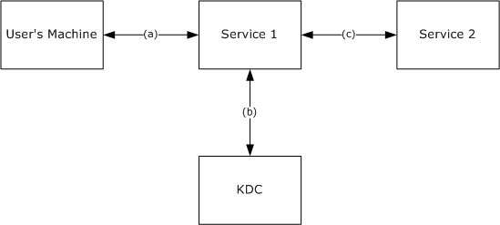
Figure 3: Entities Involved in Service for User (S4U) Protocols
The previous figure shows the entities involved in S4U protocols and the principal communications between them. In the following discussions of processing the S4U messages, it is assumed that Service 1 has started up and has already authenticated itself to its own Key Distribution Center (KDC) via the standard KRB_AS_REQ and KRB_AS_REP message exchange (b) (also known as an Authentication Service (AS) exchange). In addition, the user has contacted the service and authenticated through some mechanism (a) other than using the KDC. Service 1 authenticates to Service 2 via the application protocol using the standard KRB_AP_REQ and KRB_AP_REP message exchange (c) (also known as an Authentication Protocol (AP) exchange).

Service for User to Self
The Service for User to Self (S4U2self) extension allows Service 1 to use the service's ticket-granting ticket (TGT) in a Kerberos KRB_TGS_REQ message to retrieve a service ticket to the service itself, as if the ticket was originally requested by the user.

Service Sends S4U2self KRB_TGS_REQ
In the S4U2self request, the user is identified by the user realm and the user name or alternatively, by using the user's certificate if the service has it, as specified in sections 3.1.5.1.1.1 and 3.1.5.1.1.2. The user identification for these cases is carried in a PA-FOR-USER padata type or a PA-S4U-X509-USER padata type, respectively.
The SFU client SHOULD:<8>
- When sending the KRB_TGS_REQ message, add a PA-PAC-OPTIONS [167] ([MS-KILE] section 2.2.10) padata type with the claims bit set to request claims authorization data and with the resource-based constrained delegation bit set to inform the KDC that it supports resource-based constrained delegation.<9>
- When receiving the KRB_TGS_REP message, if the claims bit is set in PA-SUPPORTED-ENCTYPES [165] ([MS-KILE] section 2.2.8) and not set in PA-PAC-OPTIONS [167], the Kerberos client SHOULD locate a DS_BEHAVIOR_WIN2012 DC ([MS-KILE] section 3.2.5.3) and go back to step 1.

Using the User's Realm and User Name to Identify the User
Service 1 uses the name and realm of the user to locate the appropriate domain controller (DC) to provide the authorization information for the user. The user's realm can be found by local policy, or, if the user name is a user principal name, by using KRB_AS_REQ and KRB-ERROR messages as follows. Service 1 sends a KRB_AS_REQ without any pre-authentication to Service 1's Key Distribution Center (KDC). If this KDC holds the user's account, then it MUST return KDC_ERR_PREAUTH_REQUIRED, and the user's realm is handled by the KDC. Otherwise, the KDC can refer Service 1 to another realm that might contain the user account or that might have better information about the realm of the user account, as specified in [Referrals] section 4. The KDC does this by returning a KDC_ERR_WRONG_REALM error (as specified in [RFC4120] section 7.5.9) in the KRB_ERROR message and setting the crealm field to the next realm to try. Service 1 then sends a KRB_AS_REQ to the next realm, repeating the process until it reaches a KDC in the user's realm or receives some other error.
After the realm with the user's account is identified, Service 1 begins the protocol to retrieve the service ticket on behalf of the user. The first step is for the service to retrieve a TGT to the ticket-granting service (TGS) in the user's realm.
If the user's realm is the same as Service 1's realm, the service already has the TGT that it needs. If the user's account is in a different realm, the service constructs a KRB_TGS_REQ message with the name of the TGS of the user's realm as the sname field in the request. The cname and crealm fields are set to the name and realm of Service 1. See [RFC4120] section 5.3 for the use of sname and cname. If there is not a direct trust relationship with an inter-realm key between Service 1's realm and the user's realm, the service's TGS MUST return a TGT to a realm closer to the user's realm. This process is repeated until Service 1 obtains a TGT to a TGS in the user's realm.
Using the TGT to the TGS in the user's realm, Service 1 requests a service ticket to itself. The S4U2self information in the KRB_TGS_REQ consists of: padata-type = PA-FOR-USER (ID129), which consists of four fields: userName, userRealm, cksum, and auth-package. Service 1 sets these fields as follows: The userName is a structure consisting of a name type and a sequence of a name string (as specified in [RFC4120] section 6.2). The name type and name string fields are set to indicate the name of the user. The default name-type is NT_UNKNOWN. The userRealm is the realm of the user account. If the user 's realm name is unknown, Service 1 SHOULD use its own realm name. The auth-package field MUST be set to the string, "Kerberos". The auth-package field is not case-sensitive.
Multiple intermediate realms might need to be transited. Service 1 MUST send a KRB_TGS_REQ with the S4U2self data in the PA-FOR-USER structure to each TGS in turn along the referral path (as specified in [Referrals]).
The service MUST request a forwardable ticket if it wants to use the returned service ticket as the input for a later Service for User to Proxy (S4U2proxy) request.

Using the User's Certificate to Identify the User
If Service 1 has the user certificate, it SHOULD<10> present the certificate to the domain controller (DC) to identify the user. To locate the user account object if the user's name is not available, Service 1 MUST send a KRB_AS_REQ message to its KDC with a PA_S4U_X509_USER (ID 130) padata type that contains the client's X509 certificate encoded in ASN.1, as specified in [RFC3280].

Service Receives S4U2self KRB_TGS_REP
Services can detect whether the KDC supports S4U by checking the cname of the returned ticket. KDCs that do not support S4U ignore the S4U2self and S4U2proxy data and return a service ticket with the cname containing the name of the service that made the request ([RFC4120] section 3.3.3). In service tickets from KDCs that support S4U, the cname contains the name of the user.

Service for User to Proxy

Sends S4U2proxy KRB_TGS_REQ
If Service 1 did not obtain a user's service ticket to Service 1 when the client connected to Service 1, then it can use S4U2self to obtain a user's service ticket to Service 1. If the user's service ticket is neither:
- Forwardable; that is, the forwardable bit is set on the ticket
nor
- A nonforwardable S4U2self-generated user's service ticket for a nonsensitive user where:
  - Nonforwardable means the forwardable bit is not set on the ticket.
  - Nonsensitive user means the USER_NOT_DELEGATED bit is not set in the UserAccountControl field in the KERB_VALIDATION_INFO structure ([MS-PAC] section 2.5) of the ticket.
then the SFU client SHOULD fail the request.
Service 1 requests a service ticket to Service 2 by sending a KRB_TGS_REQ message with the S4U2proxy extensions:
- PA-PAC-OPTIONS [167] ([MS-KILE] section 2.2.10) padata type with the resource-based constrained delegation bit set.<11>
- kdc-options field: MUST include the new cname-in-addl-tkt options flag.
- additional-tickets field: The user's service ticket to Service 1.
- sname and realm fields: the name and realm of Service 2.
If a nonforwardable S4U2self-generated user's service ticket for a nonsensitive user is used, then the SFU client SHOULD locate a DS_BEHAVIOR_WIN2012 DC ([MS-KILE] section 3.2.5.3) to send the request.<12>

Receives Referral
If Service 1 receives a referral ([Referrals] section 8) and does not have its own service ticket for Service 2, then Service 1 SHOULD obtain a service ticket for Service 2.<13>
The SFU client SHOULD send a KRB_TGS_REQ message for the user to each referral Key Distribution Center (KDC) until it receives a referral ticket-granting ticket (TGT) for Service 2’s realm. Because the SFU client already has a service ticket for Service 2 (that is, the service ticket obtained by Service 1 for itself), it has the name of Service 2’s realm. The SFU client SHOULD send a KRB_TGS_REQ with the S4U2proxy extensions using the Service 1’s referral TGT:
- kdc-options field: MUST include the new cname-in-addl-tkt options flag.
- additional-tickets field: The user's referral TGT.
- sname and realm fields: The name and realm of Service 2.

Receives KRB-ERR-BADOPTION
If Service 1 receives a KRB-ERR-BADOPTION with STATUS_NOT_SUPPORTED or STATUS_NO_MATCH and a DS_BEHAVIOR_WIN2012 DC was not used, then the SFU client SHOULD locate a DS_BEHAVIOR_WIN2012 domain controller (DC) ([MS-KILE] section 3.2.5.3) and retry sending the S4U2proxy KRB_TGS_REQ message.<14> If a DS_BEHAVIOR_WIN2012 DC cannot be found, then the SFU client fails.

Receives S4U2proxy KRB_TGS_REP
Services can detect whether the KDC supports S4U by checking the cname of the returned ticket. KDCs that do not support S4U ignore the S4U2self and S4U2proxy data and return a service ticket with the cname containing the name of the service that made the request ([RFC4120] section 3.3.3). In service tickets from KDCs that support S4U, the cname contains the name of the user.
Service 1 now has a service ticket to Service 2 with the cname and crealm of the user and authorization data of the user, just as if the user had requested the service ticket. Note, however, that the session key for authenticating to that ticket is owned by Service 1.

Timer Events
None.

Other Local Events
None.

KDC Details
This section defines the message processing for KDCs responding to S4U requests<15>.

Abstract Data Model
To support all functionality of SFU, the account database MUST be extended to support the following additional information for each principal:
DelegationNotAllowed: A Boolean setting to prevent PROXIABLE or FORWARDABLE ticket flags ([RFC4120] sections 2.5 and 2.6) in tickets for the principal. KILE implementations that use an Active Directory for the account database SHOULD use the userAccountControl attribute ([MS-ADTS] section 2.2.16) ND flag. The default is FALSE.
ServicesAllowedToReceiveForwardedTicketsFrom: A SECURITY_DESCRIPTOR ([MS-DTYP] section 2.4.6) which specifies from which services a service will accept forwarded service tickets. SFU implementations that use an Active Directory for the configuration database SHOULD use the msDS-AllowedToActOnBehalfOfOtherIdentity attribute ([MS-ADA2] section 2.210).<16>
ServicesAllowedToSendForwardedTicketsTo: A list of services to which a service will be allowed to forward tickets to support constrained delegation. SFU implementations that use an Active Directory for the configuration database SHOULD use the msDS-AllowedToDelegateTo attribute ([MS-ADA2] section 2.211).
TrustedToAuthenticationForDelegation: A Boolean setting to control whether the KDC sets the FORWARDABLE ticket flag ([RFC4120] section 2.6) in S4U2self service tickets for principals for the service. SFU implementations that use an Active Directory for the account database SHOULD use the userAccountControl attribute ([MS-ADTS] section 2.2.16) TA flag. The default is FALSE.

Timers
None.

Initialization
None.

Higher-Layer Triggered Events
None.

Message Processing Events and Sequencing Rules
If an implementation supports the SFU extensions, then the TGS-REQ processing rules in the following sections extend the rules in specified related sections of [RFC4120] and [Referrals].
If the KDC supports the Privilege Attribute Certificate Data Structure [MS-PAC], the SFU KDC MUST copy the populated fields from the PAC in the TGT to the newly created PAC and, after processing all fields it supports, the SFU KDC MUST generate a new Server Signature ([MS-KILE], section 3.3.5.6.4.3) and KDC Signature ([MS-KILE], section 3.3.5.6.4.4) which replace the existing signature fields in the PAC, as discussed in the sections that follow.
If the KDC does not support the Privilege Attribute Certificate Data Structure [MS-PAC], then the SFU KDC processes the IF-RELEVANT data as specified in related sections of [RFC4120].

KDC Receives S4U2self KRB_TGS_REQ
When a KDC processes a TGS-REQ ([RFC4120], section 3.3.2) and it is a S4U2self KRB_TGS_REQ message, the KDC MUST verify the client name as follows:
- If the KDC supports the Privilege Attribute Certificate Data Structure [MS-PAC], a referral TGT is received and a PAC is provided, the Name field in the PAC_CLIENT_INFO structure MUST have the form of "client name@client realm".
- If PA-S4U-X509-USER was sent in KRB_TGS_REQ, the client name and client realm MUST match cname and crealm in the user_id field in PA-S4U-X509-USER.
- Otherwise, the client name and client realm MUST match userName and userRealm in PA-FOR-USER sent in KRB_TGS_REQ.
If any of these verifications fails, the KDC MUST return KDC_ERR_POLICY.

KDC Replies with Referral TGT
When a KDC determines that a referral TGT is required ([Referrals] section 8), then if Service 1 is not in the KDC's realm, the KDC SHOULD reply with referral TGT ([Referrals]) where:
- KRB_TGS_REP cname contains the name of Service 1.
- KRB_TGS_REP crealm contains the realm of Service 1.
- If the KDC supports the Privilege Attribute Certificate Data Structure [MS-PAC], and a PAC is provided, the referral TGT Name field in the PAC_CLIENT_INFO structure of the PAC contains username@userRealm. This format is the syntax of the single-string representation ([RFC1964] section 2.1.1) using the username and userRealm fields from the PA-FOR-USER pre-authentication data.

KDC Replies with Service Ticket
When a KDC processes a TGS-REQ ([RFC4120] section 3.3.2) and if the Service 1 account is in the KDC's realm, the KDC MUST reply with the service ticket, where:
sname contains the name of Service 1.
realm contains the realm of Service 1.
cname contains the userName field of the PA-FOR-USER data.
crealm contains the userRealm fields of the PA-FOR-USER data.
If the TrustedToAuthenticationForDelegation parameter on the Service 1 principal is set to:
TRUE: the KDC MUST set the FORWARDABLE ticket flag ([RFC4120] section 2.6) in the S4U2self service ticket.
FALSE and ServicesAllowedToSendForwardedTicketsTo is nonempty: the KDC MUST NOT set the FORWARDABLE ticket flag ([RFC4120] section 2.6) in the S4U2self service ticket.<17>
If the DelegationNotAllowed parameter on the principal is set, then the KDC SHOULD NOT set the FORWARDABLE ticket flag ([RFC4120], section 2.6) in the S4U2self service ticket.<18>
If the KRB_TGS_REQ message contains a PA-S4U-X509-USER padata type, the KDC MUST include the PA-S4U-X509-USER padata type in the KRB_TGS_REP message.
If the KDC supports the Privilege Attribute Certificate Data Structure [MS-PAC], the KDC, when populating the KERB_VALIDATION_INFO Structure ([MS-KILE] section 3.3.5.6.4.1), MUST NOT include the AUTHENTICATION_AUTHORITY_ASSERTED_IDENTITY SID ([MS-DTYP] section 2.4.2.4) in the ExtraSids field and SHOULD add the SERVICE_ASSERTED_IDENTITY SID ([MS-DTYP] section 2.4.2.4) instead.<19>

KDC Receives S4U2proxy KRB_TGS_REQ
When a KDC processes a TGS-REQ ([RFC4120] section 3.3.2) and it is a S4U2proxy KRB_TGS_REQ message, the KDC will perform the following steps.
If the service ticket in the additional-tickets field is not set to forwardable<20> and the PA-PAC-OPTIONS [167] ([MS-KILE] section 2.2.10) padata type has the resource-based constrained delegation bit:
- Not set, then the KDC MUST return KRB-ERR-BADOPTION with STATUS_NO_MATCH.
- Set and the USER_NOT_DELEGATED bit is set in the UserAccountControl field in the KERB_VALIDATION_INFO structure ([MS-PAC] section 2.5), then the KDC MUST return KRB-ERR-BADOPTION with STATUS_NOT_FOUND.
Service 1's KDC verifies both server ([MS-PAC] section 2.8.1) and KDC ([MS-PAC] section 2.8.2) signatures of the PAC. If Service 2 is in another domain, then its KDC verifies only the KDC signature of the PAC. If verification fails, the KDC MUST return KRB-AP-ERR-MODIFIED.
When a KDC determines that a referral TGT is required ([Referrals] section 8), then if Service 2 is not in the KDC's realm, the KDC SHOULD reply with referral TGT (section 3.2.5.3.1).<21>

KDC Confirms Delegation is Allowed
If the KDC is for the realm of:
- Service 2 only: The KDC uses the ServicesAllowedToReceiveForwardedTicketsFrom parameter to check if Service 1 is allowed to receive a service ticket for the principal.<22>
- Service 1 and Service 2: First the KDC uses the ServicesAllowedToReceiveForwardedTicketsFrom parameter to check if Service 1 is allowed to receive a service ticket for the principal. If it fails or the ServicesAllowedToReceiveForwardedTicketsFrom parameter is empty, then the KDC uses the ServicesAllowedToSendForwardedTicketsTo parameter to check if Service 2 is listed on Service 1 as allowed to receive a service ticket for the principal. <23>

Using ServicesAllowedToReceiveForwardedTicketsFrom
If the Service 2 account's ServicesAllowedToReceiveForwardedTicketsFrom is nonempty and cname in the encrypted part of both TGTs match, the KDC creates a Token/Authorization Context ([MS-DTYP] section 2.5.2) for Service 1 from the PAC data in Service 1's TGT, and performs an access check using the ServicesAllowedToReceiveForwardedTicketsFrom parameter. If the access check succeeds, then the KDC replies with a service ticket for Service 2 (section 5.2.5.4.1).<24>

Using ServicesAllowedToSendForwardedTicketsTo
The KDC checks if the security principal name (SPN) for Service 2, identified in the sname and srealm fields of the KRB_TGS_REQ message, is in the Service 1 account's ServicesAllowedToSendForwardedTicketsTo parameter. If it is, then the KDC replies with a service ticket for Service 2. Otherwise the KDC MUST return KRB-ERR-BADOPTION.

KDC Replies with Service Ticket
The KDC MUST reply with the service ticket where:
- The sname field contains the name of Service 2.
- The realm field contains the realm of Service 2.
- The cname field contains the cname from the service ticket in the additional-tickets field.
- The crealm field contains the crealm from the service ticket in the additional-tickets field.
- The FORWARDABLE ticket flag is set.
- The S4U_DELEGATION_INFO structure is in the new PAC.
The TGS returns the new service ticket in the KRB_TGS_REP message to Service 1.
If the PAC of the service ticket in the additional-tickets field does not have an S4U_DELEGATION_INFO structure ([MS-PAC] section 2.9), the KDC MUST add an S4U_DELEGATION_INFO structure to the new PAC where:
- S4U2proxyTarget contains the name of Service 2.
- TransitedListSize is set to 1.
Otherwise, if a PAC was provided, the KDC MUST copy the existing S4U_DELEGATION_INFO structure into the new PAC and increment the TransitedListSize field by 1.
The KDC MUST also add the name of Service 1 to the S4UTransitedServices list in the structure.

Timer Events
None.

Other Local Events
None.

Protocol Examples

S4U2self Single Realm Example
The following figure depicts the S4U2self KRB_TGS_REQ message being processed from the service to the Kerberos TGS. In this case, the user's account belongs to the same realm as the service.
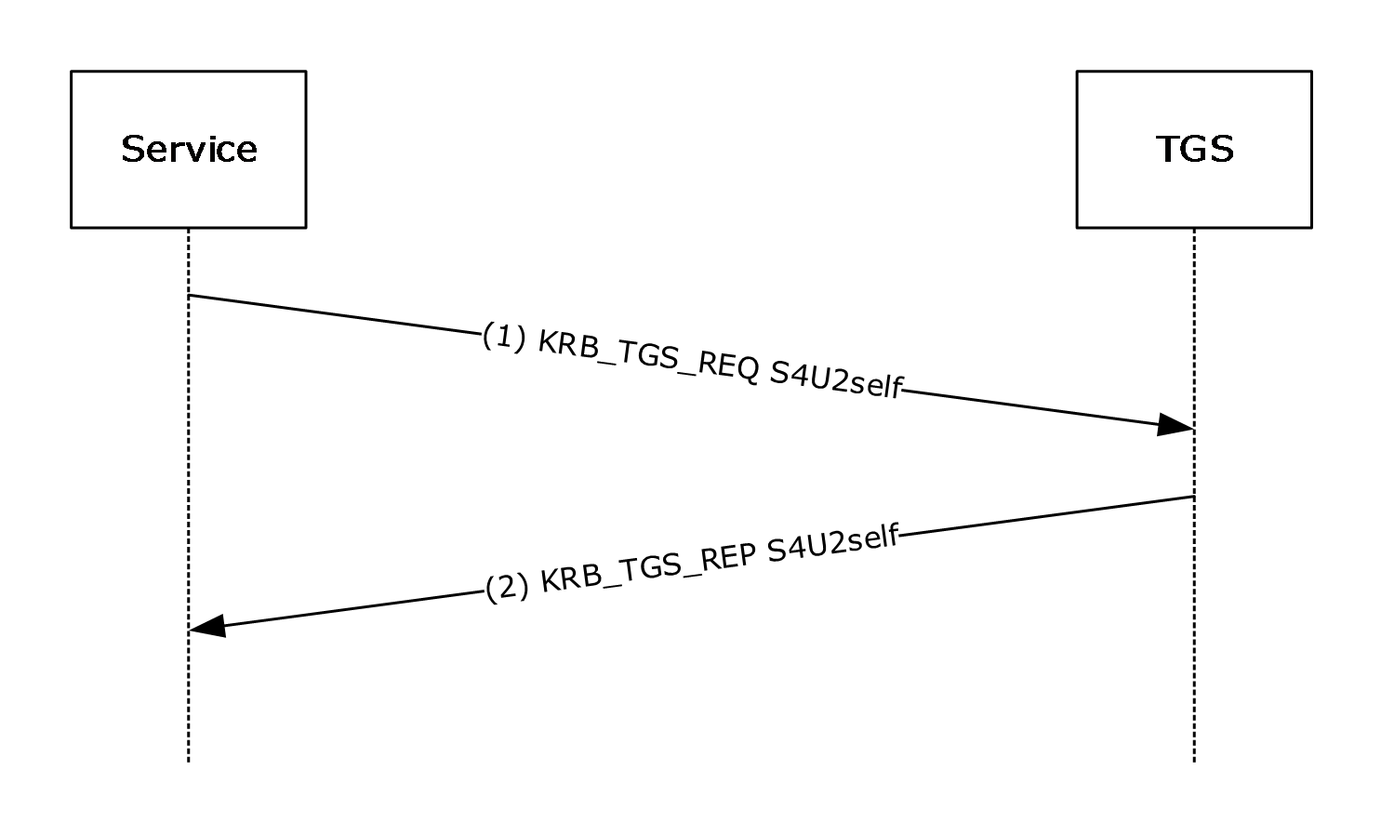
Figure 4: S4U2self KRB_TGS_REQ
The precondition to the previous figure is that the service has already authenticated to the KDC and has a TGT.
In step 1, the service uses the S4U2self extension to retrieve a service ticket to itself on behalf of the user. The service fills out the PA_FOR_USER data structure and sends the KRB_TGS_REQ message to the TGS.
Assuming that the TGS supports the PA_FOR_USER extension, the TGS returns the service ticket for the user in the KRB_TGS_REP message in step 2. The privilege attribute certificate (PAC) returned in the service ticket contains the authorization data, as specified in [MS-PAC] section 3. If the service requested the forwardable option and the local policy of the TGS allows it, the TGS shall set the ticket-flag field to forwardable.

S4U2self Multiple Realm Example
The multiple-realm scenario requires extra KRB_TGS_REQ and KRB_TGS_REP message exchanges. The service retrieves a S4U2self service ticket for the user from the service's KDC. To do so, the service retrieves a TGT for the user to the service's TGS. This is accomplished by first obtaining a TGT to the user's TGS and then following referrals from the user's TGS to the service's TGS.
There are two preconditions to the following figure. The first is that the service has already authenticated to its KDC and has a TGT to its TGS. The second precondition is that the service has identified the realm for the user account. One approach for finding the user's realm is through the use of KRB_AS_REQ messages and using the information returned from the KDC, as specified in [Referrals].
In the following figure, TGS A represents the TGS in the service's realm. TGS B represents the TGS in the user's realm.
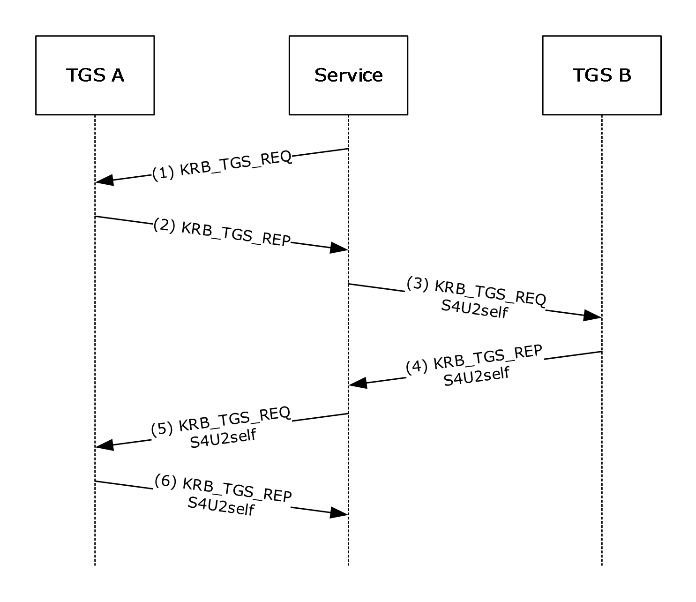
Figure 5: S4U2self Multiple Realm Example
- The service sends a request to its TGS, TGS A, for a TGT to TGS B. No S4U2self information is included in this request.
- TGS A responds with the cross-realm TGT to TGS B. If TGS B was not the user's realm but was instead just a realm closer, then the service would send a KRB_TGS_REQ message to TGS B to get a TGT to the next realm.
- The service now uses the TGT to TGS B to make the S4U2self request in the KRB_TGS_REQ. The service uses the PA-FOR-USER padata type in the request to indicate the user information in the S4U2self request.
- TGS B creates a PAC with the user's authorization information (as specified in [MS-PAC] section 3) and returns it in a TGT referral in the KRB_TGS_REP message. TGS B cannot create the service ticket. TGS B does not possess the service's account information, because the service is part of the realm served by TGS A.
If there are more TGSs involved in the referral chain, steps 3 and 4 will be repeated to follow the chain.
- The server uses the TGT from the referral from step 4 and uses the PA-FOR-USER padata type to request the service ticket to itself on behalf of the user.
- TGS A creates the service ticket for the user to the service and returns it. The PAC returned in this step will contain the appropriate combination of authorization data placed in the PAC by TGS B in step 4 and the data from TGS A in step 6, as specified in [MS-PAC] section 4.1.2.1.

S4U2proxy Example
The following figure depicts a service obtaining a service ticket on behalf of a client to another service, a proxy service. The ticket-granting service (TGS) is the TGS for both the service and the proxy service. It is also assumed that service has already authenticated to the Key Distribution Center (KDC) and has obtained a ticket-granting ticket (TGT) to the TGS.
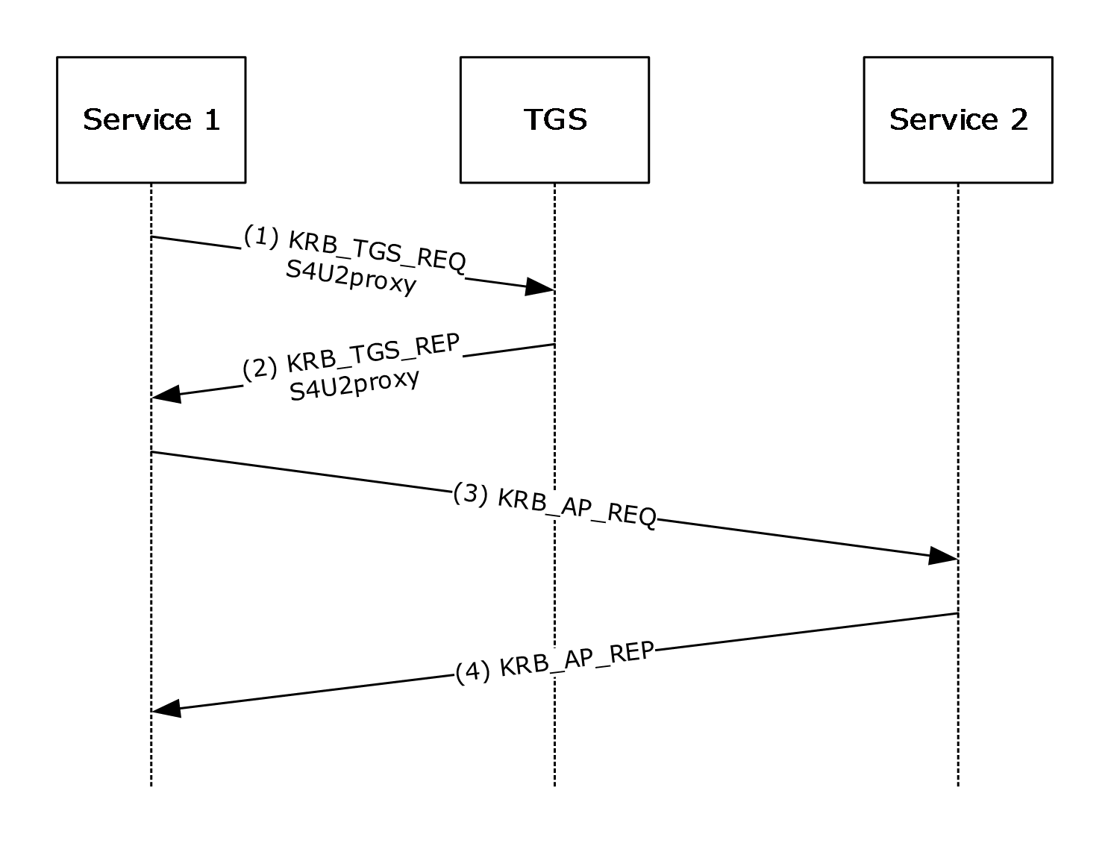
Figure 6: S4U2proxy Example
In step 1, Service 1 is attempting to obtain a service ticket to Service 2 on behalf of the user. Service 1 sends the KRB_TGS_REQ message with the user's service ticket for Service 1 as an additional ticket in the request. Service 1 also sets the CNAME-IN-ADDL-TKT flag in the kdc-options in the request.
The TGS makes sure the forwardable flag is set in the additional-ticket and uses its local policy to determine if Service 1 is allowed to obtain a service ticket on behalf of a user to Service 2. If these conditions are met, the TGS crafts the KRB_TGS_REP message to return a service ticket. This response will contain the cname field of the user that is taken from the additional-ticket, instead of using the cname of Service 1. The forwardable flag will be set in the service ticket. The authorization data in the service ticket will be copied from the service ticket passed to the TGS in the additional-tickets field.
In step 3, Service 1 uses the service ticket from step 2 to contact Service 2. The service ticket will contain the user's name as the cname field. Step 4 shows the KRB_AP_REP message from Service 2 to Service 1 in response to the KRB_AP_REQ message, as described in step 3.<25>

Security

Security Considerations for Implementers
The S4U2self extension allows a service to obtain a service ticket to itself on behalf of a user. This extension is used to obtain authorization data for the user to allow the service to make access control decisions on the local system. As such, the service has to adequately authenticate the user before obtaining the service ticket.
The S4U2proxy extension allows a service to obtain a service ticket to a second service on behalf of a user. When combined with S4U2self, this allows the first service to impersonate any user principal while accessing the second service. This gives any service allowed access to the S4U2proxy extension a degree of power similar to that of the KDC itself. This implies that each of the services allowed to invoke this extension have to be protected nearly as strongly as the KDC and the services are limited to those that the implementer knows to have correct behavior.
A service can confirm that the service ticket did not originate from the client by the S4UTransitedServices field in the S4U_DELEGATION_INFO structure (see [MS-PAC] section 2.9).

Index of Security Parameters
None.

Appendix A: Product Behavior
The information in this specification is applicable to the following Microsoft products or supplemental software. References to product versions include updates to those products.
- Windows 2000 operating system
- Windows XP operating system
- Windows Server 2003 operating system
- Windows Vista operating system
- Windows Server 2008 operating system
- Windows 7 operating system
- Windows Server 2008 R2 operating system
- Windows 8 operating system
- Windows Server 2012 operating system
- Windows 8.1 operating system
- Windows Server 2012 R2 operating system
- Windows 10 operating system
- Windows Server 2016 operating system
- Windows Server operating system
- Windows Server 2019 operating system
Exceptions, if any, are noted in this section. If an update version, service pack or Knowledge Base (KB) number appears with a product name, the behavior changed in that update. The new behavior also applies to subsequent updates unless otherwise specified. If a product edition appears with the product version, behavior is different in that product edition.
Unless otherwise specified, any statement of optional behavior in this specification that is prescribed using the terms "SHOULD" or "SHOULD NOT" implies product behavior in accordance with the SHOULD or SHOULD NOT prescription. Unless otherwise specified, the term "MAY" implies that the product does not follow the prescription.
<1> Section 1.3.3: In Windows Server 2003, Windows Vista, Windows Server 2008, Windows 7, and Windows Server 2008 R2, Service 1 and Service 2 have to be in the same realm. The user, however, can be in a different realm.
<2> Section 1.5: Windows 2000 Server operating system and Windows XP will ignore the S4U_DELEGATION_INFO PAC buffer if it is present. Windows 2000 Server and Windows XP can process the PAC_CLIENT_INFO buffer. For more information, see section 3.1.5.1.1.
<3> Section 2.2: The S4U protocol extensions are not supported on Windows 2000 or Windows XP.
<4> Section 2.2.2: Windows Vista, Windows Server 2008, Windows 7, and Windows Server 2008 R2 send the PA-S4U-X509-USER padata type alone if the user's certificate is available. If the user's certificate is not available, it sends both the PA-S4U-X509-USER padata type and the PA-FOR-USER padata type. When the PA-S4U-X509-USER padata type is used without the user's certificate, the certificate field is not present.
Except in Windows Server 2003, Windows domain controllers first look for the information in the PA-S4U-X509-USER padata type if present; if it is not present Windows domain controllers look at the PA-FOR-USER padata type.
In Windows 2000 Server, Windows Server 2003, and Windows Server 2008 operating system with Service Pack 2 (SP2), KDCs do not add the PA-S4U-X509-USER padata type in the encrypted-pa-data field in TGS-REP.
<5> Section 2.2.2: Except in Windows 2000, Windows XP, Windows Server 2003, Windows Vista, and Windows Server 2008, Windows S4U clients always set this option. If the KDC is running Windows Server 2008 R2 operating system, it replies with the same option bit in the reply.
<6> Section 2.2.5: Resource-based constrained delegation is not supported in Windows 2000, Windows XP, Windows Server 2003, Windows Vista, Windows Server 2008, Windows 7, or Windows Server 2008 R2.
<7> Section 3.1: Windows 2000 and Windows XP do not support S4U.
<8> Section 3.1.5.1.1: Claims is not supported in Windows 2000, Windows XP, Windows Server 2003, Windows Vista, Windows Server 2008, Windows 7, or Windows Server 2008 R2.
<9> Section 3.1.5.1.1: Resource-based constrained delegation is not supported in Windows 2000, Windows XP, Windows Server 2003, Windows Vista, Windows Server 2008, Windows 7, or Windows Server 2008 R2.
<10> Section 3.1.5.1.1.2: S4U2self requests using the user's certificate are not supported on Windows 2000, Windows XP, and Windows Server 2003.
On all applicable Windows Server releases except Windows 2000 Server and Windows Server 2003, KDCs support the following mapping options:
- Based on the user principal name (UPN) contained in the SubjectAltName (SAN) field of the certificate
- Based on the issuer name and subject name combination
- Based on the subject name alone
- Based on subject name and serial number in the certificate
- Based on the subject key identifier
- Based on the SHA1 hash of the public key
- Based on the user's email name as defined in [RFC822]
The algorithm used to locate the user account is as follows:
- If the certificate contains an SAN/UPN extension, KDC will use that to map the client. If the certificate contains an SAN/UPN extension and no user object is found based on the UPN, the authentication fails.
- If there is no UPN in the certificate, the KDC constructs the string "X509:<I><S>" (where "I" is the value from the Issuer field and "S" is the value from the Subject field in the certificate) to look up.
- If there is no UPN in the certificate and no user object is located in the previous steps, the client account is looked up based on the distinguished name (DN) of the subject; the KDC constructs the "X509:<S>" string (where "S" is the value from the Subject field in the certificate) to look up.
- If there is no UPN in the certificate and no user object is located in the previous steps, the KDC uses the subject and serial number to construct the "X509:<S><SR>" string (where "S" is the subject name and "SR" is the serial number from the certificate) to look up.
- If there is no UPN in the certificate and no user object is located, and the client certificate contains a subject key identifier, the KDC constructs the "X509:<SKI>" string (where "SKI" is the subject key identifier) to look up.
- If there is no UPN in the certificate and no user object is located in the previous steps, the KDC constructs the "X509:<SHA1-PUKEY>" string to look up.
- If there is no UPN in the certificate and no user object is located in the previous steps, the client account is looked up based on the SAN/822name, and the KDC constructs the "X509:<RFC822>" string to look up.
<11> Section 3.1.5.2.1: Resource-based constrained delegation is not supported in Windows 2000, Windows XP, Windows Server 2003, Windows Vista, Windows Server 2008, Windows 7, or Windows Server 2008 R2.
<12> Section 3.1.5.2.1: Resource-based constrained delegation is not supported in Windows 2000, Windows XP, Windows Server 2003, Windows Vista, Windows Server 2008, Windows 7, or Windows Server 2008 R2.
<13> Section 3.1.5.2.2: In Windows Server 2003, Windows Vista, Windows Server 2008, Windows 7, and Windows Server 2008 R2, the SFU client does not support referrals for S4U2proxy.
<14> Section 3.1.5.2.3: In Windows Server 2003, Windows Vista, Windows Server 2008, Windows 7, and Windows Server 2008 R2, the SFU client does not support KRB-ERR-BADOPTION retries.
<15> Section 3.2: Windows 2000 KDCs do not support S4U.
<16> Section 3.2.1: Windows Server 2003, Windows Server 2008, and Windows Server 2008 R2 KDCs do not support ServicesAllowedToReceiveForwardedTicketsFrom.
<17> Section 3.2.5.1.2: Windows Server 2003, Windows Server 2008, and Windows Server 2008 R2 KDCs do not set the FORWARDABLE ticket flag based on the ServicesAllowedToSendForwardedTicketsTo parameter.
<18> Section 3.2.5.1.2: Windows Server 2003, Windows Server 2008, and Windows Server 2008 R2 KDCs do not set the FORWARDABLE ticket flag based on the ServicesAllowedToSendForwardedTicketsTo parameter.
<19> Section 3.2.5.1.2: In Windows 2000, Windows XP, Windows Server 2003, Windows Vista, Windows Server 2008, Windows 7, or Windows Server 2008 R2, the SidCount field is set to zero and the ExtraSids field is NULL.
<20> Section 3.2.5.2: Windows 2000, Windows Server 2003, Windows Server 2008, or Windows Server 2008 R2 KDC will always return KRB-ERR-BADOPTION when not forwardable.
<21> Section 3.2.5.2: Windows Server 2003, Windows Server 2008, and Windows Server 2008 R2 KDCs return KRB-ERR-BADOPTION whenever Service 1 and Service 2 do not belong to the same realm.
<22> Section 3.2.5.2.1: Windows Server 2003, Windows Server 2008, and Windows Server 2008 R2 KDCs do not support ServicesAllowedToReceiveForwardedTicketsFrom.
<23> Section 3.2.5.2.1: Windows Server 2003, Windows Server 2008, and Windows Server 2008 R2 KDCs do not support ServicesAllowedToReceiveForwardedTicketsFrom.
<24> Section 3.2.5.2.1.1: Windows Server 2003, Windows Server 2008, and Windows Server 2008 R2 KDCs do not support ServicesAllowedToReceiveForwardedTicketsFrom.
<25> Section 4.3: The TGS checks the service's account in Active Directory for the Allowed-to-Authenticate-for-Delegation setting. The UserAccountControl flag for this feature is 0x1000000.
The following behavior is applicable to Windows 7 and Windows Server 2008 R2 only: The padata type PA-S4U-X509-USER (ID 130) is used in the encrypted-pa-data and the KERB_S4U_OPTIONS_use_reply_key_usage option bit is set (KERB_S4U_OPTIONS_use_reply_key_usage is described in section 2.2.2).

Change Tracking
This section identifies changes that were made to this document since the last release. Changes are classified as Major, Minor, or None.
The revision class Major means that the technical content in the document was significantly revised. Major changes affect protocol interoperability or implementation. Examples of major changes are:
- A document revision that incorporates changes to interoperability requirements.
- A document revision that captures changes to protocol functionality.
The revision class Minor means that the meaning of the technical content was clarified. Minor changes do not affect protocol interoperability or implementation. Examples of minor changes are updates to clarify ambiguity at the sentence, paragraph, or table level.
The revision class None means that no new technical changes were introduced. Minor editorial and formatting changes may have been made, but the relevant technical content is identical to the last released version.
The changes made to this document are listed in the following table. For more information, please contact dochelp@microsoft.com.
Section | Description | Revision class
6 Appendix A: Product Behavior | Added Windows Server 2019 to the applicability list. | Major

Index
A

Abstract data model
KDC 23
service 19
Applicability 14

C

Capability negotiation 14
Change tracking 35
CNAME-IN-ADDL-TKT 17
CNAME-IN-ADDL-TKT message 17

D

Data model - abstract
KDC 23
service 19

E

Examples
S4U2proxy 29
S4U2self multiple realm 27
S4U2self single realm 27

F

Fields - vendor-extensible 14

G

Glossary 6

H

Higher-layer triggered events
KDC 24
service
overview 19
S4U2proxy 19
S4U2self 19

I

Implementer - security considerations 30
Index of security parameters 30
Informative references 9
Initialization
KDC 23
service 19
Introduction 6

K

KDC
abstract data model 23
higher-layer triggered events 24
initialization 23
local events 26
message processing
S4U2proxy KRB_TGS_REQ - receiving 25
S4U2self KRB_TGS_REQ - receiving 24
sequencing rules
S4U2proxy KRB_TGS_REQ - receiving 25
S4U2self KRB_TGS_REQ - receiving 24
timer events 26
timers 23

L

Local events
KDC 26
service 23

M

Message processing
KDC
S4U2proxy KRB_TGS_REQ - receiving 25
S4U2self KRB_TGS_REQ - receiving 24
service
KRB-ERR-BADOPTION - receiving 22
referral - receiving 22
S4U2proxy KRB_TGS_REP - receiving 22
S4U2proxy KRB_TGS_REQ - sending 21
S4U2self KRB_TGS_REP - receiving 21
S4U2self KRB_TGS_REQ - sending 20
Message processing events
service
overview 20
Messages
CNAME-IN-ADDL-TKT 17
PA_S4U_X509_USER 16
PA-FOR-USER 15
PA-PAC-OPTIONS 18
S4U_DELEGATION_INFO 17
syntax 15
transport 15
Multiple realm example - S4U2self 27

N

Normative references 8

O

Overview 10
Overview (synopsis) 9

P

PA_S4U_X509_USER 16
PA_S4U_X509_USER message 16
PA-FOR-USER 15
PA-FOR-USER message 15
PA-PAC-OPTIONS message 18
Parameter index - security 30
Parameters - security index 30
Preconditions 14
Prerequisites 14
Product behavior 31

R

References 8
informative 9
normative 8
Relationship to other protocols 13

S

S4U_DELEGATION_INFO 17
S4U_DELEGATION_INFO message 17
S4U2proxy
example 29
overview 10
S4U2self
multiple realm example 27
overview 9
single realm example 27
Security
implementer considerations 30
parameter index 30
Sequencing rules
KDC
S4U2proxy KRB_TGS_REQ - receiving 25
S4U2self KRB_TGS_REQ - receiving 24
service
KRB-ERR-BADOPTION - receiving 22
overview 20
referral - receiving 22
S4U2proxy KRB_TGS_REP - receiving 22
S4U2proxy KRB_TGS_REQ - sending 21
S4U2self KRB_TGS_REP - receiving 21
S4U2self KRB_TGS_REQ - sending 20
Service
abstract data model 19
higher-layer triggered events
overview 19
S4U2proxy 19
S4U2self 19
initialization 19
local events 23
message processing
KRB-ERR-BADOPTION - receiving 22
referral - receiving 22
S4U2proxy KRB_TGS_REP - receiving 22
S4U2proxy KRB_TGS_REQ - sending 21
S4U2self KRB_TGS_REP - receiving 21
S4U2self KRB_TGS_REQ - sending 20
message processing events
overview 20
overview 19
sequencing rules
KRB-ERR-BADOPTION - receiving 22
overview 20
referral - receiving 22
S4U2proxy KRB_TGS_REP - receiving 22
S4U2proxy KRB_TGS_REQ - sending 21
S4U2self KRB_TGS_REP - receiving 21
S4U2self KRB_TGS_REQ - sending 20
timer events 23
timers 19
Service for User to Proxy (S4U2proxy) extension 21
Service for User to Self (S4U2self) extension 20
Single realm example - S4U2self 27
Standards assignments 14
Synopsis 9
Syntax 15

T

Timer events
KDC 26
service 23
Timers
KDC 23
service 19
Tracking changes 35
Transport 15
Triggered events - higher-layer
KDC 24
service
overview 19
S4U2proxy 19
S4U2self 19

U

User identification
realm and name 20
user's certificate 21

V

Vendor-extensible fields 14
Versioning 14

