[MS-RDPEGT]:
Remote Desktop Protocol: Geometry Tracking Virtual Channel Protocol Extension

Intellectual Property Rights Notice for Open Specifications Documentation
- Technical Documentation. Microsoft publishes Open Specifications documentation (“this documentation”) for protocols, file formats, data portability, computer languages, and standards support. Additionally, overview documents cover inter-protocol relationships and interactions.
- Copyrights. This documentation is covered by Microsoft copyrights. Regardless of any other terms that are contained in the terms of use for the Microsoft website that hosts this documentation, you can make copies of it in order to develop implementations of the technologies that are described in this documentation and can distribute portions of it in your implementations that use these technologies or in your documentation as necessary to properly document the implementation. You can also distribute in your implementation, with or without modification, any schemas, IDLs, or code samples that are included in the documentation. This permission also applies to any documents that are referenced in the Open Specifications documentation.
- No Trade Secrets. Microsoft does not claim any trade secret rights in this documentation.
- Patents. Microsoft has patents that might cover your implementations of the technologies described in the Open Specifications documentation. Neither this notice nor Microsoft's delivery of this documentation grants any licenses under those patents or any other Microsoft patents. However, a given Open Specifications document might be covered by the Microsoft Open Specifications Promise or the Microsoft Community Promise. If you would prefer a written license, or if the technologies described in this documentation are not covered by the Open Specifications Promise or Community Promise, as applicable, patent licenses are available by contacting iplg@microsoft.com.
- Trademarks. The names of companies and products contained in this documentation might be covered by trademarks or similar intellectual property rights. This notice does not grant any licenses under those rights. For a list of Microsoft trademarks, visit www.microsoft.com/trademarks.
- Fictitious Names. The example companies, organizations, products, domain names, email addresses, logos, people, places, and events that are depicted in this documentation are fictitious. No association with any real company, organization, product, domain name, email address, logo, person, place, or event is intended or should be inferred.
Reservation of Rights. All other rights are reserved, and this notice does not grant any rights other than as specifically described above, whether by implication, estoppel, or otherwise.
Tools. The Open Specifications documentation does not require the use of Microsoft programming tools or programming environments in order for you to develop an implementation. If you have access to Microsoft programming tools and environments, you are free to take advantage of them. Certain Open Specifications documents are intended for use in conjunction with publicly available standards specifications and network programming art and, as such, assume that the reader either is familiar with the aforementioned material or has immediate access to it.
Revision Summary
Date | Revision History | Revision Class | Comments
3/30/2012 | 1.0 | New | Released new document.
7/12/2012 | 1.0 | None | No changes to the meaning, language, or formatting of the technical content.
10/25/2012 | 2.0 | Major | Significantly changed the technical content.
1/31/2013 | 2.0 | None | No changes to the meaning, language, or formatting of the technical content.
8/8/2013 | 3.0 | Major | Significantly changed the technical content.
11/14/2013 | 4.0 | Major | Significantly changed the technical content.
2/13/2014 | 4.0 | None | No changes to the meaning, language, or formatting of the technical content.
5/15/2014 | 4.0 | None | No changes to the meaning, language, or formatting of the technical content.
6/30/2015 | 5.0 | Major | Significantly changed the technical content.
10/16/2015 | 5.0 | None | No changes to the meaning, language, or formatting of the technical content.
7/14/2016 | 5.0 | None | No changes to the meaning, language, or formatting of the technical content.
Table of Contents
1 Introduction 5
1.1 Glossary 5
1.2 References 5
1.2.1 Normative References 5
1.2.2 Informative References 6
1.3 Overview 6
1.4 Relationship to Other Protocols 6
1.5 Prerequisites/Preconditions 6
1.6 Applicability Statement 6
1.7 Versioning and Capability Negotiation 6
1.8 Vendor-Extensible Fields 7
1.9 Standards Assignments 7
2 Messages 8
2.1 Transport 8
2.2 Message Syntax 8
2.2.1 Structures 8
2.2.1.1 MAPPED_GEOMETRY_PACKET Structure 8
3 Protocol Details 11
3.1 Common Details 11
3.1.1 Create or Update the Geometry Mapping for a Window 12
3.1.2 Create or Update the Geometry Mapping for an Arbitrary Region 12
3.1.3 Clear the Existing Geometry Mapping 12
3.1.4 Abstract Data Model 12
3.1.5 Timers 13
3.1.6 Initialization 13
3.1.7 Higher-Layer Triggered Events 13
3.1.8 Message Processing Events and Sequencing Rules 13
3.1.8.1 Message Validation 13
3.1.9 Timer Events 13
3.1.10 Other Local Events 13
3.2 Client Details 13
3.2.1 Abstract Data Model 13
3.2.2 Timers 13
3.2.3 Initialization 13
3.2.4 Higher-Layer Triggered Events 14
3.2.5 Message Processing Events and Sequencing Rules 14
3.2.6 Timer Events 14
3.2.7 Other Local Events 14
3.3 Server Details 14
3.3.1 Abstract Data Model 14
3.3.2 Timers 14
3.3.3 Initialization 14
3.3.4 Higher-Layer Triggered Events 14
3.3.5 Message Processing Events and Sequencing Rules 14
3.3.6 Timer Events 14
3.3.7 Other Local Events 14
4 Protocol Examples 15
4.1 MAPPED_GEOMETRY_PACKET – GEOMETRY_UPDATE – Simple Geometry 15
4.1.1 Geometry Buffer (RGNDATA) 16
4.2 MAPPED_GEOMETRY_PACKET – GEOMETRY_CLEAR 17
5 Security 19
5.1 Security Considerations for Implementers 19
5.2 Index of Security Parameters 19
6 Appendix A: Product Behavior 20
7 Change Tracking 21
8 Index 22

Introduction
The Remote Desktop Protocol: Geometry Tracking Virtual Channel Extension is an extension of the Remote Desktop Protocol: Basic Connectivity and Graphics Remoting protocol [MS-RDPBCGR], which runs over a dynamic virtual channel, as specified in [MS-RDPEDYC]. The Remote Desktop Protocol: Geometry Tracking Virtual Channel Extension facilitates applications on a remote desktop host to render graphics content on a remote desktop client without having to explicitly know where the content originated. This protocol specifies the communication between a remote desktop host and a remote desktop client.
Sections 1.5, 1.8, 1.9, 2, and 3 of this specification are normative. All other sections and examples in this specification are informative.

Glossary
This document uses the following terms:
protocol data unit (PDU): Information that is delivered as a unit among peer entities of a network and that may contain control information, address information, or data. For more information on remote procedure call (RPC)-specific PDUs, see [C706] section 12.
Remote Desktop Protocol (RDP): A multi-channel protocol that allows a user to connect to a computer running Microsoft Terminal Services (TS). RDP enables the exchange of client and server settings and also enables negotiation of common settings to use for the duration of the connection, so that input, graphics, and other data can be exchanged and processed between client and server.
terminal server: A computer on which terminal services is running.
Transmission Control Protocol (TCP): A protocol used with the Internet Protocol (IP) to send data in the form of message units between computers over the Internet. TCP handles keeping track of the individual units of data (called packets) that a message is divided into for efficient routing through the Internet.
z-order: The rendering order of an object on a z axis.
MAY, SHOULD, MUST, SHOULD NOT, MUST NOT: These terms (in all caps) are used as defined in [RFC2119]. All statements of optional behavior use either MAY, SHOULD, or SHOULD NOT.

References
Links to a document in the Microsoft Open Specifications library point to the correct section in the most recently published version of the referenced document. However, because individual documents in the library are not updated at the same time, the section numbers in the documents may not match. You can confirm the correct section numbering by checking the Errata.

Normative References
We conduct frequent surveys of the normative references to assure their continued availability. If you have any issue with finding a normative reference, please contact dochelp@microsoft.com. We will assist you in finding the relevant information.
[MS-DTYP] Microsoft Corporation, "Windows Data Types".
[MS-ERREF] Microsoft Corporation, "Windows Error Codes".
[MS-RDPBCGR] Microsoft Corporation, "Remote Desktop Protocol: Basic Connectivity and Graphics Remoting".
[MS-RDPEDYC] Microsoft Corporation, "Remote Desktop Protocol: Dynamic Channel Virtual Channel Extension".
[MSDN-WindowsGDI] Microsoft Corporation, "Windows GDI", http://msdn.microsoft.com/en-us/library/dd145203.aspxx
[RFC2119] Bradner, S., "Key words for use in RFCs to Indicate Requirement Levels", BCP 14, RFC 2119, March 1997, http://www.rfc-editor.org/rfc/rfc2119.txt

Informative References
None.

Overview
This protocol enables a protocol server to send geometry to a protocol client. The protocol client can then use this geometry to render graphics content to the area that is represented by the geometry.
Geometry, in the scope of this document, is defined as a list of rectangles on the virtual desktop. This geometry, when sent coupled with an identifier from the server to the client, allows the client to render some content to a specific location as if it was rendered on the server.

Relationship to Other Protocols
The Remote Desktop Protocol: Geometry Tracking Virtual Channel Extension is embedded in the dynamic virtual channel transport, as defined by [MS-RDPEDYC]. This protocol is concerned with transmitting the raw geometry of some graphics content from the server to the client.

Prerequisites/Preconditions
The Remote Desktop Protocol: Geometry Tracking Virtual Channel Extension operates only after the dynamic virtual channel transport is fully established. If the dynamic virtual channel transport is terminated, no other communication over this protocol extension occurs.
This protocol is message-based. It assumes preservation of the packet as a whole and does not allow for fragmentation. Additionally, it assumes that no packets are lost.
It is assumed that the visible regions of all geometries sent from the server are non-overlapping. If there are any regions that overlap, then the z-order of those regions will be non-deterministic.

Applicability Statement
The Remote Desktop Protocol: Geometry Tracking Virtual Chanel Extension is designed to be run within the context of a Remote Desktop Protocol (RDP) virtual channel established between a client and a server. This protocol extension is applicable when an application running on the terminal server has content from a third party that is rendered directly on the client (as opposed to being rendered on the server and then sent to the client as bitmaps via the Remote Desktop Protocol: Basic Connectivity and Graphics Remoting protocol specified in [MS-RDPBCGR]).

Versioning and Capability Negotiation
This protocol supports versioning and capability negotiation only when the underlying virtual channel attempts to open. A client that supports this protocol does allow this virtual channel to be opened, and a client that does not support this protocol does not allow this virtual channel to be opened.

Vendor-Extensible Fields
The Remote Desktop Protocol: Geometry Tracking Virtual Chanel Extension uses HRESULTs as specified in [MS-ERREF] section 2.1. Vendors are free to choose their own values as long as the C bit (0x20000000) is set, indicating that it is a customer code.
This protocol also uses Win32 error codes. These values are taken from the error number space as specified in [MS-ERREF] section 2.2. Vendors SHOULD reuse those values with their indicated meanings. Choosing any other value runs the risk of a collision in the future.

Standards Assignments
None.

Messages

Transport
The Remote Desktop Protocol: Geometry Tracking Virtual Channel Extension is designed to operate over dynamic virtual channels, as specified in [MS-RDPEDYC]. The channel name used for this protocol is "Microsoft::Windows::RDS::Geometry::v08.01". The use of channel names when opening a dynamic virtual channel is specified in [MS-RDPEDYC] section 2.2.2.1.
This channel MUST be implemented using a reliable protocol, such as TCP. Messages written to this channel are assumed to arrive in their entirety and in order on the opposite side of the connection.

Message Syntax

Structures

MAPPED_GEOMETRY_PACKET Structure
The MAPPED_GEOMETRY_PACKET protocol data unit (PDU) is the only message sent as part of this protocol. It consists of a command, geometry (rectangles), and an identifier that allows correlation of the geometry in the current message to any previous geometry the server has sent.
0 | 1 | 2 | 3 | 4 | 5 | 6 | 7 | 8 | 9 | 1  0 | 1 | 2 | 3 | 4 | 5 | 6 | 7 | 8 | 9 | 2  0 | 1 | 2 | 3 | 4 | 5 | 6 | 7 | 8 | 9 | 3  0 | 1
cbGeometryData
Version
MappingId
...
UpdateType
Flags
TopLevelId
...
Left
Top
Right
Bottom
TopLevelLeft
TopLevelTop
TopLevelRight
TopLevelBottom
GeometryType
cbGeometryBuffer
pGeometryBuffer (variable)
...
Reserved
cbGeometryData (4 bytes): UINT32. The length, in bytes, of this message.
Version (4 bytes): UINT32. The current version of the Remote Desktop Protocol: Geometry Tracking Virtual Channel Extension. In RDP 8, this MUST be set to 0x01.
MappingId (8 bytes): UINT64. A number that uniquely identifies this geometry mapping on the server. The server MUST ensure that mapping IDs are unique across all active mappings. If a message arrives at the client with the same mapping ID as an already known mapping ID, then the geometry associated with the previous mapping MUST be updated with the geometry contained in the current mapping.
UpdateType (4 bytes): UINT32. A number that identifies which operation the client is to perform. The following values are supported:
- 0x01 – GEOMETRY_UPDATE
- 0x02 – GEOMETRY_CLEAR
If the command is to clear geometry, only the MappingId, Version, and cbGeometryData fields are valid.
Flags (4 bytes): UINT32. This field is reserved and MUST be set to 0x0.
TopLevelId (8 bytes): UINT64. If window tracking mode is in effect (see section 3.1.1), this field MUST be set to the window handle of the top-level parent of the window being tracked, or to the window handle of the window itself, if it is a top-level window. If window tracking mode is not in effect (see section 3.1.2), this field MUST be set to 0x0. When window tracking mode is in effect, this field SHOULD be used to create a window hierarchy between the tracked window and top-level window only if the top-level window information is available through other channels. If the top-level window information is not available, this value SHOULD be ignored.
Left (4 bytes): INT32. The position of the left edge of the tracked rectangle, relative to the top-level parent rectangle (labeled Left in Figure 1).
Top (4 bytes): INT32. The position of the top edge of the tracked rectangle, relative to the top-level parent rectangle (labeled Top in Figure 1).
Right (4 bytes): INT32. The position of the right edge of the tracked rectangle relative to the top-level parent rectangle (see Left + Tracked-rectangle width in Figure 1).
Bottom (4 bytes): INT32. The position of the bottom edge of the tracked rectangle, relative to the top-level parent rectangle (see Top + Tracked-rectangle height in Figure 1).
TopLevelLeft (4 bytes): INT32. The position of the left edge of the top-level rectangle in virtual desktop coordinates (labeled TopLevelLeft in Figure 1 and Figure 2).
TopLevelTop (4 bytes): INT32. The position of the top edge of the top-level rectangle in virtual desktop coordinates (labeled TopLevelTop in Figure 1 and Figure 2).
TopLevelRight (4 bytes): INT32. The position of the right edge of the top-level rectangle in virtual desktop coordinates (see TopLevelLeft + Top-level parent rectangle width in Figure 1).
TopLevelBottom (4 bytes): INT32. The position of the bottom edge of the top-level rectangle in virtual desktop coordinates (see TopLevelTop + Top-level parent rectangle height in Figure 1).
GeometryType (4 bytes): UINT32. This MUST be set to 0x02 in RDP 8.
cbGeometryBuffer (4 bytes): UINT32. The length of the pGeometryBuffer appended to this message.
pGeometryBuffer (variable): Array of UINT8 ([MS-DTYP] section 2.2.47). This field contains a RGNDATA structure, as specified in [MSDN-WindowsGDI]. The rectangles in this structure are relative to the tracked rectangle, and represent the parts of the tracked rectangle that are visible. If window tracking mode is not in effect, the rcBound field in the RGNDATA structure MUST be ignored. The total number of bytes in this field is set in the cbGeometryBuffer field.
Reserved (1 byte): UINT8 ([MS-DTYP] section 2.2.47). This field is reserved and MUST be ignored.

Protocol Details

Common Details
The Remote Desktop Protocol: Geometry Tracking Virtual Channel Extension consists of a single message that is sent from the server to the client with different parameters in order to signal different states to the client. These states are as follows:
- Create or update a geometry mapping for a window.
- Create or update a geometry mapping for an arbitrary region of a window.
- Clear an existing geometry mapping.
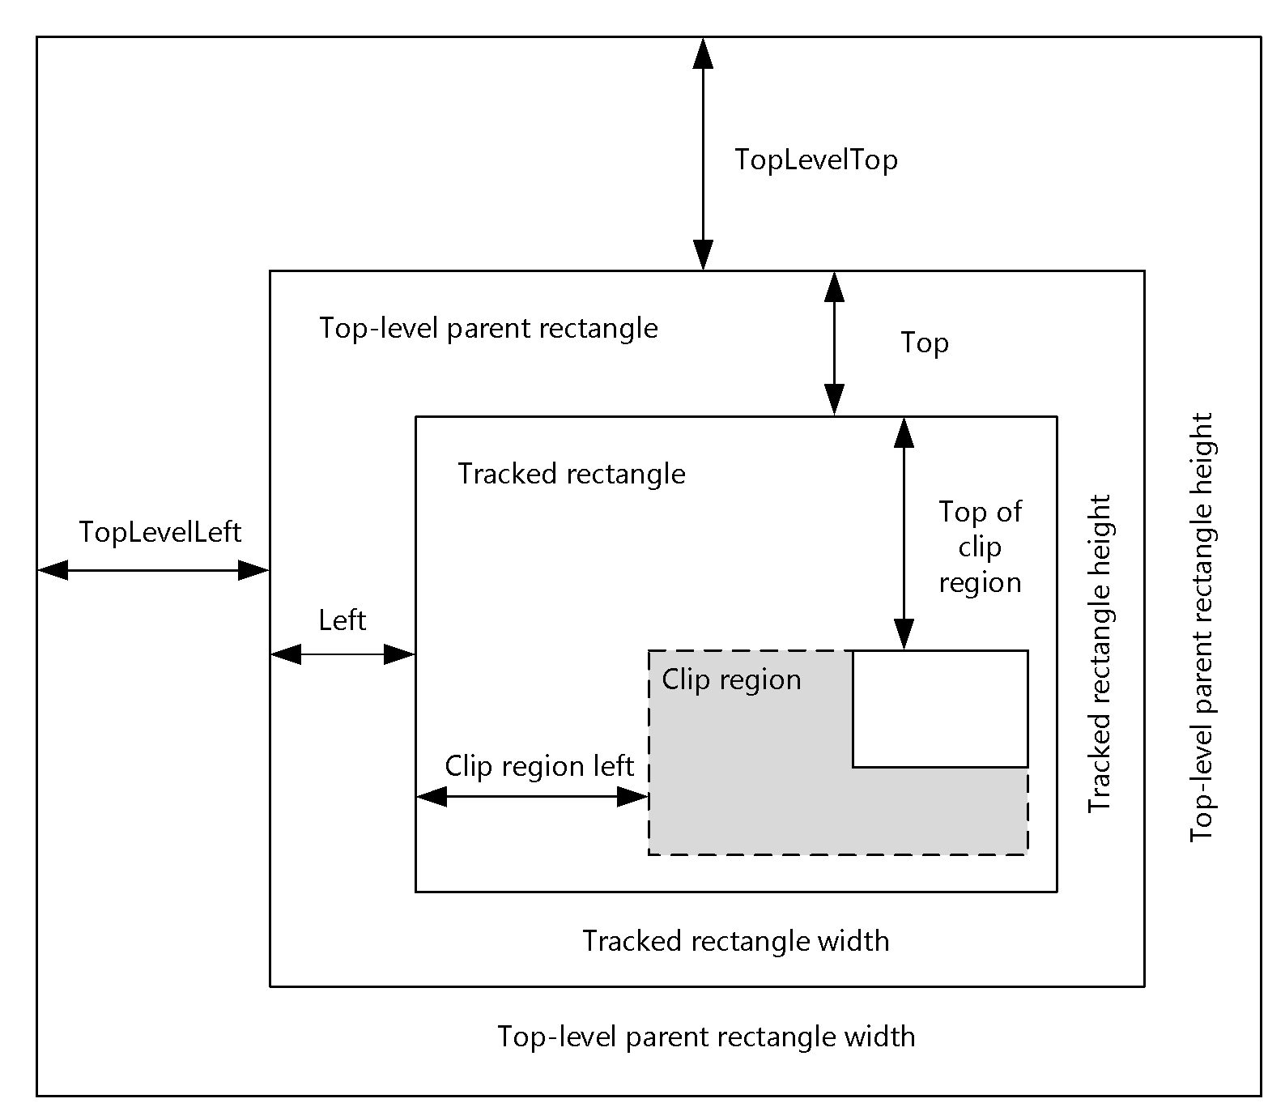
Figure 1: Complete window tracking
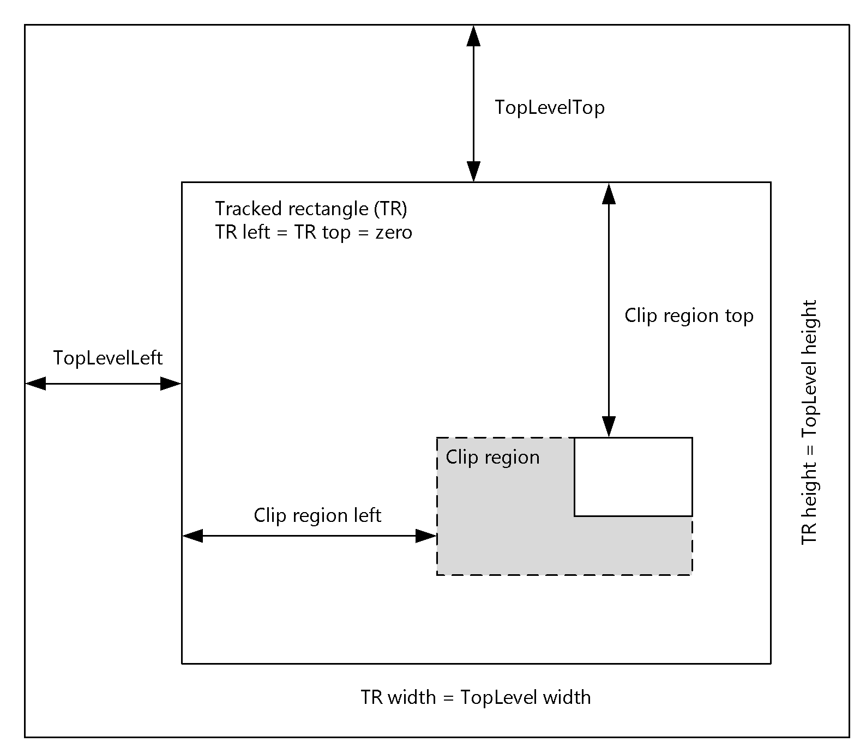
Figure 2: Partial window tracking

Create or Update the Geometry Mapping for a Window
In this mode, it is assumed that the region being tracked represents the visible area of a window on the server. In this case, the window being tracked corresponds to the tracked rectangle, and its top-level parent corresponds to the top-level parent rectangle.

Create or Update the Geometry Mapping for an Arbitrary Region
In this mode, it is assumed that the region being tracked is arbitrary. In this mode, the tracked rectangle is the width and height of the region of interest, with the top-level parent rectangle controlling the position.

Clear the Existing Geometry Mapping
When clearing a mapping, the server is expressing intent to no longer send any updates for the mapping ID indicated in the message. Any and all geometry associated with that mapping MUST be deleted, and the screen MUST be updated accordingly. If no geometry is associated with the mapping ID indicated in the message, then the message MUST be ignored.

Abstract Data Model
None.

Timers
None.

Initialization
There is no specific initialization for the Remote Desktop Protocol: Geometry Tracking Virtual Channel Extension. Each message is wholly self-contained and, since the network transport is assumed to be lossless, current. Each message will contain either geometry specific to a particular mapping (which MUST then be either updated if known or created if not known) or instructions to clear a mapping if it exists. Aside from this logic, there is no additional handling or processing necessary.

Higher-Layer Triggered Events
None.

Message Processing Events and Sequencing Rules

Message Validation
In all cases, the protocol endpoints MUST validate messages received from the network by validating:
- That the length of the message matches the specified type.
- That the message is received at an appropriate time in the sequence.
- The message content.

Timer Events
None.

Other Local Events
None.

Client Details

Abstract Data Model
The abstract data model is as specified in section 3.1.4.

Timers
None.

Initialization
There is no specific initialization for the Remote Desktop Protocol: Geometry Tracking Virtual Channel Extension. Each message is wholly self-contained and, since the network transport is assumed to be lossless, current.

Higher-Layer Triggered Events
None.

Message Processing Events and Sequencing Rules
None.

Timer Events
None.

Other Local Events
None.

Server Details

Abstract Data Model
The abstract data model is as specified in section 3.1.4.

Timers
None.

Initialization
There is no specific initialization for the Remote Desktop Protocol: Geometry Tracking Virtual Channel Extension. Each message is wholly self-contained and, since the network transport is assumed to be lossless, current.

Higher-Layer Triggered Events
None.

Message Processing Events and Sequencing Rules
None.

Timer Events
None.

Other Local Events
None.

Protocol Examples
In this section, two packets will be examined. The first example shows a MAPPED_GEOMETRY_PACKET with the UpdateType field set to GEOMETRY_UPDATE and a simple geometry. The second example shows a MAPPED_GEOMETRY_PACKET with the UpdateType field set to GEOMETRY_CLEAR.

MAPPED_GEOMETRY_PACKET – GEOMETRY_UPDATE – Simple Geometry
This example shows geometry that expresses a simple rectangle of size 480x244 pixels. The raw packet data is as follows:
78000000 01000000 22020400 BA7A0080 01000000 00000000 E2010300 00000000
10000000 8A000000 F0010000 7E010000 23010000 72000000 78040000 CA020000
02000000 30000000 20000000 01000000 01000000 00000000 00000000 00000000
E0010000 F4000000 00000000 00000000 E0010000 F4000000 00
MAPPED_GEOMETRY_PACKET:
- UINT32 cbGeometryData – 78000000
- 0x00000078 = 120 (bytes)
- UINT32 Version – 01000000
- 0x00000001 = 1
- UINT64 MappingId - 22020400 BA7A0080
- 0x80007ABA00040222
- UINT32 UpdateType – 01000000
- 0x00000001 = 1 (GEOMETRY_UPDATE)
- UINT32 Flags – 00000000
- 0x00000000 = 0
- UINT64 TopLevelId - E2010300 00000000
- 0x00000000’000301E2
- INT32 Left – 10000000
- 0x00000010 = 16
- INT32 Top – 8A000000
- 0x0000008A = 138
- INT32 Right – F0010000
- 0x000001F0 = 496
- INT32 Bottom – 7E010000
- 0x0000017E = 382
- INT32 TopLevelLeft – 23010000
- 0x00000123 = 291
- INT32 TopLevelTop – 71000000
- 0x00000071 = 114
- INT32 TopLevelRight – 78040000
- 0x00000478 = 1144
- INT32 TopLevelBottom – CA010000
- 0x000001CA = 714
- UINT32 GeometryType – 02000000
- 0x00000002 = 2 (GEOMETRY_TYPE_REGION)
- UINT32 cbGeometryBuffer – 30000000
- 0x00000030 = 48 (bytes)
- BYTE pGeometryBuffer[48] – (Cast to RGNDATA)
UINT8 Reserved - 00

Geometry Buffer (RGNDATA)
- UINT32 RGNDATA.rdh.dwSize – 20000000
- 0x00000020 = 32 (bytes)
- UINT32 RGNDATA.rdh.iType – 01000000
- 0x00000001 = 1 (RDH_RECTANGLES)
- UINT32 RGNDATA.rdh.nCount – 01000000
- 0x00000001 = 1
- UINT32 RGNDATA.rdh.nRgnSize – 00000000
- 0x00000000 = 0
- INT32 RGNDATA.rdh.rcBound.left - 00000000
- 0x00000000 = 0
- INT32 RGNDATA.rdh.rcBound.top – 00000000
- 0x00000000 = 0
- INT32 RGNDATA.rdh.rcBound.right – E0010000
- 0x000001E0 = 480
- INT32 RGNDATA.rdh.rcBound.bottom – F4000000
- 0x000000F4 = 244
- INT32 ((RECT*)RGNDATA.Buffer)[0].left – 00000000
- 0x00000000 = 0
- INT32 ((RECT*)RGNDATA.Buffer)[0].top – 00000000
- 0x00000000 = 0
- INT32 ((RECT*)RGNDATA.Buffer)[0].right – E0010000
- 0x000001E0 = 480
- INT32 ((RECT*)RGNDATA.Buffer)[0].bottom – F4000000
0x000000F4 = 244

MAPPED_GEOMETRY_PACKET – GEOMETRY_CLEAR
This example shows geometry that clears an existing mapping. The raw packet data is as follows:
48000000 01000000 22020400 BA7A0080 02000000 00000000 00000000 00000000
00000000 00000000 00000000 00000000 00000000 00000000 00000000 00000000
00000000 00000000 00
MAPPED_GEOMETRY_PACKET:
- UINT32 cbGeometryData – 48000000
- 0x00000048 = 72 (bytes)
- UINT32 Version – 01000000
- 0x00000001 = 1
- UINT64 MappingId - 22020400 BA7A0080
- 0x80007ABA00040222
- UINT32 UpdateType – 02000000
- 2 (GEOMETRY_CLEAR)
- UINT32 Flags – 00000000
- 0x00000000 = 0
- UINT64 TopLevelId - 00000000 00000000
- 0x00000000’00000000 = 0x0
- INT32 Left – 00000000
- 0x00000000 = 0
- INT32 Top – 00000000
- 0x00000000 = 0
- INT32 Right – 00000000
- 0x00000000 = 0
- INT32 Bottom – 00000000
- 0x00000000 = 0
- INT32 TopLevelLeft – 00000000
- 0x00000000 = 0
- INT32 TopLevelTop – 00000000
- 0x00000000 = 0
- INT32 TopLevelRight – 00000000
- 0x00000000 = 0
- INT32 TopLevelBottom – 00000000
- 0x00000000 = 0
- UINT32 GeometryType – 00000000
- 0x00000000 = 0
- UINT32 cbGeometryBuffer – 00000000
- 0x00000000 = 0 (bytes)
UINT8 Reserved - 00

Security

Security Considerations for Implementers
There are no security considerations for the Remote Desktop Protocol: Geometry Tracking Virtual Channel Extension messages because all traffic is secured by the underlying RDP core protocol. For information about the security-related mechanisms that are implemented in the RDP core protocol, see [MS-RDPBCGR] section 5.

Index of Security Parameters
The security considerations are the same as those in [MS-RDPBCGR]. The Virtual Channel security considerations that this protocol uses are covered under that protocol.

Appendix A: Product Behavior
The information in this specification is applicable to the following Microsoft products or supplemental software. References to product versions include released service packs.
- Windows 8 operating system
- Windows Server 2012 operating system
- Windows 8.1 operating system
- Windows Server 2012 R2 operating system
- Windows 10 operating system
- Windows Server 2016 operating system
Exceptions, if any, are noted below. If a service pack or Quick Fix Engineering (QFE) number appears with the product version, behavior changed in that service pack or QFE. The new behavior also applies to subsequent service packs of the product unless otherwise specified. If a product edition appears with the product version, behavior is different in that product edition.
Unless otherwise specified, any statement of optional behavior in this specification that is prescribed using the terms SHOULD or SHOULD NOT implies product behavior in accordance with the SHOULD or SHOULD NOT prescription. Unless otherwise specified, the term MAY implies that the product does not follow the prescription.

Change Tracking
No table of changes is available. The document is either new or has had no changes since its last release.

Index
A

Abstract data model
client 13
server 14
Applicability 6

C

Capability negotiation 6
Change tracking 21
Client
abstract data model 13
higher-layer triggered events 14
initialization 13
message processing 14
validation 13
other local events 14
overview 11
sequencing rules 14
validating messages 13
timer events 14
timers 13

D

Data model - abstract
client 13
server 14

F

Fields - vendor-extensible 7

G

Glossary 5

H

Higher-layer triggered events
client 14
server 14

I

Implementer - security considerations 19
Index of security parameters 19
Informative references 6
Initialization
client 13
server 14
Introduction 5

M

Message processing
client 14
validating messages 13
server 14
validating messages 13
Messages
transport 8

N

Normative references 5

O

Other local events
client 14
server 14
Overview (synopsis) 6

P

Parameters - security index 19
Preconditions 6
Prerequisites 6
Product behavior 20
Proxy
overview 11

R

References 5
informative 6
normative 5
Relationship to other protocols 6

S

Security
implementer considerations 19
parameter index 19
Sequencing rules
client 14
validating messages 13
server 14
validating messages 13
Server
abstract data model 14
higher-layer triggered events 14
initialization 14
message processing 14
validation 13
other local events 14
overview 11
sequencing rules 14
validating messages 13
timer events 14
timers 14
Standards assignments 7

T

Timer events
client 14
server 14
Timers
client 13
server 14
Tracking changes 21
Transport 8
Triggered events - higher-layer
client 14
server 14

V

Validating messages 13
Vendor-extensible fields 7
Versioning 6

