[MS-MSBD]:
Media Stream Broadcast Distribution (MSBD) Protocol

Intellectual Property Rights Notice for Open Specifications Documentation
- Technical Documentation. Microsoft publishes Open Specifications documentation (“this documentation”) for protocols, file formats, data portability, computer languages, and standards support. Additionally, overview documents cover inter-protocol relationships and interactions.
- Copyrights. This documentation is covered by Microsoft copyrights. Regardless of any other terms that are contained in the terms of use for the Microsoft website that hosts this documentation, you can make copies of it in order to develop implementations of the technologies that are described in this documentation and can distribute portions of it in your implementations that use these technologies or in your documentation as necessary to properly document the implementation. You can also distribute in your implementation, with or without modification, any schemas, IDLs, or code samples that are included in the documentation. This permission also applies to any documents that are referenced in the Open Specifications documentation.
- No Trade Secrets. Microsoft does not claim any trade secret rights in this documentation.
- Patents. Microsoft has patents that might cover your implementations of the technologies described in the Open Specifications documentation. Neither this notice nor Microsoft's delivery of this documentation grants any licenses under those patents or any other Microsoft patents. However, a given Open Specifications document might be covered by the Microsoft Open Specifications Promise or the Microsoft Community Promise. If you would prefer a written license, or if the technologies described in this documentation are not covered by the Open Specifications Promise or Community Promise, as applicable, patent licenses are available by contacting iplg@microsoft.com.
- Trademarks. The names of companies and products contained in this documentation might be covered by trademarks or similar intellectual property rights. This notice does not grant any licenses under those rights. For a list of Microsoft trademarks, visit www.microsoft.com/trademarks.
- Fictitious Names. The example companies, organizations, products, domain names, email addresses, logos, people, places, and events that are depicted in this documentation are fictitious. No association with any real company, organization, product, domain name, email address, logo, person, place, or event is intended or should be inferred.
Reservation of Rights. All other rights are reserved, and this notice does not grant any rights other than as specifically described above, whether by implication, estoppel, or otherwise.
Tools. The Open Specifications documentation does not require the use of Microsoft programming tools or programming environments in order for you to develop an implementation. If you have access to Microsoft programming tools and environments, you are free to take advantage of them. Certain Open Specifications documents are intended for use in conjunction with publicly available standards specifications and network programming art and, as such, assume that the reader either is familiar with the aforementioned material or has immediate access to it.
Revision Summary
Date | Revision History | Revision Class | Comments
10/22/2006 | 0.01 | New | Version 0.01 release
1/19/2007 | 1.0 | Major | Version 1.0 release
3/2/2007 | 1.1 | Minor | Version 1.1 release
4/3/2007 | 1.2 | Minor | Version 1.2 release
5/11/2007 | 1.3 | Minor | Version 1.3 release
6/1/2007 | 2.0 | Major | Updated and revised the technical content.
7/3/2007 | 2.0.1 | Editorial | Changed language and formatting in the technical content.
7/20/2007 | 3.0 | Major | Updated and revised the technical content.
8/10/2007 | 4.0 | Major | Updated and revised the technical content.
9/28/2007 | 4.1 | Minor | Clarified the meaning of the technical content.
10/23/2007 | 5.0 | Major | Made revisions for maximum field.
11/30/2007 | 5.1 | Minor | Clarified the meaning of the technical content.
1/25/2008 | 5.1.1 | Editorial | Changed language and formatting in the technical content.
3/14/2008 | 5.1.2 | Editorial | Changed language and formatting in the technical content.
5/16/2008 | 5.1.3 | Editorial | Changed language and formatting in the technical content.
6/20/2008 | 5.1.4 | Editorial | Changed language and formatting in the technical content.
7/25/2008 | 5.1.5 | Editorial | Changed language and formatting in the technical content.
8/29/2008 | 5.1.6 | Editorial | Changed language and formatting in the technical content.
10/24/2008 | 5.1.7 | Editorial | Changed language and formatting in the technical content.
12/5/2008 | 5.1.8 | Editorial | Changed language and formatting in the technical content.
1/16/2009 | 5.1.9 | Editorial | Changed language and formatting in the technical content.
2/27/2009 | 5.1.10 | Editorial | Changed language and formatting in the technical content.
4/10/2009 | 5.1.11 | Editorial | Changed language and formatting in the technical content.
5/22/2009 | 5.1.12 | Editorial | Changed language and formatting in the technical content.
7/2/2009 | 5.1.13 | Editorial | Changed language and formatting in the technical content.
8/14/2009 | 5.1.14 | Editorial | Changed language and formatting in the technical content.
9/25/2009 | 5.2 | Minor | Clarified the meaning of the technical content.
11/6/2009 | 5.2.1 | Editorial | Changed language and formatting in the technical content.
12/18/2009 | 5.2.2 | Editorial | Changed language and formatting in the technical content.
1/29/2010 | 5.3 | Minor | Clarified the meaning of the technical content.
3/12/2010 | 5.3.1 | Editorial | Changed language and formatting in the technical content.
4/23/2010 | 5.3.2 | Editorial | Changed language and formatting in the technical content.
6/4/2010 | 5.3.3 | Editorial | Changed language and formatting in the technical content.
7/16/2010 | 5.3.3 | None | No changes to the meaning, language, or formatting of the technical content.
8/27/2010 | 5.3.3 | None | No changes to the meaning, language, or formatting of the technical content.
10/8/2010 | 5.3.3 | None | No changes to the meaning, language, or formatting of the technical content.
11/19/2010 | 5.3.3 | None | No changes to the meaning, language, or formatting of the technical content.
1/7/2011 | 5.3.3 | None | No changes to the meaning, language, or formatting of the technical content.
2/11/2011 | 5.3.3 | None | No changes to the meaning, language, or formatting of the technical content.
3/25/2011 | 5.3.3 | None | No changes to the meaning, language, or formatting of the technical content.
5/6/2011 | 5.3.3 | None | No changes to the meaning, language, or formatting of the technical content.
6/17/2011 | 5.4 | Minor | Clarified the meaning of the technical content.
9/23/2011 | 5.4 | None | No changes to the meaning, language, or formatting of the technical content.
12/16/2011 | 5.4 | None | No changes to the meaning, language, or formatting of the technical content.
3/30/2012 | 5.4 | None | No changes to the meaning, language, or formatting of the technical content.
7/12/2012 | 5.4 | None | No changes to the meaning, language, or formatting of the technical content.
10/25/2012 | 5.4 | None | No changes to the meaning, language, or formatting of the technical content.
1/31/2013 | 5.4 | None | No changes to the meaning, language, or formatting of the technical content.
8/8/2013 | 5.4 | None | No changes to the meaning, language, or formatting of the technical content.
11/14/2013 | 5.4 | None | No changes to the meaning, language, or formatting of the technical content.
2/13/2014 | 5.4 | None | No changes to the meaning, language, or formatting of the technical content.
5/15/2014 | 5.4 | None | No changes to the meaning, language, or formatting of the technical content.
6/30/2015 | 5.4 | None | No changes to the meaning, language, or formatting of the technical content.
10/16/2015 | 5.4 | None | No changes to the meaning, language, or formatting of the technical content.
7/14/2016 | 5.4 | None | No changes to the meaning, language, or formatting of the technical content.
Table of Contents
1 Introduction 7
1.1 Glossary 7
1.2 References 7
1.2.1 Normative References 7
1.2.2 Informative References 8
1.3 Overview 8
1.4 Relationship to Other Protocols 8
1.5 Prerequisites/Preconditions 8
1.6 Applicability Statement 8
1.7 Versioning and Capability Negotiation 8
1.8 Vendor-Extensible Fields 9
1.9 Standards Assignments 9
2 Messages 10
2.1 Transport 10
2.2 Message Syntax 10
2.2.1 MSBMSGBASE 10
2.2.2 MSB_MSG_RES_PING 11
2.2.3 MSB_MSG_REQ_PING 11
2.2.4 MSB_MSG_REQ_STREAMINFO 12
2.2.5 MSB_MSG_RES_STREAMINFO 12
2.2.6 MSB_MSG_IND_STREAMINFO 14
2.2.7 MSB_MSG_REQ_CONNECT 16
2.2.8 MSB_MSG_RES_CONNECT 16
2.2.9 MSB_MSG_IND_EOS 17
2.2.10 MSB_MSG_IND_PACKET 18
3 Protocol Details 19
3.1 Server Details 19
3.1.1 Abstract Data Model 19
3.1.2 Timers 19
3.1.3 Initialization 19
3.1.4 Higher-Layer Triggered Events 19
3.1.5 Message Processing Events and Sequencing Rules 20
3.1.5.1 Receiving an MSB_MSG_REQ_CONNECT Packet 20
3.1.5.2 Receiving an MSB_MSG_REQ_STREAMINFO Packet 20
3.1.5.3 Reaching the End of the Stream 20
3.1.6 Timer Events 20
3.1.7 Other Local Events 20
3.2 Client Details 20
3.2.1 Abstract Data Model 21
3.2.2 Timers 21
3.2.3 Initialization 21
3.2.4 Higher-Layer Triggered Events 21
3.2.5 Message Processing Events and Sequencing Rules 22
3.2.5.1 Receiving an MSB_MSG_REQ_PING Packet 22
3.2.5.2 Receiving an MSB_MSG_IND_STREAMINFO Packet 22
3.2.6 Timer Events 22
3.2.7 Other Local Events 22
4 Protocol Example 23
4.1 General MSBD Sequence 23
4.2 Using MSBD for Server-Side Playlist Streaming 24
5 Security 26
5.1 Security Considerations for Implementers 26
5.2 Index of Security Parameters 26
6 Appendix A: Product Behavior 27
7 Change Tracking 28
8 Index 29

Introduction
The Media Stream Broadcast Distribution (MSBD) Protocol is a protocol that is used for transferring an audio-visual content stream from a server to a single client or multiple clients.
Sections 1.5, 1.8, 1.9, 2, and 3 of this specification are normative. All other sections and examples in this specification are informative.

Glossary
This document uses the following terms:
.nsc file: A file that serves as an announcement for, and contains information about, a media stream broadcast. This file allows a client to tune in to a broadcast. The .nsc file was originally known as a NetShow Station Configuration file. Because the NetShow protocol suite is now obsolete, the original nomenclature is no longer applicable and is not used. Also known as a Windows Media Station file or an NSC file.
Advanced Systems Format (ASF): An extensible file format that is designed to facilitate streaming digital media data over a network. This file format is used by Windows Media.
HRESULT: An integer value that indicates the result or status of an operation. A particular HRESULT can have different meanings depending on the protocol using it. See [MS-ERREF] section 2.1 and specific protocol documents for further details.
little-endian: Multiple-byte values that are byte-ordered with the least significant byte stored in the memory location with the lowest address.
parity packet: An ASF data packet that contains parity data and is used for reconstructing other lost packets. Unlike other ASF data packets, parity packets always have the Opaque Data Present bit set to 1 in the ASF data packet header.
MAY, SHOULD, MUST, SHOULD NOT, MUST NOT: These terms (in all caps) are used as defined in [RFC2119]. All statements of optional behavior use either MAY, SHOULD, or SHOULD NOT.

References
Links to a document in the Microsoft Open Specifications library point to the correct section in the most recently published version of the referenced document. However, because individual documents in the library are not updated at the same time, the section numbers in the documents may not match. You can confirm the correct section numbering by checking the Errata.

Normative References
We conduct frequent surveys of the normative references to assure their continued availability. If you have any issue with finding a normative reference, please contact dochelp@microsoft.com. We will assist you in finding the relevant information.
[ASF] Microsoft Corporation, "Advanced Systems Format Specification", December 2004, http://download.microsoft.com/download/7/9/0/790fecaa-f64a-4a5e-a430-0bccdab3f1b4/ASF_Specification.doc
[MS-DTYP] Microsoft Corporation, "Windows Data Types".
[MS-ERREF] Microsoft Corporation, "Windows Error Codes".
[MS-MSB] Microsoft Corporation, "Media Stream Broadcast (MSB) Protocol".
[RFC2119] Bradner, S., "Key words for use in RFCs to Indicate Requirement Levels", BCP 14, RFC 2119, March 1997, http://www.rfc-editor.org/rfc/rfc2119.txt

Informative References
None.

Overview
The MSBD Protocol is used for transferring a live stream of audio-visual content from a server to a single client or to multiple clients. For example, the MSBD Protocol might be used when transmitting the digitized sound and images of a lecture from a computer that is encoding the lecture in real time to another computer that is running the appropriate streaming media server software, such as Windows Media Services version 4.1.
The MSBD Protocol can also be used for transmitting a live stream from one Windows Media Services server installation to another. Certain versions of Windows Media Player<1> also support the MSBD Protocol and can use it to monitor a live stream by connecting to a server that is running Windows Media Services or by connecting directly to a real-time encoder.

Relationship to Other Protocols
MSBD packets are encapsulated in TCP. However, one MSBD packet type, MSB_MSG_IND_PACKET, can also be encapsulated in the User Datagram Protocol (UDP). UDP encapsulation mode is only used for transmitting packets to an IPv4 multicast group.<2>

Prerequisites/Preconditions
The MSBD Protocol does not provide a mechanism for a client to discover the URL to the server. Therefore, it is a prerequisite that the client obtain a URL to the server before this protocol can be used.

Applicability Statement
The MSBD Protocol can be used to distribute Advanced Systems Format (ASF) packets over an IP-based network. The MSBD Protocol is designed for distribution of content between servers or from an encoder to a server.<3> The MSBD Protocol is not intended for use by an end-user application, such as Windows Media Player, except for troubleshooting use.
The UDP encapsulation mode of this protocol might not be suitable for content that uses large ASF data packets. Large ASF data packets can cause the UDP packets to be fragmented into multiple IP datagrams, and fragmentation of IP datagrams might be undesirable. When the content uses these large packets, TCP is the recommended encapsulation mode.

Versioning and Capability Negotiation
The MSBD Protocol does not support negotiation of versioning or capabilities. However, server implementations of the MSBD Protocol are not required to support delivery of MSB_MSG_IND_PACKET packets over UDP. If a client requests such delivery, and the server does not support it, the server sends an MSB_MSG_RES_CONNECT packet to indicate that the operation failed.

Vendor-Extensible Fields
This protocol uses HRESULT values as defined in [MS-ERREF]. Vendors can define their own HRESULT values, provided that they set the C bit (0x20000000) for each vendor-defined value, indicating that the value is a customer code.

Standards Assignments
The MSBD Protocol has no applicable standards assignments.

Messages
The following sections specify how MSBD Protocol messages are transported and give details on MSBD Protocol message syntax.
This protocol references commonly used data types as defined in [MS-DTYP].

Transport
MSB_MSG_IND_PACKET packets are encapsulated in UDP packets if IP multicasting is used to deliver those packets. Otherwise, the MSB_MSG_IND_PACKET packets are encapsulated in TCP. All other MSBD Protocol packets MUST be encapsulated in TCP. The UDP and TCP packets MUST be encapsulated in the IP version 4 (IPv4).
There is no officially assigned TCP port for the MSBD Protocol; however, MSBD servers often listen on TCP port 7007 for client requests.

Message Syntax
All 16-bit and 32-bit integer fields MUST be transmitted in little-endian byte order, unless otherwise specified.
All fields that are unsigned 16-bit integers have valid ranges from 0x0000 to 0xFFFF, inclusive, unless otherwise specified.
All fields that are unsigned 32-bit integers have valid ranges from 0x00000000 to 0x0000FFFF, inclusive, unless otherwise specified.

MSBMSGBASE
The MSBMSGBASE header defines the packet header.
0 | 1 | 2 | 3 | 4 | 5 | 6 | 7 | 8 | 9 | 1  0 | 1 | 2 | 3 | 4 | 5 | 6 | 7 | 8 | 9 | 2  0 | 1 | 2 | 3 | 4 | 5 | 6 | 7 | 8 | 9 | 3  0 | 1
dwSignature
wVersion |  |  |  |  |  |  |  |  |  |  |  |  |  |  |  | wMessageId
cbMessage
hr
dwSignature (4 bytes): An unsigned 32-bit integer that identifies the protocol as the MSBD Protocol. This value MUST be 0x2042534D, which is the little-endian representation of the ASCII character sequence "MSB[space]".
wVersion (2 bytes): An unsigned 16-bit integer that represents the version number of the MSBD Protocol. This value is currently 0x0106.
wMessageId (2 bytes): An unsigned 16-bit integer that designates the MSBD packet type. This value MUST be one of the following.
Value | Meaning
0x0001 | Designates an MSB_MSG_REQ_PING packet.
0x0002 | Designates an MSB_MSG_RES_PING packet.
0x0003 | Designates an MSB_MSG_REQ_STREAMINFO packet.
0x0004 | Designates an MSB_MSG_RES_STREAMINFO packet.
0x0005 | Designates an MSB_MSG_IND_STREAMINFO packet.
0x0007 | Designates an MSB_MSG_REQ_CONNECT packet.
0x0008 | Designates an MSB_MSG_RES_CONNECT packet.
0x0009 | Designates an MSB_MSG_IND_EOS packet.
0x000A | Designates an MSB_MSG_IND_PACKET packet.
cbMessage (4 bytes): An unsigned 32-bit integer that contains the byte length of the packet, including the header. The cbMessage field MUST be set to a value in the range 0x0010 to 0xFFFF, inclusive.
hr (4 bytes): An unsigned 32-bit integer field representing the status of an operation. The hr field MUST be set to an HRESULT code. For HRESULT codes, see [MS-ERREF] section 2.1.

MSB_MSG_RES_PING
The client MUST respond with the MSB_MSG_RES_PING packet to the MSB_MSG_REQ_PING packet that is sent by the server. This packet informs the server that the client is still active.
0 | 1 | 2 | 3 | 4 | 5 | 6 | 7 | 8 | 9 | 1  0 | 1 | 2 | 3 | 4 | 5 | 6 | 7 | 8 | 9 | 2  0 | 1 | 2 | 3 | 4 | 5 | 6 | 7 | 8 | 9 | 3  0 | 1
Header (16 bytes)
...
...
Header (16 bytes): An MSBMSGBASE packet that defines the packet header. The wMessageId field MUST be set to 0x0002.

MSB_MSG_REQ_PING
The server MAY send an MSB_MSG_REQ_PING packet to confirm that the client is still active. It is recommended that the server send this packet approximately every 2 minutes. If active, the client MUST respond with an MSB_MSG_RES_PING packet; otherwise, the server SHOULD end the session.
0 | 1 | 2 | 3 | 4 | 5 | 6 | 7 | 8 | 9 | 1  0 | 1 | 2 | 3 | 4 | 5 | 6 | 7 | 8 | 9 | 2  0 | 1 | 2 | 3 | 4 | 5 | 6 | 7 | 8 | 9 | 3  0 | 1
Header (16 bytes)
...
...
Header (16 bytes): An MSBMSGBASE packet that defines the packet header. The wMessageId field MUST be set to 0x0001.

MSB_MSG_REQ_STREAMINFO
The client MAY send the MSB_MSG_REQ_STREAMINFO packet to request information about the media stream. This request is optional because the server always sends the stream information in an MSB_MSG_IND_STREAMINFO packet immediately after sending an MSB_MSG_RES_CONNECT packet. The MSB_MSG_REQ_STREAMINFO packet is deprecated and SHOULD NOT be sent by clients.
0 | 1 | 2 | 3 | 4 | 5 | 6 | 7 | 8 | 9 | 1  0 | 1 | 2 | 3 | 4 | 5 | 6 | 7 | 8 | 9 | 2  0 | 1 | 2 | 3 | 4 | 5 | 6 | 7 | 8 | 9 | 3  0 | 1
Header (16 bytes)
...
...
Header (16 bytes): An MSBMSGBASE packet that defines the packet header. The wMessageId field MUST be set to 0x0003.

MSB_MSG_RES_STREAMINFO
The server MUST respond with an MSB_MSG_RES_STREAMINFO packet to a client MSB_MSG_REQ_STREAMINFO packet that requests media stream information. The structure and purpose of this packet are identical to those of the MSB_MSG_IND_STREAMINFO packet. The client requests media stream information from the server only if the server omits sending the MSB_MSG_IND_STREAMINFO packet immediately after the MSB_MSG_RES_CONNECT packet.
0 | 1 | 2 | 3 | 4 | 5 | 6 | 7 | 8 | 9 | 1  0 | 1 | 2 | 3 | 4 | 5 | 6 | 7 | 8 | 9 | 2  0 | 1 | 2 | 3 | 4 | 5 | 6 | 7 | 8 | 9 | 3  0 | 1
Header (16 bytes)
...
...
wStreamId |  |  |  |  |  |  |  |  |  |  |  |  |  |  |  | cbPacketSize
cTotalPackets
dwBitRate
msDuration
cbTitle
cbDescription
cbLink
cbHeader
bBinaryData (variable)
...
Header (16 bytes): An MSBMSGBASE packet that defines the packet header. The wMessageId field MUST be set to 0x0004.
wStreamId (2 bytes): An unsigned 16-bit integer that uniquely identifies the media stream that is currently being transmitted. The value of this field MUST be identical to the value of wStreamId that is used in the MSB_MSG_IND_STREAMINFO packet that the server transmitted for the current stream. If the server has not transmitted an MSB_MSG_IND_STREAMINFO packet for the current stream, the value of wStreamId MUST be chosen in accordance with the rules for choosing a wStreamId value for an MSB_MSG_IND_STREAMINFO packet. The value of the wStreamId field MUST be in the range 0x0000 to 0xFFFF, inclusive.
cbPacketSize (2 bytes): An unsigned 16-bit integer that specifies the maximum size, in bytes, of the payload in each MSB_MSG_IND_PACKET packet. The value of the cbPacketSize field MUST be in the range 0x0000 to 0xFFFF, inclusive.
cTotalPackets (4 bytes): An unsigned 32-bit integer that MUST be set to the total number of MSB_MSG_IND_PACKET packets that are needed to transmit the entire media stream—if this information is known. Otherwise, the field MUST be set to zero. The value of the cTotalPackets field MUST be in the range 0x00000000 to 0x0000FFFF, inclusive.
dwBitRate (4 bytes): An unsigned 32-bit integer that contains the bit rate, in bits per second, of the media stream that is measured. For an ASF stream, the value of the dwBitRate field corresponds to the value of the Maximum Bitrate field in the ASF File Properties Object. The value of the dwBitRate field MUST be in the range 0x00000000 to 0x0000FFFF, inclusive.
msDuration (4 bytes): An unsigned 32-bit integer that MUST be set to the duration, in milliseconds, of the media stream, if this information is known. Otherwise, this value MUST be set to -1 (FFFFFFFF hexadecimal). For an ASF stream, the value of the msDuration field corresponds to the value of the Play Duration field in the ASF File Properties Object. The value of the msDuration field MUST be in the range 0x00000000 to 0x0000FFFF, inclusive.
cbTitle (4 bytes): An unsigned 32-bit integer that contains the size, in bytes, of the media stream title. The stream title MUST be first in the bBinaryData field. The value of the cbTitle field MUST be in the range 0x00000000 to 0x0000FFCF, inclusive.
cbDescription (4 bytes): An unsigned 32-bit integer that contains the size, in bytes, of the media stream description. The stream description MUST follow the stream title in the bBinaryData field. The value of the cbDescription field MUST be in the range 0x00000000 to 0x0000FFCF, inclusive.
cbLink (4 bytes): An unsigned 32-bit integer that contains the size, in bytes, of the media stream link (an arbitrary moniker for the connection over which the media stream is to be transmitted). The stream link MUST follow the stream description in the bBinaryData field. The value of the cbLink field MUST be in the range 0x00000000 to 0x0000FFCF, inclusive.
cbHeader (4 bytes): An unsigned 32-bit integer that contains the size, in bytes, of the media stream header. The stream header MUST follow the stream link in the bBinaryData field. If the szChannel field of the MSB_MSG_REQ_CONNECT packet is set to NetShow, the stream is in ASF, as specified in [ASF] section 2, and the stream header is an ASF header. In the case of an ASF Header, the value of the cbHeader field is the size of the entire ASF Header Object, as described in [ASF] section 3.1, plus 50 bytes (which represents the fixed initial portion of the ASF Data Object, as described in [ASF] section 5.1). The value of the cbHeader field MUST be in the range 0x00000000 to 0x0000FFCF, inclusive.
bBinaryData (variable): The binary data that contains the title, description, link, and header of the media stream, in that order. The method for generating the binary data comprising the title, description, link or header (if not an ASF header) of the media stream is implementation-specific and outside the scope of this documentation. The size of the bBinaryData field is equal to the sum of the values of the cbTitle, cbDescription, cbLink, and cbHeader fields. The size of the bBinaryData field MUST be in the range of 0 to 65,487 bytes. Note that these requirements impose a restriction on the values that the cbTitle, cbDescription, cbLink, and cbHeader fields can assume. For example, cbTitle and cbDescription cannot both have a value of 0x8000 at the same time.

MSB_MSG_IND_STREAMINFO
The server MUST send the MSB_MSG_IND_STREAMINFO packet, which describes the media stream, in the following circumstances:
- Following an MSB_MSG_RES_CONNECT packet.
- When a stream switch occurs while playing a server playlist.
- Following an MSB_MSG_IND_EOS packet. For more information about sending an MSB_MSG_IND_STREAMINFO packet in this case, see section 3.1.5.3.
0 | 1 | 2 | 3 | 4 | 5 | 6 | 7 | 8 | 9 | 1  0 | 1 | 2 | 3 | 4 | 5 | 6 | 7 | 8 | 9 | 2  0 | 1 | 2 | 3 | 4 | 5 | 6 | 7 | 8 | 9 | 3  0 | 1
Header (16 bytes)
...
...
wStreamId |  |  |  |  |  |  |  |  |  |  |  |  |  |  |  | cbPacketSize
cTotalPackets
dwBitRate
msDuration
cbTitle
cbDescription
cbLink
cbHeader
bBinaryData (variable)
...
Header (16 bytes): An MSBMSGBASE packet that defines the packet header. The wMessageId field MUST be set to 0x0005.
wStreamId (2 bytes): An unsigned 16-bit integer that uniquely identifies the media stream that will be transmitted, within the current server playlist. The value of this field can be chosen arbitrarily by the server; however, it MUST be different from the wStreamId values that are used for any other streams in the same server playlist. This allows the client to distinguish MSB_MSG_IND_PACKET packets that belong to the new stream from MSB_MSG_IND_PACKET packets that belong to previous streams (if any). The value of the wStreamId field MUST be in the range 0x0000 to 0x07FF, inclusive, or in the range 0x8000 to 0x87FF, inclusive.
cbPacketSize (2 bytes): An unsigned 16-bit integer that specifies the maximum size, in bytes, of the payload in each MSB_MSG_IND_PACKET packet. The value of the cbPacketSize field MUST be in the range 0x0000 to 0xFFF7, inclusive.
cTotalPackets (4 bytes): An unsigned 32-bit integer that MUST be set to the total number of MSB_MSG_IND_PACKET packets that are needed to transmit the entire media stream—if this information is known. Otherwise, the field MUST be set to 0. The value of the cTotalPackets field MUST be in the range 0x00000000 to 0xFFFFFFFF, inclusive.
dwBitRate (4 bytes): An unsigned 32-bit integer that represents the bit rate, measured in bits per second, of the media stream. For an ASF stream, the value of the dwBitRate field corresponds to the value of the Maximum Bitrate field in the ASF File Properties Object. The value of the dwBitRate field MUST be in the range 0x00000000 to 0xFFFFFFFF, inclusive.
msDuration (4 bytes): An unsigned 32-bit integer that MUST be set to the duration, in milliseconds, of the media stream—if this information is known. Otherwise, this value MUST be set to -1 (FFFFFFFF hexadecimal). For an ASF stream, the value of the msDuration field corresponds to the value of the Play Duration field in the ASF File Properties Object. The value of the msDuration field MUST be in the range 0x00000000 to 0xFFFFFFFF, inclusive.
cbTitle (4 bytes): An unsigned 32-bit integer that contains the size, in bytes, of the media stream title. The stream title MUST be first in the bBinaryData field. The value of the cbTitle field MUST be in the range 0x00000000 to 0x0000FFCF, inclusive.
cbDescription (4 bytes): An unsigned 32-bit integer that represents the size, in bytes, of the media stream description. The stream description MUST follow the stream title in the bBinaryData field. The value of the cbDescription field MUST be in the range 0x00000000 to 0x0000FFCF, inclusive.
cbLink (4 bytes): An unsigned 32-bit integer that contains the size, in bytes, of the media stream link (an arbitrary moniker for the connection over which the media stream is to be transmitted). The stream link MUST follow the stream description in the bBinaryData field. The value of the cbLink field MUST be in the range 0x00000000 to 0x0000FFCF, inclusive.
cbHeader (4 bytes): An unsigned 32-bit integer that contains the size, in bytes, of the media stream header. The stream header MUST follow the stream link in the bBinaryData field. If the szChannel field of the MSB_MSG_REQ_CONNECT packet is set to NetShow, the stream is in the ASF, as specified in [ASF] section 2, and the stream header is an ASF header. In the case of an ASF Header, the value of the cbHeader field is the size of the entire ASF Header Object, as described in [ASF] section 3.1, plus 50 bytes (which represents the fixed initial portion of the ASF Data Object, as described in [ASF] section 5.1). The value of the cbHeader field MUST be in the range 0x00000000 to 0x0000FFCF, inclusive.
bBinaryData (variable): The binary data that contains the title, description, link, and header of the media stream, in that order. The method for generating the binary data comprising the title, description, link or header (if not an ASF header) of the media stream is implementation-specific and outside the scope of this documentation. The size of the bBinaryData field is equal to the sum of the values of the cbTitle, cbDescription, cbLink, and cbHeader fields. The size of the bBinaryData field MUST be in the range of 0 to 65,487 bytes. Note that these requirements impose a restriction on the values that the cbTitle, cbDescription, cbLink, and cbHeader fields can assume. For example, cbTitle and cbDescription cannot both have a value of 0x8000 at the same time.

MSB_MSG_REQ_CONNECT
The client sends an MSB_MSG_REQ_CONNECT packet to request a media stream from the server.
0 | 1 | 2 | 3 | 4 | 5 | 6 | 7 | 8 | 9 | 1  0 | 1 | 2 | 3 | 4 | 5 | 6 | 7 | 8 | 9 | 2  0 | 1 | 2 | 3 | 4 | 5 | 6 | 7 | 8 | 9 | 3  0 | 1
Header (16 bytes)
...
...
dwFlags
szChannel (variable)
...
Header (16 bytes): An MSBMSGBASE packet that defines the packet header. The wMessageId field MUST be set to 0x0007.
dwFlags (4 bytes): An unsigned 32-bit integer that represents the connection type. The value MUST be one of the following.
Value | Meaning
0x0002 | The media stream is sent to multiple clients simultaneously by using IP multicasting; each client maintains an individual TCP control connection to the server.
0x0001 | The media stream is sent to a single client using the current TCP connection.
szChannel (variable): This field SHOULD be set to the word NetShow, which MUST be represented as a string of Unicode characters. The terminating null character SHOULD NOT be included. The size of the string can be determined by subtracting the sizes of all other fields from the value of the cbMessage field in the packet header MSBMSGBASE. The size of the szChannel field MUST be between 0 and 65,514 bytes. Because the szChannel field consists of a Unicode character string, the size of the field must be an even number of bytes.

MSB_MSG_RES_CONNECT
The server MUST send the MSB_MSG_RES_CONNECT packet in response to the MSB_MSG_REQ_CONNECT packet that is sent by the client.
0 | 1 | 2 | 3 | 4 | 5 | 6 | 7 | 8 | 9 | 1  0 | 1 | 2 | 3 | 4 | 5 | 6 | 7 | 8 | 9 | 2  0 | 1 | 2 | 3 | 4 | 5 | 6 | 7 | 8 | 9 | 3  0 | 1
Header (16 bytes)
...
...
dwFlags
sin_family |  |  |  |  |  |  |  |  |  |  |  |  |  |  |  | sin_port
sin_addr
sin_zero
...
Header (16 bytes): An MSBMSGBASE packet that defines the packet header. The wMessageId field MUST be set to 0x0008.
dwFlags (4 bytes): An unsigned 32-bit integer that specifies ASF information. This field SHOULD be set to 0x00000002 if the ASF header is present in a Windows Media Station .nsc file; otherwise, this field MUST be set to 0x00000000. For information about .nsc files, see [MS-MSB] section 2.2.1.
Value | Meaning
0x00000000 | ASF header NOT present in .nsc file
0x00000002 | ASF header present in .nsc file
sin_family (2 bytes): An unsigned 16-bit integer. The sin_family field MUST be set to 2 if the media stream is being multicast; otherwise, it SHOULD be set to 0.
sin_port (2 bytes): An unsigned 16-bit integer transmitted in big-endian byte order. If the media stream is being multicast, the sin_port field MUST be set to the UDP port number for the requested channel; otherwise, it SHOULD be set to 0. The value of the sin_port field MUST be in the range 0x0000 to 0xFFFF, inclusive.
sin_addr (4 bytes): An unsigned 32-bit integer that is transmitted in big-endian byte order. If the media stream is being multicast, the sin_addr field MUST be set to a valid IPv4 multicast address for the requested channel; otherwise, it SHOULD be set to 0. The value of the sin_addr field MUST be in the range 0x00000000 to 0xFFFFFFFF, inclusive.
sin_zero (8 bytes): An array of 8 bytes. Each byte in the array SHOULD be set to 0 and MUST be ignored on receipt.

MSB_MSG_IND_EOS
The server MUST send the MSB_MSG_IND_EOS packet to indicate the end of the media stream. This packet always precedes an empty MSB_MSG_IND_STREAMINFO packet.
0 | 1 | 2 | 3 | 4 | 5 | 6 | 7 | 8 | 9 | 1  0 | 1 | 2 | 3 | 4 | 5 | 6 | 7 | 8 | 9 | 2  0 | 1 | 2 | 3 | 4 | 5 | 6 | 7 | 8 | 9 | 3  0 | 1
Header (16 bytes)
...
...
Header (16 bytes): An MSBMSGBASE packet that defines the packet header. The wMessageId field MUST be set to 0x0009.

MSB_MSG_IND_PACKET
The server transmits the media stream by using MSB_MSG_IND_PACKET packets. Each ASF data packet in the media stream MUST be encapsulated in a separate MSB_MSG_IND_PACKET packet. The server MUST NOT combine multiple ASF packets in a single MSB_MSG_IND_PACKET and MUST NOT fragment an ASF packet across multiple MSB_MSG_IND_PACKET packets.
The MSB_MSG_IND_PACKET packets MUST be transmitted over the MSBD TCP connection (that is, the same TCP connection on which the server transmitted the MSB_MSG_RES_CONNECT packet, except when the server has agreed to use IP multicasting to deliver the MSB_MSG_IND_PACKET packets). When IP multicasting is used, the server MUST transmit the MSB_MSG_IND_PACKET packets to the IP multicast address/UDP port number combination indicated in the MSB_MSG_RES_CONNECT packet.
0 | 1 | 2 | 3 | 4 | 5 | 6 | 7 | 8 | 9 | 1  0 | 1 | 2 | 3 | 4 | 5 | 6 | 7 | 8 | 9 | 2  0 | 1 | 2 | 3 | 4 | 5 | 6 | 7 | 8 | 9 | 3  0 | 1
Header (16 bytes)
...
...
dwPacketId
wStreamId |  |  |  |  |  |  |  |  |  |  |  |  |  |  |  | wPacketSize
bPayload (variable)
...
Header (16 bytes): An MSBMSGBASE packet that defines the packet header. The wMessageId field MUST be set to 0x000A.
dwPacketId (4 bytes): An unsigned 32-bit integer that identifies the MSB_MSG_IND_PACKET packet. This value SHOULD start with 0 for the first MSB_MSG_IND_PACKET packet that is transmitted; alternatively, the starting value MAY be chosen randomly. The value of the dwPacketId field MUST be incremented for each new MSB_MSG_IND_PACKET packet that is transmitted. The value of the dwPacketId field MUST fall within the range 0x00000000 to 0xFFFFFFFF, inclusive.
wStreamId (2 bytes): An unsigned 16-bit integer that identifies the content. This value MUST be the same as the wStreamId field in the MSB_MSG_IND_STREAMINFO packet. The value of the wStreamId field MUST be in the range 0x0000 to 0x07FF, inclusive, or in the range 0x8000 to 0x87FF, inclusive.
wPacketSize (2 bytes): An unsigned 16-bit integer that contains the size, in bytes, of the bPayload field plus the size of the wStreamId, dwPacketId, and wPacketSize fields. The wPacketSize field MUST be set to a value in the range 0x0008 to 0xFFEF, inclusive.
bPayload (variable): One ASF packet. If the ASF packet contains a nonzero Padding Data field, this field MUST be included in bPayload. Details on the Padding Data field are as specified in [ASF] section 5.2.4. Error correction, as specified in [MS-MSB] section 2.2.2, MAY be used, in which case some of the ASF packets are parity packets, as specified in [MS-MSB] section 2.2.2. If the bPayload field contains a parity packet, the dwPacketId field MUST be identical to that of the previously transmitted MSB_MSG_IND_PACKET.

Protocol Details
The following sections specify details of the MSBD Protocol, including abstract data models and message processing rules for both server and client.

Server Details
This section specifies details for server implementations of the MSBD Protocol. The state machine for MSBD on a server is depicted in the following diagram.
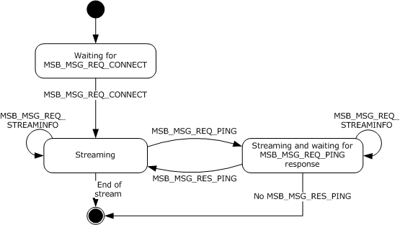
Figure 1: State machine for MSBD on a server

Abstract Data Model
Not applicable for this protocol specification.

Timers
An implementation of the MSBD Protocol on a server can use a timer to schedule the transmission of MSB_MSG_REQ_PING packets.

Initialization
If a timer is used to schedule the transmission of MSB_MSG_REQ_PING packets, that timer cannot be running initially.
The server initializes by listening for incoming TCP connections on the TCP port that is reserved by the server for communication using the MSBD Protocol. The server MUST then wait for an MSB_MSG_REQ_CONNECT packet to be received on a new TCP connection.
For more information about how to process the MSB_MSG_REQ_CONNECT packet, see section 3.1.5.1.

Higher-Layer Triggered Events
Not applicable for this protocol specification.

Message Processing Events and Sequencing Rules

Receiving an MSB_MSG_REQ_CONNECT Packet
If the value of the dwFlags field in the MSB_MSG_REQ_CONNECT packet is 0x0002 and the server does not support delivery of MSB_MSG_IND_PACKET packets over UDP, then the server MUST reject the connection request. In that case, the server MUST respond with an MSB_MSG_RES_CONNECT packet where the hr field is set to an HRESULT failure code. The value of the hr field SHOULD then be set either to 0xC00D001A or to 0x80070057, but the server MAY set the hr field to a different value as long as it corresponds to an HRESULT failure code. For more information about HRESULT codes, see [MS-ERREF].
If the connection is accepted, the server MUST send an MSB_MSG_RES_CONNECT packet with the hr field set to 0x00000000 and MUST follow it with an MSB_MSG_IND_STREAMINFO packet. If the connection is rejected, the server MUST close the TCP connection after having sent the MSB_MSG_RES_CONNECT packet.
If the connection is accepted, then the server transmits the stream as a sequence of MSB_MSG_IND_PACKET packets.

Receiving an MSB_MSG_REQ_STREAMINFO Packet
The server MUST send an MSB_MSG_RES_STREAMINFO packet.

Reaching the End of the Stream
When the server transmits the last MSB_MSG_IND_PACKET packet for a stream, the server MUST send an MSB_MSG_IND_EOS packet that is followed by an MSB_MSG_IND_STREAMINFO packet. The MSB_MSG_IND_STREAMINFO packet MUST contain information about the next stream to be transmitted. If there are no additional streams to transmit, the MSB_MSG_IND_STREAMINFO packet MUST be "empty". In an empty MSB_MSG_IND_STREAMINFO packet, the size of the bBinaryData field MUST be 0 bytes, and the hr field SHOULD be set to 0xC00D0033. The server SHOULD set all the remaining fields in the empty MSB_MSG_IND_STREAMINFO packet to 0.<4>

Timer Events
If the server uses a timer to schedule the transmission of the MSB_MSG_REQ_PING packets, when that timer expires, the server SHOULD send an MSB_MSG_REQ_PING packet. If after sending an MSB_MSG_REQ_PING packet, the server does not receive an MSB_MSG_RES_PING packet within 2 minutes, the server SHOULD end the session by closing the TCP connection to the client.

Other Local Events
Not applicable for this protocol specification.

Client Details
This section specifies details for client implementations of the MSBD Protocol. The state machine for MSBD on a client is depicted in the following diagram.
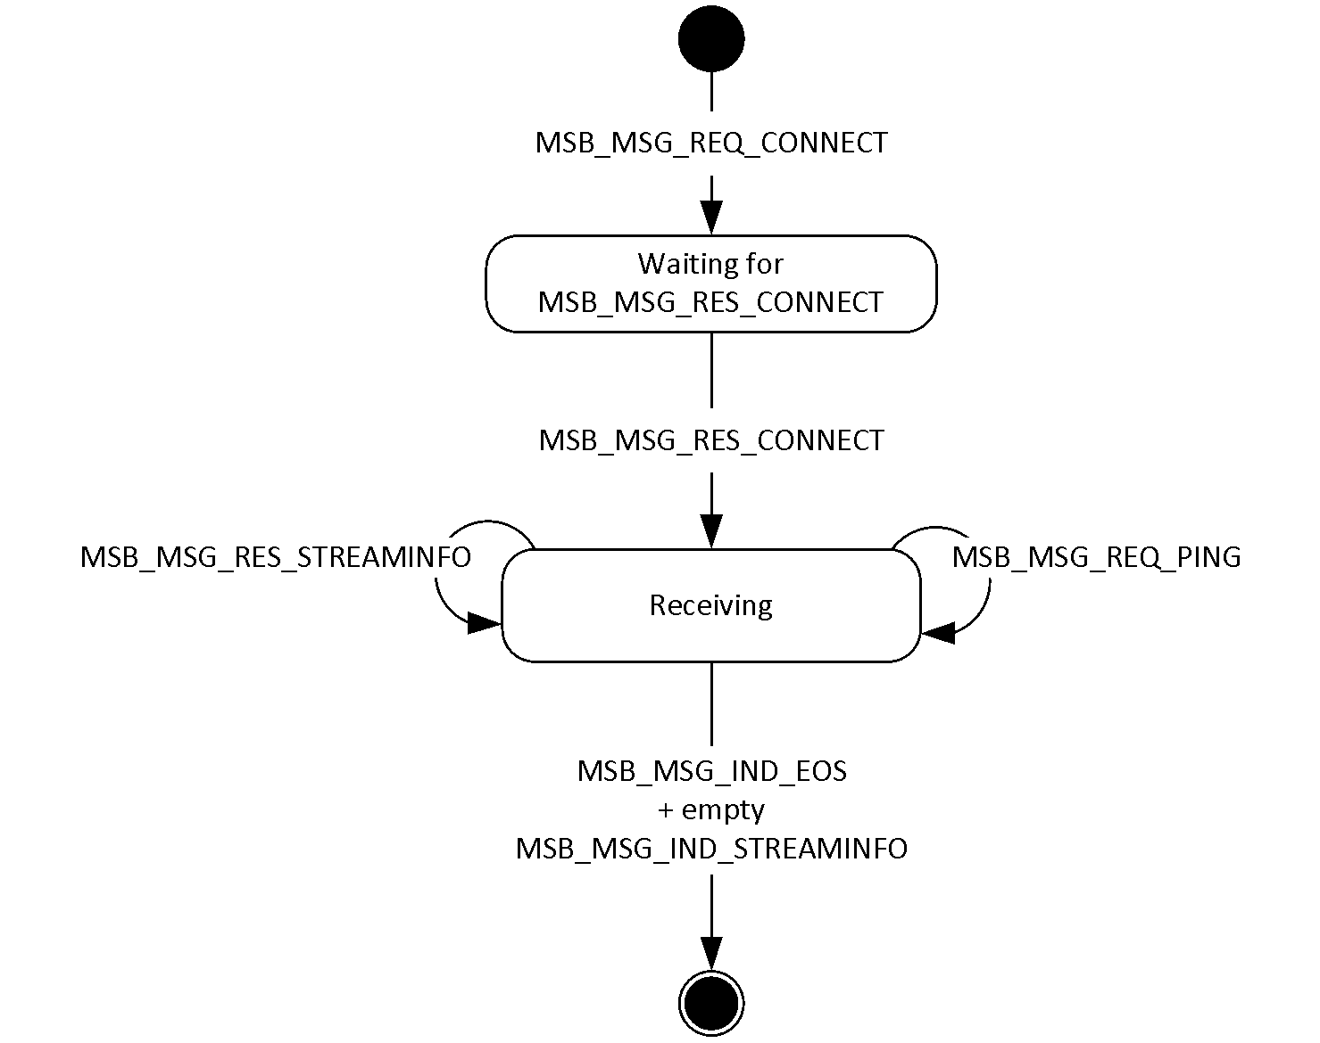
Figure 2: State machine for MSBD on a client

Abstract Data Model
Not applicable for this protocol specification.

Timers
Not applicable for this protocol specification.

Initialization
The client initializes an MSBD streaming session by establishing a TCP connection to the TCP port that the server reserves for communication by using the MSBD Protocol. The client and server MUST agree on the TCP port number that is used for the MSBD Protocol through some mechanism not addressed in the MSBD Protocol, because the port number MUST be known prior to the transmission of the first MSBD packet.
After the TCP connection is established, the client MUST send an MSB_MSG_REQ_CONNECT packet.

Higher-Layer Triggered Events
Not applicable for this protocol specification.

Message Processing Events and Sequencing Rules

Receiving an MSB_MSG_REQ_PING Packet
The client MUST send an MSB_MSG_RES_PING packet.

Receiving an MSB_MSG_IND_STREAMINFO Packet
If the client receives an "empty" MSB_MSG_IND_STREAMINFO packet (as specified in section 3.1.5.3), the portion of the packet that does not include the Header field MUST be ignored.

Timer Events
Not applicable for this protocol specification.

Other Local Events
Not applicable for this protocol specification.

Protocol Example
The following sections describe several operations as used in common scenarios to illustrate the function of the MSBD Protocol.

General MSBD Sequence
The following diagram shows a typical communication sequence between the client and server.
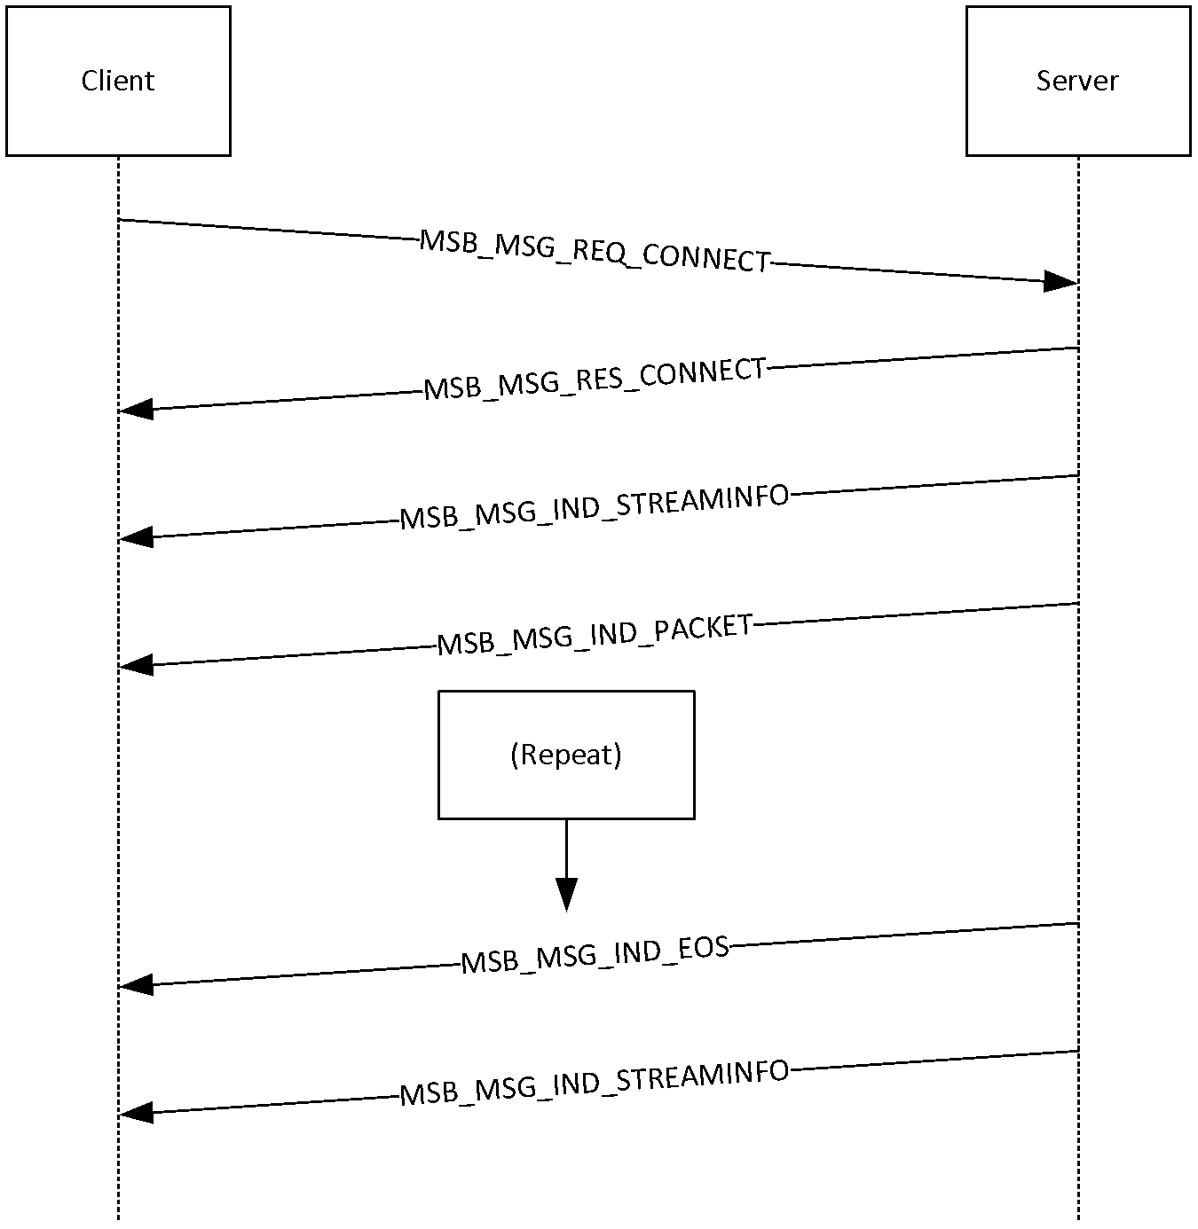
Figure 3: Client/server communication sequence
- The client opens a TCP connection to the server and sends an MSB_MSG_REQ_CONNECT packet.
- The server responds with an MSB_MSG_RES_CONNECT packet followed by an MSB_MSG_IND_STREAMINFO packet that describes the media stream.
- The server sends one or more MSB_MSG_IND_PACKET packets, each of which contains one ASF packet. The packets are sent either over the TCP connection or by using UDP to an IP multicast group.
- When the stream ends, the server sends an MSB_MSG_IND_EOS packet that is followed by an empty MSB_MSG_IND_STREAMINFO packet.
During the previous message exchange, the server periodically pings the client by using an MSB_MSG_REQ_PING packet. If the client does not respond to the MSB_MSG_REQ_PING packet with an MSB_MSG_RES_PING packet, the server closes the TCP connection. In other cases, the client is responsible for ending the session by closing the TCP connection.

Using MSBD for Server-Side Playlist Streaming
The following diagram shows a typical communication sequence between a client and server when streaming content from a server-side playlist.
Note When using the MSBD Protocol, the client does not have the capability to seek or skip to a new entry in a server-side playlist.
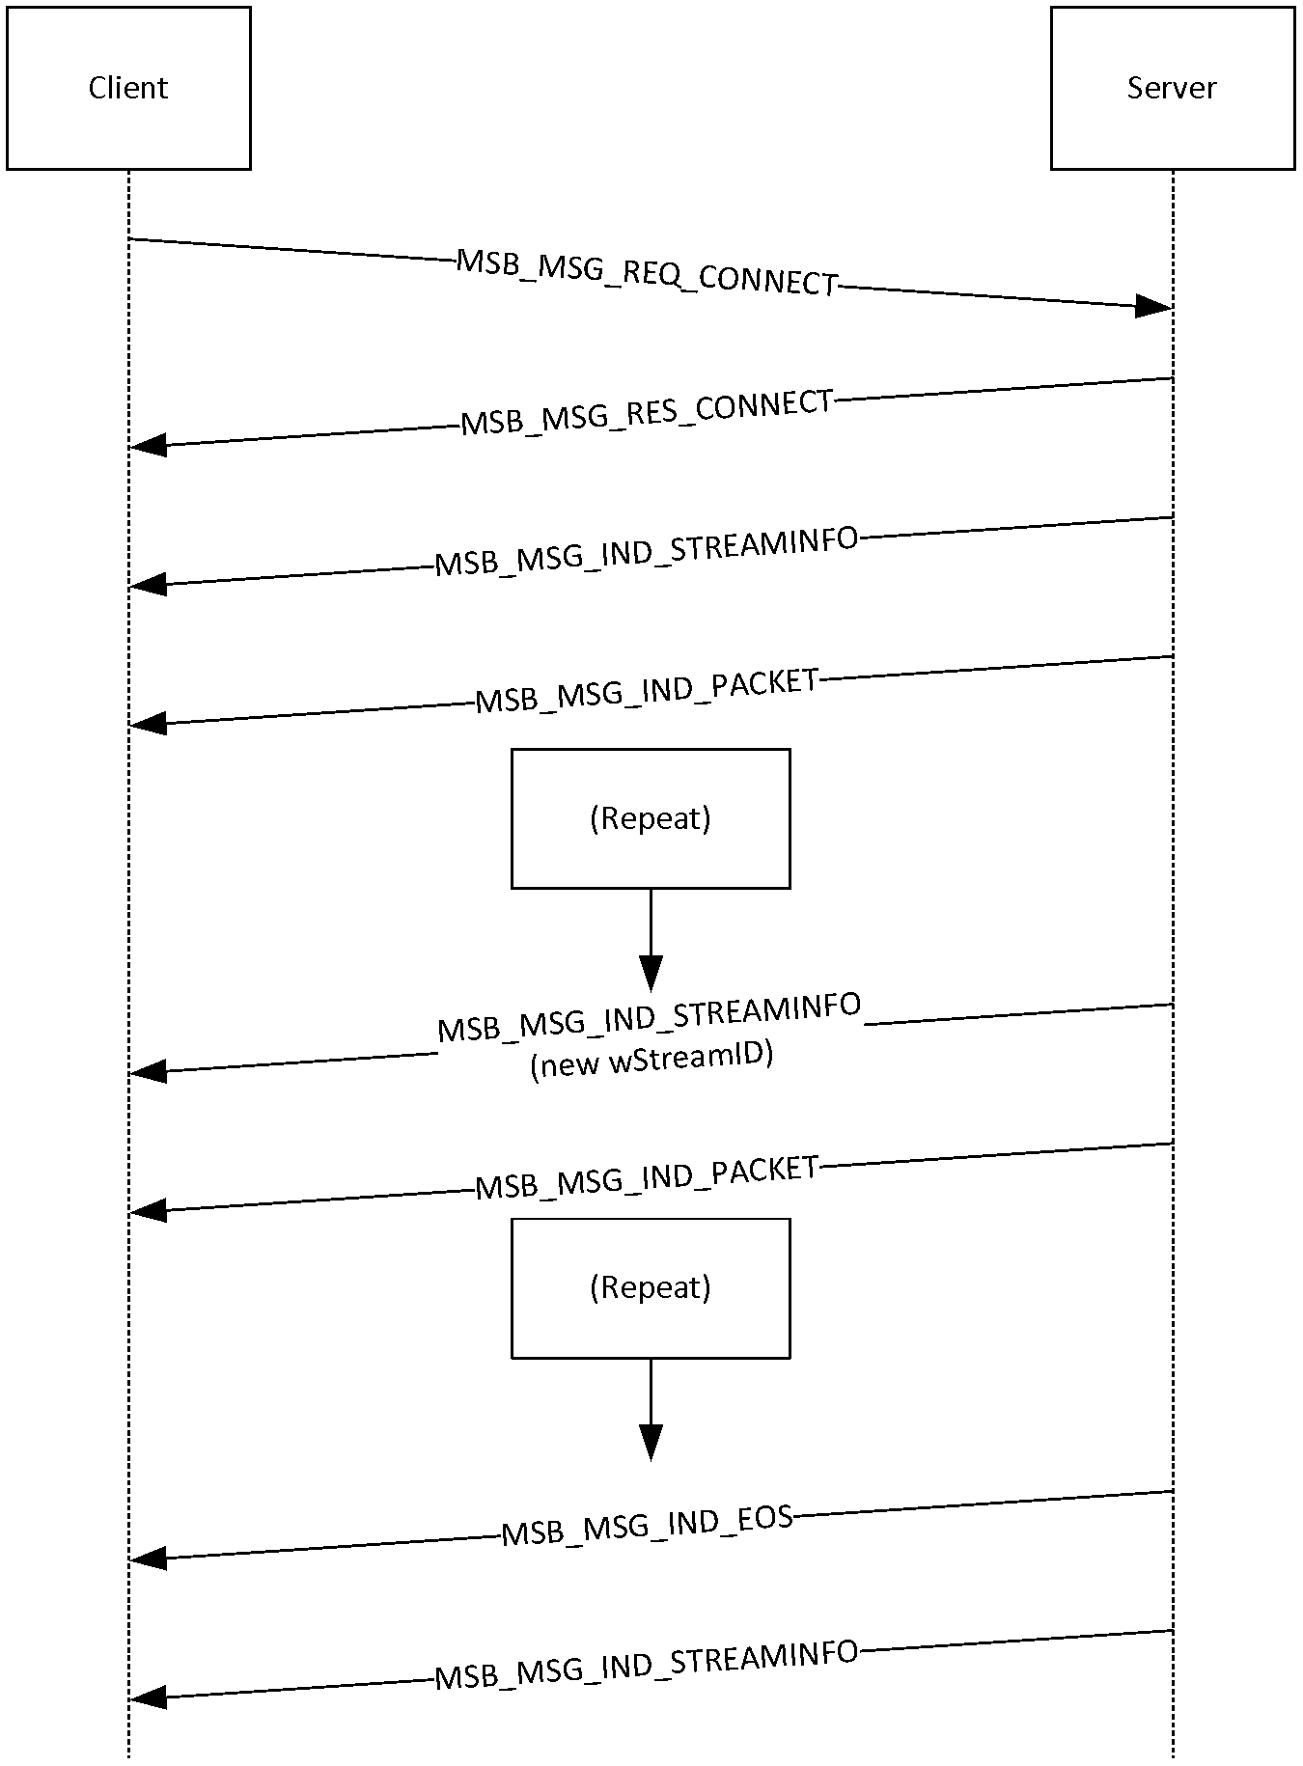
Figure 4: Client/server communication sequence when streaming from a server-side playlist
- The client opens a TCP connection to the server and sends an MSB_MSG_REQ_CONNECT packet.
- The server responds with an MSB_MSG_RES_CONNECT packet followed by an MSB_MSG_IND_STREAMINFO packet that describes the media stream.
- The server sends one or more MSB_MSG_IND_PACKET packets, each of which contains one ASF packet. The packets are sent either over the TCP connection or by using UDP to an IP multicast group.
- When the entry changes in the server-side playlist, the server sends a MSB_MSG_IND_STREAMINFO packet with a new wStreamId value. For more information, see section 2.2.6.
- The server sends one or more MSB_MSG_IND_PACKET packets for the new playlist entry, each of which contains one ASF packet. The packets are sent either over the TCP connection or by using UDP to an IP multicast group.
- The preceding two steps are repeated for all entries in the server-side playlist.
- When the streams end, the server sends an MSB_MSG_IND_EOS packet that is followed by an empty MSB_MSG_IND_STREAMINFO packet.
During the preceding message exchange, the server periodically pings the client by using an MSB_MSG_REQ_PING packet. If the client does not respond to the MSB_MSG_REQ_PING packet with an MSB_MSG_RES_PING packet, the server closes the TCP connection. In other cases, the client is responsible for ending the session by closing the TCP connection.

Security
The following sections specify security considerations for implementers of the MSBD Protocol.

Security Considerations for Implementers
For any packet that contains fields that specify other field lengths, implementers ensure that the length values do not exceed the size of the packet itself. For example, MSB_MSG_IND_STREAMINFO is one packet that has multiple length fields.
Implementers do not assume that the ASF data in the MSB_MSG_IND_STREAMINFO and MSB_MSG_IND_PACKET packets can be trusted. Use caution when parsing variable-length fields, ensuring that length information, if any, does not cause the size of buffers to be exceeded.

Index of Security Parameters
The MSBD Protocol has no applicable security parameters.

Appendix A: Product Behavior
The information in this specification is applicable to the following Microsoft products or supplemental software. References to product versions include released service packs.
- Windows NT operating system
- Windows 2000 operating system
- Windows XP operating system
- Windows Server 2003 operating system
Exceptions, if any, are noted below. If a service pack or Quick Fix Engineering (QFE) number appears with the product version, behavior changed in that service pack or QFE. The new behavior also applies to subsequent service packs of the product unless otherwise specified. If a product edition appears with the product version, behavior is different in that product edition.
Unless otherwise specified, any statement of optional behavior in this specification that is prescribed using the terms SHOULD or SHOULD NOT implies product behavior in accordance with the SHOULD or SHOULD NOT prescription. Unless otherwise specified, the term MAY implies that the product does not follow the prescription.
<1> Section 1.3: The MSBD Protocol is only supported by Windows Media Player 6.4.
<2> Section 1.4: The IP multicast is supported only by Windows Media Services implementations in Windows NT 4.0 operating system and Windows 2000 Server operating system.
<3> Section 1.6: The server role is only supported in Windows NT 4.0 and Windows 2000 Server.
<4> Section 3.1.5.3: Windows Media Services on Windows NT 4.0, Windows 2000 Server, and Windows Server 2003 does not assign values to the wStreamId, cbPacketSize, cTotalPackets, dwBitRate, msDuration, cbTitle, cbDescription, cbLink, or cbHeader fields.

Change Tracking
No table of changes is available. The document is either new or has had no changes since its last release.

Index
A

Abstract data model
client 21
server 19
Applicability 8
Applicability statement 8

C

Capability negotiation 8
Change tracking 28
Client
abstract data model 21
higher-layer triggered events 21
initialization 21
local events 22
message processing
MSB_MSG_IND_STREAMINFO 22
MSB_MSG_REQ_PING 22
other local events 22
overview 20
sequencing rules
MSB_MSG_IND_STREAMINFO 22
MSB_MSG_REQ_PING 22
timer events 22
timers 21

D

Data model - abstract
client 21
server 19
Data model – abstract
client 21
server 19

E

Examples (section 4 23, section 4.1 23, section 4.2 24)

F

Fields - vendor-extensible 9
Fields – vendor-extensible 9

G

Glossary 7

H

Higher-layer triggered events
client 21
server 19

I

Implementer - security considerations 26
Implementers – security considerations 26
Index of security parameters 26
Informative references 8
Initialization
client 21
server 19
Introduction 7

L

Local events
client 22
server 20

M

Message processing
client
MSB_MSG_IND_STREAMINFO 22
MSB_MSG_REQ_PING 22
server
end of stream 20
MSB_MSG_REQ_CONNECT 20
MSB_MSG_REQ_STREAMINFO 20
Messages
MSB_MSG_IND_EOS 17
MSB_MSG_IND_PACKET 18
MSB_MSG_IND_STREAMINFO 14
MSB_MSG_REQ_CONNECT 16
MSB_MSG_REQ_PING 11
MSB_MSG_REQ_STREAMINFO 12
MSB_MSG_RES_CONNECT 16
MSB_MSG_RES_PING 11
MSB_MSG_RES_STREAMINFO 12
MSBMSGBASE 10
syntax 10
transport 10
MSB_MSG_IND_EOS message 17
MSB_MSG_IND_EOS packet 17
MSB_MSG_IND_PACKET message 18
MSB_MSG_IND_PACKET packet 18
MSB_MSG_IND_STREAMINFO message 14
MSB_MSG_IND_STREAMINFO packet 14
MSB_MSG_REQ_CONNECT message 16
MSB_MSG_REQ_CONNECT packet 16
MSB_MSG_REQ_PING message 11
MSB_MSG_REQ_PING packet 11
MSB_MSG_REQ_STREAMINFO message 12
MSB_MSG_REQ_STREAMINFO packet 12
MSB_MSG_RES_CONNECT message 16
MSB_MSG_RES_CONNECT packet 16
MSB_MSG_RES_PING message 11
MSB_MSG_RES_PING packet 11
MSB_MSG_RES_STREAMINFO message 12
MSB_MSG_RES_STREAMINFO packet 12
MSBMSGBASE message 10
MSBMSGBASE packet 10

N

Normative references 7

O

Other local events
client 22
server 20
Overview (synopsis) 8

P

Parameters – security 26
Parameters - security index 26
Preconditions 8
Prerequisites 8
Product behavior 27
Protocol Details
overview 19

R

References 7
informative 8
normative 7
Relationship to other protocols 8

S

Security 26
implementer considerations 26
parameter index 26
Sequencing rules
client
MSB_MSG_IND_STREAMINFO 22
MSB_MSG_REQ_PING 22
server
end of stream 20
MSB_MSG_REQ_CONNECT 20
MSB_MSG_REQ_STREAMINFO 20
Server
abstract data model 19
higher-layer triggered events 19
initialization 19
local events 20
message processing
end of stream 20
MSB_MSG_REQ_CONNECT 20
MSB_MSG_REQ_STREAMINFO 20
other local events 20
overview 19
sequencing rules
end of stream 20
MSB_MSG_REQ_CONNECT 20
MSB_MSG_REQ_STREAMINFO 20
timer events 20
timers 19
Standards assignments 9
Syntax – message 10

T

Timer events
client 22
server 20
Timers
client 21
server 19
Tracking changes 28
Transport 10
Transport – message 10
Triggered events – higher layer
client 21
server 19
Triggered events - higher-layer
client 21
server 19

V

Vendor-extensible fields 9
Versioning 8

