[MS-IPHTTPS]:
IP over HTTPS (IP-HTTPS) Tunneling Protocol

Intellectual Property Rights Notice for Open Specifications Documentation
- Technical Documentation. Microsoft publishes Open Specifications documentation (“this documentation”) for protocols, file formats, data portability, computer languages, and standards support. Additionally, overview documents cover inter-protocol relationships and interactions.
- Copyrights. This documentation is covered by Microsoft copyrights. Regardless of any other terms that are contained in the terms of use for the Microsoft website that hosts this documentation, you can make copies of it in order to develop implementations of the technologies that are described in this documentation and can distribute portions of it in your implementations that use these technologies or in your documentation as necessary to properly document the implementation. You can also distribute in your implementation, with or without modification, any schemas, IDLs, or code samples that are included in the documentation. This permission also applies to any documents that are referenced in the Open Specifications documentation.
- No Trade Secrets. Microsoft does not claim any trade secret rights in this documentation.
- Patents. Microsoft has patents that might cover your implementations of the technologies described in the Open Specifications documentation. Neither this notice nor Microsoft's delivery of this documentation grants any licenses under those patents or any other Microsoft patents. However, a given Open Specifications document might be covered by the Microsoft Open Specifications Promise or the Microsoft Community Promise. If you would prefer a written license, or if the technologies described in this documentation are not covered by the Open Specifications Promise or Community Promise, as applicable, patent licenses are available by contacting iplg@microsoft.com.
- License Programs. To see all of the protocols in scope under a specific license program and the associated patents, visit the Patent Map.
- Trademarks. The names of companies and products contained in this documentation might be covered by trademarks or similar intellectual property rights. This notice does not grant any licenses under those rights. For a list of Microsoft trademarks, visit www.microsoft.com/trademarks.
- Fictitious Names. The example companies, organizations, products, domain names, email addresses, logos, people, places, and events that are depicted in this documentation are fictitious. No association with any real company, organization, product, domain name, email address, logo, person, place, or event is intended or should be inferred.
Reservation of Rights. All other rights are reserved, and this notice does not grant any rights other than as specifically described above, whether by implication, estoppel, or otherwise.
Tools. The Open Specifications documentation does not require the use of Microsoft programming tools or programming environments in order for you to develop an implementation. If you have access to Microsoft programming tools and environments, you are free to take advantage of them. Certain Open Specifications documents are intended for use in conjunction with publicly available standards specifications and network programming art and, as such, assume that the reader either is familiar with the aforementioned material or has immediate access to it.
Support. For questions and support, please contact dochelp@microsoft.com.
Revision Summary
Date | Revision History | Revision Class | Comments
12/5/2008 | 0.1 | Major | Initial Availability
1/16/2009 | 0.1.1 | Editorial | Changed language and formatting in the technical content.
2/27/2009 | 0.1.2 | Editorial | Changed language and formatting in the technical content.
4/10/2009 | 0.1.3 | Editorial | Changed language and formatting in the technical content.
5/22/2009 | 1.0 | Major | Updated and revised the technical content.
7/2/2009 | 1.0.1 | Editorial | Changed language and formatting in the technical content.
8/14/2009 | 1.0.2 | Editorial | Changed language and formatting in the technical content.
9/25/2009 | 2.0 | Major | Updated and revised the technical content.
11/6/2009 | 3.0 | Major | Updated and revised the technical content.
12/18/2009 | 4.0 | Major | Updated and revised the technical content.
1/29/2010 | 5.0 | Major | Updated and revised the technical content.
3/12/2010 | 5.0.1 | Editorial | Changed language and formatting in the technical content.
4/23/2010 | 5.0.2 | Editorial | Changed language and formatting in the technical content.
6/4/2010 | 5.0.3 | Editorial | Changed language and formatting in the technical content.
7/16/2010 | 5.0.3 | None | No changes to the meaning, language, or formatting of the technical content.
8/27/2010 | 5.0.3 | None | No changes to the meaning, language, or formatting of the technical content.
10/8/2010 | 5.0.3 | None | No changes to the meaning, language, or formatting of the technical content.
11/19/2010 | 5.0.3 | None | No changes to the meaning, language, or formatting of the technical content.
1/7/2011 | 5.0.3 | None | No changes to the meaning, language, or formatting of the technical content.
2/11/2011 | 5.0.3 | None | No changes to the meaning, language, or formatting of the technical content.
3/25/2011 | 5.0.3 | None | No changes to the meaning, language, or formatting of the technical content.
5/6/2011 | 5.0.3 | None | No changes to the meaning, language, or formatting of the technical content.
6/17/2011 | 5.1 | Minor | Clarified the meaning of the technical content.
9/23/2011 | 5.1 | None | No changes to the meaning, language, or formatting of the technical content.
12/16/2011 | 6.0 | Major | Updated and revised the technical content.
3/30/2012 | 6.0 | None | No changes to the meaning, language, or formatting of the technical content.
7/12/2012 | 7.0 | Major | Updated and revised the technical content.
10/25/2012 | 7.0 | None | No changes to the meaning, language, or formatting of the technical content.
1/31/2013 | 7.0 | None | No changes to the meaning, language, or formatting of the technical content.
8/8/2013 | 8.0 | Major | Updated and revised the technical content.
11/14/2013 | 8.0 | None | No changes to the meaning, language, or formatting of the technical content.
2/13/2014 | 8.0 | None | No changes to the meaning, language, or formatting of the technical content.
5/15/2014 | 8.0 | None | No changes to the meaning, language, or formatting of the technical content.
6/30/2015 | 9.0 | Major | Significantly changed the technical content.
10/16/2015 | 9.0 | None | No changes to the meaning, language, or formatting of the technical content.
7/14/2016 | 9.0 | None | No changes to the meaning, language, or formatting of the technical content.
6/1/2017 | 9.0 | None | No changes to the meaning, language, or formatting of the technical content.
Table of Contents
1 Introduction 6
1.1 Glossary 6
1.2 References 6
1.2.1 Normative References 6
1.2.2 Informative References 7
1.3 Overview 7
1.4 Relationship to Other Protocols 7
1.5 Prerequisites/Preconditions 8
1.6 Applicability Statement 8
1.7 Versioning and Capability Negotiation 9
1.8 Vendor-Extensible Fields 9
1.9 Standards Assignments 9
2 Messages 10
2.1 Transport 10
2.2 Message Syntax 11
3 Protocol Details 12
3.1 IP-HTTPS Client Details 12
3.1.1 Abstract Data Model 13
3.1.2 Timers 14
3.1.2.1 Reconnect Timer 14
3.1.3 Initialization 14
3.1.4 Higher-Layer Triggered Events 15
3.1.4.1 Enable IP-HTTPS Link 15
3.1.4.2 Disable IP-HTTPS Link 15
3.1.5 Processing Events and Sequencing Rules 15
3.1.5.1 Establishing the HTTPS Connection 15
3.1.5.2 Bringing the IP-HTTPS Link Up 15
3.1.5.3 Data Transfer 15
3.1.5.4 Error Handling 16
3.1.6 Timer Events 16
3.1.7 Other Local Events 16
3.2 IP-HTTPS Server Details 16
3.2.1 Abstract Data Model 16
3.2.2 Timers 17
3.2.3 Initialization 17
3.2.3.1 Entering the Listen State 17
3.2.4 Higher-Layer Triggered Events 17
3.2.4.1 Enable IP-HTTPS Link 17
3.2.4.2 Disable IP-HTTPS Link 17
3.2.5 Processing Events and Sequencing Rules 17
3.2.5.1 Accepting IP-HTTPS Clients 17
3.2.5.2 Data Transfer 17
3.2.5.2.1 Sending a Packet to a Client 17
3.2.5.2.2 Receiving a Packet from a Client 18
3.2.5.3 Error Handling 18
3.2.6 Timer Events 18
3.2.7 Other Local Events 18
3.2.7.1 Changing Authentication Mode 19
3.2.7.2 Client Disconnection 19
3.2.7.3 Shutdown 19
4 Protocol Examples 20
4.1 Packet Flow and Connection Establishment 20
4.2 Attack Scenarios 21
4.2.1 Unauthorized Client Connecting to an IP-HTTPS Server 21
4.2.2 Unauthorized Client Connecting to an IP-HTTPS Server (When Authentication Mode Is Set to Certificates) 21
4.2.3 Unauthorized Client Connecting to an IP-HTTPS Server (When Authentication Mode Is Set to None) 22
4.2.4 Unauthorized IP-HTTPS Server Accepting Connections from a Genuine IP-HTTPS Client 23
4.2.5 Man in the Middle 24
5 Security 25
5.1 Security Considerations for Implementers 25
5.2 Index of Security Parameters 25
6 Appendix A: Product Behavior 26
7 Change Tracking 27
8 Index 28

Introduction
This document specifies the IP over HTTPS (IP-HTTPS) Protocol, a mechanism to transport IPv6 packets on an HTTPS connection.
Sections 1.5, 1.8, 1.9, 2, and 3 of this specification are normative. All other sections and examples in this specification are informative.

Glossary
This document uses the following terms:
IP-HTTPS client: A computer that implements the IP over HTTPS (IP-HTTPS) Protocol and that initiates an IP-HTTPS connection to an IP-HTTPS server over TCP port 443.
IP-HTTPS endpoint: An entity that communicates to an IP-HTTPS client via the IP-HTTPS server.
IP-HTTPS server: A computer that implements the IP over HTTPS (IP-HTTPS) Protocol and listens and accepts IP-HTTPS connections from IP-HTTPS clients over TCP port 443.
Uniform Resource Identifier (URI): A string that identifies a resource. The URI is an addressing mechanism defined in Internet Engineering Task Force (IETF) Uniform Resource Identifier (URI): Generic Syntax [RFC3986].
MAY, SHOULD, MUST, SHOULD NOT, MUST NOT: These terms (in all caps) are used as defined in [RFC2119]. All statements of optional behavior use either MAY, SHOULD, or SHOULD NOT.

References
Links to a document in the Microsoft Open Specifications library point to the correct section in the most recently published version of the referenced document. However, because individual documents in the library are not updated at the same time, the section numbers in the documents may not match. You can confirm the correct section numbering by checking the Errata.

Normative References
We conduct frequent surveys of the normative references to assure their continued availability. If you have any issue with finding a normative reference, please contact dochelp@microsoft.com. We will assist you in finding the relevant information.
[RFC1945] Berners-Lee, T., Fielding, R., and Frystyk, H., "Hypertext Transfer Protocol -- HTTP/1.0", RFC 1945, May 1996, http://www.ietf.org/rfc/rfc1945.txt
[RFC2119] Bradner, S., "Key words for use in RFCs to Indicate Requirement Levels", BCP 14, RFC 2119, March 1997, http://www.rfc-editor.org/rfc/rfc2119.txt
[RFC2460] Deering, S., and Hinden, R., "Internet Protocol, Version 6 (IPv6) Specification", RFC 2460, December 1998, http://www.rfc-editor.org/rfc/rfc2460.txt
[RFC2616] Fielding, R., Gettys, J., Mogul, J., et al., "Hypertext Transfer Protocol -- HTTP/1.1", RFC 2616, June 1999, http://www.rfc-editor.org/rfc/rfc2616.txt
[RFC2818] Rescorla, E., "HTTP Over TLS", RFC 2818, May 2000, http://www.rfc-editor.org/rfc/rfc2818.txt
[RFC4346] Dierks, T., and Rescorla, E., "The Transport Layer Security (TLS) Protocol Version 1.1", RFC 4346, April 2006, http://www.ietf.org/rfc/rfc4346.txt
[RFC4861] Narten, T., Nordmark, E., Simpson, W., and Soliman, H., "Neighbor Discovery for IP version 6 (IPv6)", RFC 4861, September 2007, http://www.ietf.org/rfc/rfc4861.txt
[SSLPROXY] Luotonen, A., "Tunneling SSL Through a WWW Proxy", March 1997, http://tools.ietf.org/html/draft-luotonen-ssl-tunneling-03

Informative References
[RFC1661] Simpson, W., Ed., "The Point-to-Point Protocol (PPP)", STD 51, RFC 1661, July 1994, http://www.ietf.org/rfc/rfc1661.txt
[RFC3971] Arkko, J., Ed., Kempf, J., Zill, B., and Nikander, P., "SEcure Neighbor Discovery (SEND)", RFC 3971, March 2005, http://www.rfc-editor.org/rfc/rfc3971.txt

Overview
Many virtual private network (VPN) services provide a way for mobile and home users to access the corporate network remotely by using the Point-to-Point Tunneling Protocol (PPTP) and the Layer Two Tunneling Protocol/Internet Protocol security (L2TP/IPsec). However, with the popularization of firewalls and web proxies, many service providers (for example, hotels) do not allow the PPTP and L2TP/IPsec traffic. This results in users not receiving ubiquitous connectivity to their corporate networks. For example, generic routing encapsulation (GRE) port blocking by many Internet service providers (ISPs) is a common problem when using PPTP.
The IP over HTTPS (IP-HTTPS) Tunneling Protocol Specification defines the IP over HTTPS (IP-HTTPS) Protocol. IP-HTTPS is a mechanism to encapsulate IP traffic over an HTTPS protocol, as defined in [RFC1945], [RFC2616], and [RFC2818]. This protocol enables remote users behind a protocol blocking firewall or proxy server to access a private network using HTTPS. The use of HTTPS enables traversal of most firewalls and web proxies. IP-HTTPS supports HTTP proxy authentication.
This protocol employs two main roles: client and server. The IP-HTTPS client and IP-HTTPS server can use either HTTPS or HTTP as a transport.
An IP-HTTPS client: This component is similar to a VPN client. The IP-HTTPS client initiates connections to a configured IP-HTTPS server. The client could become active either automatically (for example, when the client machine is located behind an HTTP firewall and/or HTTP proxy), or based on administrative policy (for example, always on), or based on an explicit user action.
When an IP-HTTPS client is behind an HTTP proxy, the client first establishes a tunnel to the IP-HTTPS server using the CONNECT method, as described in [SSLPROXY].
An IP-HTTPS server: This component is similar to a VPN server, and it is typically positioned at the edge of a network. The IP-HTTPS server directly accepts HTTPS connections made by IP-HTTPS clients. When positioned behind a device that terminates HTTPS on its behalf (such as a reverse proxy or a TLS/SSL load balancer), the server can be configured to listen over HTTP.

Relationship to Other Protocols
The IP over HTTPS (IP-HTTPS) Protocol allows encapsulation of IPv6 traffic over HTTPS. To do so, it depends on the following protocols:
- Hypertext Transfer Protocol -- HTTP/1.0 [RFC1945].
- Hypertext Transfer Protocol -- HTTP/1.1 [RFC2616].
- HTTP Over TLS [RFC2818].
- Tunneling SSL Through a WWW Proxy [SSLPROXY].
- The Transport Layer Security (TLS) Protocol Version 1.1 [RFC4346].
Once the underlying transport is established, IP-HTTPS enables IPv6 traffic exchanges per usual IPv6 specifications such as:
- Neighbor Discovery for IP Version 6 (IPv6) [RFC4861].
- Protocol, Version 6 (IPv6) Specification [RFC2460].
Note The IP-HTTPS Protocol itself does not have any security or authentication methods. Instead, it relies on HTTPS for authentication, data integrity, and confidentiality.
The relationship between these protocols is illustrated in the following diagram:
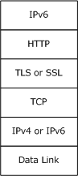
Figure 1: Protocol relationships

Prerequisites/Preconditions
The IP-HTTPS Protocol requires IPv6 and either HTTP or HTTPS. If HTTPS is used, TLS/SSL is also required for operation.
IP-HTTPS supports both HTTP and HTTPS transports. Unless otherwise noted, the rest of this document uses the term "HTTPS" to also refer to operation over HTTP.
When the transport is HTTPS (as opposed to HTTP), the IP-HTTPS Protocol requires a certificate to be installed on each client and server machine. It also requires the client and the server to be configured with the Uniform Resource Identifier (URI) of the server.
The HTTPS connection can be set up over an IPv4 or an IPv6 network.

Applicability Statement
The IP-HTTPS Protocol is useful for enabling remote users behind a protocol blocking firewall or proxy server to access a private network using HTTPS.
IP-HTTPS only supports IPv6 encapsulation over HTTPS.

Versioning and Capability Negotiation
The IP over HTTPS (IP-HTTPS) Protocol is a simple encapsulation of IP over HTTPS. It does not have any versioning or capability negotiations with peers.

Vendor-Extensible Fields
The IP-HTTPS Protocol has no vendor-extensible fields.

Standards Assignments
There are no standards assignments for this protocol.

Messages

Transport
The following diagrams show the IP-HTTPS protocol stack options for client and server.
Figure 2: IP-HTTPS client protocol stack
Figure 3: IP-HTTPS server protocol stack when using HTTPS encapsulation
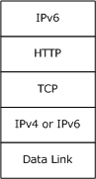
Figure 4: IP-HTTPS server protocol stack when using HTTP encapsulation
IPv6 packets are carried directly within the HTTP payload. HTTP requests and responses are transmitted as described in [RFC2616]. The content type of the HTTP entity body carrying IPv6 packets is "application/octet-stream". The sender of the HTTP payload MAY include a Content-Type header in the HTTP request or response to indicate that the content type is an application/octet-stream.

Message Syntax
The IP-HTTPS Protocol uses HTTP, HTTPS, TLS/SSL and IPv6 as described in section 2.1. The IP-HTTPS Protocol does not introduce any new packet formats.

Protocol Details
The IP-HTTPS Protocol encapsulates IPv6 packets over an HTTPS connection. This is achieved by creating a tunneled interface, which provides a symmetric link, with multicast and neighbor discovery capabilities, including unreachable neighbor detection and duplicate address detection per [RFC4861]. Like other point-to-point links, for instance PPP [RFC1661], IP-HTTPS uses a static network-layer to link-layer address mapping.
There are two main components to IP-HTTPS: IP-HTTPS clients that are connecting to resources inside a private network (such as an enterprise network) and IP-HTTPS servers that facilitate the connection, as illustrated in the diagram below.
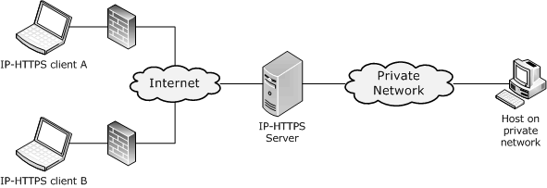
Figure 5: IP-HTTPS clients connected to an IP-HTTPS server

IP-HTTPS Client Details
The following figure shows the state machine when a client establishes the outgoing IP-HTTPS tunnel.
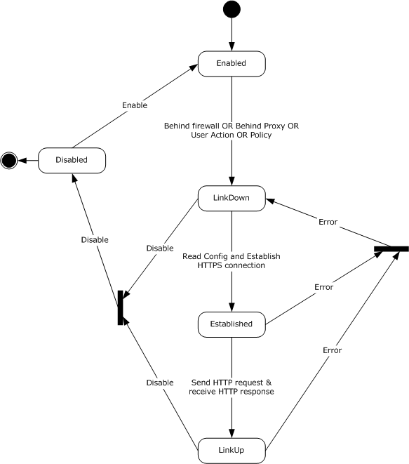
Figure 6: IP-HTTPS client state diagram

Abstract Data Model
This section describes a conceptual model of possible data organization that an implementation maintains to participate in this protocol. The described organization is provided to facilitate the explanation of how the protocol behaves. This document does not mandate that implementations adhere to this model as long as their external behavior is consistent with that described in this document.
URI: The URI on which the IP-HTTPS server will accept incoming IP-HTTPS connections. IP-HTTPS clients must be configured with this address in order to use it.
State: Specifies the current state of the IP-HTTPS client. The possible states are:
Enabled: In this state, the IP-HTTPS client waits for the pre-conditions specified in Section 3.1.3 to happen. These preconditions transition the IP-HTTPS client to the LinkDown state.
LinkDown: In this state, the IP-HTTPS client reads the configuration and tries to establish an HTTPS connection to the server. Once the HTTPS connection is established, the IP-HTTPS client transitions to the Established state.
Established: In this state the IP-HTTPS client establishes a bidirectional HTTP stream. It achieves this by sending an HTTP request message to the server and waiting for a HTTP response. Upon receiving a successful HTTP response, it transitions to the LinkUp state.
LinkUp: In this state the IP-HTTPS link is up and usable for sending and receiving IPv6 traffic.
Disabled: A higher-layer trigger (such as a user action to disable IP-HTTPS) transitions the IP-HTTPS client to the disabled state. IP-HTTPS operations are not possible in this state.
Further details about state processing, handling error conditions, and state transitions are specified below.

Timers

Reconnect Timer
To work around transient failures (for example, lack of resources on the local machine, on the network, proxy, or at the IP-HTTPS server), the IP-HTTPS clients SHOULD use a reconnect timer to retry an unsuccessful HTTPS connection or to reestablish a successful HTTPS connection that was terminated abnormally.
The reconnection attempts follow an exponential back-off algorithm. The first failure marks the beginning of the reconnection algorithm. Upon the first failure, the reconnection timer is started for an initial timeout of 30 seconds. Each subsequent failure starts a reconnection timer with a timeout set to the time elapsed since the beginning of the algorithm, up to a maximum timeout of 15 minutes. Following this algorithm, reconnection attempts will be made after the following intervals since the first failure, where T represents the time taken for the connection attempt to fail.
- 30 seconds
- 30 + T seconds
- 60 + 2T seconds
- 120 + 3T seconds
- ... and so on, up to 15 minutes.
- Every 15 minutes thereafter.
A successful HTTPS connection resets the timer.
It is possible that other timing logic is dictated by the other protocols upon which the IP-HTTPS Protocol relies.

Initialization
If the IP-HTTPS link is Enabled (section 3.1.4.1), the IP-HTTPS link MUST be initialized when any of the following conditions are met.
- Client detects that it is behind an HTTP proxy.
- Client is detected behind a port/protocol blocking firewall.
- Administrative policy requires the IP-HTTPS link to be always on.
- User chooses to bring up the IP-HTTPS link.
Initialization of the client involves the client reading the URI of the server.

Higher-Layer Triggered Events
The following events are triggered by an end user or by administrative policy.

Enable IP-HTTPS Link
The Enable IP-HTTPS Link event transitions the client from the Disabled to Enabled state, making initialization possible as defined in section 3.1.3.

Disable IP-HTTPS Link
The Disable IP-HTTPS Link event transitions the client to the Disabled state. The underlying transport protocols tear down their state. No further IP-HTTPS operations are possible while in this state.

Processing Events and Sequencing Rules
The IP-HTTPS client waits for the pre-conditions specified in section 3.1.3 to happen and triggers the following events.

Establishing the HTTPS Connection
Immediately following initialization per section 3.1.3, the IP-HTTPS client MUST establish an HTTPS connection to the IP-HTTPS server (per the configuration in section 3.1.3), as defined in [RFC1945], [RFC2616], [RFC2818], [RFC4346], and [SSLPROXY].
The IP-HTTPS client SHOULD<1> support proxy authentication as specified in [SSLPROXY].

Bringing the IP-HTTPS Link Up
After the HTTPS connection is established, the IP-HTTPS client MUST send an HTTP POST request to the configured URI. The POST request SHOULD use content length encoding [RFC2616], and the value SHOULD be set to 18446744073709551615. After receiving a successful HTTP response, the IP-HTTPS client transitions to the LinkUp state.
The IP-HTTPS link is now usable to send and receive IPv6 traffic (including neighbor and router discovery). The default MTU for the IP-HTTPS link is set to the minimum IPv6 MTU of 1280 [RFC2460].
Sections 3.1.5.3 and 3.1.5.4 apply when the IP-HTTPS client is in LinkUp state.

Data Transfer
Framing in the IP-HTTPS Protocol relies exclusively on the length of the IPv6 header.
Outgoing IPv6 packets MUST be sent within the HTTP request entity body, and incoming IPv6 packets MUST be received as HTTP response entity body. The HTTP entity body is received as a byte stream; therefore, the IP-HTTPS client MUST delimit the IPv6 packet boundaries using the Payload Length field in the IPv6 header. The IP-HTTPS client MUST discard non IPv6 packets.

Error Handling
Upon loss of connectivity in any of the underlying transports that IP-HTTPS client relies on (section 2.1), the client MUST attempt to establish the HTTPS connection as specified above.

Timer Events
Re-connect timer: When this timer expires, the IP-HTTPS tunnel MUST be re-established, as described in 3.1.5.2.

Other Local Events
None.

IP-HTTPS Server Details

Abstract Data Model
This section describes a conceptual model of possible data organization that an implementation maintains to participate in this protocol. The described organization is provided to facilitate the explanation of how the protocol behaves. This document does not mandate that implementations adhere to this model as long as their external behavior is consistent with that described in this document.
URI: The URI on which the IP-HTTPS server will accept incoming IP-HTTPS connections.
State: Specifies the current state of the IP-HTTPS server. The possible states are as follows:
Stopped: This is the initial state. IP-HTTPS operations are not possible until the IP-HTTPS server is started.
Listen: In this state, the IP-HTTPS server enables its HTTP stack to listen on the configured URI waiting for IP-HTTPS clients to connect. When the IP-HTTPS server is in the Listen state, it is usable for sending and receiving IPv6 traffic. In the Listen state, the IP-HTTPS server uses Neighbor Discovery [RFC4861] to maintain the link to which the IP-HTTPS clients connect.
Disabled: IP-HTTPS operations are not possible in this state. The IP-HTTPS server transitions to this state based on user actions or administrative policy.
Authentication Mode: Specifies whether the server needs to authenticate the incoming IP-HTTPS client connections. This parameter SHOULD<2> be configurable by an administrator. The possible states are as follows:
Certificates: In this state, the IP-HTTPS server is required to authenticate IP-HTTPS clients. This state MUST be supported.
None: In this state, the IP-HTTPS server does not authenticate IP-HTTPS clients. This state SHOULD<3> be supported.
Client Table: For each IP-HTTPS client connected, the server maintains the following state:
HTTP Connection: The HTTP connection over which the client has connected.
Further details about state processing, handling error conditions, and state transitions are specified in subsequent sections.

Timers
The IP-HTTPS Protocol does not introduce any new timers. It is possible that other timing logic is dictated by the other protocols upon which IP-HTTPS relies.

Initialization
If the IP-HTTPS server is in the Stopped state, the IP-HTTPS server MUST transition to the Listen state as specified in section 3.2.3.1.

Entering the Listen State
When the IP-HTTPS server transitions to the Listen state, the IP-HTTPS link at the server is considered to be up. The default MTU for the IP-HTTPS link MUST be set to the minimum IPv6 MTU, which is 1,280 octets per [RFC2460]. The server SHOULD then act as a router between its IP-HTTPS clients and other networks to which it is connected.

Higher-Layer Triggered Events
The following events are triggered by an end user or administrative policy.

Enable IP-HTTPS Link
When this event is triggered and the server is in the Disabled state, the IP-HTTPS server MUST transition to the Listen state, as specified in section 3.2.3.1.

Disable IP-HTTPS Link
This transitions the server to the Disabled state. If there are any client connections, the IP-HTTPS server MUST disconnect them, causing the underlying transport protocols to tear down their state. No further IP-HTTPS operations are possible while in this state.

Processing Events and Sequencing Rules
The IP-HTTPS server stays in the Listen state waiting for clients to connect to it. When a client tries to connect to the server the following events are triggered.

Accepting IP-HTTPS Clients
When an HTTP request for the configured server URI is received from a client, the server MUST attempt to add an entry to its HTTP Client Table. If the attempt fails, it MUST disconnect the client. Otherwise, it MUST send an HTTP 200 OK reply with the Date and Server headers.
Sections 3.2.5.2.1 and 3.2.5.2.2 apply when the IP-HTTPS server is in the Listen state.

Data Transfer
Framing in the IP-HTTPS Protocol relies exclusively on the length of the IPv6 header.

Sending a Packet to a Client
Outgoing IPv6 packets are sent within the HTTP response entity body.
If the Authentication Mode is set to None, Router Advertisement (RA) packets sent or forwarded from the server SHOULD be allowed to be multicast to clients and the IP-HTTPS server MUST NOT send or forward any other multicast traffic over the IP-HTTPS link.

Receiving a Packet from a Client
The HTTP entity body is received as a byte stream; therefore, the IP-HTTPS server MUST delimit the IPv6 packet boundaries using the Payload Length field in the IPv6 header. The IP-HTTPS server MUST discard non-IPv6 packets and SHOULD terminate the IP-HTTPS session with the offending client.
If the Authentication Mode on the IP-HTTPS server is set to None, the following processing MUST be enforced on the IP-HTTPS server to ensure that unauthenticated IP-HTTPS client peers do not abuse the IP-HTTPS link.
- All link-local unicast packets MUST be dropped unless the destination is the server itself.
- When a multicast packet is received, the IP-HTTPS server MUST drop the packet except in the following conditions:
  - Router Solicitation packets MUST NOT be dropped.
  - When a Neighbor Solicitation packet with an unspecified source address and a solicited-node multicast destination address is received from a client, the following processing MUST be done.
If the target address in the Neighbor Solicitation packet is being used by another client (determined by checking the Neighbor Cache), the packet MUST NOT be forwarded, but a multicast Neighbor Advertisement (NA) MUST be created as if the IP-HTTPS server were the client with the target address (for example, the Router flag MUST NOT be set). The NA MUST NOT contain a Target Link-Layer option. Then the NA MUST be sent back over the HTTP connection.
- If the Authentication Mode is set to Certificates, the following processing MUST be done.
  - When a multicast packet is received, the IP-HTTPS server MUST forward the packet to all other IP-HTTPS clients, except in the following conditions:
    - When the packet is either a multicast Neighbor Advertisement packet, or a Neighbor Solicitation packet with an unspecified source address and a solicited-node multicast destination address:
      - If the Target Address in the packet is present in at least one entry in the Neighbor Cache, then the packet SHOULD NOT<4> be forwarded to a client that has no such entry in the Neighbor Cache.

Error Handling
When any of the underlying transport connections to an IP-HTTPS client terminate, the IP-HTTPS server tears down the state for that client and remains in or transitions to Listen state.

Timer Events
None.

Other Local Events
None.

Changing Authentication Mode
When the Authentication Mode is changed, all existing connections from IP-HTTPS clients MUST be terminated.

Client Disconnection
When any of the underlying transport connections to an IP-HTTPS client terminate, the IP-HTTPS server MUST remove the Client Table entry for that client.

Shutdown
When the IP-HTTPS server is shut down, the server MUST disconnect all IP-HTTPS clients and transition to the Stopped state.

Protocol Examples
These examples assume HTTPS is used as transport for IP-HTTPS.

Packet Flow and Connection Establishment
The following diagram shows packet flows between an IP-HTTPS client, IP-HTTPS server, and an IP-HTTPS endpoint.
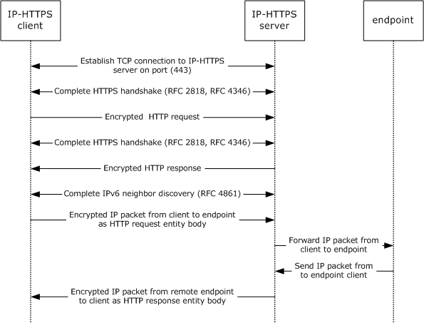
Figure 7: IP-HTTPS packet flow
When an IP-HTTPS client is behind an HTTP proxy, the client first establishes a tunnel using the CONNECT method, as described in [SSLPROXY]. Subsequent message exchanges are identical to the above diagram and happen over the established tunnel.
The HTTP request sent to the IP-HTTPS server is described below.
POST /IPTLS HTTP/1.1 \r\n
Content-Length: 18446744073709551615 \r\n
Host: <IP-address of IP-HTTPS server> \r\n
\r\n
The HTTP response sent from the IP-HTTPS server to the IP-HTTPS client is described below.

HTTP/1.1 200 OK \r\n
Server: Microsoft-HTTPAPI/2.0 \r\n
Date: Sun, 10 Aug 2008 03:51:52 GMT \r\n
\r\n

Attack Scenarios

Unauthorized Client Connecting to an IP-HTTPS Server
In this scenario, an unauthorized attacker poses as a valid IP-HTTPS client and tries to connect to a valid IP-HTTPS server. The HTTPS connection is not allowed to go through, as the attacker will not have a valid client certificate to present to the IP-HTTPS server.
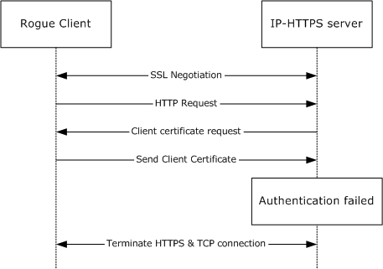
Figure 8: Unauthorized IP-HTTPS client

Unauthorized Client Connecting to an IP-HTTPS Server (When Authentication Mode Is Set to Certificates)
In this scenario, an unauthorized attacker poses as a valid IP-HTTPS client and tries to connect to a valid IP-HTTPS server. The HTTPS connection is not allowed to go through, as the attacker will not have a valid client certificate to present to the IP-HTTPS server.
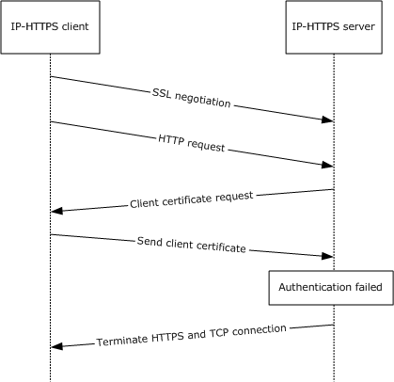
Figure 9: Unauthorized IP-HTTPS client when configured to use client authentication

Unauthorized Client Connecting to an IP-HTTPS Server (When Authentication Mode Is Set to None)
In this scenario, an unauthorized client poses as an IP-HTTPS client and tries to connect to a valid IP-HTTPS server. The HTTPS connection is allowed to go through, as the server has been configured not to require client authentication.
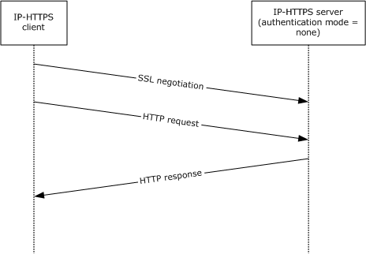
Figure 10: IP-HTTPS server configured not to use client authentication

Unauthorized IP-HTTPS Server Accepting Connections from a Genuine IP-HTTPS Client
In this scenario, a valid IP-HTTPS client is redirected by an attacker to an unauthorized IP-HTTPS server (for example, by DNS poisoning). In this scenario, the HTTPS connection is terminated by the client when the client is unable to validate the server’s identity using its certificate. It is recommended that the IP-HTTPS client validate the certificate per normal TLS certificate validation procedures.
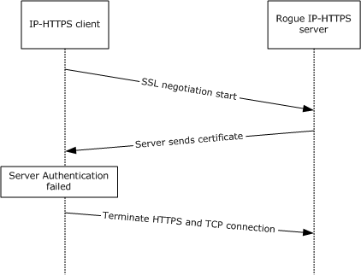
Figure 11: Unauthorized IP-HTTPS server

Man in the Middle
In this scenario, an attacker poses as a man in the middle (MITM). For example, an MITM could be using a rogue wireless access point in a wireless-enabled enterprise environment.
This attack is prevented by requiring mutual authentication using certificates at the HTTPS layers.

Security

Security Considerations for Implementers
IP-HTTPS does not implement any form of security mechanism. It can use security mechanisms implemented by HTTPS (TLS), as described in [RFC2818] and [RFC4346].
As a transport for IP-HTTPS, HTTP provides none of the security services offered by HTTPS. Accordingly, when using HTTP as a transport, it is recommended that the IP-HTTPS payload be protected by some other means. Additionally, some proxies are known to inspect HTTP exchanges, and prevent communications when these do not appear to be normal web traffic. Because of these security and operational considerations, it is recommended that IP-HTTPS use HTTPS as a transport.
When the IP-HTTPS server is configured to use the HTTP transport, it is possible to use it in conjunction with another device (such as a reverse proxy or an SSL/TLS load balancer), which terminates the HTTPS connection from the client on behalf of the server. In this case, the security mechanisms are ensured by that device. There is an implicit relationship of trust between the IP-HTTPS server and the device that terminates HTTPS on its behalf.
It is not possible to use the SEcure Neighbor Discovery (SEND) protocol [RFC3971] when the server authentication mode is None because the server generates Neighbor Advertisements on behalf of clients.

Index of Security Parameters
IP-HTTPS assumes that security has already been negotiated by the HTTPS/TLS layers, as described in section (1.5).
Security Parameter | Section
Mutual authentication, Hashing/Encryption algorithms, and so on. | 1.5

Appendix A: Product Behavior
The information in this specification is applicable to the following Microsoft products or supplemental software. References to product versions include released service packs.
- Windows 7 operating system
- Windows Server 2008 R2 operating system
- Windows 8 operating system
- Windows Server 2012 operating system
- Windows 8.1 operating system
- Windows Server 2012 R2 operating system
- Windows 10 operating system
- Windows Server 2016 operating system
Exceptions, if any, are noted below. If a service pack or Quick Fix Engineering (QFE) number appears with the product version, behavior changed in that service pack or QFE. The new behavior also applies to subsequent service packs of the product unless otherwise specified. If a product edition appears with the product version, behavior is different in that product edition.
Unless otherwise specified, any statement of optional behavior in this specification that is prescribed using the terms "SHOULD" or "SHOULD NOT" implies product behavior in accordance with the SHOULD or SHOULD NOT prescription. Unless otherwise specified, the term "MAY" implies that the product does not follow the prescription.
<1> Section 3.1.5.1: Windows 7 and Windows Server 2008 R2 operating system did not support proxy authentication for IP-HTTPS.
<2> Section 3.2.1: Windows 7 and Windows Server 2008 R2 do not support configuration of the Authentication Mode ADM element.
<3> Section 3.2.1: Windows 7 and Windows Server 2008 R2 do not support a state value of None for the Authentication Mode ADM element.
<4> Section 3.2.5.2.2: Windows 7 and Windows Server 2008 R2 forward multicast Neighbor Solicitations and Neighbor Advertisements to all other IP-HTTPS clients.

Change Tracking
No table of changes is available. The document is either new or has had no changes since its last release.

Index
A

Abstract data model
client 13
server 16
Applicability 8

C

Capability negotiation 9
Change tracking 27
Client
abstract data model 13
higher-layer triggered events 15
Disable IP-HTTPS Link 15
Enable IP-HTTPS Link 15
overview 15
initialization 14
local events 16
message processing
bringing up IP-HTTPS link 15
data transfer 15
error handling 16
establishing HTTPS connection 15
overview 15
other local events 16
overview 12
sequencing rules
bringing up IP-HTTPS link 15
data transfer 15
error handling 16
establishing HTTPS connection 15
overview 15
timer events 16
timers - reconnect 14
unauthorized connecting to server
certificate not valid example (section 4.2.1 21, section 4.2.2 21)
not configured to require client authentication example 22

D

Data model - abstract
client 13
server 16

E

Examples
man-in-the-middle attack 24
overview 20
packet flow and connection establishment 20
unauthorized client connecting to server
certificate not valid (section 4.2.1 21, section 4.2.2 21)
not configured to require client authentication 22
unauthorized server accepting connections from genuine client 23

F

Fields - vendor-extensible 9

G

Glossary 6

H

Higher-layer triggered events
client 15
Disable IP-HTTPS Link 15
Enable IP-HTTPS Link 15
overview 15
server 17
Disable IP-HTTPS Link 17
Enable IP-HTTPS Link 17
overview 17

I

Implementer - security considerations 25
Index of security parameters 25
Informative references 7
Initialization
client 14
server 17
entering listen state 17
overview 17
Introduction 6

L

Local events
client 16
server
changing authentication mode 19
client disconnection 19
shutdown 19

M

Man-in-the-middle attack example 24
Message processing
client
bringing up IP-HTTPS link 15
data transfer 15
error handling 16
establishing HTTPS connection 15
overview 15
server
accepting clients 17
data transfer 17
error handling 18
overview 17
Messages
syntax 11
transport 10

N

Normative references 6

O

Other local events
client 16
server 18
Overview (synopsis) 7

P

Packet flow and connection establishment example 20
Parameters - security index 25
Preconditions 8
Prerequisites 8
Product behavior 26
Protocol Details
overview 12

R

References 6
informative 7
normative 6
Relationship to other protocols 7

S

Security
implementer considerations 25
parameter index 25
Sequencing rules
client
bringing up IP-HTTPS link 15
data transfer 15
error handling 16
establishing HTTPS connection 15
overview 15
server
accepting clients 17
data transfer 17
error handling 18
overview 17
Server
abstract data model 16
higher-layer triggered events 17
Disable IP-HTTPS Link 17
Enable IP-HTTPS Link 17
overview 17
initialization 17
entering listen state 17
overview 17
local events
changing authentication mode 19
client disconnection 19
shutdown 19
message processing
accepting clients 17
data transfer 17
error handling 18
overview 17
other local events 18
sequencing rules
accepting clients 17
data transfer 17
error handling 18
overview 17
timer events 18
timers 17
unauthorized - accepting connections from genuine client example 23
Standards assignments 9
Syntax 11

T

Timer events
client 16
server 18
Timers
client - reconnect 14
server 17
Tracking changes 27
Transport 10
Triggered events
client
Disable IP-HTTPS Link 15
Enable IP-HTTPS Link 15
overview 15
server
Disable IP-HTTPS Link 17
Enable IP-HTTPS Link 17
overview 17
Triggered events - higher-layer
client 15
server 17

V

Vendor-extensible fields 9
Versioning 9

