[MS-GSSA]:
Generic Security Service Algorithm for Secret Key Transaction Authentication for DNS (GSS-TSIG) Protocol Extension

Intellectual Property Rights Notice for Open Specifications Documentation
- Technical Documentation. Microsoft publishes Open Specifications documentation for protocols, file formats, languages, standards as well as overviews of the interaction among each of these technologies.
- Copyrights. This documentation is covered by Microsoft copyrights. Regardless of any other terms that are contained in the terms of use for the Microsoft website that hosts this documentation, you may make copies of it in order to develop implementations of the technologies described in the Open Specifications and may distribute portions of it in your implementations using these technologies or your documentation as necessary to properly document the implementation. You may also distribute in your implementation, with or without modification, any schema, IDL's, or code samples that are included in the documentation. This permission also applies to any documents that are referenced in the Open Specifications.
- No Trade Secrets. Microsoft does not claim any trade secret rights in this documentation.
- Patents. Microsoft has patents that may cover your implementations of the technologies described in the Open Specifications. Neither this notice nor Microsoft's delivery of the documentation grants any licenses under those or any other Microsoft patents. However, a given Open Specification may be covered by Microsoft Open Specification Promise or the Community Promise. If you would prefer a written license, or if the technologies described in the Open Specifications are not covered by the Open Specifications Promise or Community Promise, as applicable, patent licenses are available by contacting iplg@microsoft.com.
- Trademarks. The names of companies and products contained in this documentation may be covered by trademarks or similar intellectual property rights. This notice does not grant any licenses under those rights. For a list of Microsoft trademarks, visit www.microsoft.com/trademarks.
- Fictitious Names. The example companies, organizations, products, domain names, e-mail addresses, logos, people, places, and events depicted in this documentation are fictitious. No association with any real company, organization, product, domain name, email address, logo, person, place, or event is intended or should be inferred.
Reservation of Rights. All other rights are reserved, and this notice does not grant any rights other than specifically described above, whether by implication, estoppel, or otherwise.
Tools. The Open Specifications do not require the use of Microsoft programming tools or programming environments in order for you to develop an implementation. If you have access to Microsoft programming tools and environments you are free to take advantage of them. Certain Open Specifications are intended for use in conjunction with publicly available standard specifications and network programming art, and assumes that the reader either is familiar with the aforementioned material or has immediate access to it.
Revision Summary
Date | Revision History | Revision Class | Comments
4/3/2007 | 1.0 |  | Version 1.0 release
5/11/2007 | 1.2 |  | Version 1.2 release
6/1/2007 | 1.2.1 | Editorial | Changed language and formatting in the technical content.
7/3/2007 | 1.3 | Minor | Clarified the meaning of the technical content.
8/10/2007 | 1.3.1 | Editorial | Changed language and formatting in the technical content.
9/28/2007 | 1.3.2 | Editorial | Changed language and formatting in the technical content.
10/23/2007 | 1.3.3 | Editorial | Changed language and formatting in the technical content.
1/25/2008 | 1.3.4 | Editorial | Changed language and formatting in the technical content.
3/14/2008 | 1.3.5 | Editorial | Changed language and formatting in the technical content.
6/20/2008 | 1.3.6 | Editorial | Changed language and formatting in the technical content.
7/25/2008 | 1.3.7 | Editorial | Changed language and formatting in the technical content.
8/29/2008 | 1.3.8 | Editorial | Changed language and formatting in the technical content.
10/24/2008 | 1.3.9 | Editorial | Changed language and formatting in the technical content.
12/5/2008 | 2.0 | Major | Updated and revised the technical content.
1/16/2009 | 3.0 | Major | Updated and revised the technical content.
2/27/2009 | 4.0 | Major | Updated and revised the technical content.
4/10/2009 | 4.0.1 | Editorial | Changed language and formatting in the technical content.
5/22/2009 | 4.0.2 | Editorial | Changed language and formatting in the technical content.
7/2/2009 | 4.0.3 | Editorial | Changed language and formatting in the technical content.
8/14/2009 | 4.0.4 | Editorial | Changed language and formatting in the technical content.
9/25/2009 | 4.0.5 | Editorial | Changed language and formatting in the technical content.
11/6/2009 | 4.0.6 | Editorial | Changed language and formatting in the technical content.
12/18/2009 | 4.0.7 | Editorial | Changed language and formatting in the technical content.
1/29/2010 | 4.0.8 | Editorial | Changed language and formatting in the technical content.
3/12/2010 | 4.0.9 | Editorial | Changed language and formatting in the technical content.
4/23/2010 | 4.0.10 | Editorial | Changed language and formatting in the technical content.
6/4/2010 | 4.0.11 | Editorial | Changed language and formatting in the technical content.
7/16/2010 | 4.0.11 | None | No changes to the meaning, language, or formatting of the technical content.
8/27/2010 | 4.0.11 | None | No changes to the meaning, language, or formatting of the technical content.
10/8/2010 | 4.0.11 | None | No changes to the meaning, language, or formatting of the technical content.
11/19/2010 | 4.0.11 | None | No changes to the meaning, language, or formatting of the technical content.
1/7/2011 | 4.0.11 | None | No changes to the meaning, language, or formatting of the technical content.
2/11/2011 | 4.0.11 | None | No changes to the meaning, language, or formatting of the technical content.
3/25/2011 | 4.0.11 | None | No changes to the meaning, language, or formatting of the technical content.
5/6/2011 | 4.0.11 | None | No changes to the meaning, language, or formatting of the technical content.
6/17/2011 | 4.1 | Minor | Clarified the meaning of the technical content.
9/23/2011 | 4.1 | None | No changes to the meaning, language, or formatting of the technical content.
12/16/2011 | 5.0 | Major | Updated and revised the technical content.
3/30/2012 | 6.0 | Major | Updated and revised the technical content.
7/12/2012 | 6.0 | None | No changes to the meaning, language, or formatting of the technical content.
10/25/2012 | 6.0 | None | No changes to the meaning, language, or formatting of the technical content.
1/31/2013 | 6.0 | None | No changes to the meaning, language, or formatting of the technical content.
8/8/2013 | 7.0 | Major | Updated and revised the technical content.
11/14/2013 | 7.0 | None | No changes to the meaning, language, or formatting of the technical content.
2/13/2014 | 7.0 | None | No changes to the meaning, language, or formatting of the technical content.
5/15/2014 | 7.0 | None | No changes to the meaning, language, or formatting of the technical content.
6/30/2015 | 8.0 | Major | Significantly changed the technical content.
10/16/2015 | 8.0 | No Change | No changes to the meaning, language, or formatting of the technical content.
Table of Contents
1 Introduction 5
1.1 Glossary 5
1.2 References 5
1.2.1 Normative References 5
1.2.2 Informative References 6
1.3 Overview 6
1.4 Relationship to Other Protocols 6
1.5 Prerequisites/Preconditions 6
1.6 Applicability Statement 6
1.7 Versioning and Capability Negotiation 6
1.8 Vendor-Extensible Fields 6
1.9 Standards Assignments 6
2 Messages 7
2.1 Transport 7
2.2 Message Syntax 7
3 Protocol Details 8
3.1 Common Details 8
3.1.1 Abstract Data Model 8
3.1.2 Timers 8
3.1.3 Initialization 8
3.1.4 Higher-Layer Triggered Events 8
3.1.5 Message Processing Events and Sequencing Rules 8
3.1.5.1 Handling the MAC Field While Digesting DNS Messages 8
3.1.5.2 Support for the HDAC-MD5 Algorithm 8
3.1.5.3 Signing DNS Update Response Messages 9
3.1.6 Timer Events 9
3.1.7 Other Local Events 9
4 Protocol Examples 10
5 Security 13
5.1 Security Considerations for Implementers 13
5.2 Index of Security Parameters 13
6 Appendix A: Product Behavior 14
7 Change Tracking 15
8 Index 16

Introduction
Secret Key Transaction Authentication for DNS (TSIG), as specified in [RFC2845], provides extensible transaction level authentication for DNS. The Generic Security Service Algorithm for Secret Key Transaction Authentication for DNS (GSS-TSIG), as specified in [RFC3645], identifies one possible extension to TSIG based on the Generic Security Service Application Program Interface (GSS-API), as specified in [RFC2743].
This document specifies an extension to GSS-TSIG.
Sections 1.8, 2, and 3 of this specification are normative and can contain the terms MAY, SHOULD, MUST, MUST NOT, and SHOULD NOT as defined in [RFC2119]. Sections 1.5 and 1.9 are also normative but do not contain those terms. All other sections and examples in this specification are informative.

Glossary
The following terms are specific to this document:
Message Authentication Code (MAC): A message authenticator computed through the use of a symmetric key. A MAC algorithm accepts a secret key and a data buffer, and outputs a MAC. The data and MAC can then be sent to another party, which can verify the integrity and authenticity of the data by using the same secret key and the same MAC algorithm.
security support provider (SSP): A dynamic-link library (DLL) that implements the Security Support Provider Interface (SSPI) by making one or more security packages available to applications. Each security package provides mappings between an application's SSPI function calls and an actual security model's functions. Security packages support security protocols such as Kerberos authentication and NTLM.
MAY, SHOULD, MUST, SHOULD NOT, MUST NOT: These terms (in all caps) are used as defined in [RFC2119]. All statements of optional behavior use either MAY, SHOULD, or SHOULD NOT.

References
Links to a document in the Microsoft Open Specifications library point to the correct section in the most recently published version of the referenced document. However, because individual documents in the library are not updated at the same time, the section numbers in the documents may not match. You can confirm the correct section numbering by checking the Errata.

Normative References
We conduct frequent surveys of the normative references to assure their continued availability. If you have any issue with finding a normative reference, please contact dochelp@microsoft.com. We will assist you in finding the relevant information.
[RFC2119] Bradner, S., "Key words for use in RFCs to Indicate Requirement Levels", BCP 14, RFC 2119, March 1997, http://www.rfc-editor.org/rfc/rfc2119.txt
[RFC2136] Thomson, S., Rekhter Y. and Bound, J., "Dynamic Updates in the Domain Name System (DNS UPDATE)", RFC 2136, April 1997, http://www.ietf.org/rfc/rfc2136.txt
[RFC2743] Linn, J., "Generic Security Service Application Program Interface Version 2, Update 1", RFC 2743, January 2000, http://www.rfc-editor.org/rfc/rfc2743.txt
[RFC2845] Vixie, P., Gudmundsson, O., Eastlake III, D., and Wellington, B., "Secret Key Transaction Authentication for DNS (TSIG)", RFC 2845, May 2000, http://www.ietf.org/rfc/rfc2845.txt
[RFC2930] Eastlake III, D., "Secret Key Establishment for DNS (TKEY RR)", RFC 2930, September 2000, http://www.ietf.org/rfc/rfc2930.txt
[RFC3645] Kwan, S., Garg, P., Gilroy, J., Esibov, L., Westhead, J., and Hall, R., "Generic Security Service Algorithm for Secret Key Transaction Authentication for DNS (GSS-TSIG)", RFC 3645, October 2003, http://www.ietf.org/rfc/rfc3645.txt

Informative References
None.

Overview
Secret Key Transaction Authentication for DNS (TSIG), as specified in [RFC2845], is an extensible protocol by which DNS messages can be authenticated and validated. The Generic Security Service Algorithm for Secret Key Transaction Authentication for DNS (GSS-TSIG), as specified in [RFC3645], defines an algorithm for use with TSIG, which is based on the Generic Security Service Application Program Interface, as specified in [RFC2743].
In [RFC3645] section 2.2, GSS-TSIG specifies that the final transaction key (TKEY) response indicating successful negotiation must be signed. In [RFC2845] section 3.4, TSIG specifies which data is to be digested when generating or verifying the contents of a TSIG record. This protocol extension defines an alternate method of building the digest that is used to sign the last message in the GSS-TSIG TKEY negotiation.

Relationship to Other Protocols
This specification defines an extension to GSS-TSIG, as specified in [RFC3645]. The relationship of GSS-TSIG to other protocols is not changed by this protocol extension.

Prerequisites/Preconditions
All prerequisites and preconditions applicable to GSS-TSIG, as specified in [RFC3645], apply to this protocol extension.

Applicability Statement
This protocol extension does not change the way in which GSS-TSIG, as specified in [RFC3645], is used.

Versioning and Capability Negotiation
None.

Vendor-Extensible Fields
None.

Standards Assignments
None.

Messages
This protocol extension does not change the format of messages defined by GSS-TSIG, as specified in [RFC3645]. The format of messages remains the same, although the contents of the TSIG record attached to the final TKEY response in the negotiation are changed.

Transport
This protocol extension does not change the base transport used by GSS-TSIG, as specified in [RFC3645].

Message Syntax
This document does not specify any new messages.

Protocol Details

Common Details

Abstract Data Model
None.

Timers
None.

Initialization
This protocol extension does not require any initialization that is not already required by GSS-TSIG, as specified in [RFC3645].

Higher-Layer Triggered Events
None.

Message Processing Events and Sequencing Rules
This protocol extension does not change message processing events or sequencing rules of messages defined by GSS-TSIG, as specified in [RFC3645], beyond the changes described in the following sections.

Handling the MAC Field While Digesting DNS Messages
GSS-TSIG, as specified in [RFC3645], specifies how the client and server exchange tokens obtained from GSS-API calls (as specified in [RFC2743]). The tokens are contained in DNS TKEY records, as specified in [RFC2930]. In [RFC3645] section 4.1.3, GSS-TSIG specifies that the server MUST sign the final TKEY response in GSS-TSIG negotiation.
In [RFC2845] section 3.4.3, TSIG specifies that the request message authentication code (MAC) is to be included in the digest when generating or validating a DNS message. However, because the final TKEY response in the GSS-TSIG is the first DNS message in the exchange that has been signed, there is no request MAC that can be included when performing the digest operation.
When there is no request MAC, the most obvious interpretation of [RFC2845] section 3.4.3 is that the 2-byte MAC length with a value of zero be included in the digest to indicate that no MAC data bytes are being included in the digest. This protocol extension specifies that when building the digest for this message, the request MAC MUST be completely omitted. In other words, the request MAC length and request MAC data fields MUST NOT be included in the digest, so the only components of the digest will be the DNS response message and TSIG response variables.
After GSS-TSIG negotiation is complete, the digesting of further DNS messages MUST include the request MAC, as specified in [RFC2845] section 3.4.

Support for the HDAC-MD5 Algorithm
[RFC2845] section 2.2 specifies that TSIG MUST support the "HMAC-MD5" algorithm. GSS-API does not explicitly define the MAC formats supported. Instead it relies on the security support provider (SSP) that is exposed by the operating system. Implementations of this protocol extension MUST NOT support the "HMAC-MD5.SIG-ALG.REG.INT" algorithm in [RFC2845] section 7. Implementations of this protocol extension MUST support the "gss-tsig" algorithm, as specified in [RFC3645] section 3.1.2.

Signing DNS Update Response Messages
As described in [RFC2136] section 3.8, the DNS server MUST send a DNS update response back to the DNS client after processing a DNS update request. If the DNS update request is signed and includes a TSIG record, as specified in [RFC3645] and [RFC2845] section 4, then the DNS server SHOULD<1> sign the DNS update response and include the resulting TSIG record as described in [RFC3645].

Timer Events
None.

Other Local Events
None.

Protocol Examples
Examples that clarify the difference between a strict interpretation of the relevant RFCs and the Microsoft implementation are included in the figures in this section.
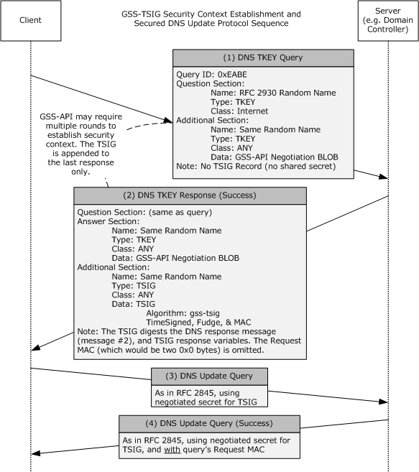
Figure 1: Example of a protocol sequence
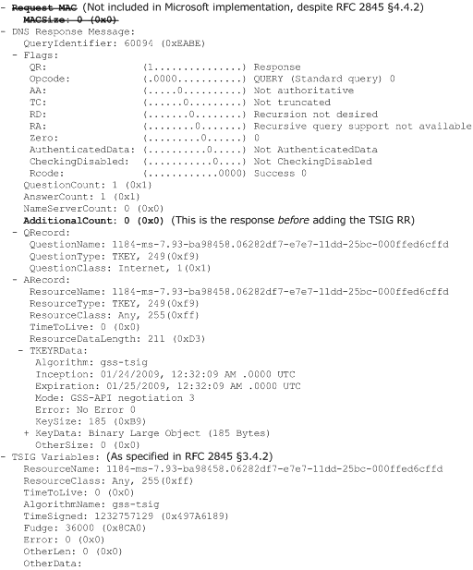
Figure 2: Example of Message #2 input to the GSS_GetMIC TSIG generation function
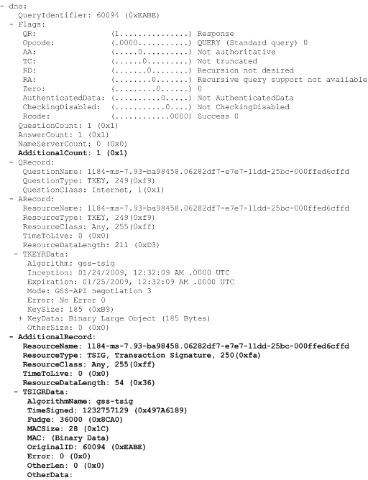
Figure 3: Example of Message #2, as it appears on the wire

Security

Security Considerations for Implementers
None.

Index of Security Parameters
None.

Appendix A: Product Behavior
The information in this specification is applicable to the following Microsoft products or supplemental software. References to product versions include released service packs.
Note: Some of the information in this section is subject to change because it applies to a preliminary product version, and thus may differ from the final version of the software when released. All behavior notes that pertain to the preliminary product version contain specific references to it as an aid to the reader.
- Windows 2000 operating system
- Windows XP operating system
- Windows Server 2003 operating system
- Windows Vista operating system
- Windows Server 2008 operating system
- Windows 7 operating system
- Windows Server 2008 R2 operating system
- Windows 8 operating system
- Windows Server 2012 operating system
- Windows 8.1 operating system
- Windows Server 2012 R2 operating system
- Windows 10 operating system
- Windows Server 2016 Technical Preview operating system
Exceptions, if any, are noted below. If a service pack or Quick Fix Engineering (QFE) number appears with the product version, behavior changed in that service pack or QFE. The new behavior also applies to subsequent service packs of the product unless otherwise specified. If a product edition appears with the product version, behavior is different in that product edition.
Unless otherwise specified, any statement of optional behavior in this specification that is prescribed using the terms SHOULD or SHOULD NOT implies product behavior in accordance with the SHOULD or SHOULD NOT prescription. Unless otherwise specified, the term MAY implies that the product does not follow the prescription.
<1> Section 3.1.5.3: In the Windows implementation of the DNS server, the DNS client will find that the DNS server signed a DNS update response, as described in [RFC3645], only if the RCODE value in the response message is zero (indicating success).
If the RCODE value in the DNS update response message is not zero (indicating failure), the DNS client will find that the DNS server did not sign the response. Instead, the DNS server copied the DNS update request message, changed the RCODE value to the applicable nonzero error value, and sent that message back to the DNS client as the response. The message was otherwise unmodified; that is, the response message contains the same signature that was in the request message.

Change Tracking
No table of changes is available. The document is either new or has had no changes since its last release.

Index
A

Abstract data model 8
Applicability 6

C

Capability negotiation 6
Change tracking 15
Common details 8

D

Data model - abstract 8
Details - common 8

E

Examples 10

F

Fields - vendor-extensible 6

G

Glossary 5

H

Higher-layer triggered events 8

I

Implementer - security considerations 13
Index of security parameters 13
Informative references 6
Initialization 8
Introduction 5

L

Local events 9

M

Message processing 8
Messages
overview 7
syntax 7
transport 7

N

Normative references 5

O

Overview
common details 8
main 6
Overview (synopsis) 6

P

Parameters - security index 13
Preconditions 6
Prerequisites 6
Product behavior 14

R

References 5
informative 6
normative 5
Relationship to other protocols 6

S

Secret Key Transaction Authentication for DNS (TSIG) described 6
Security
implementer considerations 13
parameter index 13
Sequencing rules 8
Standards assignments 6
Syntax 7

T

Timer events 9
Timers 8
Tracking changes 15
Transport 7
Triggered events - higher-layer 8

V

Vendor-extensible fields 6
Versioning 6

