[MS-DSCPM]:
Desired State Configuration Pull Model Protocol

Intellectual Property Rights Notice for Open Specifications Documentation
- Technical Documentation. Microsoft publishes Open Specifications documentation (“this documentation”) for protocols, file formats, data portability, computer languages, and standards support. Additionally, overview documents cover inter-protocol relationships and interactions.
- Copyrights. This documentation is covered by Microsoft copyrights. Regardless of any other terms that are contained in the terms of use for the Microsoft website that hosts this documentation, you can make copies of it in order to develop implementations of the technologies that are described in this documentation and can distribute portions of it in your implementations that use these technologies or in your documentation as necessary to properly document the implementation. You can also distribute in your implementation, with or without modification, any schemas, IDLs, or code samples that are included in the documentation. This permission also applies to any documents that are referenced in the Open Specifications documentation.
- No Trade Secrets. Microsoft does not claim any trade secret rights in this documentation.
- Patents. Microsoft has patents that might cover your implementations of the technologies described in the Open Specifications documentation. Neither this notice nor Microsoft's delivery of this documentation grants any licenses under those patents or any other Microsoft patents. However, a given Open Specifications document might be covered by the Microsoft Open Specifications Promise or the Microsoft Community Promise. If you would prefer a written license, or if the technologies described in this documentation are not covered by the Open Specifications Promise or Community Promise, as applicable, patent licenses are available by contacting iplg@microsoft.com.
- License Programs. To see all of the protocols in scope under a specific license program and the associated patents, visit the Patent Map.
- Trademarks. The names of companies and products contained in this documentation might be covered by trademarks or similar intellectual property rights. This notice does not grant any licenses under those rights. For a list of Microsoft trademarks, visit www.microsoft.com/trademarks.
- Fictitious Names. The example companies, organizations, products, domain names, email addresses, logos, people, places, and events that are depicted in this documentation are fictitious. No association with any real company, organization, product, domain name, email address, logo, person, place, or event is intended or should be inferred.
Reservation of Rights. All other rights are reserved, and this notice does not grant any rights other than as specifically described above, whether by implication, estoppel, or otherwise.
Tools. The Open Specifications documentation does not require the use of Microsoft programming tools or programming environments in order for you to develop an implementation. If you have access to Microsoft programming tools and environments, you are free to take advantage of them. Certain Open Specifications documents are intended for use in conjunction with publicly available standards specifications and network programming art and, as such, assume that the reader either is familiar with the aforementioned material or has immediate access to it.
Support. For questions and support, please contact dochelp@microsoft.com.
Revision Summary
Date | Revision History | Revision Class | Comments
8/8/2013 | 1.0 | New | Released new document.
11/14/2013 | 2.0 | Major | Updated and revised the technical content.
2/13/2014 | 2.1 | Minor | Clarified the meaning of the technical content.
5/15/2014 | 2.1 | None | No changes to the meaning, language, or formatting of the technical content.
6/30/2015 | 3.0 | Major | Significantly changed the technical content.
10/16/2015 | 4.0 | Major | Significantly changed the technical content.
7/14/2016 | 5.0 | Major | Significantly changed the technical content.
6/1/2017 | 5.0 | None | No changes to the meaning, language, or formatting of the technical content.
Table of Contents
1 Introduction 7
1.1 Glossary 7
1.2 References 8
1.2.1 Normative References 8
1.2.2 Informative References 8
1.3 Overview 8
1.4 Relationship to Other Protocols 8
1.5 Prerequisites/Preconditions 8
1.6 Applicability Statement 9
1.7 Vendor-Extensible Fields 9
1.8 Standards Assignments 9
2 Messages 10
2.1 Transport 10
2.2 Common Data Types 10
2.2.1 Namespaces 10
2.2.2 HTTP Headers 10
2.2.2.1 Content-Type 10
2.2.2.1.1 Application/octet-stream 11
2.2.2.1.2 Application/json 11
2.2.2.2 Checksum 11
2.2.2.3 ChecksumAlgorithm 11
2.2.2.4 ConfigurationName 11
2.2.2.5 ProtocolVersion 11
2.2.2.6 AgentId 12
2.2.2.7 Authorization 12
2.2.3 Common URI Parameters 12
2.2.3.1 ConfigurationId 12
2.2.3.2 ModuleName 12
2.2.3.3 ModuleVersion 13
2.2.3.4 AgentId 13
3 Protocol Details 14
3.1 GetConfiguration Versions 1.0 and 1.1 Details 14
3.1.1 Abstract Data Model 14
3.1.2 Timers 14
3.1.3 Initialization 14
3.1.4 Higher-Layer Triggered Events 14
3.1.5 Message Processing Events and Sequencing Rules 14
3.1.5.1 Action(ConfigurationId={ConfigurationId})/ConfigurationContent 15
3.1.5.1.1 GET 15
3.1.5.1.1.1 Request Body 16
3.1.5.1.1.2 Response Body 16
3.1.5.1.1.3 Processing Details 16
3.1.6 Timer Events 17
3.1.7 Other Local Events 17
3.2 GetModule Versions 1.0 and 1.1 Details 17
3.2.1 Abstract Data Model 17
3.2.2 Timers 17
3.2.3 Initialization 17
3.2.4 Higher-Layer Triggered Events 17
3.2.5 Message Processing Events and Sequencing Rules 17
3.2.5.1 Module(ConfigurationId={ConfigurationId},ModuleName={moduleName},ModuleVersion={moduleVersion})/ModuleContent 18
3.2.5.1.1 GET 18
3.2.5.1.1.1 Request Body 19
3.2.5.1.1.2 Response Body 19
3.2.5.1.1.3 Processing Details 19
3.2.6 Timer Events 20
3.2.7 Other Local Events 20
3.3 GetAction Versions 1.0 and 1.1 Details 20
3.3.1 Abstract Data Model 20
3.3.2 Timers 20
3.3.3 Initialization 20
3.3.4 Higher-Layer Triggered Events 20
3.3.5 Message Processing Events and Sequencing Rules 20
3.3.5.1 Action(ConfigurationId={ConfigurationId})/GetAction 20
3.3.5.1.1 POST 21
3.3.5.1.1.1 Request Body 22
3.3.5.1.1.2 Response Body 22
3.3.5.1.1.3 Processing Details 22
3.3.6 Timer Events 22
3.3.7 Other Local Events 22
3.4 SendStatusReport Versions 1.0 and 1.1 Details 22
3.4.1 Abstract Data Model 22
3.4.2 Timers 23
3.4.3 Initialization 23
3.4.4 Higher-Layer Triggered Events 23
3.4.5 Message Processing Events and Sequencing Rules 23
3.4.5.1 Node(ConfigurationID={ConfigurationId})/SendStatusReport 23
3.4.5.1.1 POST 23
3.4.5.1.1.1 Request Body 24
3.4.5.1.1.2 Response Body 25
3.4.5.1.1.3 Processing Details 25
3.4.6 Timer Events 25
3.4.7 Other Local Events 25
3.5 GetStatusReport Versions 1.0 and 1.1 Details 25
3.5.1 Abstract Data Model 25
3.5.2 Timers 25
3.5.3 Initialization 25
3.5.4 Higher-Layer Triggered Events 26
3.5.5 Message Processing Events and Sequencing Rules 26
3.5.5.1 Node(ConfigurationId={ConfigurationId})/StatusReports 26
3.5.5.1.1 GET 26
3.5.5.1.1.1 Request Body 27
3.5.5.1.1.2 Response Body 27
3.5.5.1.1.3 Processing Details 27
3.5.6 Timer Events 27
3.5.7 Other Local Events 28
3.6 GetConfiguration Version 2.0 Details 28
3.6.1 Abstract Data Model 28
3.6.2 Timers 28
3.6.3 Initialization 28
3.6.4 Higher-Layer Triggered Events 28
3.6.5 Message Processing Events and Sequencing Rules 28
3.6.5.1 Nodes(AgentId={AgentId})/ Configurations(ConfigurationName={ConfigurationName})/ConfigurationContent 29
3.6.5.2 GET 29
3.6.5.2.1 Request Body 30
3.6.5.2.2 Response Body 30
3.6.5.2.3 Processing Details 31
3.6.6 Timer Events 31
3.6.7 Other Local Events 31
3.7 GetModule Version 2.0 Details 31
3.7.1 Abstract Data Model 31
3.7.2 Timers 31
3.7.3 Initialization 31
3.7.4 Higher-Layer Triggered Events 31
3.7.5 Message Processing Events and Sequencing Rules 32
3.7.5.1 Modules(ModuleName={moduleName},ModuleVersion={moduleVersion})/ModuleContent 32
3.7.5.1.1 GET 32
3.7.5.1.1.1 Request Body 34
3.7.5.1.1.2 Response Body 34
3.7.5.1.1.3 Processing Details 34
3.7.6 Timer Events 34
3.7.7 Other Local Events 34
3.8 GetDscAction Version 2.0 Details 34
3.8.1 Abstract Data Model 34
3.8.2 Timers 34
3.8.3 Initialization 34
3.8.4 Higher-Layer Triggered Events 35
3.8.5 Message Processing Events and Sequencing Rules 35
3.8.5.1 Nodes(AgentId={AgentId})/GetDscAction 35
3.8.5.1.1 POST 35
3.8.5.1.1.1 Request Body 36
3.8.5.1.1.2 Response Body 36
3.8.5.1.1.3 Processing Details 37
3.8.6 Timer Events 37
3.8.7 Other Local Events 37
3.9 RegisterDscAgent Version 2 Details 37
3.9.1 Abstract Data Model 37
3.9.2 Timers 37
3.9.3 Initialization 37
3.9.4 Higher-Layer Triggered Events 37
3.9.5 Message Processing Events and Sequencing Rules 37
3.9.5.1 Nodes(AgentId={AgentId}) 38
3.9.5.1.1 PUT 38
3.9.5.1.1.1 Request Body 39
3.9.5.1.1.2 Response Body 39
3.9.5.1.1.3 Processing Details 39
3.9.6 Timer Events 39
3.9.7 Other Local Events 40
3.10 SendReport Version 2.0 Details 40
3.10.1 Abstract Data Model 40
3.10.2 Timers 40
3.10.3 Initialization 40
3.10.4 Higher-Layer Triggered Events 40
3.10.5 Message Processing Events and Sequencing Rules 40
3.10.5.1 Nodes(AgentID={AgentId})/SendReport 40
3.10.5.1.1 POST 41
3.10.5.1.1.1 Request Body 42
3.10.5.1.1.2 Response Body 42
3.10.5.1.1.3 Processing Details 42
3.10.6 Timer Events 42
3.10.7 Other Local Events 43
3.11 GetReports Version 2.0 Details 43
3.11.1 Abstract Data Model 43
3.11.2 Timers 43
3.11.3 Initialization 43
3.11.4 Higher-Layer Triggered Events 43
3.11.5 Message Processing Events and Sequencing Rules 43
3.11.5.1 Nodes(AgentId={AgentId})/Reports 43
3.11.5.1.1 GET 44
3.11.5.1.1.1 Request Body 45
3.11.5.1.1.2 Response Body 45
3.11.5.1.1.3 Processing Details 45
3.11.6 Timer Events 45
3.11.7 Other Local Events 45
4 Protocol Examples 46
4.1 GetConfiguration Sequence 46
4.2 GetModule Sequence 46
4.3 GetAction Sequence 47
4.4 SendStatusReport Sequence 48
4.5 GetStatusReport Sequence 49
4.6 RegisterDscAgent Sequence 50
4.7 SendReport Sequence 51
4.8 GetDscAction Sequence 51
5 Security 53
5.1 Security Considerations for Implementers 53
5.2 Index of Security Parameters 53
6 Appendix A: Full JSON Schema 54
7 Appendix B: Product Behavior 58
8 Change Tracking 60
9 Index 61

Introduction
The Desired State Configuration Pull Model Protocol is based on the Hypertext Transfer Protocol (HTTP) (as specified in [RFC2616]). It is used for getting a client's configuration and modules from the server and for reporting back the client's status to the server.
Sections 1.5, 1.8, 1.9, 2, and 3 of this specification are normative. All other sections and examples in this specification are informative.

Glossary
This document uses the following terms:
Augmented Backus-Naur Form (ABNF): A modified version of Backus-Naur Form (BNF), commonly used by Internet specifications. ABNF notation balances compactness and simplicity with reasonable representational power. ABNF differs from standard BNF in its definitions and uses of naming rules, repetition, alternatives, order-independence, and value ranges. For more information, see [RFC5234].
binary large object (BLOB): A collection of binary data stored as a single entity in a database.
checksum: A value that is the summation of a byte stream. By comparing the checksums computed from a data item at two different times, one can quickly assess whether the data items are identical.
configuration: Represents a binary large object (BLOB). The protocol does not process the content of the BLOB and it is passed as-is to the higher layer.
Hypertext Transfer Protocol (HTTP): An application-level protocol for distributed, collaborative, hypermedia information systems (text, graphic images, sound, video, and other multimedia files) on the World Wide Web.
module: A BLOB in the Desired State Configuration Pull Model Protocol [MS-DSCPM]. The protocol does not process the content of the BLOB, and it is passed as it is to the higher layer.
Transmission Control Protocol (TCP): A protocol used with the Internet Protocol (IP) to send data in the form of message units between computers over the Internet. TCP handles keeping track of the individual units of data (called packets) that a message is divided into for efficient routing through the Internet.
Uniform Resource Identifier (URI): A string that identifies a resource. The URI is an addressing mechanism defined in Internet Engineering Task Force (IETF) Uniform Resource Identifier (URI): Generic Syntax [RFC3986].
Uniform Resource Locator (URL): A string of characters in a standardized format that identifies a document or resource on the World Wide Web. The format is as specified in [RFC1738].
universally unique identifier (UUID): A 128-bit value. UUIDs can be used for multiple purposes, from tagging objects with an extremely short lifetime, to reliably identifying very persistent objects in cross-process communication such as client and server interfaces, manager entry-point vectors, and RPC objects. UUIDs are highly likely to be unique. UUIDs are also known as globally unique identifiers (GUIDs) and these terms are used interchangeably in the Microsoft protocol technical documents (TDs). Interchanging the usage of these terms does not imply or require a specific algorithm or mechanism to generate the UUID. Specifically, the use of this term does not imply or require that the algorithms described in [RFC4122] or [C706] must be used for generating the UUID.
MAY, SHOULD, MUST, SHOULD NOT, MUST NOT: These terms (in all caps) are used as defined in [RFC2119]. All statements of optional behavior use either MAY, SHOULD, or SHOULD NOT.

References
Links to a document in the Microsoft Open Specifications library point to the correct section in the most recently published version of the referenced document. However, because individual documents in the library are not updated at the same time, the section numbers in the documents may not match. You can confirm the correct section numbering by checking the Errata.

Normative References
We conduct frequent surveys of the normative references to assure their continued availability. If you have any issue with finding a normative reference, please contact dochelp@microsoft.com. We will assist you in finding the relevant information.
[RFC2119] Bradner, S., "Key words for use in RFCs to Indicate Requirement Levels", BCP 14, RFC 2119, March 1997, http://www.rfc-editor.org/rfc/rfc2119.txt
[RFC2616] Fielding, R., Gettys, J., Mogul, J., et al., "Hypertext Transfer Protocol -- HTTP/1.1", RFC 2616, June 1999, http://www.rfc-editor.org/rfc/rfc2616.txt
[RFC4122] Leach, P., Mealling, M., and Salz, R., "A Universally Unique Identifier (UUID) URN Namespace", RFC 4122, July 2005, http://www.rfc-editor.org/rfc/rfc4122.txt
[RFC4234] Crocker, D., Ed., and Overell, P., "Augmented BNF for Syntax Specifications: ABNF", RFC 4234, October 2005, http://www.rfc-editor.org/rfc/rfc4234.txt
[RFC4634] Eastlake III, D. and Hansen, T., "US Secure Hash Algorithms (SHA and HMAC-SHA)", RFC 4634, July 2006, http://www.ietf.org/rfc/rfc4634.txt
[RFC4648] Josefsson, S., "The Base16, Base32, and Base64 Data Encodings", RFC 4648, October 2006, http://www.rfc-editor.org/rfc/rfc4648.txt

Informative References
None.

Overview

The Desired State Configuration Pull Model Protocol is used to register a client, to get the configuration and the module from the server, and to report back some elements to the server.
The protocol depends on HTTP for the transfer of all protocol messages, including the transfer of the binary data. In this specification, the entity that initiates the HTTP connection is referred to as the client, and the entity that responds to the HTTP connection is referred to as the server. With the Desired State Configuration Pull Model Protocol, binary data flows from the server to the client.

Relationship to Other Protocols
This protocol depends on HTTP as specified in [RFC2616]. HTTP version 1.1 is used with this protocol.

Prerequisites/Preconditions
This protocol does not provide a mechanism for a client to discover the Uniform Resource Locator (URL) of the server. Thus, it is a prerequisite that the client obtain the URL of the server before this protocol can be used.

Applicability Statement
The Desired State Configuration Pull Model Protocol is capable of downloading the configuration and modules from the server.
This document covers versioning issues in the following areas:
Supported Transports: This protocol can be implemented on top of HTTP, as specified in section 2.1.
Security and Authentication Methods: This protocol supports HTTP access authentication, as specified in [RFC2616] section 11.
Localization: This specification does not specify any localization-dependent protocol behavior.

Vendor-Extensible Fields
None.

Standards Assignments
None.

Messages

Transport
The Desired State Configuration Pull Model Protocol uses HTTP 1.1, as specified in [RFC2616], as the transport layer.
A Transmission Control Protocol (TCP) port has not been reserved for this protocol. TCP port 80 is commonly used because many HTTP proxy servers forward only HTTP traffic that uses port 80.
The protocol uses the access authentication functionality of the HTTP layer as specified in [RFC2616] section 11.

Common Data Types
None.

Namespaces
None.

HTTP Headers
The Desired State Configuration Pull Model Protocol uses existing headers as specified in [RFC2616].
Unless specified otherwise, the headers defined in this specification are used in both request and response messages.
If a client or server receives an HTTP header that is not defined in this section, or if the header is not defined in the current context (for example, receiving a request-only header in a response), the header MUST be interpreted as specified in [RFC2616].
This section defines the syntax of the HTTP headers that use the Augmented Backus-Naur Form (ABNF) syntax, as specified in [RFC4234].
The following table summarizes the HTTP headers defined by this specification.
Header | Description
Content-Type | Section 2.2.2.1
Checksum | Section 2.2.2.2

Content-Type
The Content-Type header specifies the type of data that is included in the body of the GET or POST request.
The syntax of the Content-Type header is defined as follows.

Content-Type = "Content-Type: " "application/octet-stream" CRLF /
"Content-Type: " "application/json" [";charset=UTF-8"] CRLF
Example: Content-Type: application/octet-stream
Content-Type: application/json;charset=UTF-8

Application/octet-stream
This Content-Type is defined only for use in a request sent to the server and used in a GET response to get the module or configuration from a server.

Application/json
This Content-Type is defined only for use in a request sent to the server and used in a POST response.

Checksum
The Checksum header field is defined only for use in a response message sent to a client as part of a GET request for the module and configuration.
Checksum = "Checksum" : DQUOTE Check-sumvalue DQUOTE CRLF
Check-sumvalue = BASE16 ; specified in [RFC4648]
/ 0x00 (Null Character)

Example: "Checksum":"8eDMbsSDig15Xx+B3msvRrDa5N1njaf5smVujQjhOeI="
"Checksum":""

ChecksumAlgorithm
The ChecksumAlgorithm header field specifies the checksum algorithm used to generate the checksum.
ChecksumAlgorithm = "ChecksumAlgorithm" : DQUOTE Check-sumAlgorithmvalue DQUOTE CRLF
Check-sumAlgorithmvalue = "SHA-256" ; specified in [RFC4634]

Example: "ChecksumAlgorithm":"SHA-256"

ConfigurationName
The ConfigurationName header field SHOULD<1> be used in the request message sent to the server as part of a GET request for the configuration.
ConfigurationName = "ConfigurationName" : DQUOTE Configuration-Namevalue DQUOTE CRLF
Configuration-Namevalue = Element *(Element)
Element = DIGIT / ALPHA
Example: "ConfigurationName":"SubPart1"

ProtocolVersion
The ProtocolVersion header field SHOULD<2> be used in the request message sent to the server as part of every request. The current version is hardcoded to 2.0.
ProtocolVersion = "ProtocolVersion" : DQUOTE ProtocolVersion-Namevalue DQUOTE CRLF
ProtocolVersion-Namevalue = Element . *(Element)
Element = DIGIT
Example: "ProtocolVersion":"2.0"

AgentId
The AgentId header field SHOULD<3> be used in the request message sent to the server as part of every request. The AgentId is a unique GUID value generated once and stored in the Registry.
AgentId = "AgentId" : DQUOTE AgentId-Namevalue DQUOTE CRLF
AgentId-Namevalue : Element *(Element)
Element = DIGIT / ALPHA / "-"
Example: "AgentId":"34C8104D-F7BA-4672-8226-0809B0A3BEC3"

Authorization
The Authorization header field SHOULD<4> be used in the request message sent to the server as part of every request. The Shared authorization key is generated during the registration and serves to verify the payload sent to the server.
Authorization = "Authorization": Shared DQUOTE Authorization-Namevalue DQUOTE CRLF
Authorization-Namevalue = A signature generated from an HMAC hash of the request body.
Element = DIGIT / ALPHA / "-" / "+"
Example: "Authorization": "Shared GKtPgocze1AM/pgc3LQzyGpDCRs15KoKx/2eXxlL8+w="

Common URI Parameters
The following table summarizes the set of common URI parameters defined by this protocol.
URI parameter | Section
ConfigurationId | Section 2.2.3.1
ModuleName | Section 2.2.3.2
ModuleVersion | Section 2.2.3.3

ConfigurationId
The ConfigurationId parameter is a universally unique identifier (UUID) as specified in [RFC4122] section 3.

ModuleName
The ModuleName parameter is a string that is used by the server to identify a specific module.
MODULENAME = Element *(Element)
Element = DIGIT / ALPHA / 0x5f

ModuleVersion
The ModuleVersion parameter identifies the version of a module. It can be either an empty string or a string containing two to four groups of digits where the groups are separated by a period.
MODULEVERSION = MULTIDIGIT 0x2E MULTIDIGIT
/ MULTIDIGIT 0x2E MULTIDIGIT 0x2E MULTIDIGIT
/ MULTIDIGIT 0x2E MULTIDIGIT 0x2E MULTIDIGIT 0x2E MULTIDIGIT
/ 0x00 (NULL character)
MULTIDIGIT = DIGIT *[DIGIT]

AgentId
The AgentId parameter SHOULD<5> be used in the request message sent to the server as part of every request. The AgentId is a unique GUID value generated once and stored in the Registry.
AgentId: "AgentId" : DQUOTE AgentId-Namevalue DQUOTE CRLF
AgentId-Namevalue: Element . *(Element)
Element: DIGIT / ALPHA
Example: "AgentId":"{34C8104D-F7BA-4672-8226-0809B0A3BEC3}"

Protocol Details

GetConfiguration Versions 1.0 and 1.1 Details
The purpose of the GetConfiguration request is to get the configuration from the server. The GetConfiguration request maps to an HTTP GET request in which the Content-Type header is an application/octet-stream.

Abstract Data Model
The server MUST maintain a ConfigurationTable where each entry contains:
ServerConfigurationId: A unique combination of a ConfigurationId (section 2.2.3.1) and a ConfigurationName (section 2.2.2.4). The ConfigurationId MUST NOT be empty.
ServerConfigurationData: A binary large object (BLOB). This data is not interpreted as part of this protocol and is passed on to higher layers as is.

Timers
None.

Initialization
None.

Higher-Layer Triggered Events
None.

Message Processing Events and Sequencing Rules
The server MUST match the ConfigurationId from the URL and, if specified, the ConfigurationName from the headers with the ServerConfigurationId in the ConfigurationTable. The server MUST use case-insensitive ordinal comparison to match the ConfigurationId (section 2.2.3.1) and ConfigurationName (section 2.2.2.4). If a match is found, the server MUST return ConfigurationData to the client with status code 200. If a match is not found, the server MUST return status code 404.
Resource | Description
Action(ConfigurationId={ConfigurationId})/ConfigurationContent | Gets the configuration from the server.

Request header | Usage | Value
ConfigurationName | Optional | As specified in section 2.2.2.4.
The responses to all the methods can result in the following status codes.
Status code | Reason phrase | Description
200 | OK | Returned when the request is completed.
400 | BAD REQUEST | The request could not be understood by the server due to malformed syntax.
404 | NOT FOUND | Returned when the resource is not found.
The response message for this operation contains the following HTTP headers.
Response header | Usage | Value
checksum | Required | As specified in section 2.2.2.2.
checksumalgorithm | Required | As specified in section 2.2.2.3.

Action(ConfigurationId={ConfigurationId})/ConfigurationContent
The following HTTP method is allowed to be performed on this resource.
HTTP method | Description
GET | Gets the configuration from the server.

GET
The URL specified by the client in the HTTP request line of the GET request identifies a "configuration point" targeted for the client. The server can have multiple configuration points and different configuration points can have different access permissions associated with them. For example, some configuration points require HTTP access authentication (as specified in [RFC2616] section 11). As another example, a configuration point could also allow only clients that connect from a specific IP address.
The syntax of the GetConfiguration request is defined as follows.

DSC-GetConfiguration-Request = DSC-GetConfiguration-Req-Line
DSC-GetConfigurationSetReq-Headers

DSC-GetConfiguration-Req-Line = "GET" SP Request-URI SP HTTP-Version CRLF

Request-URI = Request-URI-Start DSC-GetConfigurationRequest-URI-End

DSC-GetConfigurationSetReq-Headers = *( DSC-GetConfigurationSetReq-Header-REQ
/ DSC-GetConfigurationSetReq-Header-OPT )

DSC-GetConfigurationSetReq-Header-REQ = Host ; section 14.23 of [RFC2616]

DSC-GetConfigurationSetReq-Header-OPT = Connection ; section 14.10 of [RFC2616]
/ ConfigurationName ; section 2.2.2.4
DSC-GetConfigurationRequest-URI-End = "Action(ConfigurationId=" SQUOTE CONFIGURATIONID SQUOTE

RBRACKET FSLASH "ConfigurationContent"
SQUOTE = %x27 ; ' (Single Quote)
RBRACKET = %29 ; ) (Closing Bracket)
FSLASH = %2F ; / (Forward Slash)
CONFIGURATIONID = UUID ; as specified in [RFC4122]
The syntax of the GetConfiguration response is defined as follows:

DSC-GetConfiguration-Response = Status-Line
DSC-GetConfigurationResp-Headers
DSC-GetConfigurationResp-Body

DSC-GetConfigurationResp-Headers = *( DSC-GetConfigurationResp-Header-REQ
/ DSC-GetConfigurationResp-Header-OPT
/ DSC-GetConfigurationResp-Body)

DSC-GetConfigurationResp-Header-REQ = Content-Length ; section 14.13 of [RFC2616]
/ Content-Type ; section 2.2.2.1.1
/ Checksum ; section 2.2.2.2
/ ChecksumAlgorithm ; section 2.2.2.3

DSC-GetConfigurationResp-Header-OPT = Server ; section 14.38 of [RFC2616]

DSC-GetConfigurationResp-Body = Configuration ; section 3.1.5.2.2
The response message for this operation contains the following HTTP headers.
Response header | Usage | Value
checksum | Required | As specified in section 2.2.2.2.
checksumalgorithm | Required | As specified in section 2.2.2.3.
The response message for this method can result in the following status codes.
Status code | Description
200 | Request completed.
400 | Bad request.
404 | The resource is not found.

Request Body
None.

Response Body
In the response body, configuration represents a BLOB.

Processing Details
The client gets the configuration from the server as content-type application/octet-stream in the response body for the GetConfiguration request. The server MUST send the checksum in the response headers as specified in section 2.2.2.2. The server MUST send the ChecksumAlgorithm in the response headers as specified in section 2.2.2.3. The server MUST generate the checksum using the following algorithm:
- Use the algorithm specified in section 2.2.2.3 to compute the hash of the response body as specified in [RFC4634] section 4.1.
- Perform base16 encoding of the computed hash as specified in [RFC4648] section 8.

Timer Events
None.

Other Local Events
None.

GetModule Versions 1.0 and 1.1 Details
The GetModule request gets the module from the server. The GetModule request maps to HTTP GET request with content-type as application/octet-stream as part of the request.

Abstract Data Model
The server MUST maintain a ModuleTable in which each entry contains the following:
ServerConfigurationId: The ConfigurationId (section 2.2.3.1).
ServerModuleName: The ModuleName (section 2.2.3.2).
ServerModuleVersion: The ModuleVersion (section 2.2.3.3).
ServerModuleData: A BLOB of data. This data is not interpreted as part of this protocol and is passed on to higher layers as is.

Timers
None.

Initialization
None.

Higher-Layer Triggered Events
None.

Message Processing Events and Sequencing Rules
The server MUST match ConfigurationId from the URL with ServerConfigurationId, ModuleName with ServerModuleName, and ModuleVersion with ServerModuleVersion of the ModuleTable. The server uses case-insensitive ordinal comparison to match ConfigurationId, ModuleName, and ModuleVersion. For a ServerConfigurationId, the server MUST have a unique combination of ServerModuleName and ServerModuleVersion. ServerModuleName in the ModuleTable MUST NOT be empty. If a match is found, the server returns ModuleData to the client with status code 200. If a match is not found, the server returns status code 404.
Resource | Description
Module(ConfigurationId={ConfigurationId},ModuleName={moduleName},ModuleVersion={moduleVersion})/ModuleContent | Get the module from the server.
The responses to all the methods can result in the following status codes.
Status code | Reason phrase | Description
200 | OK | Request completed.
400 | BAD REQUEST | The request could not be understood by the server due to malformed syntax.
404 | NOT FOUND | Used in cases where the resource is not found.
The response message for this operation contains the following HTTP headers.
Response header | Usage | Value
Checksum | Required | As specified in section 2.2.2.2.
ChecksumAlgorithm | Required | As specified in section 2.2.2.3.

Module(ConfigurationId={ConfigurationId},ModuleName={moduleName},ModuleVersion={moduleVersion})/ModuleContent
The following HTTP method is allowed to be performed on this resource.
HTTP method | Description
GET | Gets the module from the server.

GET
The URL specified by the client in the HTTP request line of the GET request identifies a "module point" targeted for the client. The server might have multiple module points and different modules points can have different access permissions associated with them. For example, some module points require HTTP access authentication (as specified in [RFC2616] section 11). Other module points allow only clients that connect from a specific IP address.
The syntax of the GetModule request is defined as follows.

DSC-GetModule-Request = DSC-GetModule-Req-Line
DSC-GetModuleSetReq-Headers

DSC-GetModule-Req-Line = "GET" SP Request-URI SP HTTP-Version CRLF
Request-URI = Request-URI-Start DSC-GetModuleRequest-URI-End
DSC-GetModuleSetReq-Headers = *( DSC-GetModuleSetReq-Header-REQ
/ DSC-GetModuleSetReq-Header-OPT )

DSC-GetModuleSetReq-Header-REQ = Host ; section 14.23 of [RFC2616]

DSC-GetModuleSetReq-Header-OPT = Connection ; section 14.10 of [RFC2616]
DSC-GetModuleRequest-URI-End = "Module(ConfigurationId=" SQUOTE CONFIGURATIONID SQUOTE
",ModuleName=" SQUOTE MODULENAME SQUOTE
",ModuleVersion=" SQUOTE MODULEVERSION SQUOTE
RBRACKET FSLASH "ModuleContent"

SQUOTE = %x27 ; ' (Single Quote)
MODULENAME = ModuleName; as specified in section 2.2.3.2
MODULEVERSION = *(DIGIT)[ 0x2E *(DIGIT)]; as specified in section 2.2.3.3
RBRACKET = %29 ; ) (Closing Bracket)
FSLASH = %2F ; / (Forward Slash)
CONFIGURATIONID = UUID ; as specified in [RFC4122]
The syntax of the GetModule response is defined as follows:

DSC-GetModule-Response = Status-Line
DSC-GetModuleResp-Headers
DSC-GetModuleResp-Body

DSC-GetModuleResp-Headers = *( DSC-GetModuleResp-Header-REQ
/ DSC-GetModuleResp-Header-OPT)

DSC-GetModuleResp-Header-REQ = Content-Length ; section 14.13 of [RFC2616]
/ Content-Type ; section 2.2.2.1.1
/ Checksum ; section 2.2.2.2
/ ChecksumAlgorithm ; section 2.2.2.3

DSC-GetModuleResp-Header-OPT = Server ; section 14.38 of [RFC2616]
DSC-GetModuleResp-Body = ModuleData ; section 3.2.5.1.1.2
The response message for this operation contains the following HTTP headers.
Response header | Usage | Value
checksum | Required | As specified in section 2.2.2.2.
checksumalgorithm | Required | As specified in section 2.2.2.3.
The response message for this method can result in the following status codes.
Status code | Description
200 | Request completed.
400 | Bad request.
404 | The resource is not found.

Request Body
None.

Response Body
ModuleData represents a binary large object (BLOB) .

Processing Details
The client gets the module from the server as content-type application/octet-stream in the response body for GetModule request. The server MUST send the checksum in response headers as specified in section 2.2.2.2. The server MUST send the ChecksumAlgorithm in the response headers as specified in section 2.2.2.3. The server generates the checksum using the following algorithm:
- Use the algorithm specified in ChecksumAlgorithm to compute the hash of the response body as specified in [RFC4634] section 4.1.
- Perform base16 encoding of the computed hash as specified in [RFC4648] in section 8.

Timer Events
None.

Other Local Events
None.

GetAction Versions 1.0 and 1.1 Details
The purpose of the GetAction request is to get the action, as specified in section 3.3.5.1.1.2, from the server. GetAction request maps to HTTP POST request with content-type as application/json, as specified in Appendix A: Full JSON Schema (section 6), as part of the request.

Abstract Data Model
None.

Timers
None.

Initialization
None.

Higher-Layer Triggered Events
None.

Message Processing Events and Sequencing Rules
Resource | Description
Action(ConfigurationId={ConfigurationId})/GetAction | Get the action from the server.
The responses to all the methods can result in the following status codes.

Status code | Reason phrase | Description
200 | OK | The Request completed.
400 | BAD REQUEST | The request could not be understood by the server due to malformed syntax.
404 | NOT FOUND | The resource is not found.

Action(ConfigurationId={ConfigurationId})/GetAction
The following HTTP method can be performed on this resource.
HTTP method | Description
POST | POSTs the data to the server and gets action from the server.

POST
The URL specified by the client in the HTTP request line of the POST request identifies the action point targeted for the client. The server can have multiple action points and different action points can have different access permissions associated with them. For example, some action points require HTTP access authentication (as specified in [RFC2616] section 11). Or, action points can also allow only clients that connect from a specific IP address.
The syntax of the GetAction request is defined as follows.

DSC-GetAction-Request = DSC-GetAction-Req-Line
DSC-GetActionSetReq-Headers
DSC-GetActionReq-Body

DSC-GetAction-Req-Line = "POST" SP Request-URI SP HTTP-Version CRLF
Request-URI = Request-URI-Start DSC-GetActionRequest-URI-End

DSC-GetActionRequest-URI-End = "Action(ConfigurationId=" SQUOTE CONFIGURATIONID SQUOTE

RBRACKET FSLASH "GetAction"
SQUOTE = %x27 ; ' (Single Quote)
RBRACKET = %29 ; ) (Closing Bracket)
FSLASH = %2F ; / (Forward Slash)
CONFIGURATIONID = UUID ; as specified in [RFC4122]

DSC-GetActionSetReq-Headers = *( DSC-GetActionSetReq-Header-REQ
/ DSC-GetActionSetReq-Header-OPT )

DSC-GetActionSetReq-Header-REQ = Host ; section 14.23 of [RFC2616]
/ Accept ; section 14.1 of [RFC2616]
/ ContentType ' section 2.2.2.1.2
/ Content-Length ; section 14.13 of [RFC2616]

DSC-GetActionSetReq-Header-OPT = Connection ; section 14.10 of [RFC2616]
/ Expect ; section 14.20 of [RFC2616]

DSC-GetActionReq-Body = ActionRequest ; section 3.3.5.1.1.1
The syntax of the GetAction response is defined as follows:

DSC-GetAction-Response = Status-Line
DSC-GetActionResp-Headers
DSC-GetActionResp-Body

DSC-GetActionResp-Headers = *( DSC-GetActionResp-Header-REQ
/ DSC-GetActionResp-Header-OPT)

DSC-GetActionResp-Header-REQ = Content-Length ; section 14.13 of [RFC2616]
/ Content-Type ; section 2.2.2.1.2

DSC-GetActionResp-Header-OPT = Server ; section 14.38 of [RFC2616]
DSC-GetActionResp-Body = ActionContent ; section 3.3.5.1.1.2
The response message for this method can result in the following status codes.
Status code | Description
200 | Request completed.
400 | Bad request.
404 | The resource is not found.

Request Body
The ActionRequest packet is used by the client to transfer the following data fields:
Checksum: A checksum as specified in section 2.2.2.2.
ChecksumAlgorithm: The algorithm for the Checksum as specified in section 2.2.2.3.
NodeCompliant: A value indicating TRUE or FALSE.
StatusCode: A value indicating a number between –2147483648 and 2147483647.
ConfigurationName: An opaque name as specified in section 2.2.2.4.

Response Body
The ActionContent packet is used by the server to transfer the following data field:
Value: MUST be either GetConfiguration, Retry<6>, or OK.

Processing Details
The client sends the GetAction request with content-type as application/json to the server with a request body as specified in section 3.3.5.1.1.1. The client MUST include Checksum and ChecksumAlgorithm in the request body. The client SHOULD include StatusCode in the request body. The server responds back with content-type as application/json with response body as specified in section 3.3.5.1.1.2.

Timer Events
None.

Other Local Events
None.

SendStatusReport Versions 1.0 and 1.1 Details
The SendStatusReport request SHOULD<7> send the status report, as specified in section 3.4.5.1.1.1, to the server. The SendStatusReport request maps to the HTTP POST request with content-type as application/json, as specified in Appendix A: Full JSON Schema (section 6), as part of the request.

Abstract Data Model
None.

Timers
None.

Initialization
None.

Higher-Layer Triggered Events
None.

Message Processing Events and Sequencing Rules
Resource | Description
Node(ConfigurationID={ConfigurationId})/SendStatusReport | Send the status report to the server.

The response to all the methods results in one of the following status codes.
Status code | Reason phrase | Description
200 | OK | The request completed.
400 | BAD REQUEST | The server could not read the request due to malformed syntax.
404 | NOT FOUND | The resource is not found.

Node(ConfigurationID={ConfigurationId})/SendStatusReport
The following HTTP method can be performed on this resource.
HTTP method | Description
POST | Posts the data to the server and gets status from the server.

POST
The URL specified by the client in the HTTP request line of the POST request identifies the status point targeted for the client. The server can have multiple status points that have different access permissions associated with them. For example, some status points require HTTP access authentication (as specified in [RFC2616] section 11). As another example, status points allow only clients that connect from a specific IP address.
The syntax of the SendStatusReport request is defined as follows.
DSC-SendStatusReport-Request = DSC-SendStatusReport-Req-Line
DSC-SendStatusReportSetReq-Headers
DSC-SendStatusReportReq-Body

DSC-SendStatusReport-Req-Line = "POST" SP Request-URI SP HTTP-Version CRLF
Request-URI = Request-URI-Start DSC-SendStatusReportRequest-URI-End

DSC-SendStatusReportRequest-URI-End = "Nodes(ConfigurationId=" SQUOTE CONFIGURATIONID SQUOTE

RBRACKET FSLASH "SendStatusReport"
SQUOTE = %x27 ; ' (Single Quote)
RBRACKET = %29 ; ) (Closing Bracket)
FSLASH = %2F ; / (Forward Slash)
ConfigurationID = UUID ; as specified in [RFC4122]

DSC-SendStatusReportSetReq-Headers = *( DSC-SendStatusReportSetReq-Header-REQ
/ DSC-SendStatusReportSetReq-Header-OPT )

DSC-SendStatusReportSetReq-Header-REQ = Host ; section 14.23 of [RFC2616]
/ Accept ; section 14.1 of [RFC2616]
/ ContentType ' section 2.2.2.1.2
/ Content-Length ; section 14.13 of [RFC2616]

DSC-SendStatusReportSetReq-Header-OPT = Connection ; section 14.10 of [RFC2616]
/ Expect ; section 14.20 of [RFC2616]

DSC-SendStatusReportReq-Body = StatusReportRequest ; section 3.4.5.1.1.1
The syntax of the SendStatusReport response is defined as follows:
DSC-SendStatusReport-Response = Status-Line
DSC-SendStatusReportResp-Headers
DSC-SendStatusReportResp-Body

DSC-SendStatusReportResp-Headers = *( DSC-SendStatusReportResp-Header-REQ
/ DSC-SendStatusReportResp-Header-OPT)

DSC-SendStatusReportResp-Header-REQ = Content-Length ; section 14.13 of [RFC2616]
/ Content-Type ; section 2.2.2.1.2

DSC-SendStatusReportResp-Header-OPT = Server ; section 14.38 of [RFC2616]
DSC-SendStatusReportResp-Body = StatusReportContent ; section 3.4.5.1.1.2

The response message for this method can result in the following status codes.
Status code | Description
200 | Request completed.
400 | Bad request.
404 | The resource is not found.

Request Body
The StatusReportRequest packet is used by the client to transfer the following data fields:
JobId: The JobId parameter is a universally unique identifier (UUID) as specified in [RFC4122] section 3.
NodeName: A value that is used to identify the name of the client.
OperationType: A string value that identifies the type for the operation.
LCMVersion: A value that contains a string of two to four groups of digits where the groups are separated by a period that identifies the report generator on the client.
ReportFormatVersion: A value that contains a string of two to four groups of digits where the groups are separated by a period that finds the identifier for the report.
ConfigurationVersion: A value that contains a string of two to four groups of digits where the groups are separated by a period.
IpAddress: A value that identifies the IP addresses of the client separated by a semicolon (;).
StartTime: A value that identifies the start time of an operation on the client.
EndTime: A value that identifies the end time of an operation on the client.
Errors: A set of string values that represents the errors for an operation on the client.
StatusData: A set of string values that represents the status of an operation on the client.

Response Body
The StatusReportContent packet does not contain any data.

Processing Details
The client sends the SendStatusReport request with content-type as application/json to the server with a request body as specified in section 3.4.5.1.1.1. The client MUST include JobId in the request body. The server responds back with status codes as specified in section 3.4.5.1.1.

Timer Events
None.

Other Local Events
None.

GetStatusReport Versions 1.0 and 1.1 Details
The GetStatusReport request SHOULD<8> get the status report from the server, as specified in section 3.5.5.1.1. The GetStatusReport request maps to the HTTP GET request with content-type as application/json, as specified in Appendix A: Full JSON Schema (section 6), as part of the request.

Abstract Data Model
None.

Timers
None.

Initialization
None.

Higher-Layer Triggered Events
None.

Message Processing Events and Sequencing Rules

Resource | Description
Node(ConfigurationId={ConfigurationId})/Reports(JobId={JobId})) | Get the status report from the server.
The responses to all the methods can result in the following status codes.
Status Code | Reason Phrase | Description
200 | OK | The request completed.
400 | BAD REQUEST | The request could not be understood by the server due to malformed syntax.
404 | NOT FOUND | The resource is not found.

Node(ConfigurationId={ConfigurationId})/StatusReports
The following HTTP method can be performed on this resource.
HTTP Method | Description
GET | Gets the status report from the server.

GET
The URL specified by the client in the HTTP request line of the GET request identifies the "status point" targeted for the client. The server might have multiple status points and different status points might have different access permissions associated with them. For example, some status points require HTTP access authentication (as specified in [RFC2616] section 11). Other status points allow only clients that connect from a specific IP address.
The syntax of the GetStatusReport request is defined as follows.
DSC-GetStatusReport-Request = DSC-GetStatusReport-Req-Line
DSC-GetStatusReportSetReq-Headers

DSC-GetStatusReport-Req-Line = "GET" SP Request-URI SP HTTP-Version CRLF
Request-URI = Request-URI-Start DSC-GetStatusReportRequest-URI-End

DSC-GetStatusReportRequest-URI-End = "Node (ConfigurationId=" SQUOTE CONFIGURATIONID SQUOTE

RBRACKET FSLASH "Reports(JobId=" SQUOTE JOBID SQUOTE
RBRACKET
SQUOTE = %x27 ; ' (Single Quote)
RBRACKET = %29 ; ) (Closing Bracket)
FSLASH = %2F ; / (Forward Slash)
ConfigurationID = UUID ; as specified in [RFC4122]
JOBID = UUID; as specified in [RFC4122]

DSC-GetStatusReportSetReq-Headers = *( DSC-GetStatusReportSetReq-Header-REQ
/ DSC-GetStatusReportSetReq-Header-OPT )

DSC-GetStatusReportSetReq-Header-REQ = Host ; section 14.23 of [RFC2616]
/ Accept ; section 14.1 of [RFC2616]
/ ContentType ' section 2.2.2.1.2
/ Content-Length ; section 14.13 of [RFC2616]

DSC-GetStatusReportSetReq-Header-OPT = Connection ; section 14.10 of [RFC2616]
/ Expect ; section 14.20 of [RFC2616]
The syntax of the GetStatusReport response is defined as follows:
DSC-GetStatusReport-Response = Status-Line
DSC-GetStatusReportResp-Headers
DSC-GetStatusReportResp-Body

DSC-GetStatusReportResp-Headers = *( DSC-GetStatusReportResp-Header-REQ
/ DSC-GetStatusReportResp-Header-OPT)

DSC-GetStatusReportResp-Header-REQ = Content-Length ; section 14.13 of [RFC2616]
/ Content-Type ; section 2.2.2.1.2

DSC-GetStatusReportResp-Header-OPT = Server ; section 14.38 of [RFC2616]
DSC-GetStatusReportResp-Body = StatusReportContent ; section 3.4.5.1.1.2

The response message for this method can result in the following status codes.
Status code | Description
200 | Request completed.
400 | Bad request.
404 | The resource is not found.

Request Body
There is no information transferred in the request body.

Response Body
StatusReportContent represents a BLOB.

Processing Details
The client sends the GetStatusReport request with the content-type as application/json to the server with a request body as specified in section 3.5.5.1.1.1. The server responds back with status codes as specified in section 3.5.5.1.1.

Timer Events
None.

Other Local Events
None.

GetConfiguration Version 2.0 Details
The GetConfiguration request SHOULD<9> get the configuration from the server. The GetConfiguration request maps to an HTTP GET request in which the Content-Type header is an application/octet-stream.

Abstract Data Model
The server MUST maintain a ConfigurationTable where each entry contains:
ServerAgentId: A unique combination of an AgentId (section 2.2.3.4) and a ConfigurationName (section 2.2.2.4). The AgentId MUST NOT be empty.
ServerConfigurationData: A BLOB that is not interpreted as part of this protocol and is passed on to higher layers as is.

Timers
None.

Initialization
None.

Higher-Layer Triggered Events
None.

Message Processing Events and Sequencing Rules
The server MUST match the AgentId (section 2.2.3.4) from the URL and, if specified, the ConfigurationName (section 2.2.2.4) from the headers with the ServerAgentId in the ConfigurationTable. The server MUST use case-insensitive ordinal comparison to match the AgentId and ConfigurationName. If a match is found, the server MUST return ServerConfigurationData to the client with status code 200. If a match is not found, the server MUST return status code 404.
Resource | Description
Nodes(AgentId={AgentId})/ Configurations(ConfigurationName={ConfigurationName})/ConfigurationContent | Gets the configuration from the server.

Request header | Usage | Value
ProtocolVersion | Required | Specified in section 2.2.2.5.
The responses to all the methods can result in the following status codes.
Status code | Reason phrase | Description
200 | OK | Returned when the request is completed.
400 | BAD REQUEST | The request could not be understood by the server due to malformed syntax.
401 | UNAUTHORIZED | The client is not authorized.
404 | NOT FOUND | Returned when the resource is not found.
The response message for this operation contains the following HTTP headers.
Response header | Usage | Value
checksum | Required | Specified in section 2.2.2.2.
checksumalgorithm | Required | See section 2.2.2.3.
configurationname | Optional | See section 2.2.2.4.
protocolversion | Required | See section 2.2.2.5.

Nodes(AgentId={AgentId})/ Configurations(ConfigurationName={ConfigurationName})/ConfigurationContent
The following HTTP method is allowed to be performed on this resource.
HTTP method | Description
GET | Gets the configuration from the server.

GET
The URL specified by the client in the HTTP request line of the GET request identifies a "configuration point" targeted for the client. The server can have multiple configuration points and different configuration points can have different access permissions associated with them. For example, some configuration points require HTTP access authentication (as specified in [RFC2616] section 11). Or, a configuration point could allow only clients that connect from a specific IP address.
The syntax of the GetConfiguration request is defined as follows.

DSC-GetConfiguration-Request = DSC-GetConfiguration-Req-Line
DSC-GetConfigurationSetReq-Headers

DSC-GetConfiguration-Req-Line = "GET" SP Request-URI SP HTTP-Version CRLF

Request-URI = Request-URI-Start DSC-GetConfigurationRequest-URI-End

DSC-GetConfigurationSetReq-Headers = *( DSC-GetConfigurationSetReq-Header-REQ
/ DSC-GetConfigurationSetReq-Header-OPT )

DSC-GetConfigurationSetReq-Header-REQ = Host ; section 14.23 of [RFC2616]

DSC-GetConfigurationSetReq-Header-OPT = Connection ; section 14.10 of [RFC2616]
/ ConfigurationName ; section 2.2.2.4
DSC-GetConfigurationRequest-URI-End = "Nodes(AgentId=" SQUOTE AGENTID SQUOTE RBRACKET
FSLASH (ConfigurationName=" SQUOTE CONFIGURATIONNAME SQUOTE

RBRACKET FSLASH "ConfigurationContent"
SQUOTE = %x27 ; ' (Single Quote)
RBRACKET = %29 ; ) (Closing Bracket)
FSLASH = %2F ; / (Forward Slash)
AGENTID = UUID ; as specified in [RFC4122]
CONFIGURATIONNAME as defined in 2.2.2.4

The syntax of the GetConfiguration response is defined as follows:
DSC-GetConfiguration-Response = Status-Line
DSC-GetConfigurationResp-Headers
DSC-GetConfigurationResp-Body

DSC-GetConfigurationResp-Headers = *( DSC-GetConfigurationResp-Header-REQ
/ DSC-GetConfigurationResp-Header-OPT
/ DSC-GetConfigurationResp-Body)

DSC-GetConfigurationResp-Header-REQ = Content-Length ; section 14.13 of [RFC2616]
/ Content-Type ; section 2.2.2.1.1
/ Checksum ; section 2.2.2.2
/ ChecksumAlgorithm ; section 2.2.2.3

DSC-GetConfigurationResp-Header-OPT = Server ; section 14.38 of [RFC2616]

DSC-GetConfigurationResp-Body = Configuration ; section 3.6.5.2.2
The response message for this operation contains the following HTTP headers.
Response header | Usage | Value
Checksum | Required | See section 2.2.2.2.
ChecksumAlgorithm | Required | See section 2.2.2.3.
ProtocolVersion | Required | See section 2.2.2.5
The response message for this method can result in the following status codes.
Status code | Description
200 | Request completed.
400 | Bad request.
401 | Not authorized.
404 | The resource is not found.

Request Body
None.

Response Body
In the response body, the configuration represents a BLOB.

Processing Details
The client gets the configuration from the server as content-type application/octet-stream in the response body for the GetConfiguration request. The server MUST send the checksum in the response headers as specified in section 2.2.2.2. The server MUST send the ChecksumAlgorithm in the response headers as specified in section 2.2.2.3. The server MUST send the ProtocolVersion in the response headers as specified in section 2.2.2.5. The server generates the checksum using the following algorithm:
- Use the algorithm specified in section 2.2.2.3 to compute the hash of the response body as specified in [RFC4634] section 4.1.
- Perform base16 encoding of the computed hash as specified in [RFC4648] section 8.

Timer Events
None.

Other Local Events
None.

GetModule Version 2.0 Details
The GetModule request SHOULD<10> get the module from the server. The GetModule request maps to the HTTP GET request with the content-type as application/octet-stream as part of the request.

Abstract Data Model
The server MUST maintain a ModuleTable in which each entry contains the following:
ServerAgentId: The AgentId (section 2.2.2.6).
ServerModuleName: The ModuleName (section 2.2.3.2).
ServerModuleVersion: The ModuleVersion (section 2.2.3.3).
ServerModuleData: A BLOB of data. This data is not interpreted as part of this protocol and is passed on to higher layers as is.

Timers
None.

Initialization
None.

Higher-Layer Triggered Events
None.

Message Processing Events and Sequencing Rules
The server MUST match ModuleName with ServerModuleName, and ModuleVersion with the ServerModuleVersion of the ModuleTable. The server MUST use case-insensitive ordinal comparison to match ModuleName and ModuleVersion. For a ServerAgentId, the server MUST have a unique combination of ServerModuleName and ServerModuleVersion. ServerModuleName in the ModuleTable MUST NOT be empty. If a match is found, the server returns ModuleData to the client with status code 200. If a match is not found, the server returns status code 404.
Resource | Description
Modules(ModuleName={moduleName},ModuleVersion={moduleVersion})/ModuleContent | Get the module from the server.
Responses to the methods can result in one of the following status codes.
Status code | Reason phrase | Description
200 | OK | Request completed.
400 | BAD REQUEST | The request could not be understood by the server due to malformed syntax.
401 | NOT AUTHORIZED | The client is not authorized.
404 | NOT FOUND | Used in cases where the resource is not found.
The response message for this operation contains the following HTTP headers.
Response header | Usage | Value
AgentId | Required | See section 2.2.2.6.
checksum | Required | See section 2.2.2.2.
checksumalgorithm | Required | See section 2.2.2.3.
protocolversion | Required | See section 2.2.2.5.

Modules(ModuleName={moduleName},ModuleVersion={moduleVersion})/ModuleContent
The following HTTP method can be performed on this resource.
HTTP method | Description
GET | Gets the module from the server.

GET
The URL specified by the client in the HTTP request line of the GET request identifies a "module point" targeted for the client. The server might have multiple module points and different module points can have different access permissions associated with them. For example, some module points require HTTP access authentication (as specified in [RFC2616] section 11). Other module points allow only clients that connect from a specific IP address.
The syntax of the GetModule request is as follows.

DSC-GetModule-Request = DSC-GetModule-Req-Line
DSC-GetModuleSetReq-Headers

DSC-GetModule-Req-Line = "GET" SP Request-URI SP HTTP-Version CRLF
Request-URI = Request-URI-Start DSC-GetModuleRequest-URI-End
DSC-GetModuleSetReq-Headers = *( DSC-GetModuleSetReq-Header-REQ
/ DSC-GetModuleSetReq-Header-OPT )

DSC-GetModuleSetReq-Header-REQ = Host ; section 14.23 of [RFC2616]

DSC-GetModuleSetReq-Header-OPT = Connection ; section 14.10 of [RFC2616]
DSC-GetModuleRequest-URI-End = "Modules(ModuleName=" SQUOTE MODULENAME SQUOTE ",ModuleVersion=" SQUOTE MODULEVERSION SQUOTE
RBRACKET FSLASH "ModuleContent"

SQUOTE = %x27 ; ' (Single Quote)
MODULENAME = ModuleName; as specified in section 2.2.3.3
MODULEVERSION = *(DIGIT)[ 0x2E *(DIGIT)]
RBRACKET = %29 ; ) (Closing Bracket)
FSLASH = %2F ; / (Forward Slash)
The syntax of the GetModule response is as follows:
DSC-GetModule-Response = Status-Line
DSC-GetModuleResp-Headers
DSC-GetModuleResp-Body

DSC-GetModuleResp-Headers = *( DSC-GetModuleResp-Header-REQ
/ DSC-GetModuleResp-Header-OPT)

DSC-GetModuleResp-Header-REQ = Content-Length ; section 14.13 of [RFC2616]
/ Content-Type ; section 2.2.2.1.1
/ Checksum ; section 2.2.2.2
/ ChecksumAlgorithm ; section 2.2.2.3

DSC-GetModuleResp-Header-OPT = Server ; section 14.38 of [RFC2616]
DSC-GetModuleResp-Body = ModuleData ; section 3.2.2.5.1.1.2
The response message for this operation contains the following HTTP headers.
Response header | Usage | Value
checksum | Required | See section 2.2.2.2.
ProtocolVersion | Required | See section 2.2.2.5.
ChecksumAlgorithm | Required | See section 2.2.2.3.
The response message for this method can result in the following status codes.
Status code | Description
200 | Request completed.
400 | Bad request.
401 | Not authorized.
404 | The resource is not found.

Request Body
None.

Response Body
ModuleData represents a BLOB.

Processing Details
The client gets the module from the server as content-type application/octet-stream in the response body for the GetModule request. The server MUST send the checksum in response headers as specified in section 2.2.2.2. The server MUST send the ChecksumAlgorithm in the response headers as specified in section 2.2.2.3. The server MUST send the ProtocolVersion in the response headers as specified in section 2.2.2.5. The server generates the checksum using the following algorithm:
- Use the algorithm specified in ChecksumAlgorithm to compute the hash of the response body as specified in [RFC4634] section 4.1.
- Perform base16 encoding of the computed hash as specified in [RFC4648] in section 8.

Timer Events
None.

Other Local Events
None.

GetDscAction Version 2.0 Details
The GetDscAction request SHOULD<11> get the action, as specified in section 3.8.5.1.1.2, from the server. The GetDscAction request maps to HTTP POST request with content-type as application/json, as specified in Appendix A: Full JSON Schema (section 6), as part of the request.

Abstract Data Model
None.

Timers
None.

Initialization
None.

Higher-Layer Triggered Events
None.

Message Processing Events and Sequencing Rules

Resource | Description
Nodes(AgentId={AgentId})/GetDscAction | Get the action from the server.
The responses to all the methods can result in the following status codes.
Status code | Reason phrase | Description
200 | OK | The request completed.
400 | BAD REQUEST | The request could not be understood by the server due to malformed syntax.
401 | UNAUTHORIZED | The client is not authorized to send the request.
404 | NOT FOUND | The resource is not found.

Nodes(AgentId={AgentId})/GetDscAction
The following HTTP method is allowed to be performed on this resource.
HTTP method | Description
POST | POSTs the data to the server and gets action from the server.

POST
The URL specified by the client in the HTTP request line of the POST request identifies the action point targeted for the client. The server can have multiple action points and different action points can have different access permissions associated with them. For example, some action points require HTTP access authentication (as specified in [RFC2616] section 11). Or, action points can also allow only clients that connect from a specific IP address.
The syntax of the GetDscAction request is defined as follows.

DSC-GetDscAction-Request = DSC-GetDscAction-Req-Line
DSC-GetDscActionSetReq-Headers
DSC-GetDscActionReq-Body

DSC-GetDscAction-Req-Line = "POST" SP Request-URI SP HTTP-Version CRLF
Request-URI = Request-URI-Start DSC-GetDscActionRequest-URI-End

DSC-GetDscActionRequest-URI-End = "Nodes(AgentId=" SQUOTE AGENTID SQUOTE

RBRACKET FSLASH "GetDscAction"
SQUOTE = %x27 ; ' (Single Quote)
RBRACKET = %29 ; ) (Closing Bracket)
FSLASH = %2F ; / (Forward Slash)
AGENTID = UUID ; as specified in [RFC4122]

DSC-GetDscActionSetReq-Headers = *( DSC-GetDscActionSetReq-Header-REQ
/ DSC-GetDscActionSetReq-Header-OPT )

DSC-GetDscActionSetReq-Header-REQ = Host ; section 14.23 of [RFC2616]
/ Accept ; section 14.1 of [RFC2616]
/ ContentType ' section 2.2.2.1.2
/ Content-Length ; section 14.13 of [RFC2616]

DSC-GetDscActionSetReq-Header-OPT = Connection ; section 14.10 of [RFC2616]
/ Expect ; section 14.20 of [RFC2616]

DSC-GetDscActionReq-Body = ActionRequest ; section 3.8.5.1.1.1
The syntax of the GetDscAction response is defined as follows:

DSC-GetDscAction-Response = Status-Line
DSC-GetDscActionResp-Headers
DSC-GetDscActionResp-Body

DSC-GetDscActionResp-Headers = *( DSC-GetDscActionResp-Header-REQ
/ DSC-GetDscActionResp-Header-OPT)

DSC-GetDscActionResp-Header-REQ = Content-Length ; section 14.13 of [RFC2616]
/ Content-Type ; section 2.2.2.1.2

DSC-GetDscActionResp-Header-OPT = Server ; section 14.38 of [RFC2616]
DSC-GetDscActionResp-Body = ActionContent ; section 3.8.5.1.1.2

The response message for this method can result in the following status codes.
Status code | Description
200 | Request completed.
400 | Bad request.
401 | Unauthorized.
404 | The resource is not found.

Request Body
The ActionRequest packet is used by the client to transfer the following data fields:
ClientStatus: An array of the following fields:
Checksum: A checksum as specified in section 2.2.2.2.
ChecksumAlgorithm: The algorithm for the Checksum as specified in section 2.2.2.3.
ConfigurationName: An opaque name as specified in section 2.2.2.4.

Response Body
The ActionContent packet is used by the server to transfer the following data fields:
NodeStatus: MUST be either GetConfiguration, UpdateMetaConfiguration, Retry, or OK.
Details: An array of the following fields:
ConfigurationName: An opaque name as specified in section 2.2.2.4.
Status: MUST be either GetConfiguration, UpdateMetaConfiguration, Retry, or OK.

Processing Details
The client sends the GetDscAction request with content-type as application/json to the server with a request body as specified in section 3.8.5.1.1.1. The client MAY include ClientStatus in the request body. The server responds back with content-type as application/json with response body as specified in section 3.8.5.1.1.2.

Timer Events
None.

Other Local Events
None.

RegisterDscAgent Version 2 Details
The RegisterDscAgent request SHOULD<12> register a client with a server, as specified in section 3.9.5.1.1.1. The RegisterDscAgent request maps to the HTTP PUT request with content-type as application/json, as specified in Appendix A: Full JSON Schema (section 6), as part of the request.

Abstract Data Model
None.

Timers
None.

Initialization
None.

Higher-Layer Triggered Events
None.

Message Processing Events and Sequencing Rules

Resource | Description
Nodes(AgentId={AgentId}) | Register a client.
The responses to all the methods can result in the following status codes:
Status Code | Reason Phrase | Description
200 | OK | The request completed.
400 | BAD REQUEST | The request could not be understood by the server due to malformed syntax.
404 | NOT FOUND | The resource is not found.

Nodes(AgentId={AgentId})
The following HTTP method can be performed on this resource:
HTTP Method | Description
PUT | Sends the registration to the server.

PUT
The URL specified by the client in the HTTP request line of the PUT request identifies the "registration point" targeted for the client. The server might have multiple registration points and different registration points might have different access permissions associated with them. For example, some registration points require HTTP access authentication (as specified in [RFC2616] section 11). Other registration points allow only clients that connect from a specific IP address.
The syntax of the RegisterDscAgent request is defined as follows:
DSC-RegisterDscAgent-Request = DSC-RegisterDscAgent-Req-Line
DSC-RegisterDscAgentReq-Headers

DSC-RegisterDscAgent-Req-Line = "PUT" SP Request-URI SP HTTP-Version CRLF
Request-URI = Request-URI-Start DSC-RegisterDscAgent-URI-End

DSC- RegisterDscAgentRequest-URI-End = "Nodes(Agentid=" SQUOTE AGENTID SQUOTE

RBRACKET
SQUOTE = %x27 ; ' (Single Quote)
RBRACKET = %29 ; ) (Closing Bracket)
FSLASH = %2F ; / (Forward Slash)
AgentID = UUID ; as specified in [RFC4122]

DSC-RegisterDscAgentReq-Headers = *( DSC-RegisterDscAgentSetReq-Header-REQ
/ DSC-RegisterDscAgentSetReq-Header-OPT )

DSC- RegisterDscAgentSetReq-Header-REQ = Host ; section 14.23 of [RFC2616]
/ Accept ; section 14.1 of [RFC2616]
/ ContentType ' section 2.2.2.1.2
/ Content-Length ; section 14.13 of [RFC2616]

DSC- RegisterDscAgent SetReq-Header-OPT = Connection ; section 14.10 of [RFC2616]
/ Expect ; section 14.20 of [RFC2616]

DSC-RegisterDscAgentReq-Body = RegisterDscAgentRequest ; section 3.9.5.1.1.1
The syntax of the RegisterDscAgent response is defined as follows:
DSC-RegisterDscAgent-Response = Status-Line
DSC-RegisterDscAgentResp-Headers
DSC-RegisterDscAgentResp-Body

DSC-RegisterDscAgentResp-Headers = *( DSC-RegisterDscAgentResp-Header-REQ
/ DSC-RegisterDscAgentResp-Header-OPT)

DSC-RegisterDscAgentResp-Header-REQ = Content-Length ; section 14.13 of [RFC2616]
/ Content-Type ; section 2.2.2.1.2

DSC-RegisterDscAgentResp-Header-OPT = Server ; section 14.38 of [RFC2616]
DSC-RegisterDscAgentResp-Body = RegisterDscAgentContent; section 3.9.5.1.1.2

The response message for this method can result in the following status codes:
Status code | Description
200 | Request completed.
400 | Bad request.
404 | The resource is not found.

Request Body
The RegisterDscAgentRequest packet is used by the client to transfer the following data fields:
NodeName: A value that identifies the name of the client.
LCMVersion: A value that identifies the report generator on the client.
ConfigurationNames: A set of values that define the configurations that MAY be targeted to this client.
IpAddress: A value that identifies the IP addresses of the client separated by a semicolon (;).
AgentInformation: A set of values describing the agent including LCMVersion, NodeName, and IpAddress.
CertificateInformation: A set of values describing the certificate generated on the client used for client validation, including Certificate FriendlyName, Certificate Issuer, Certificate NotAfter, Certificate NotBefore, Certificate Subject, Certificate PublicKey, Certificate Thumbprint, and Certificate Version.

Response Body
RegisterDscAgentContent represents a BLOB.

Processing Details
The client sends the RegisterDscAgent request with the content-type as application/json to the server with a request body as specified in section 3.9.5.1.1.1. The server responds back with status codes as specified in section 3.9.5.1.1.

Timer Events
None.

Other Local Events
None.

SendReport Version 2.0 Details
The SendReport request SHOULD<13> send the status report, as specified in section 3.10.5.1.1.1, to the server. The SendReport request maps to the HTTP POST request with content-type as application/json, as specified in Appendix A: Full JSON Schema (section 6), as part of the request.

Abstract Data Model
None.

Timers
None.

Initialization
None.

Higher-Layer Triggered Events
None.

Message Processing Events and Sequencing Rules

Resource | Description
Nodes(AgentID={AgentId})/SendReport | Send the status report to the server.
The response to all the methods results in one of the following status codes.
Status code | Reason phrase | Description
200 | OK | The request completed.
400 | BAD REQUEST | The server could not read the request due to malformed syntax.
401 | UNAUTHORIZED | The client is not authorized to send a report.
404 | NOT FOUND | The resource is not found.

Nodes(AgentID={AgentId})/SendReport
The following HTTP method can be performed on this resource.
HTTP method | Description
POST | Posts the data to the server and gets status from the server.

POST
The URL specified by the client in the HTTP request line of the POST request identifies the status point targeted for the client. The server can have multiple status points that have different access permissions associated with them. For example, some status points require HTTP access authentication (as specified in [RFC2616] section 11). Other status points allow only clients that connect from a specific IP address.
The syntax of the SendReport request is defined as follows.
DSC-SendReport-Request = DSC-SendReport-Req-Line
DSC-SendReportSetReq-Headers
DSC-SendReportReq-Body

DSC-SendReport-Req-Line = "POST" SP Request-URI SP HTTP-Version CRLF
Request-URI = Request-URI-Start DSC-SendReportRequest-URI-End

DSC-SendReportRequest-URI-End = "Node(AgentId=" SQUOTE AGENTID SQUOTE

RBRACKET FSLASH "SendReport"
SQUOTE = %x27 ; ' (Single Quote)
RBRACKET = %29 ; ) (Closing Bracket)
FSLASH = %2F ; / (Forward Slash)
AgentID = UUID ; as specified in [RFC4122]

DSC-SendReportSetReq-Headers = *( DSC-SendSReportSetReq-Header-REQ
/ DSC-SendReportSetReq-Header-OPT )

DSC-SendReportSetReq-Header-REQ = Host ; section 14.23 of [RFC2616]
/ Accept ; section 14.1 of [RFC2616]
/ ContentType ' section 2.2.2.1.2
/ Content-Length ; section 14.13 of [RFC2616]

DSC-SendReportSetReq-Header-OPT = Connection ; section 14.10 of [RFC2616]
/ Expect ; section 14.20 of [RFC2616]

DSC-SendReportReq-Body = ReportRequest ; section 3.10.5.1.1.1
The syntax of the SendReport response is defined as follows:
DSC-SendReport-Response = Status-Line
DSC-SendReportResp-Headers
DSC-SendReportResp-Body

DSC-SendReportResp-Headers = *( DSC-SendReportResp-Header-REQ
/ DSC-SendReportResp-Header-OPT)

DSC-SendReportResp-Header-REQ = Content-Length ; section 14.13 of [RFC2616]
/ Content-Type ; section 2.2.2.1.2

DSC-SendReportResp-Header-OPT = Server ; section 14.38 of [RFC2616]
DSC-SendReportResp-Body = ReportContent ; section 3.10.5.1.1.2
The response message for this method can result in the following status codes.
Status code | Description
200 | Request completed.
400 | Bad request.
401 | Unauthorized.
404 | The resource is not found.

Request Body
The ReportRequest packet is used by the client to transfer the following data fields:
JobId: The JobId parameter is a universally unique identifier (UUID) as specified in [RFC4122] section 3.
OperationType: A value that identifies the type for the operation.
RefreshMode: A value that identifies whether the client is in PUSH or PULL mode.
Status: A value that identifies the status of the current operation.
LCMVersion: A value that identifies the report generator on the client.
ReportFormatVersion: A value that finds the identifier for the report.
ConfigurationVersion: A value that contains a string of two to four groups of digits where the groups are separated by a period.
NodeName: A value that is used to identify the name of the client.
IpAddress: A value that identifies the IP addresses of the client separated by a semicolon (;).
StartTime: A value that identifies the start time of an operation on the client.
EndTime: A value that identifies the end time of an operation on the client.
RebootRequested: A value that identifies whether the client requested a reboot.
Errors: A value that represents the errors for an operation on the client.
StatusData: A value that represents the status of an operation on the client.
AdditionalData: An array of key value pairs that represents additional data that the client is sending to the report server.

Response Body
The ReportContent packet does not contain any data.

Processing Details
The client sends the SendReport request with content-type as application/json to the server with a request body as specified in section 3.10.5.1.1.1. The client MUST include JobId in the request body. The server responds back with status codes as specified in section 3.10.5.1.1.

Timer Events
None.

Other Local Events
None.

GetReports Version 2.0 Details
The GetReports request SHOULD<14> get the status report from the server, as specified in section 3.11.5.1.1.1. The GetReports request maps to the HTTP GET request with content-type as application/json, as specified in Appendix A: Full JSON Schema (section 6), as part of the request.

Abstract Data Model
None.

Timers
None.

Initialization
None.

Higher-Layer Triggered Events
None.

Message Processing Events and Sequencing Rules

Resource | Description
Nodes(AgentId={AgentId})/Reports(JobId={JobId})) | Get the report from the server.
The responses to all the methods can result in the following status codes.
Status Code | Reason Phrase | Description
200 | OK | The request completed.
400 | BAD REQUEST | The request could not be understood by the server due to malformed syntax.
401 | NOT AUTHORIZED | The client is not authorized to send the request.
404 | NOT FOUND | The resource is not found.

Nodes(AgentId={AgentId})/Reports
The following HTTP method can be performed on this resource.
HTTP Method | Description
GET | Gets the report from the server.

GET
The URL specified by the client in the HTTP request line of the GET request identifies the "reporting point" targeted for the client. The server might have multiple reporting points and different reporting points might have different access permissions associated with them. For example, some reporting points require HTTP access authentication (as specified in [RFC2616] section 11). Other reporting points allow only clients that connect from a specific IP address.
The syntax of the GetReports request is defined as follows.
DSC-GetReports-Request = DSC- GetReports -Req-Line
DSC- GetReportsSetReq-Headers
DSC-GetReports-Req-Line = "GET" SP Request-URI SP HTTP-Version CRLF
Request-URI = Request-URI-Start DSC-GetReportsRequest-URI-End

DSC-GetReportsRequest-URI-End = "Nodes(AgentId=" SQUOTE AGENTID SQUOTE

RBRACKET FSLASH "Reports(JobId=" SQUOTE JOBID SQUOTE
RBRACKET
SQUOTE = %x27 ; ' (Single Quote)
RBRACKET = %29 ; ) (Closing Bracket)
FSLASH = %2F ; / (Forward Slash)
AgentID = UUID ; as specified in [RFC4122]
JOBID = UUID; as specified in [RFC4122]

DSC-GetReportsSetReq-Headers = *( DSC-GetReportsSetReq-Header-REQ
/ DSC-GetReportsSetReq-Header-OPT )

DSC-GetReportsSetReq-Header-REQ = Host ; section 14.23 of [RFC2616]
/ Accept ; section 14.1 of [RFC2616]
/ ContentType ' section 2.2.2.1.2
/ Content-Length ; section 14.13 of [RFC2616]

DSC-GetReportsSetReq-Header-OPT = Connection ; section 14.10 of [RFC2616]
/ Expect ; section 14.20 of [RFC2616]
The syntax of the GetReports response is defined as follows:
DSC-GetReports-Response = Status-Line
DSC-GetReportsResp-Headers
DSC-GetReportsResp-Body

DSC-GetReportsResp-Headers = *( DSC-GetReportsResp-Header-REQ
/ DSC-GetReportsResp-Header-OPT)

DSC-GetReportsResp-Header-REQ = Content-Length ; section 14.13 of [RFC2616]
/ Content-Type ; section 2.2.2.1.2

DSC-GetReportsResp-Header-OPT = Server ; section 14.38 of [RFC2616]
DSC-GetReportsResp-Body = ReportContent ; section 3.11.5.1.1.2
The response message for this method can result in the following status codes.
Status code | Description
200 | Request completed.
400 | Bad request.
401 | Not authorized.
404 | The resource is not found.

Request Body
There is no information transferred in the request body.

Response Body
ReportsContent represents a BLOB.

Processing Details
The client sends the GetReports request with the content-type as application/json to the server with a request body as specified in section 3.11.5.1.1.1. The server responds back with status codes as specified in section 3.11.5.1.1.2.

Timer Events
None.

Other Local Events
None.

Protocol Examples

GetConfiguration Sequence
The following sequence occurs between a client and a server during a GetConfiguration request.
- The client sends a GetConfiguration request.
- If the server requires the client to be authenticated, the server and client exchange access authentication HTTP headers as specified in [RFC2616] section 11.
- If authentication is not required, or if authentication has succeeded, the server responds with a "200 OK" HTTP response.
- The client closes the TCP connection to the server.
The following figure shows a message sequence with a single GetConfiguration request.
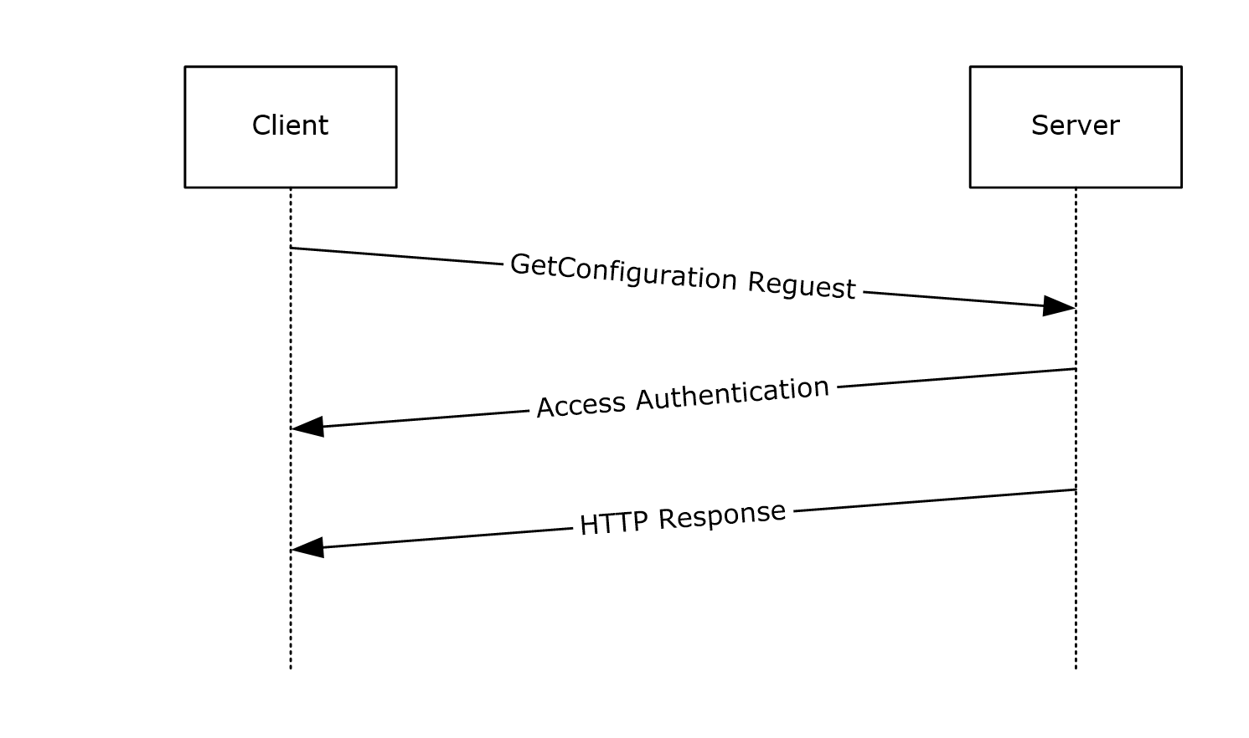
Figure 1: Message sequence for a single GetConfiguration request

GetModule Sequence
The following sequence occurs between a client and a server during a GetModule request.
- The client sends a GetModule request.
- If the server requires the client to be authenticated, the server and client exchange access authentication HTTP headers as specified in [RFC2616] section 11.
- If authentication is not required, or if authentication has succeeded, the server responds with a "200 OK" HTTP response.
- The client closes the TCP connection to the server.
The following figure shows a message sequence with a single GetModule request.
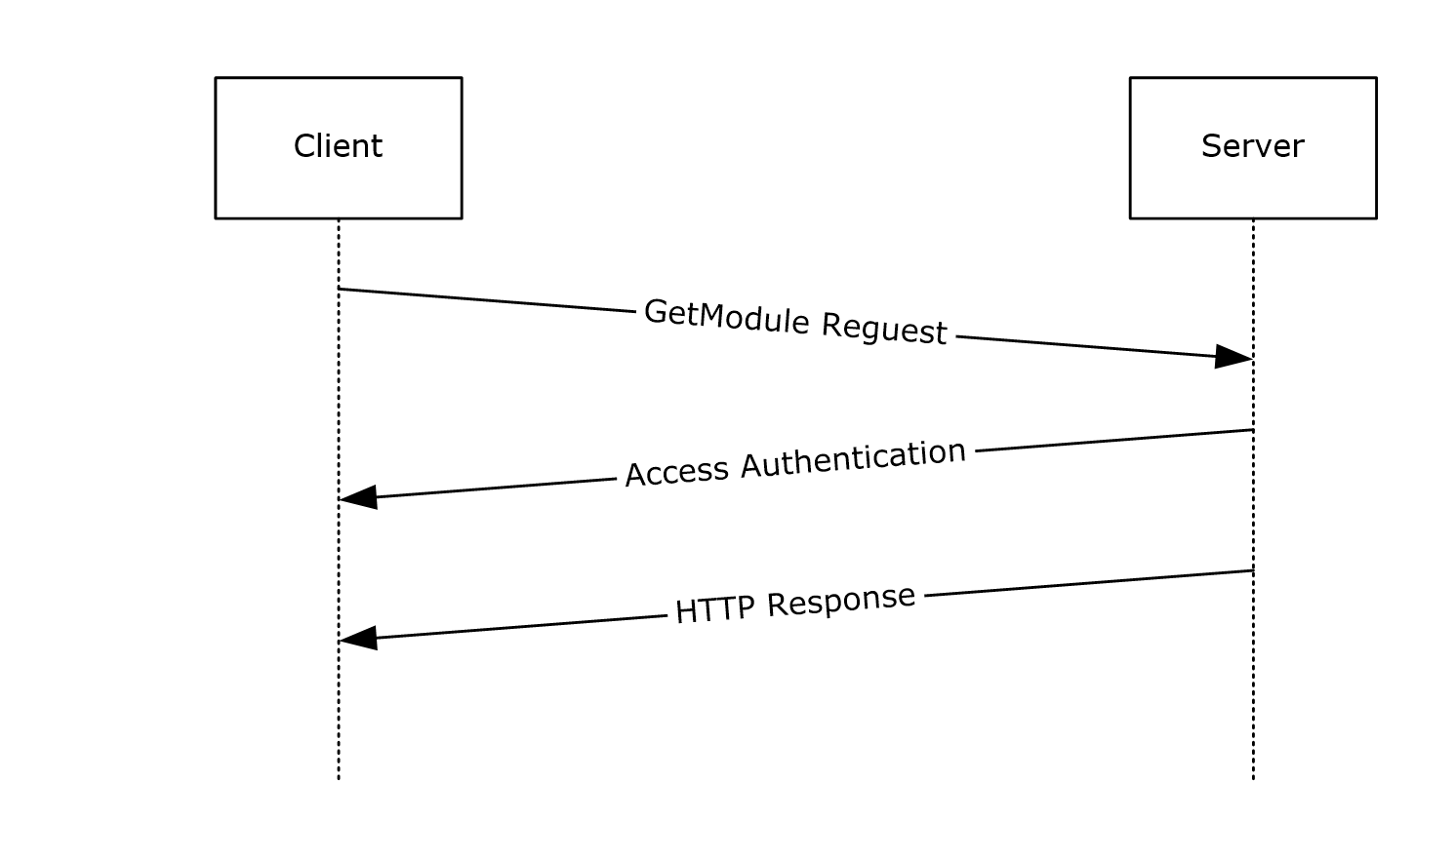
Figure 2: Message sequence for a single GetModule request

GetAction Sequence
The following sequence occurs between a client and a server during a GetAction request.
- The client sends a GetAction request.
- If the server requires the client to be authenticated, the server and client exchange access authentication HTTP headers as specified in [RFC2616] section 11.
- If authentication is not required, or if authentication has succeeded, the server responds with a "200 OK" HTTP response.
- The client closes the TCP connection to the server.
The following figure shows a message sequence with a single GetAction request.
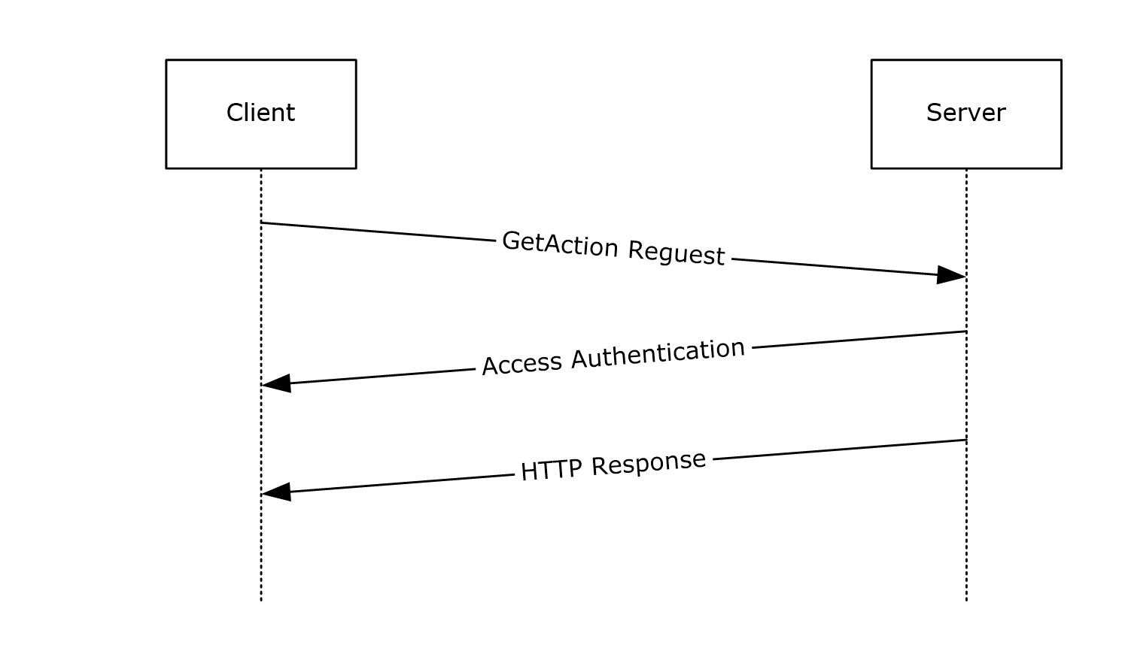
Figure 3: Message sequence with a single GetAction request

SendStatusReport Sequence
The following sequence occurs between a client and a server during a SendStatusReport request.
- The client sends a SendStatusReport request.
- If the server requires the client to be authenticated, the server and client exchange access authentication HTTP headers as specified in [RFC2616] section 11.
- If authentication is not required, or if authentication has succeeded, the server responds with a HTTP 200 (OK) response.
- The client closes the TCP connection to the server.
The following figure shows a message sequence with a single SendStatusReport request.
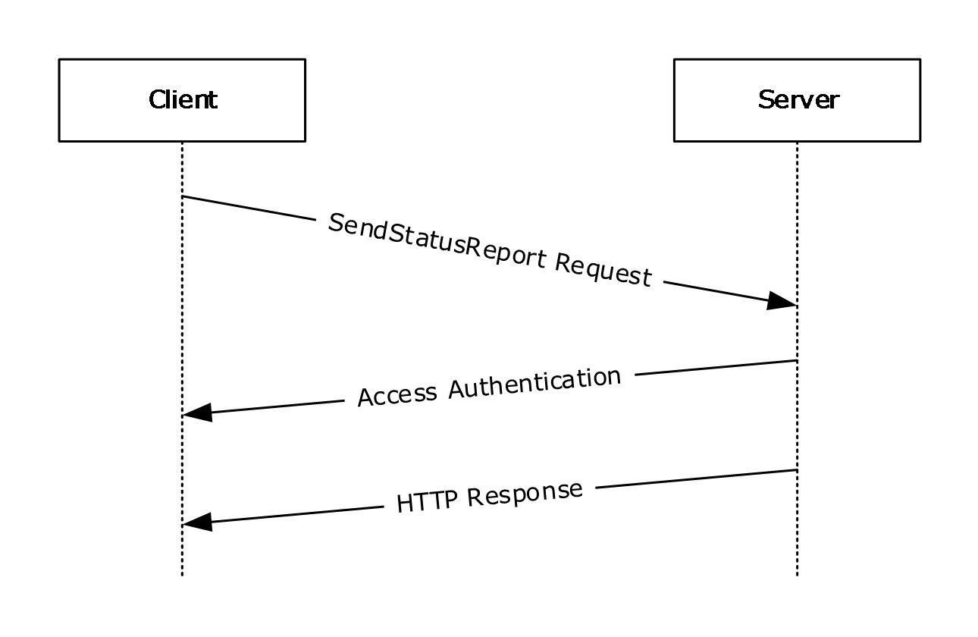
Figure 4: Message sequence with a single SendStatusReport

GetStatusReport Sequence

The following sequence occurs between a client and a server during a GetStatusReport request.
- The client sends a GetStatusReport request.
- If the server requires the client to be authenticated, the server and client exchange access authentication HTTP headers as specified in [RFC2616] section 11.
- If authentication is not required, or if authentication has succeeded, the server responds with a HTTP 200 (OK) response.
- The client closes the TCP connection to the server.
The following figure shows a message sequence with a single GetStatusReport request.
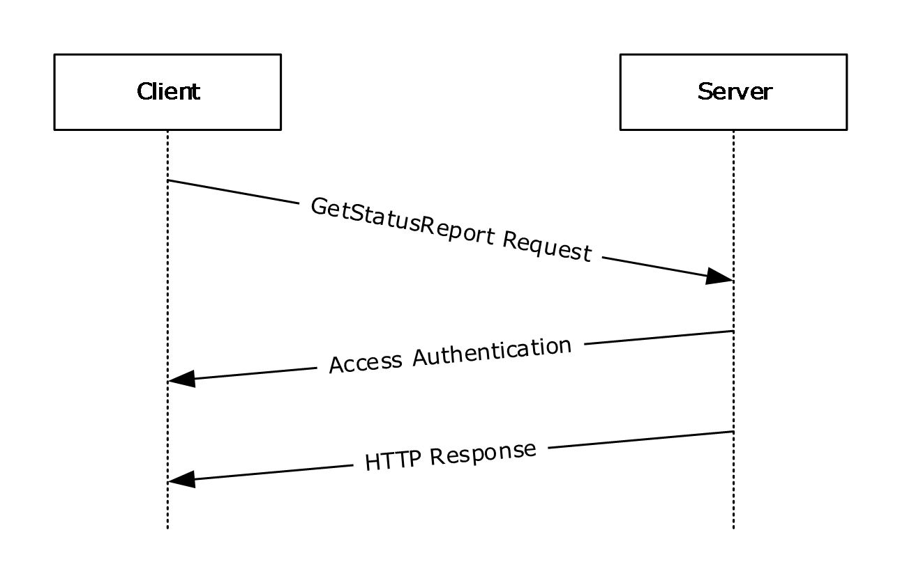
Figure 5: Message sequence with a single GetStatusReport

RegisterDscAgent Sequence
The following sequence occurs between a client and a server during a RegisterDscAgent request.
- The client sends a RegisterDscAgent request.
- If the server requires the client to be authenticated, the server and client exchange access authentication HTTP headers as specified in [RFC2616] section 11.
- If authentication is not required, or if authentication has succeeded, the server responds with a HTTP 200 (OK) response.
- The client closes the TCP connection to the server.
The following figure shows a message sequence with a single RegisterDscAgent request.
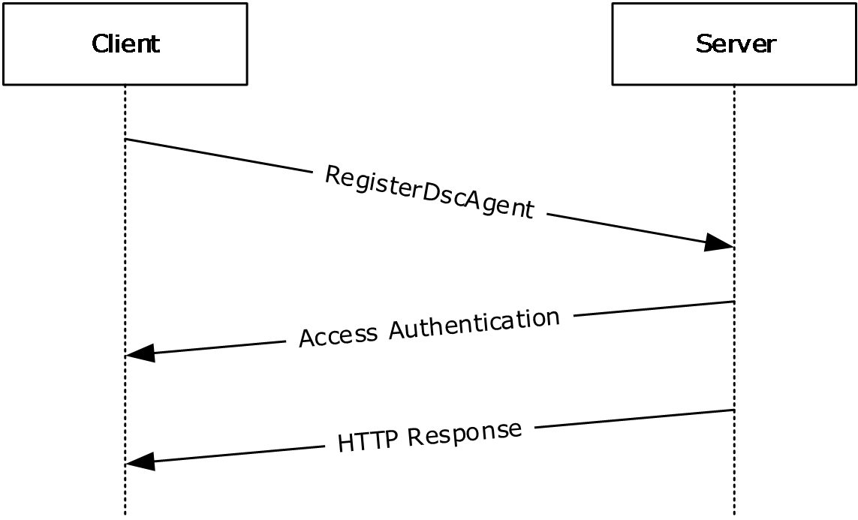
Figure 6: Message sequence with a single RegisterDscAgent

SendReport Sequence
The following sequence occurs between a client and a server during a SendReport request.
- The client sends a SendReport request.
- If the server requires the client to be authenticated, the server and client exchange access authentication HTTP headers as specified in [RFC2616] section 11.
- If authentication is not required, or if authentication has succeeded, the server responds with a HTTP 200 (OK) response.
- The client closes the TCP connection to the server.
The following figure shows a message sequence with a single SendReport request.
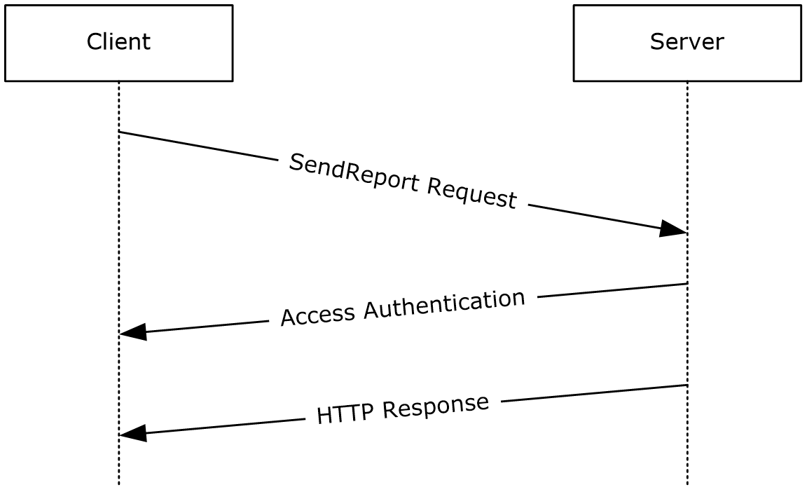
Figure 7: Message sequence with a single SendReport request

GetDscAction Sequence
The following sequence occurs between a client and a server during a GetDscAction request.
- The client sends a GetDscAction request.
- If the server requires the client to be authenticated, the server and client exchange access authentication HTTP headers as specified in [RFC2616] section 11.
- If authentication is not required, or if authentication has succeeded, the server responds with a "200 OK" HTTP response.
- The client closes the TCP connection to the server.
The following figure shows a message sequence with a single GetDscAction request.
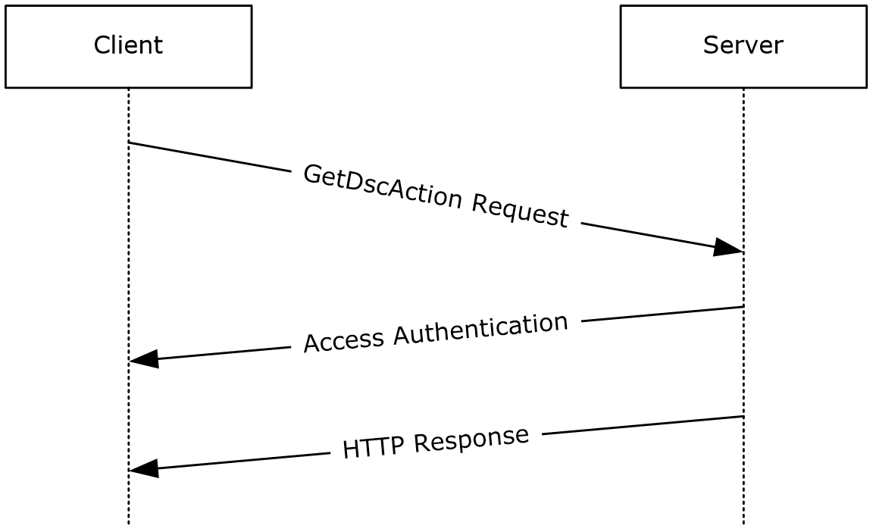
Figure 8: Message sequence with a single GetDscAction request

Security

Security Considerations for Implementers
The protocol is vulnerable to a hijacking attack in which the attacker guesses the value of the ConfigurationId (as specified in section 3.1.5.1), JobId, and/or ModuleName, ModuleVersion (as specified in section 3.2.5.1), and the TCP port number used by the client. This approach works because the attacker can establish its own TCP connection to the server and send a request by using the victim's ConfigurationId, JobId, and/or ModuleName, ModuleVersion value. To mitigate the attack, make ConfigurationId and JobId random values. Also, if HTTP access authentication is used, the server ought to authenticate access at least once on each new URL or TCP connection.

Index of Security Parameters
Security parameter | Section
HTTP access authentication | As specified in section 2.1.

Appendix A: Full JSON Schema
{
"title": "GetAction request schema",
"type" : "object",
"properties": {
"Checksum": {
"type": ["string","null"]
},
"ConfigurationName": {
"type": ["string","null"]
},
"NodeCompliant": {
"type": "boolean"

},
"ChecksumAlgorithm": {
"enum": ["SHA-256"],
"description": "Checksum algorithm used to generate checksum"
},
"StatusCode": {
"type": "integer"
}

},
"required": ["Checksum", "NodeCompliant", "ChecksumAlgorithm"]
}

{
"title": "GetAction response",
"type": "object",
"properties": {
"value": {
"enum": ["OK", "GetConfiguration", "Retry", "UpdateMetaConfiguration"],
"required": "true"
}
}
}

{
"title": "GetDscAction request schema (AgentID)",
"type": "object",
"properties": {
"ClientStatus": {
"type": "array",
"minItems": 1,
"items": [
{
"type": "object",
"properties": {
"Checksum": {
"type": [ "string", "null" ]
},
"ConfigurationName": {
"type": [ "string", "null" ]
},
"ChecksumAlgorithm": {
"enum": [ "SHA-256" ],
"description": "Checksum algorithm used to generate checksum"
}
}
}
],
"uniqueItems": true
}
}
}

{
"title": "GetDscAction response",
"type": "object",
"properties": {
"NodeStatus": {
"enum": [ "OK", "RETRY", "GetConfiguration", "UpdateMetaConfiguration" ],
"required": "true"
},
"Details": {
"type": "array",
"required": false,
"items": [
{
"type": "object",
"required": true,
"properties": {
"ConfigurationName": {
"type": "string",
"required": true
},
"Status": {
"enum": [ "OK", "RETRY", "GetConfiguration", "UpdateMetaConfiguration" ],
"required": true
}
}
}
]
}
}
}

{
"title": "SendReport request schema",
"type": "object",
"properties": {
"JobId": {
"type": [ "string", "null" ],
"required": "true"
},
"OperationType": {
"type": [ "string", "null" ]
},
"RefreshMode": {
"enum": [ "Push", "Pull" ]
},
"Status": {
"type": [ "string", "null" ]
},
"LCMVersion": {
"type": [ "string", "null" ]
},
"ReportFormatVersion": {
"type": [ "string", "null" ]
},
"ConfigurationVersion": {
"type": [ "string", "null" ]
},
"NodeName": {
"type": [ "string", "null" ]
},
"IpAddress": {
"type": [ "string", "null" ]
},
"StartTime": {
"type": [ "string", "null" ]
},
"EndTime": {
"type": [ "string", "null" ]
},
"RebootRequested": {
"enum": [ "True", "False" ]
},
"Errors": {
"type": [ "string", "null" ]
},
"StatusData": {
"type": [ "string", "null" ]
},
"AdditionalData": {
"type": "array",
"required": false,
"items": [
{
"type": "object",
"required": true,
"properties": {
"Key": {
"type": "string",
"required": true
},
"Value": {
"type": "string",
"required": true
}
}
}
]
}
}
}

{
"title": "RegisterDscAgent request",
"type": "object",
"properties": {
"AgentInformation": {
"type": "object",
"properties": {
"LCMVersion": {
"type": [ "string", "null" ]
},
"NodeName": {
"type": [ "string", "null" ]
},
"IPAddress": {
"type": [ "string", "null" ]
}
}
},
"RegistrationInformation": {
"type": "object",
"properties": {
"RegistrationMessageType" : {
"type": [ "string", "null" ]
},
"CertificateInformation": {
"type": "object",
"properties": {
"FriendlyName": {
"type": [ "string", "null" ]
},
"Issuer": {
"type": [ "string", "null" ]
},
"NotAfter": {
"type": [ "string", "null" ]
},
"NotBefore": {
"type": [ "string", "null" ]
},
"Subject": {
"type": [ "string", "null" ]
},
"PublicKey": {
"type": [ "string", "null" ]
},
"Thumbprint": {
"type": [ "string", "null" ]
},
"Version": {
"type": [ "integer", "null" ]
}
}
}
},
"ConfigurationNames": {
"type": [ "string", "null" ]
}
}
}
}

Appendix B: Product Behavior
The information in this specification is applicable to the following Microsoft products or supplemental software. References to product versions include released service packs.
- Windows 7 operating system
- Windows Server 2008 R2 operating system
- Windows Server 2012 operating system
- Windows 8.1 operating system
- Windows Server 2012 R2 operating system
- Windows 10 operating system
- Windows Server 2016 operating system
Exceptions, if any, are noted below. If a service pack or Quick Fix Engineering (QFE) number appears with the product version, behavior changed in that service pack or QFE. The new behavior also applies to subsequent service packs of the product unless otherwise specified. If a product edition appears with the product version, behavior is different in that product edition.
Unless otherwise specified, any statement of optional behavior in this specification that is prescribed using the terms "SHOULD" or "SHOULD NOT" implies product behavior in accordance with the SHOULD or SHOULD NOT prescription. Unless otherwise specified, the term "MAY" implies that the product does not follow the prescription.
<1> Section 2.2.2.4: The ConfigurationName header field is not available in Windows 7, Windows Server 2008 R2, Windows Server 2012, Windows 8.1, and Windows Server 2012 R2.
<2> Section 2.2.2.5: The ProtocolVersion header field is not available in Windows 7, Windows Server 2008 R2, Windows Server 2012, Windows 8.1, Windows Server 2012 R2, and the Windows 10 v1507 operating system.
<3> Section 2.2.2.6: The AgentId header field is not available in Windows 7, Windows Server 2008 R2, Windows Server 2012, Windows 8.1, Windows Server 2012 R2, and Windows 10 v1507.
<4> Section 2.2.2.7: The Authorization header field is available in is not available in Windows 7, Windows Server 2008 R2, Windows Server 2012, Windows 8.1, Windows Server 2012 R2, and Windows 10 v1507.
<5> Section 2.2.3.4: AgentId is not implemented in Windows 7, Windows Server 2008 R2, Windows Server 2012, Windows 8.1, and Windows Server 2012 R2.
<6> Section 3.3.5.1.1.2: Retry is not available in Windows 7, Windows Server 2008 R2, Windows Server 2012, Windows 8.1, and Windows Server 2012 R2.
<7> Section 3.4: The SendStatusReport request is not available in Windows 7, Windows Server 2008 R2, Windows Server 2012, Windows 8.1, and Windows Server 2012 R2.
<8> Section 3.5: The GetStatusReport request is not available in Windows 7, Windows Server 2008 R2, Windows Server 2012, Windows 8.1, and Windows Server 2012 R2.
<9> Section 3.6: GetConfiguration Version 2.0 is not available in Windows Server 2008 R2, Windows Server 2012, and Windows Server 2012 R2.
<10> Section 3.7: GetModule Version 2.0 is not available in Windows Server 2008 R2, Windows Server 2012, and Windows Server 2012 R2.
<11> Section 3.8: GetDscAction is not available in Windows Server 2008 R2, Windows Server 2012, and Windows Server 2012 R2.
<12> Section 3.9: The RegisterDscAgent request is not available in Windows Server 2008 R2, Windows Server 2012, and Windows Server 2012 R2.
<13> Section 3.10: The SendReport request is not available in Windows Server 2008 R2, Windows Server 2012, and Windows Server 2012 R2.
<14> Section 3.11: GetReports is not available in Windows Server 2008 R2, Windows Server 2012, and Windows Server 2012 R2.

Change Tracking
No table of changes is available. The document is either new or has had no changes since its last release.

Index
A

Applicability 9

C

Change tracking 60
Common data types 10

E

Examples
GatAction sequence 47
GetAction Sequence example 47
GetConfiguration sequence 46
GetConfiguration Sequence example 46
GetDscAction Sequence example 51
GetModule sequence 46
GetModule Sequence example 46
GetStatusReport Sequence example 49
RegisterDscAgent Sequence example 50
SendReport Sequence example 51
SendStatusReport sequence 48
SendStatusReport Sequence example 48

F

Fields - vendor-extensible 9
Full JSON schema 54

G

GetAction
abstract data model 20
higher-layer triggered events 20
initialization 20
message processing events and sequencing rules 20
other local events 22
timer events 22
timers 20
GetAction sequence example 47
Getaction versions 1.0 and 1.1
Abstract data model 20
Higher-layer triggered events 20
Initialization 20
Message processing events and sequencing rules 20
Other local events 22
Timer events 22
Timers 20
GetConfiguration
abstract data model 14
higher-layer triggered events 14
initialization 14
message processing events and sequencing rules 14
other local events 17
timer events 17
timers 14
GetConfiguration sequence example 46
Getconfiguration version 2.0
Abstract data model 28
Higher-layer triggered events 28
Initialization 28
Message processing events and sequencing rules 28
Other local events 31
Timer events 31
Timers 28
Getconfiguration versions 1.0 and 1.1
Abstract data model 14
Higher-layer triggered events 14
Initialization 14
Message processing events and sequencing rules 14
Other local events 17
Timer events 17
Timers 14
Getdscaction version 2.0
Abstract data model 34
Higher-layer triggered events 35
Initialization 34
Message processing events and sequencing rules 35
Other local events 37
Timer events 37
Timers 34
GetModule
abstract data model 17
highedr-layer triggered events 17
initialization 17
message processing events and sequencing rules 17
other local events 20
timer events 20
timers 17
GetModule sequence example 46
Getmodule version 2.0
Abstract data model 31
Higher-layer triggered events 31
Initialization 31
Message processing events and sequencing rules 32
Other local events 34
Timer events 34
Timers 31
Getmodule versions 1.0 and 1.1
Abstract data model 17
Higher-layer triggered events 17
Initialization 17
Message processing events and sequencing rules 17
Other local events 20
Timer events 20
Timers 17
Getreports version 2.0
Abstract data model 43
Higher-layer triggered events 43
Initialization 43
Message processing events and sequencing rules 43
Other local events 45
Timer events 45
Timers 43
Getstatusreport versions 1.0 and 1.1
Abstract data model 25
Higher-layer triggered events 26
Initialization 25
Message processing events and sequencing rules 26
Other local events 28
Timer events 27
Timers 25
Glossary 7

H

HTTP headers 10

I

Implementer - security considerations 53
Index of security parameters 53
Informative references 8
Introduction 7

J

JSON schema 54

M

Messages
data types 10
transport 10

N

Namespaces 10
Normative references 8

O

Overview (synopsis) 8

P

Parameters - security index 53
Preconditions 8
Prerequisites 8
Product behavior 58
Protocol Details
GetAction 20
GetAction Versions 1.0 and 1.1 20
GetConfiguration 14
GetConfiguration Version 2.0 28
GetConfiguration Versions 1.0 and 1.1 14
GetDscAction Version 2.0 34
GetModule 17
GetModule Version 2.0 31
GetModule Versions 1.0 and 1.1 17
GetReports Version 2.0 43
GetStatusReport Versions 1.0 and 1.1 25
RegisterDscAgent Version 2 37
SendReport Version 2.0 40
SendStatusReport 22
SendStatusReport Versions 1.0 and 1.1 22
Protocol examples
GetAction Sequence 47
GetConfiguration Sequence 46
GetDscAction Sequence 51
GetModule Sequence 46
GetStatusReport Sequence 49
RegisterDscAgent Sequence 50
SendReport Sequence 51
SendStatusReport Sequence 48

R

References
informative 8
normative 8
Registerdscagent version 2
Abstract data model 37
Higher-layer triggered events 37
Initialization 37
Message processing events and sequencing rules 37
Other local events 40
Timer events 39
Timers 37
Relationship to other protocols 8

S

Schema - JSON 54
Security
implementation 53
implementer considerations 53
parameter index 53
Sendreport version 2.0
Abstract data model 40
Higher-layer triggered events 40
Initialization 40
Message processing events and sequencing rules 40
Other local events 43
Timer events 42
Timers 40
SendStatusReport
abstract data model 22
higher-layer triggered events 23
initialization 23
message processing events and sequencing rules 23
timers 23
SendStatusReport sequence example 48
Sendstatusreport versions 1.0 and 1.1
Abstract data model 22
Higher-layer triggered events 23
Initialization 23
Message processing events and sequencing rules 23
Other local events 25
Timer events 25
Timers 23
Standards assignments 9
System overview - introduction 7

T

Tracking changes 60
Transport 10
common data types 10
namespaces 10

U

URI parameters 12

V

Vendor-extensible fields 9

